Homomorphic Encryption and its Contributions in Healthcare Industry
Cloud computing provides heavy computation resources and storage at cheaper prices so all organizations like social media, health care and many more are using cloud services for computation and storage but this advantage brings a security issue as data store at 3rd party cloud server away from user hand and this cloud servers may misuse user data.
To avoid misuse data encryption was introduce which will encrypt data before storage but while performing computation data must be decrypted and during decryption some data will be expose or leak to cloud servers. To avoid such exposure author of this paper giving review on Homomorphic encryption which allow any computation on encrypted data without any decryption. So by employing Homomorphic encryption we can avoid any data leakage to cloud server.
In propose paper author employing Homomorphic encryption on Healthcare data where patients will upload Homomorphic encrypted symptoms to cloud and then cloud will perform computation on encrypted data to predict patient health result. Authenticated doctor can query cloud to get patient encrypted data and predicted result and then decrypt data.
To implement this project we don’t have any patient’s health or symptoms data so we are utilizing patient Heart disease dataset where patient will enter his current heart condition and then will encrypt data using Homomorphic and the upload to cloud. Cloud will compute encrypted data using Machine Learning algorithm to predict patient condition as Normal or Abnormal.
To predict patient condition we are utilizing below heart dataset
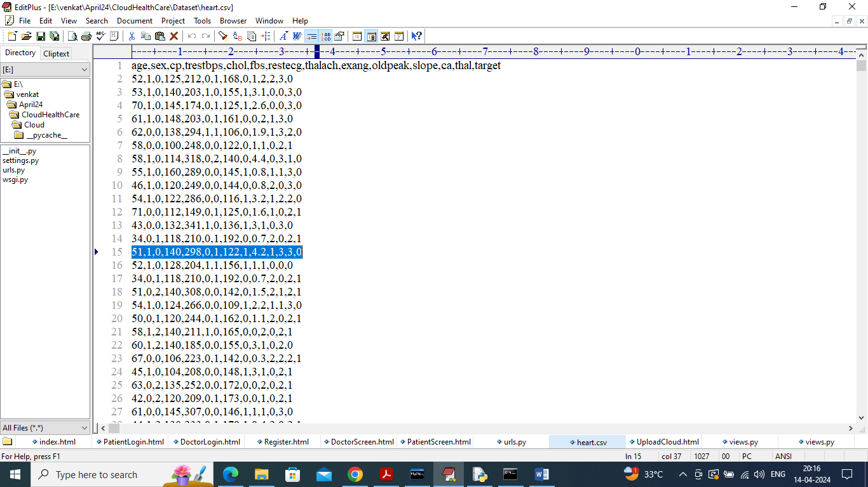
In above dataset screen first row contains dataset column names all heart condition details and remaining rows contains values and in last column we have class labels as 0 (normal) and 1 (abnormal). In above screen all data is in plain format bit when patient upload any data then it will be encrypted.
To implement this project we have designed following modules
- New User Sign up: using this module patients and doctors will sign up with the application
- Patient Login: patient can login to system and then enter his heart condition details, system will encrypt all details and upload to cloud. Cloud will compare encrypted dataset value with patient data to predict result as Normal or Abnormal. Patient can view all past observation which he store in the past
- Doctor Login: Doctor can login to system and then query cloud to get all patient encrypted data and then decrypt data to get patient condition along with predicted output.
SCREEN SHOTS
To run project install Python3.7 and then install all packages given in requirements.txt file and then install MYSQL database and then copy content from ‘db.txt’ file and paste in MYSQL console to create database.
Now double click on run.bat file to start python server and get below page
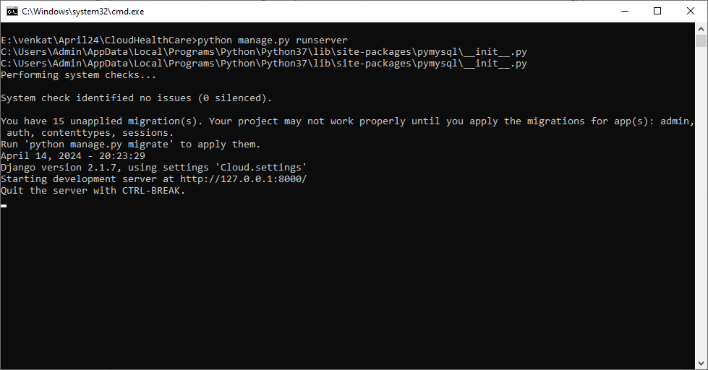
In above screen python server started and now open browser and enter URL as http://127.0.0.1:8000/index.html and press enter key to get below page
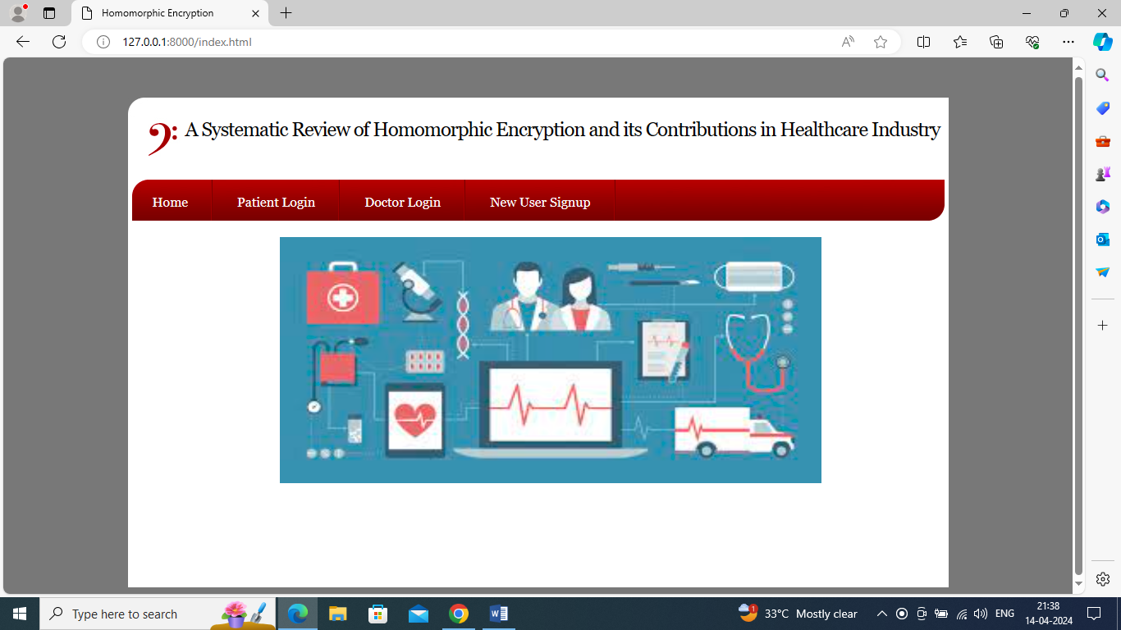
In above screen click on ‘New User Sign up’ link to register patients and doctors
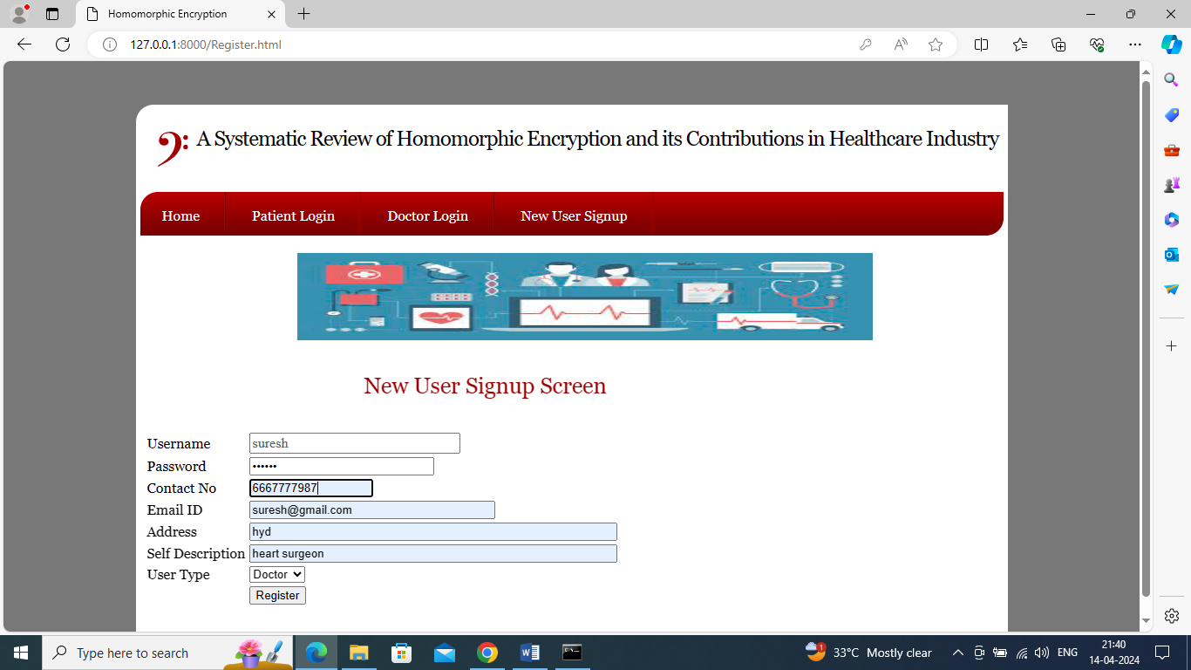
In above screen adding doctor details and now click on ‘Register’ button to save doctor details in database
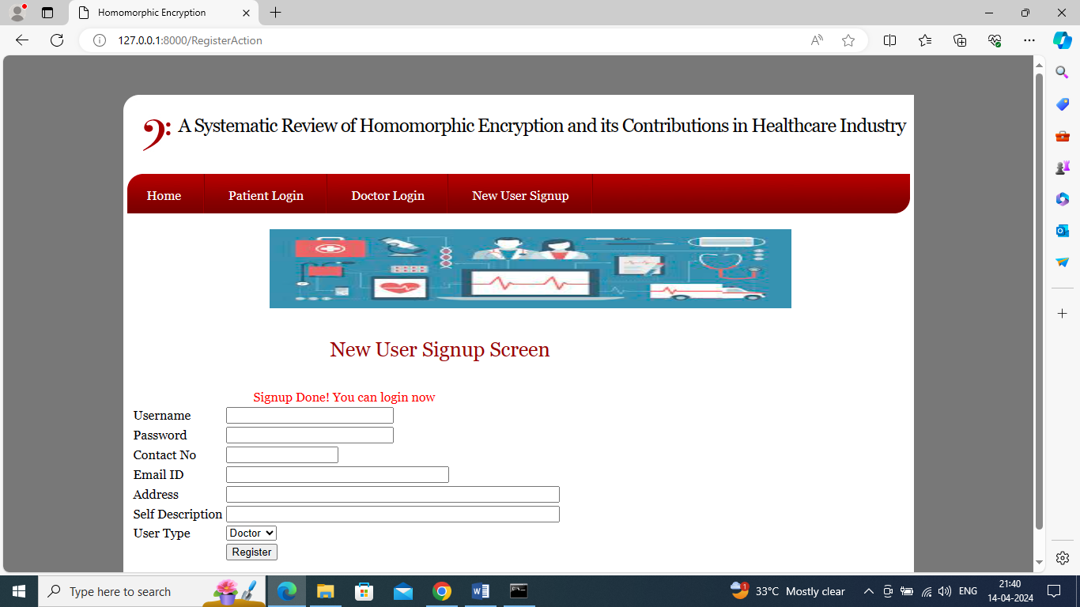
In above screen signup completed and now adding patients details
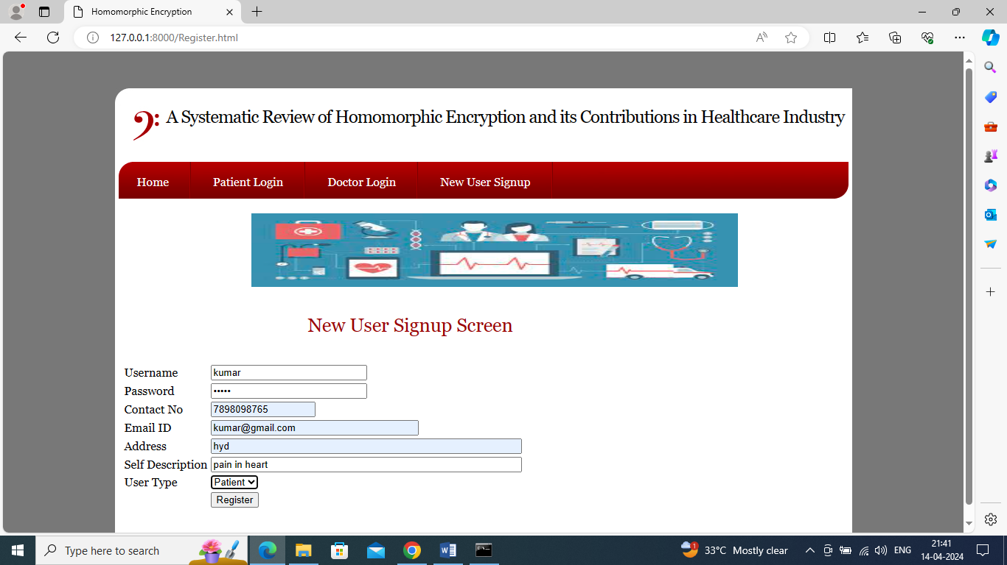
In above screen adding patient details and then press button to get below page
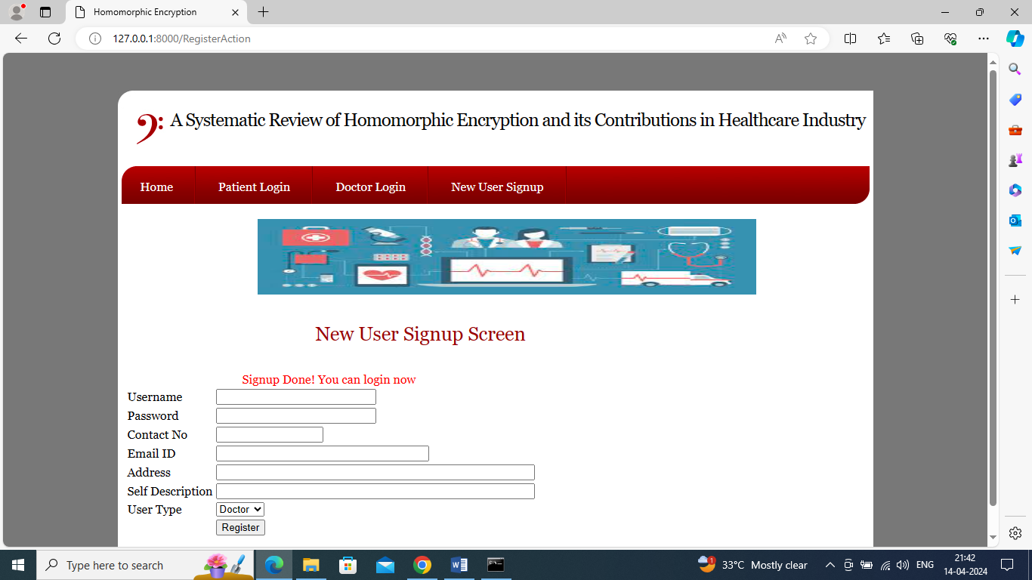
In above screen patient sign up completed and now click on ‘Patient Login’ link to get below page
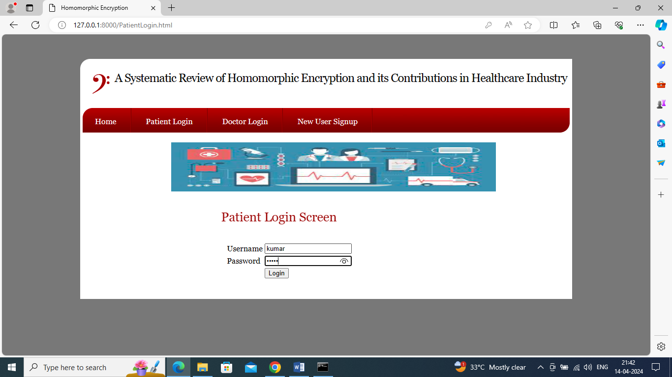
In above screen login as patient and then click on ‘Login’ button to login as patient and get below page
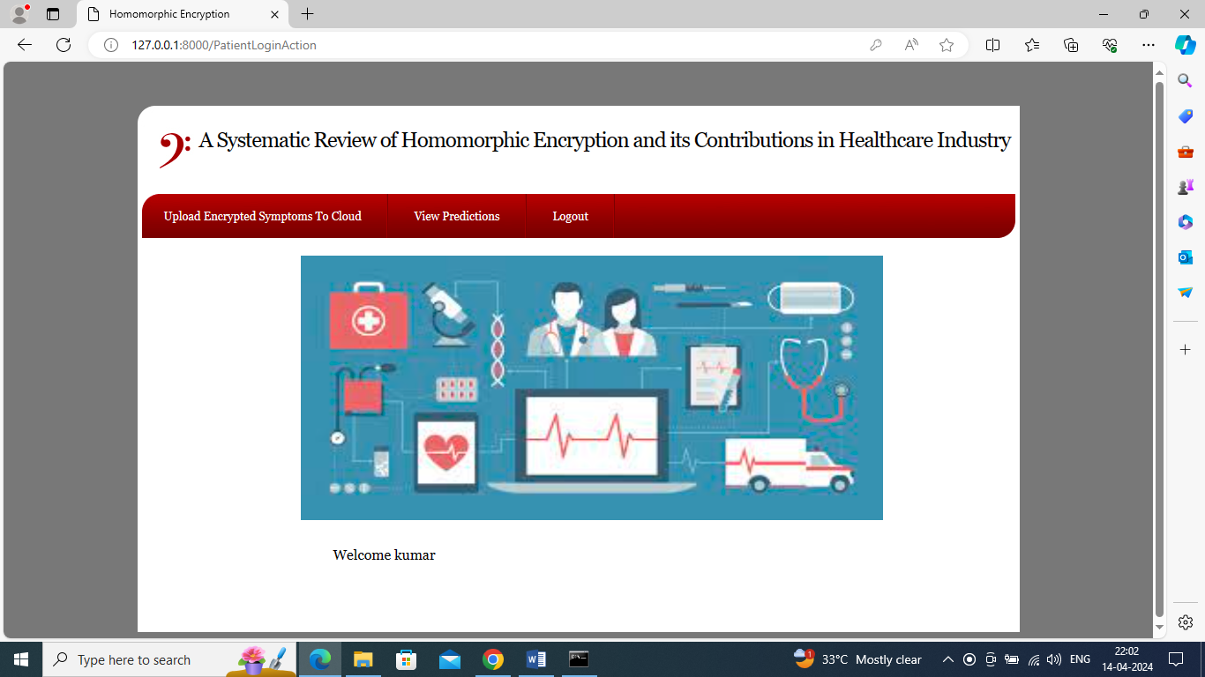
In above screen click on ‘Upload Encrypted Symptoms to Cloud’ link to upload patient data
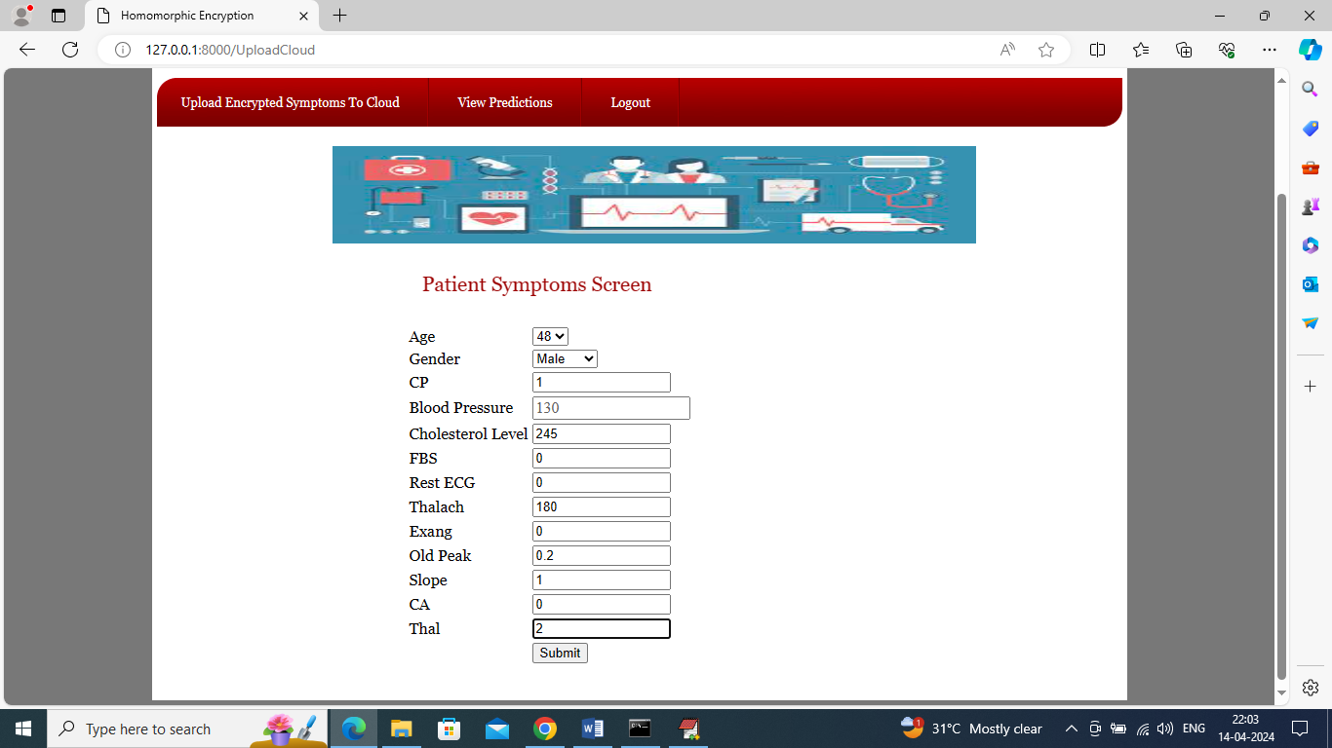
In above screen patient will enter all his heart symptoms and this symptoms you can take from Dataset/heart.csv file and then click on ‘Submit’ button to upload above details in cloud in encrypted format and get below predicted output
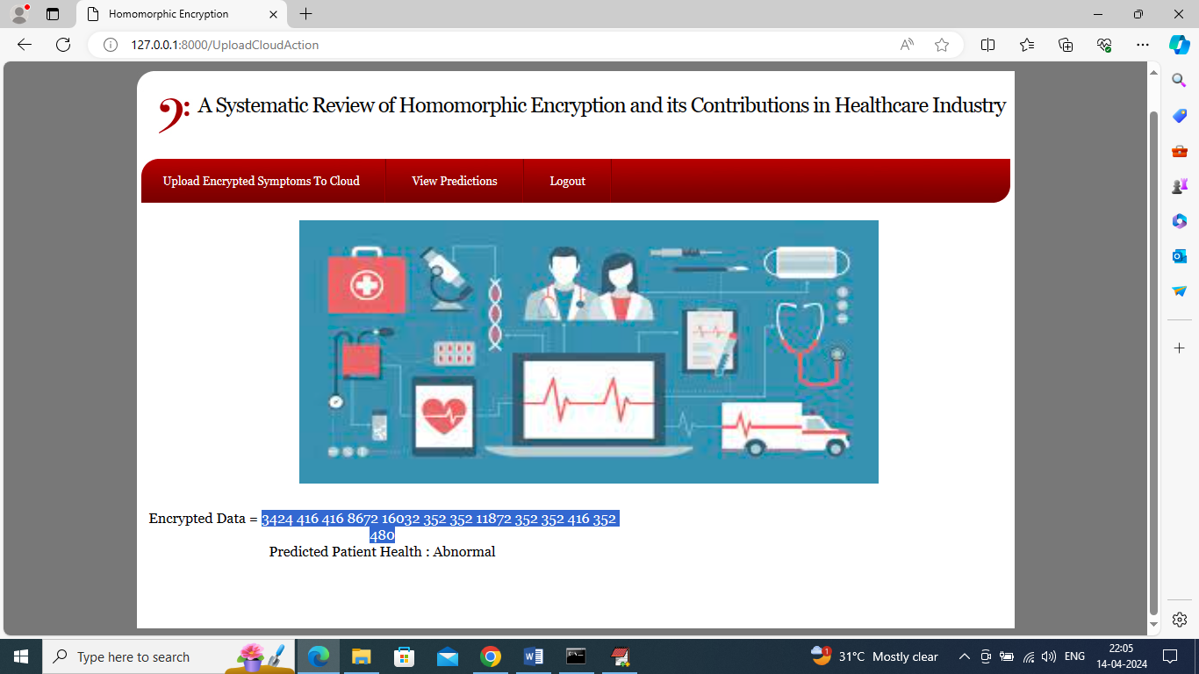
In above screen in blue colour text can see all patient heart data converted to encrypted format and then in next line can see predicted health condition as ‘Abnormal’ and similarly you can add details for any other patients and now click on ‘View Predictions’ link to view all past predictions for this patients
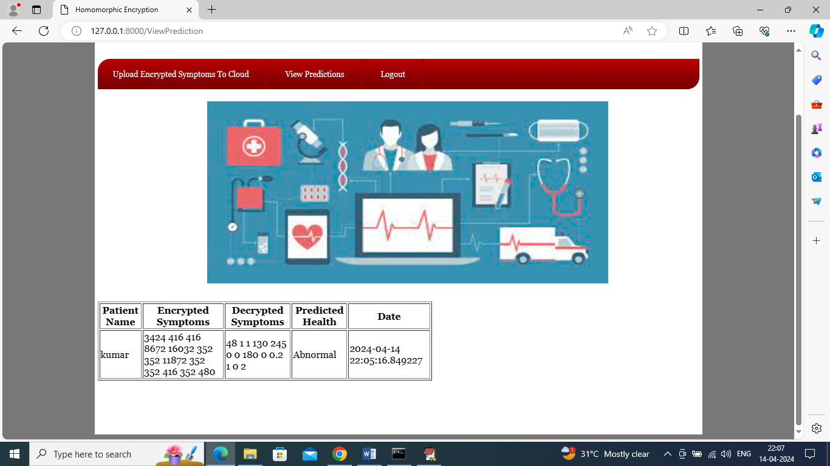
In above screen in first column patient can view his name and then can see encrypted heart details of patients and then can see Decrypted heart details and then can see predicted heart result with date and time. Now logout and login as doctor to view all patient details
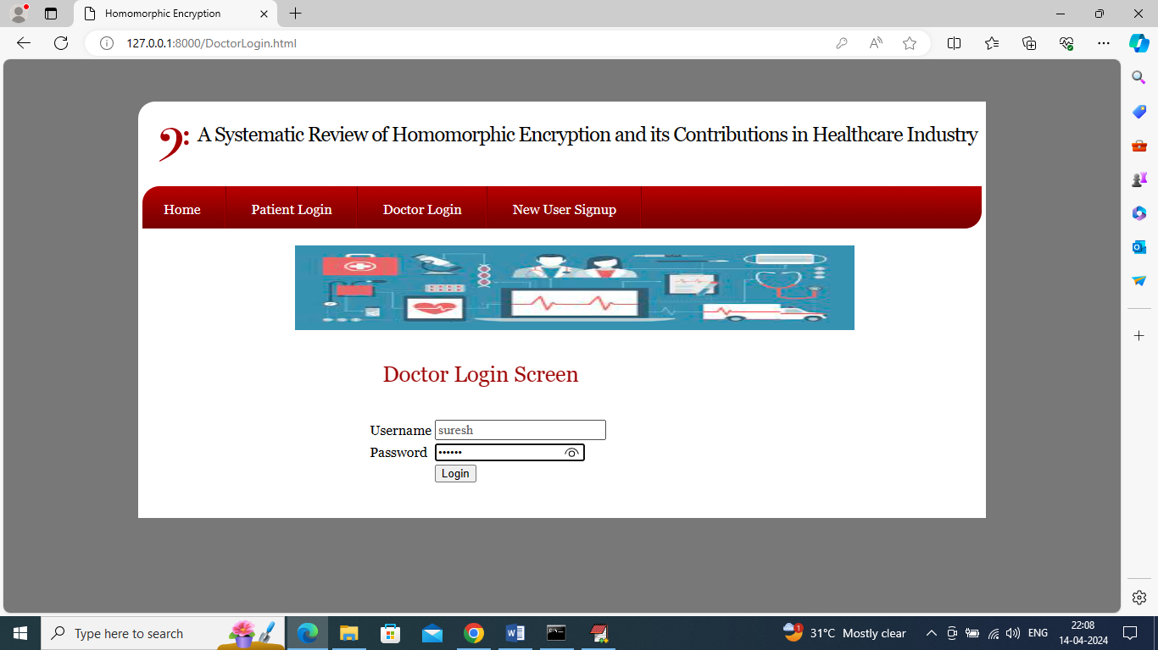
In above screen doctor is login and after login will get below page
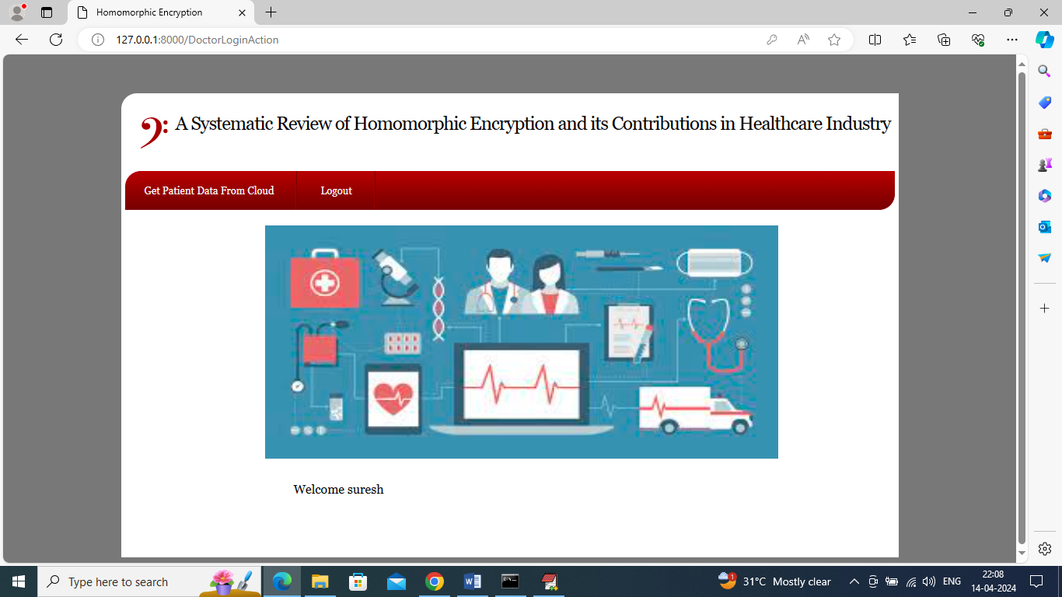
In above screen doctor can click on ‘Get Patient Data from Cloud’ link to query cloud to send al patient data and get below output
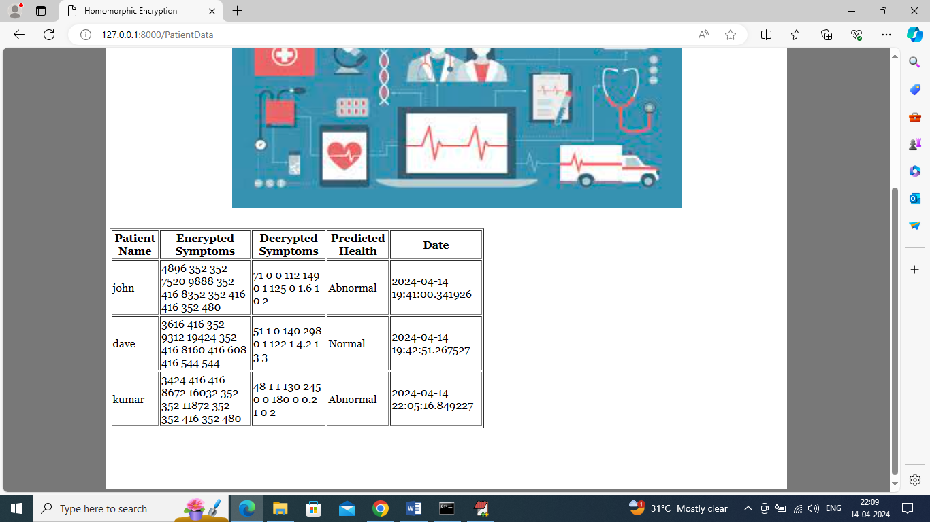
In above screen doctor can view all patient data in encrypted and decrypted details along with prediction as ‘Normal or Abnormal’.
Similarly by following above screens you can upload encrypted data to cloud which will perform computation on encrypted data to predict patient heart conditions.

