GEBZE TECHNICAL UNIVERSITY
CSE 222/502 DATA STRUCTURES AND ALGORITHMS
SPRING 2020
GROUP-5 PROJECT PROPOSAL

1. Group members
Hikmet TÜTÜNCÜ 141044054
Büşra Nur ALTUNBAŞ 121044076
Halime KUVEL 1801042677
Kemal DELİCELİ 141044072
Vedat ELLİDOKUZOĞLU 161044098
Nazmi YAZKAN 131044052
Hüseyin Sabri ALİEFENDİOĞLU 195008003033

2. Problem definition
A software system for a manufacturing company is going to be designed. System has design, planning, stock, purchasing, sales and quality capabilities. Working steps of the company is given below:
Products which consist of some raw material are manufactured in process steps by workshops. They are designed by design department. To manufacture a new product, a work order is prepared for each product. Warehouse sends necessary raw material to manufacturing. Processes are done in the order given in the work order. Finished product is sent to warehouse after approval of quality department.
Purchasing department buys the raw material from suppliers. Purchased raw material is sent to warehouse after approval of quality department. Sales department sells ready products in the warehouse.

3. Users of the system
According to requirements there has to be following users for the system.

Users | Main function
Admin | All modules
Design | Product
Planning | Work order, Stock
Warehouse | Stock
Manufacturing | Work order steps
Quality | Control of products or raw material
Purchasing | Purchase order
Seller  1 | Sales order

4. Requirements (detailed)
General structure of the system is given below.

Item | Relation | Related Class | Data
RawMaterial |  |  | id, definition
Process |  |  | id, definition
WorkShop |  |  | id, definition, hourlyCost
Supplier |  |  | id, definition, purchaserId
Customer |  |  | id, definition, sellerId
Product | includes (many) | RawMaterial | amount (many)
Product | includes (many) | Process
Product | includes (many) | WorkShop
StockRawMaterial | includes (many) | RawMaterial | amount (many)
StockProduct | includes (many) | Product | amount (many)
WorkOrder | includes (1) | Product | amount, plannerId, state
PurchaseOrder | includes(many) | RawMaterial | amount (many), supplierId, purchaserId, state
SalesOrder | includes(many) | Product | amount (many), customerId, sellerId, state

i- User requirements:

Administrator shall be able to define/ delete a raw material.
Administrator shall be able to define/ delete a process.
Administrator shall be able to define/ delete a work shop.
Administrator shall have the right of all other users.

Designer shall be able to define/ delete a product.

Planning shall be able to define/ delete a work order.
Planning shall be able to define/ delete a raw material stock.
Planning shall be able to define/ delete a product stock.

Purchaser shall be able to define/ delete a supplier.
Purchaser shall be able to define/ delete a purchase order.

Seller shall be able to define/ delete a customer.
Seller shall be able to define/ delete a sales order.

Manufacturing shall be able to upgrade/ downgrade state of work order.

Quality shall be able to approve/ reject a finished product.
2
Quality shall be able to approve/ reject a purchased raw material.

Warehouse shall be able to update stock amount when received approved product.
Warehouse shall be able to update stock amount when received approved raw material.
Warehouse shall be able to update stock amount after sending raw material to work order.

ii- Other Requirements:
All items will have a unique index.
Users shall be able to reach the data that they need
Following cases shall cause exception.
- Any item used by another one shall not be deleted.
- A used index cannot be assigned again.
- Stock amount of warehouse cannot be less than 0.
Reports replying following questions shall be available to Administrator.
- How busy are the work shops?
- What are the acceptance rates of a suppliers?
- Which products are sold most?
- Which customers buy more?
- What is the scrap rate?
- What is the rejection rate of suppliers?
- What is the rejection rate of workshops?

5. Use-case diagram
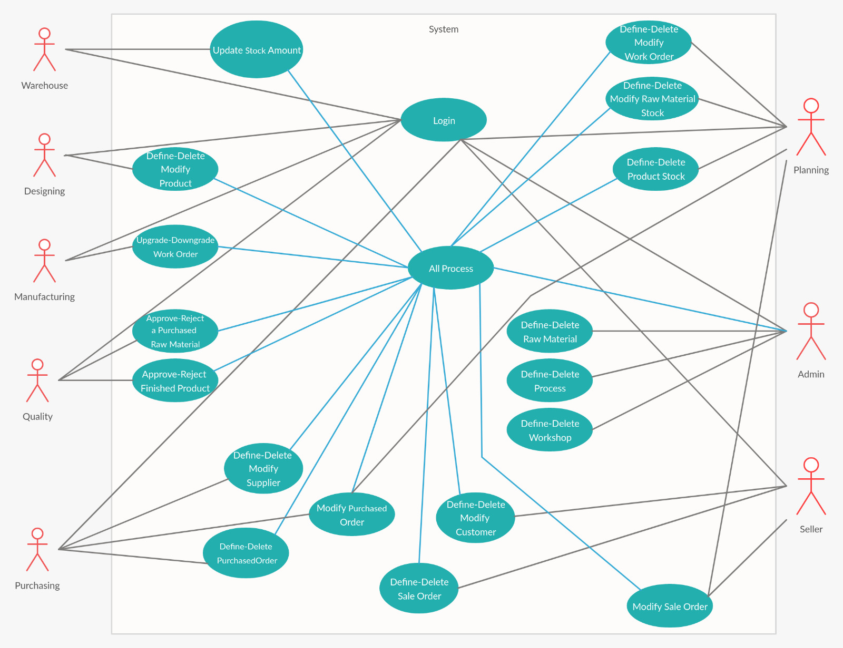
3
6. Module diagram including system modules and their interactions (high level design)
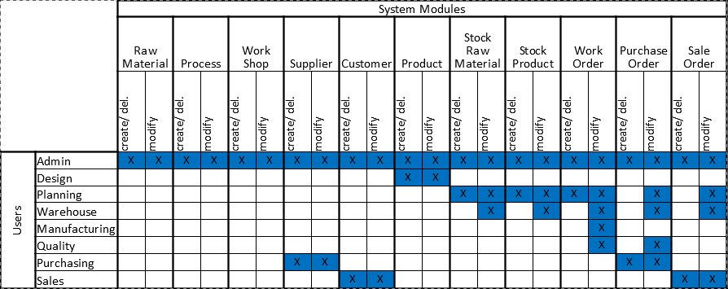
7. Notes
4
GitHub account has created. The other extra files on the github account.
https://github.com/cse222grup5/GroupProject
Jerfi Ilkcan CEYLAN has not joined the group. He said that he dropped the course.

