# *Banking System Requirements Elicitation – Mock Interview*

# *Client: THEMBA MOENG*

# *Interviewer: Student-WABATSHA PANSIRI*

# *Date: [17/09/2025]*

# Interviewer (Student): What is the main purpose of the banking system? Client (lecturer): To allow customers to open and manage accounts securely.

# Interviewer: What types of accounts should be supported? Client: Savings, Investment, and Cheque accounts. Each has its own rules.

# Interviewer: What actions can customers perform with these accounts? Client: They can deposit money into all accounts. Withdrawals are allowed for Investment and Cheque accounts but not for Savings.

# Interviewer: How is interest handled? Client: Savings accounts earn 0.05% monthly interest, while Investment accounts earn 5%. Cheque accounts don’t earn interest.

# Interviewer: What about security? Client: Only registered and authenticated customers should access accounts. The system must prevent unauthorized access.

# Interviewer: What about system performance and reliability? Client: Transactions should process instantly, and balances must remain accurate at all times.

|  |
| --- |
| Interviewer: Should the system track transactions? |

|  |
| --- |
| **Client: Yes, all deposits, withdrawals, and transfers must be recorded and accessible.**  Interviewer :should there be notifications or statements?  **Client: Yes, monthly statements and alerts for account activities**  Interviewer:How will new customers register for an account?  **Client: Customers will fill out a registration form with personal details and submit identity verification documents.**  Interviewer:How long should transaction history be stored?  **Client:At least 5 years, in compliance with banking regulations.** |

# Banking System Requirements

## Functional Requirements( What the system must do)

* Customer Registration: The system should allow the creation of new customers and record their details (name, address, etc.).
* Account Creation: Customers must be able to open different account types – Savings, Investment, or Cheque. Each account must follow specific business rules (e.g., minimum deposit for Investment, employment details for Cheque).
* Multiple Accounts: A customer should be able to hold more than one account at the same time.
* Deposits: Customers must be able to deposit money into any of their accounts.
* Withdrawals: Customers should be able to withdraw funds where permitted (Investment and Cheque only). Withdrawal attempts from Savings must be rejected.
* Interest Calculation: The system must calculate and apply monthly interest to eligible accounts (Savings and Investment).
* Balance Inquiry: Customers should be able to check account balances and view account statements.
* Transaction Records: Every deposit, withdrawal, and interest payment must be logged for audit purposes.
* Error Handling: The system should prevent invalid actions such as overdrafts, opening Investment accounts with less than BWP 500, or missing employment details for Cheque accounts.

## Non-Functional Requirements(System Qualities)

* Performance: Transactions should process quickly, and interest calculations must handle many accounts efficiently.
* Security: Customer data and account details must be protected. Unauthorized access should be prevented, and transaction logs maintained.
* Scalability: The system must be able to accommodate many customers and accounts, and allow new account types to be added easily.
* Usability: The system should have a user-friendly interface, making it simple for customers to perform operations.
* Reliability: Balances and records should always remain accurate, with the system available whenever needed.
* Maintainability: The system should be developed using proper object-oriented design, making it easy to modify or extend.
* Portability: The software should run on different operating systems that support Java.

***STRUCTURAL MODELLING***

***USE CASE***

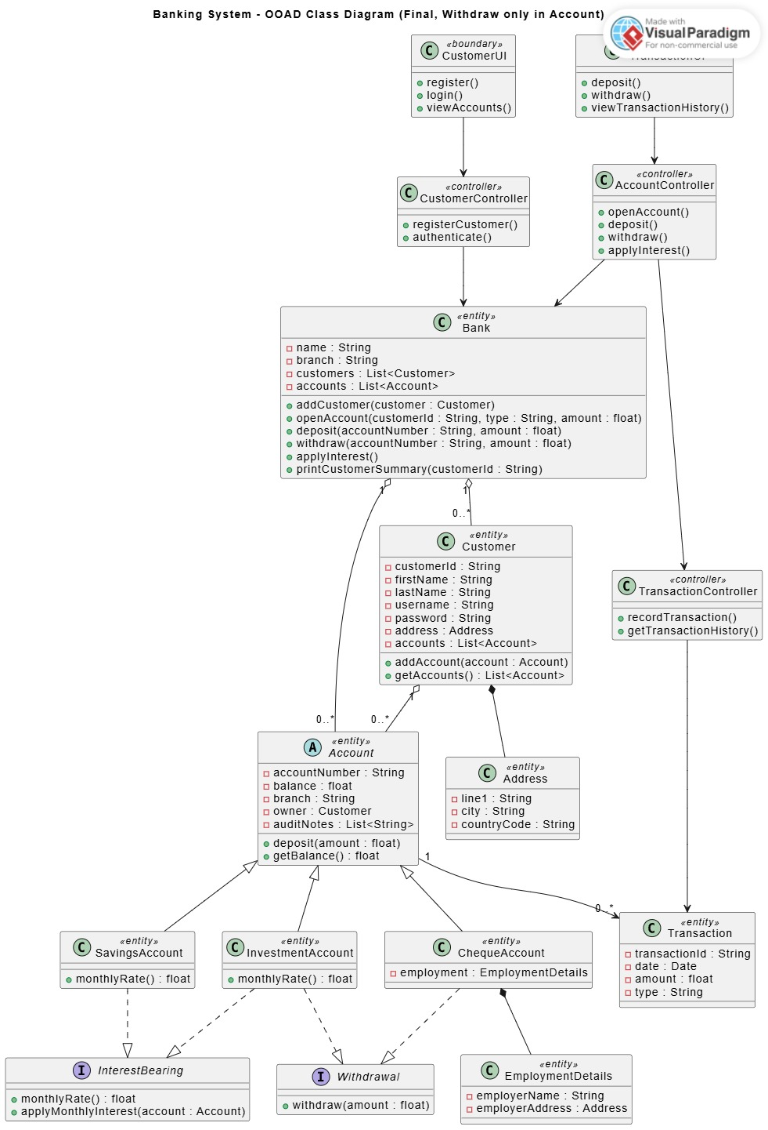***CLASS DIAGRAM***

***BEHAVIOURAL MODELLING***

***SEQUENCE DIAGRAM(LOGIN)***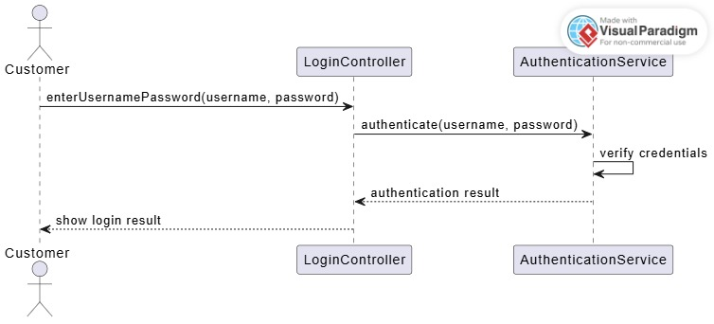

***SEQUENCE DIAGRAM (DEPOSIT)***

***STATE DIAGRAM***

