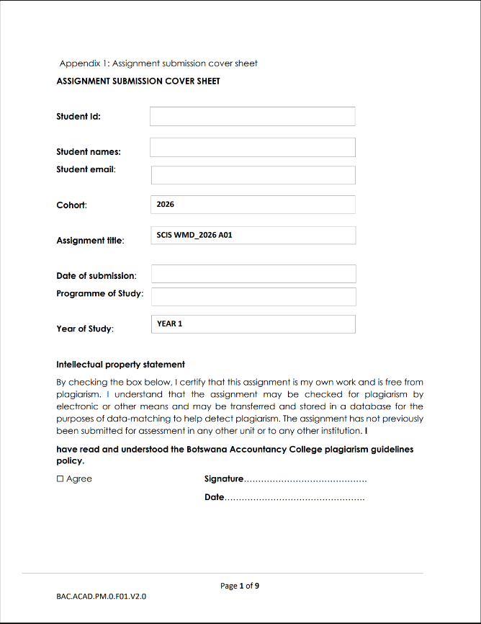
20/03/2026
T.O.Rannoko
Computer Systems Engineering
20/03/2026
cse25-201@thuto.bac.ac.bw
Tumiso Obed Rannoko
cse25-201

1. Introduction

This report is about the proposal for the planning and design of a website that is referred to as ToolNest. The main goal of this project is to design a technology resource website where users can get to know useful digital tools that can help them in their productivity and development as individuals.

Most individuals have been having problems trying to get access to useful tools that can help them in their productivity and development. Therefore, this website is created to help solve this problem by providing users with access to useful tools that can help them in their productivity and development. The planning of this website involves the objectives of the website, the target users of the website, the structure of the website, and the technologies to use in the development of the website.

2. Website Specifications

2.1 Website Objective
The main goal behind creating this ToolNest website is to create a platform where users can discover and explore new digital tools that can be used to increase productivity and creativity.

The main goal behind creating this website is to allow users to access a simple and visually appealing interface where they can access various categories of digital tools, such as artificial intelligence, developer tools, and productivity applications.

The main goal behind creating this website is to allow users to access various digital tools through this platform, as opposed to searching through various different websites for these tools.

2.2 Website Goals

The objectives for the ToolNest website will be:

• To provide a platform for users to discover useful digital tools

• To categorize digital tools in order for users to easily access them

• To provide a contemporary interface for users that is both attractive and user-friendly

• To ensure that users are able to access the website using both desktop and mobile devices

• To provide users with an engaging experience using contemporary design elements such as glassmorphism, animated backgrounds, and transitions

2.3 Target Audience

The ToolNest website would be designed keeping in mind the needs of people who often use technology tools to advance their work, study, or creative pursuits.

The primary target group of the ToolNest website would include:

• Students in need of productivity and study tools

• Developers using coding platforms and software development tools

• Designers making use of creative and graphic design tools

• Technology enthusiasts looking forward to exploring new digital platforms

The target age group would be between 16 and 35 years old. The majority of the target group would have basic knowledge of computers and the internet.

The website would be designed to be accessed through various devices like computers, laptops, tablets, and smartphones.

2.4 Type of Website

The ToolNest will be developed as a technology resource and discovery website. The website will be built as a tool discovery platform, allowing users to explore different types of digital tools for productivity, design, and software development.

The website will be built with a focus on presenting information in a simple and organized manner, so users can easily identify the tools and learn about the features.

3. Information Design & Taxonomy

Information design will concentrate on the organization of the content of the website to enable easy navigation between different pages of the website.

The ToolNest website will be arranged in a hierarchical structure. The home page will be the main page for accessing other pages. From the home page, users will be able to navigate to other pages through a navigation menu.

Website Sitemap
Home (index.html)

Explore(explore.html)
(explore.html)
Contact(contact.html)

About(about.html)

(The sitemap shows the hierarchical structure of the ToolNest website. The Home page is the main entry point, from which the user can access other pages like Explore, About, and Contact through the main navigation menu.)

Each page will have a specific function to play on the website.

The Home page will be used to introduce the website and invite users to explore the tools provided.

The Explore page will be used to display different digital tools using card-based layouts, showing the tool’s name, icon, and description.

The About page will be used to provide information about the purpose and goals of the website

The Contact page will provide users with options to contact the website administrators.

4. Technical Brief

The ToolNest website will be created using advanced web development tools that allow for responsive web design and interactive web experiences.

The main tools that will be used to develop the website include: Visual Studio Code to write the code for the website, and GitHub to store the code.

The website will also be hosted online through GitHub Pages, which enables users to host their web applications created through HTML5, CSS3, and JavaScript on the internet.

The technologies to be used in the development of the website.

•HTML5- will be used to build the structure of the website.

•CSS3- will be used to design the layout of the website. CSS3 animations will also be used to design a gradient background that is constantly moving to give the website a dynamic look.

•JavaScript- will be used to add interactivity to the website. The interactivity will be achieved through the addition of a dark mode toggle that can be used to switch between dark and light mode.

4.1 Page Template Design

Each page on the ToolNest website will adhere to a consistent page template design to make navigating the site easier. Pages will include a header, navigation menu, main content section, and footer section.

Home Page

The Home page will have:

-Hero section that provides an introduction to the website

-Call-to-action button directing visitors to the Explore page

-Feature cards describing the primary functionalities of the website

Explore Page

The Explore page will have:

-Search bar used for searching tools

-Filter options by categories

-Tool cards with icon, description, and clickable links

About Page

The About page will have:

-An explanation of the purpose of the website

-Future objectives for the website

Contact Page

The Contact page will have:

-Contact details using emails and social media links

-Cards for each method of contact

The website will be designed using modern glassmorphism with animated backgrounds.

5. Quality Assurance and Testing

Testing is crucial in ensuring that the ToolNest website functions well when viewed from different devices and web browsers.

The following tests will be conducted:

Functional Testing

These tests will ensure that:

-Navigation works as required

-The buttons work as intended

-Filtering and searching works appropriately

-Responsive Testing

This test will be done on devices including:

-Cellular phones

-Tablets

-Computer desktops

This ensures that the layout of the website adjusts accordingly based on the device being used.

Browser Testing

The website will be tested on browsers like:

-Google Chrome

-Edge

-Firefox

This ensures cross-browser compatibility.

User Interface Testing

Elements of the design such as:

-Animation

-Glassmorphism effects

-Hover effects

-Toggle for dark mode

will be tested for consistency and efficiency in use.

6. Planned Features for Future Improvement

To enhance the functionality and make the ToolNest website more engaging for users, some new features are planned for development in the future.

First, the website could be made more efficient and easier to use by incorporating a search functionality. This would enable users to easily search for certain tools on the website.

Another new feature that could be incorporated into the website is a rating and review system for the tools. This would enable users to rate and review their experience using certain tools, thus helping other users know which tools are most efficient for their tasks.

Another possible new feature for this website could be incorporating a recommendation system for users. This would enable users to be recommended certain tools depending on their interests and browsing history.

Other possible new features for this website could include animated interface elements, interactive cards, and dynamic backgrounds. These features would help in making the website more attractive and appealing for users.

Another possible new feature for this website could be incorporating user accounts for users. This would enable users to save their favorite tools and create their own collections of tools.

7.Website Testing

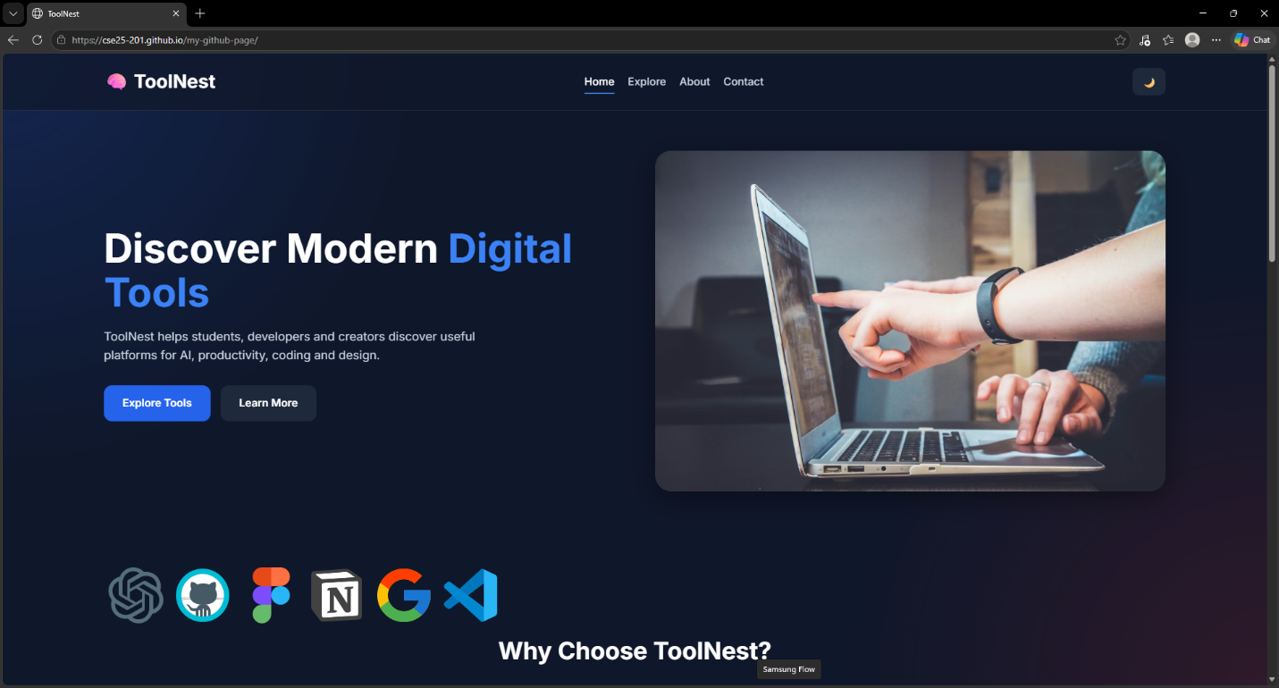

8. Conclusion

The ToolNest website is designed to be a modern platform that assists users in exploring useful digital tools in a structured and visually appealing way. The website is designed with the aim of being simple, modern, and feature-rich, making it a useful resource for students, programmers, designers, and tech enthusiasts.

The planning stage is essential in ensuring that the website is structured, has a purpose, and is set up for success and improvement in the future.

9. References
- MDN Web Docs. (2026). HTML5 Documentation. Available at: https://developer.mozilla.org/
- W3Schools. (2026). HTML, CSS and JavaScript Tutorials. Available at: https://www.w3schools.com/
- GitHub Pages Documentation. (2026). Available at: https://pages.github.com/

