Appendix 1: Assignment submission cover sheet
ASSIGNMENT SUBMISSION COVER SHEET

Student Id:
CSE25-216

Student names:
KEFILWE MARAKALALA
Student email:
CSE 25-216@thuto.bac.ac.bw

Cohort:
2026

Assignment title:
SCIS WMD_2026 A01

Date of submission:
0/2026
Programme of Study:
Bsc hons Computer systems engineering

Year of Study:
YEAR 1

Intellectual property statement
By checking the box below, I certify that this assignment is my own work and is free from plagiarism. I understand that the assignment may be checked for plagiarism by electronic or other means and may be transferred and stored in a database for the purposes of data-matching to help detect plagiarism. The assignment has not previously been submitted for assessment in any other unit or to any other institution. I
have read and understood the Botswana Accountancy College plagiarism guidelines policy.
Agree Signature……k.m…a…ra…ka…la…la………
Date 01/05/2026

NBFIRA
Non-Bank Financial Institutions Regulatory Authority

WEB SPECIFICATIONS

1.0 OBJECTIVES AND GOALS
1. INFORM & EDUCATE
- Explain NBFIRA's mandate, vision, and mission clearly to the public
- Help consumers understand their rights when dealing with non-bank financial institutions
- Provide financial literacy resources and guides

2. Regulatory Transparency
- Publish laws, directives, guidelines, and annual reports
- Make the regulatory framework accessible to licensed entities and the public
- Show which sectors NBFIRA oversees (insurance, pensions, capital markets, VASPs, etc.)

3. Consumer Protection
- Give consumers a direct channel to lodge complaints against NBFIs
- Allow the public to verify whether an institution is licensed
- Provide contact routes (phone, email, online form)
4 Industry Communication
- Announce new regulations, guidance notes, and circulars
- Share news, events, and conference participation
- Keep regulated entities updated on compliance requirements

5. Institutional Credibility
- Project professionalism and authority through design
- Align with international regulatory body standards (like FCA, FSB)
- Build public trust in Botswana's non-bank financial system

  - TARGET AUDIENCE
This website is primarily targeted at individuals aged 18 to 55, including the general public, consumers, regulated institutions, investors and analysts, media professionals, and job seekers. These users are generally familiar with the internet and digital tools. Most access the site via mobile devices, so the design is optimized to function effectively on both mobile and desktop platforms. They typically use modern browsers such as Chrome, Firefox, and Safari, and prefer websites that are fast, visually clean, and reliable, with quick loading times and smooth functionality.

  - TYPE OF WEBSITE
NBFIRA is an informational and service-based website. It serves as the official digital presence of the regulatory authority, providing a trusted and publicly accessible platform that communicates its regulatory role to a wide range of audiences. The website not only delivers important information such as regulations, policies, news, and consumer education, but also offers online services including licensing, complaints submission, and access to regulated entities. It is designed to promote transparency, improve accessibility, and enhance user engagement while supporting efficient service delivery across different user groups.

NBFIRA
Non-Bank Financial Institutions Regulatory Authority

INFORMATION DESIGN AND TAXONOMY

2.0 SITE STRUCTURE & NAVIGATION
The website is made up of nine main pages:
- Home (index.html): The landing page with an introduction and navigation to other people.
- About us (About.html):
- Regulated entities(Regulated.html)
- Consumer( consumer.html)
- Complaints(complaints.html)
- News and media(News.html) :
- Feedback (feedback.html):

2.1 SITEMAP
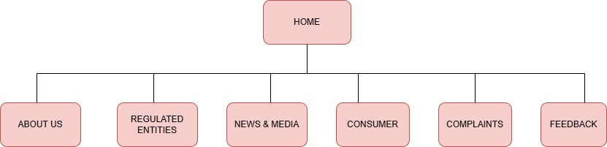

NBFIRA
Non-Bank Financial Institutions Regulatory Authority

TECHNICAL BRIEF
3.0 TECHNOLOGIES USED
- HTML 5 : Used to create the structure of each webpage.
- CSS 3: used for styling, including a dark mode feature.
- Bootstrap 5.3.2: Helped out with layout, responsiveness, and components like navbars and cards.
- JAVASCRIPT: Added interactivity, like toggling themes or handing simple actions.

Software & Tools
- Vs code: Used for all the coding work with extensions for live server preview.
- CANVA : Used to design logos and edit images and icons for this site.
- Git: Managed version control during development.
- GitHub & GitHub pages : Used to store the code online and host live version of the website.

These tools were chosen because they are easy to access and use.

