Appendix 1: Assignment submission cover sheet

ASSIGNMENT SUBMISSION COVER SHEET

Student Id: cse25-259
Student names: REFILWE CHANTEL TSHETLHO
Student email: cse25-259@thuto.bac.ac.bw
Cohort: cse2025
Assignment title: SCIS WMD_2026 A01
Date of submission: 21/05/2026
Programme of Study: COMPUTER SYSTEMS ENGINEERING
Year of Study: YEAR 1

Intellectual property statement
By checking the box below, I certify that this assignment is my own work and is free from
plagiarism. I understand that the assignment may be checked for plagiarism by
electronic or other means and may be transferred and stored in a database for the
purposes of data-matching to help detect plagiarism. The assignment has not previously
been submitted for assessment in any other unit or to any other institution. I
have read and understood the Botswana Accountancy College plagiarism guidelines
policy.
☑ Agree

Signature: R.Tshetlho

Date: 21/05/2026
MIND-AT-EASE WEBSITE

WEBSITE SPECIFICATIONS
The Mind At Ease website is an informational platform designed to educate users about mental health conditions. It is a simple but powerful website built to raise awareness about mental health and give people practical ways to cope. The site is designed to be easy to use, with clear navigation and content that speaks directly to students, young adults, and anyone who wants to learn more about mental wellness. It shares information on common conditions, offers tips for self-care, and reminds users that they are not alone. The goal is to break the silence, provide support, and create a space where people can find peace of mind and connect with helpful resources.

It consists of 5 main pages:
- HOME PAGE (index.html) – Provides introduction of the website and highlights it’s purpose

- ABOUT PAGE (about.html) – Explains the purpose of the website and it’s benefits to both users and the organisation

- MENTAL HEALTH PAGE (mental-health.html) – Contains underlying symptoms on three mental health conditions:
- Bipolar Disorder
- Post-Traumatic Stress Disorder (PTSD)
- Obsessive-Compulsive Disorder (OCD)

- TIPS AND RESOURCES PAGE (tips.html) – Provide general mental health tips and self-care strategies as well as helpful resource links.

- FEEDBACK PAGE (feedback.html) – Includes a form that allows users to submit feedback

Functional Requirements
- Easy navigation across all pages using a navigation bar
- Clear presentation of mental health information
- Display of symptoms and coping strategies
- User interaction through a feedback form
- Responsive layout for different screen sizes

Non-Functional Requirements
- User-friendly interface
- Simple and consistent design
- Fast loading pages
- Accessibility (readable text and layout)

OBJECTIVES
The Mind at Ease website aims to achieve the following objectives:
- To educate users about various mental health conditions such as depression, bipolar disorder, PTSD, and OCD
- To help users identify symptoms related to mental health challenges
- To provide practical coping strategies to living with mental health illnesses
- To promote awareness and reduce stigma surrounding mental health
- To provide a supportive and accessible online resource for users

GOALS TO THE ORGANISATION
The website supports the organisation in several ways:
Promoting Mental Health Awareness:
- The platform helps spread awareness about mental health issues within the community
Building Trust and Credibility:
- Providing reliable information positions the organisation as a trusted source by providing legitimate helpful resources existing and making them available in one click.
Enhancing Online Presence:
- The website improves the organisation’s visibility on the internet
User Engagement:
- Features such as the feedback form encourage interaction with users
Community Support:
- The website serves as a tool to support individuals in need of guidance

Target Audience
- Students and young adults 16-35
- Individuals experiencing stress, anxiety, or emotional challenges
- People seeking mental health information
- General members of the public interested in self-care
- Made for both male and females

Technical Aptitude
The website is designed for users with basic to moderate technical skills.
🔹 Basic Users:
Can browse websites
Can click links and navigate pages
Can fill out simple forms
🔹 Moderate Users:
Comfortable using mobile and desktop devices
Able to explore multiple pages and resources

INFORMATION DESIGN
The website follows a structured and user-centered design to ensure that information is easy to find and understand
- Layout Structure:

Each page includes:
- Header: Logo and navigation bar
- Main Content: Organised into sections and headings
- Footer: Basic information

- Content Organisation:

Information is presented using:
- Headings (H1, H2, H3)
- Bullet points for clarity
- Separate sections for each mental health condition
Each condition includes symptoms to look out for

- Design Principles:
- Clarity: Information is simple and easy to read
- Consistency: Same layout across all pages
- Usability: Easy navigation and structure

TAXONOMY (Content Structure)
- About
- Purpose of the website
- Benefits to users
- Benefits to the organisation

- Mental Health
- Bipolar disorder
- PTSD
- OCD
- Depression

- Tips and Resources
- Coping strategies
- Mental wellness links to relatable mental health conditions

- User Interaction
- Feedback form

Navigation structure
The website uses a web structure, meaning all pages are accessible from the navigation bar.

- HOME
- ABOUT
- MENTAL HEALTH
- TIPS
- FEEDBACK
SITE MAP

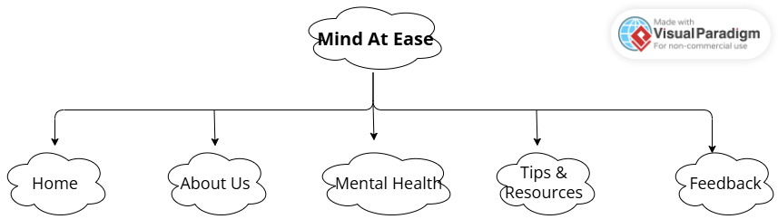

This website uses a Web structure sitemap because it has only five main pages, each directly accessible from the navigation bar. This structure ensures clarity, simplicity, and usability, allowing users to reach any section in a single click. It aligns with the project’s design principles of accessibility and consistency, while also supporting responsive layouts across devices. A hierarchical sitemap was considered, but the flat structure was chosen as the best fit for a small, informational site where ease of navigation is the priority.

This improves usability and ensures users can quickly access any section

TECHNICAL BRIEF
The technical brief outlines the tools and technologies used to develop the website
- HTML5 – For structuring content
- CSS3 – For styling and layout
- Bootstrap – For responsive design

Tools used
- Visual Studio Code – Development Environment
- GitHub – Stores the files and codes
- GitHub pages – Hosting the website
- Figma- For structuring the wireframe
- Visual paradigm- For sitemap layout

- Compatibility:
- Compatible with modern browsers
- Google chrome
- Microsoft Edge
- Opera
- Mozilla Firefox
- Responsive across:
- Mobile devices
- Tablets
- Laptops
- Desktop computer
I chose the neon pink and purple colors with a black background to create a modern and calming atmosphere. The bright colors stand out clearly on the dark background and make the website more visually appealing while still matching the mental health awareness theme.

PUBLISHING AND PROMOTION
This website is hosted live by Github and github pages on which a repository was made from which it includes all five html files. Visual studio was made to clone my repository from Github so as to track live website changes made by each commit in visual studio. Visual studio was a medium to push changes to the website along with a live server I downloaded within visual studio code to make it easy for me to see through my changes without having to log in github and visit site there.
The commands used to push changes directly to my live website without committing changes directly at the github website are:
git add .
git commit -m “”
git push
Of which all these changes or commits where made in visual studio
WEBSITE LINK: https://cse25-259.github.io/WMD-Assignment/
Repository link: https://github.com/cse25-259/WMD-Assignment
FUTURE DEVELOPMENTS/ RECOMMENDATION
- Adding a database to the website so feedback is collected and used to our advantage for maintenance and improving the website
- Meditation and relaxation audio playlists
- Different language options for users from different countries
- Online chat support for mental health help.

PAGE TEMPLATE DESIGN
Wireframe:
HOME PAGE
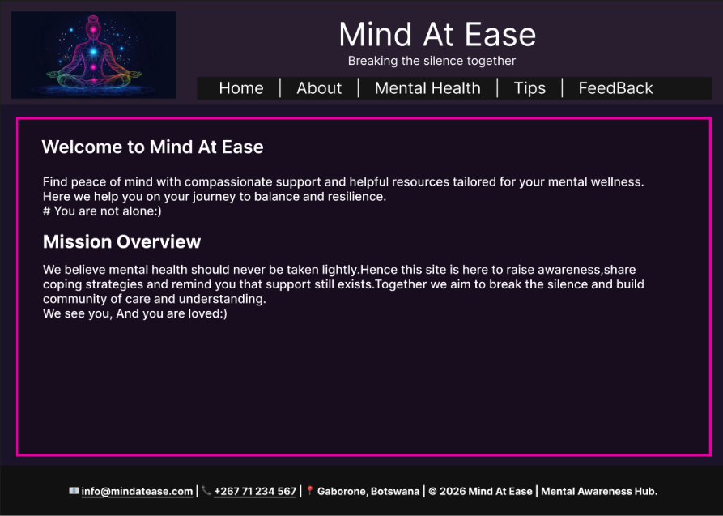

ABOUT US PAGE
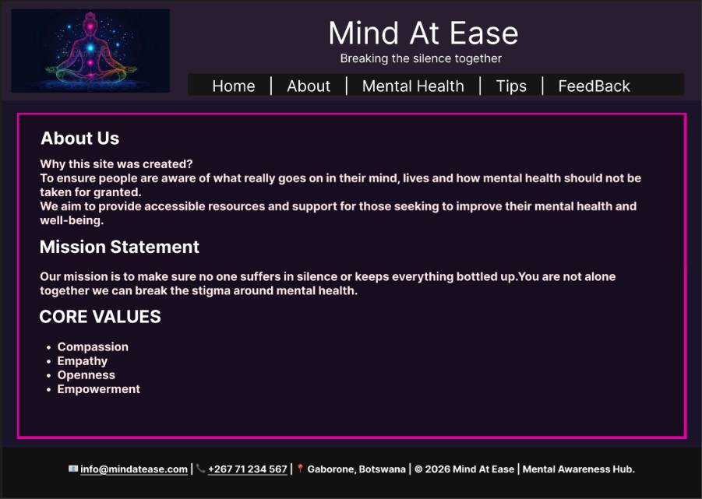

MENTAL HEALTH PAGE
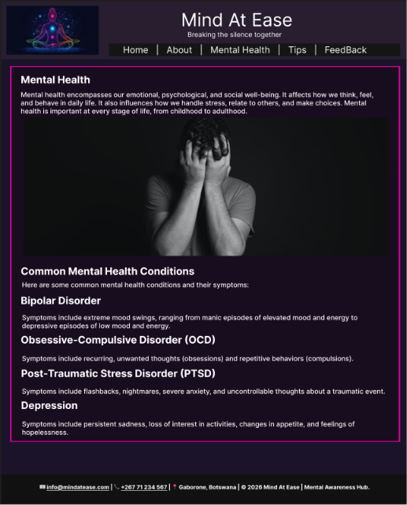

TIPS AND RESOURCES PAGE
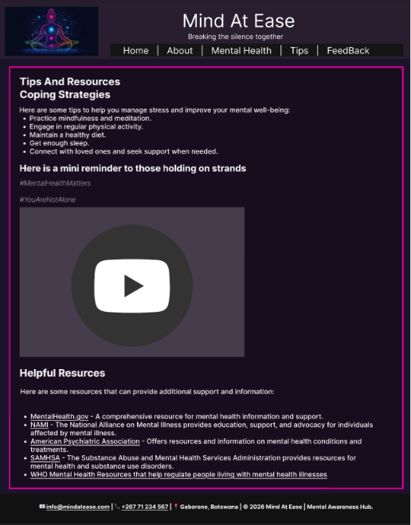

FEEDBACK PAGE
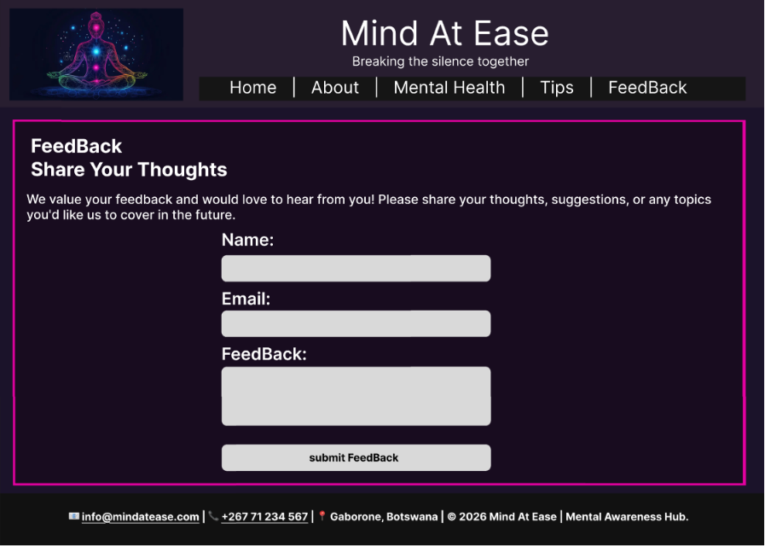

QUALITY ASSURANCE
Using a Laptop from Microsoft edge
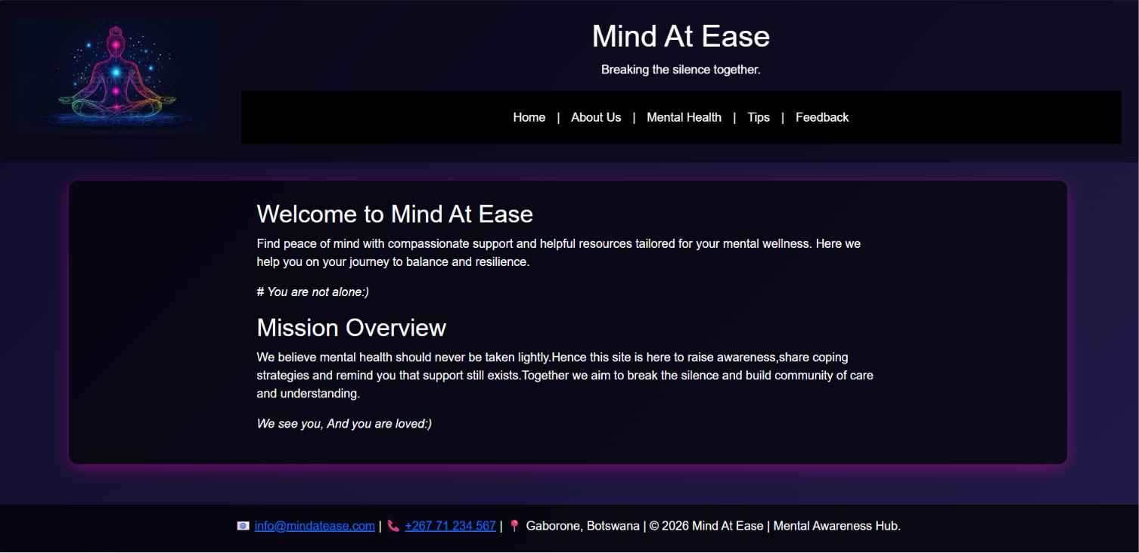
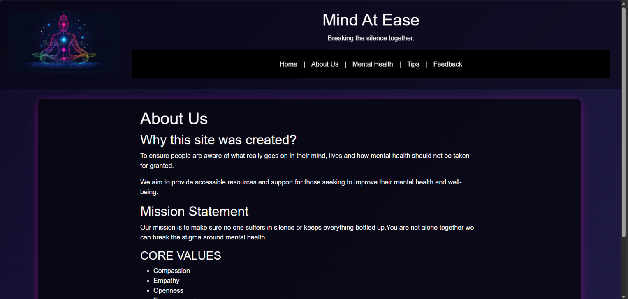
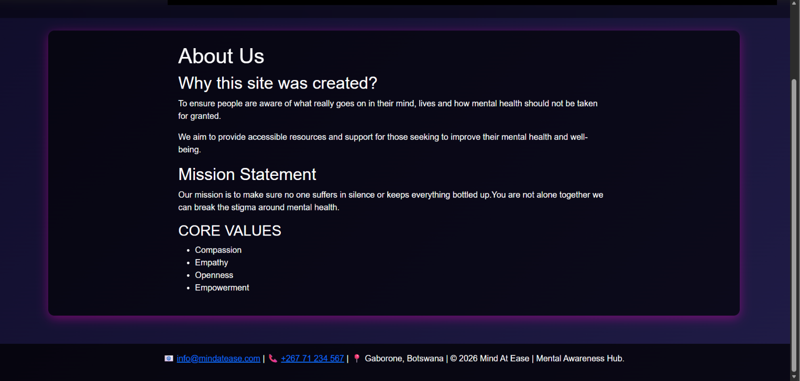
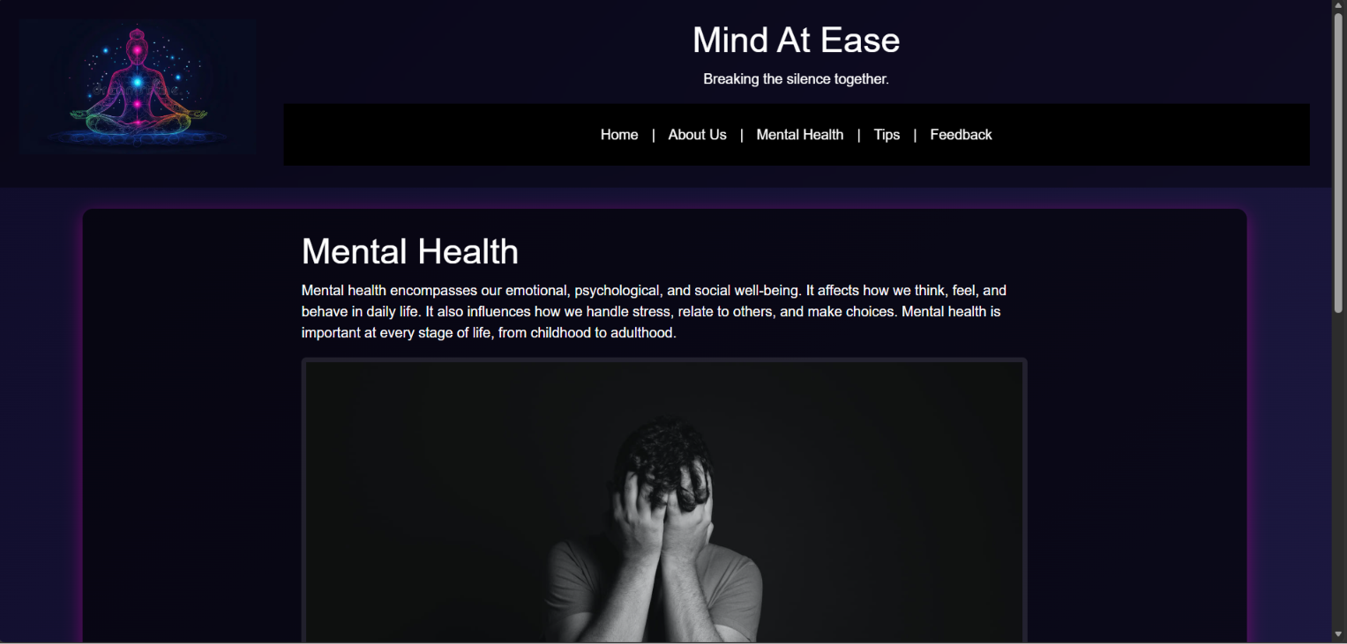
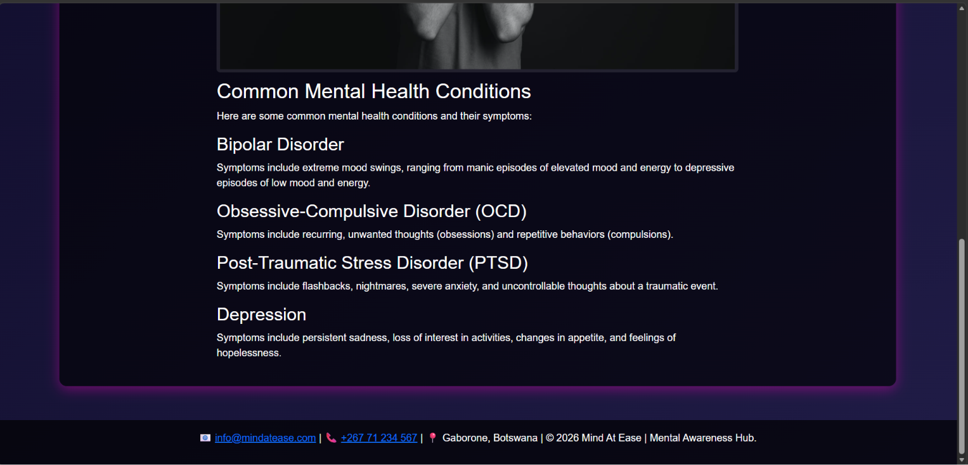
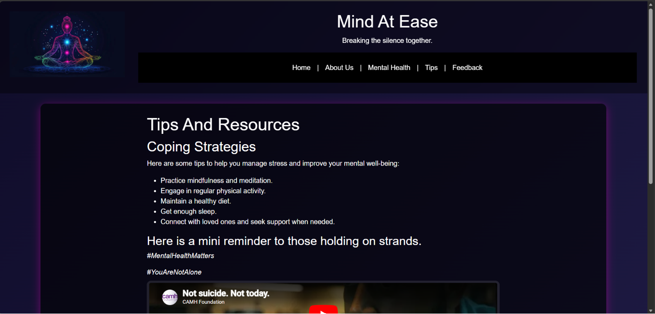
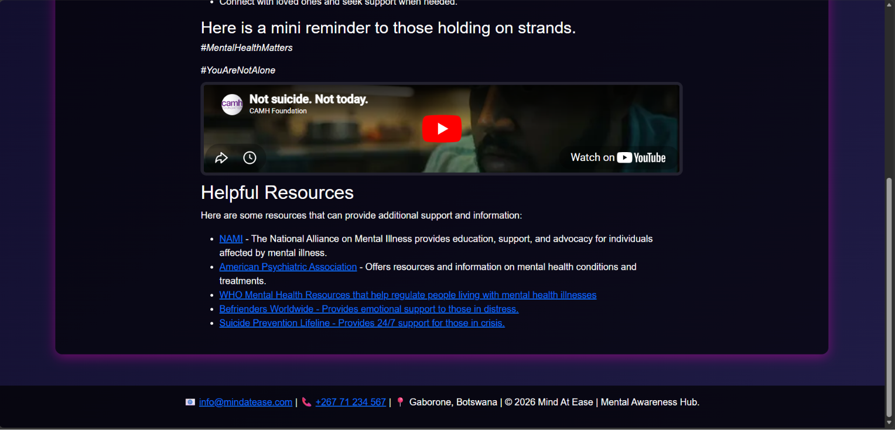
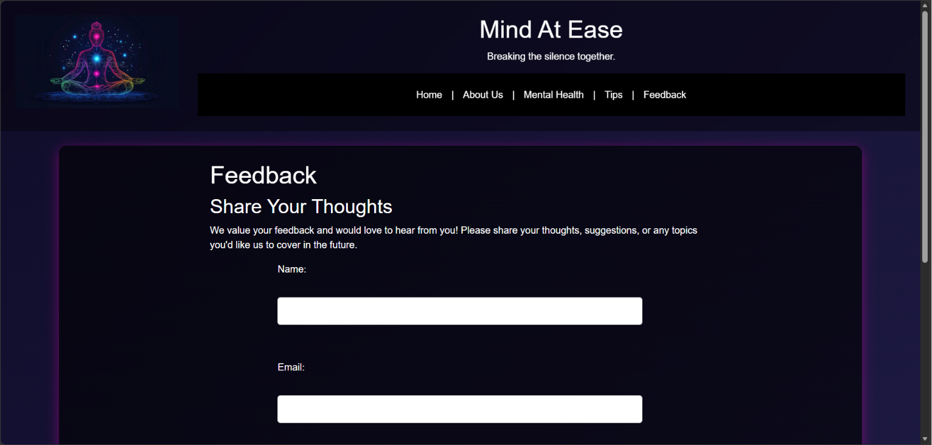
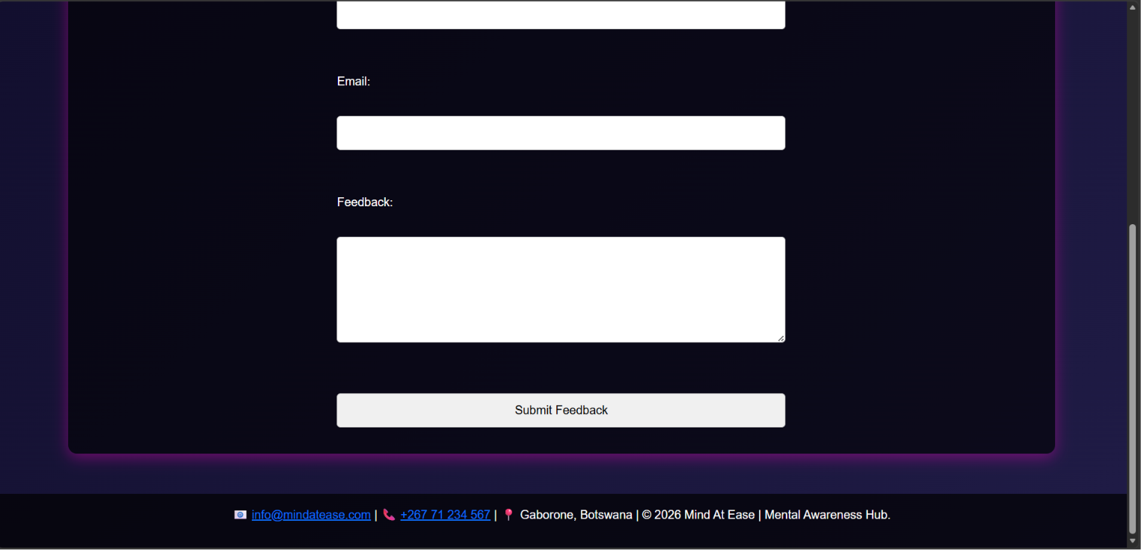
USING A MOBILE DEVICE google chrome
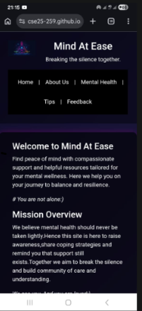
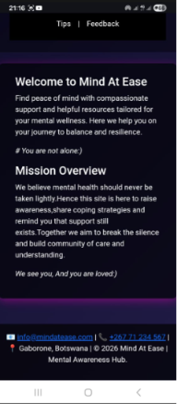

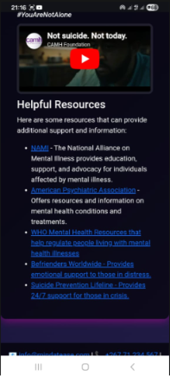
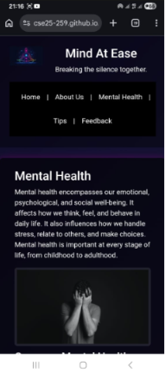
USING opera browser
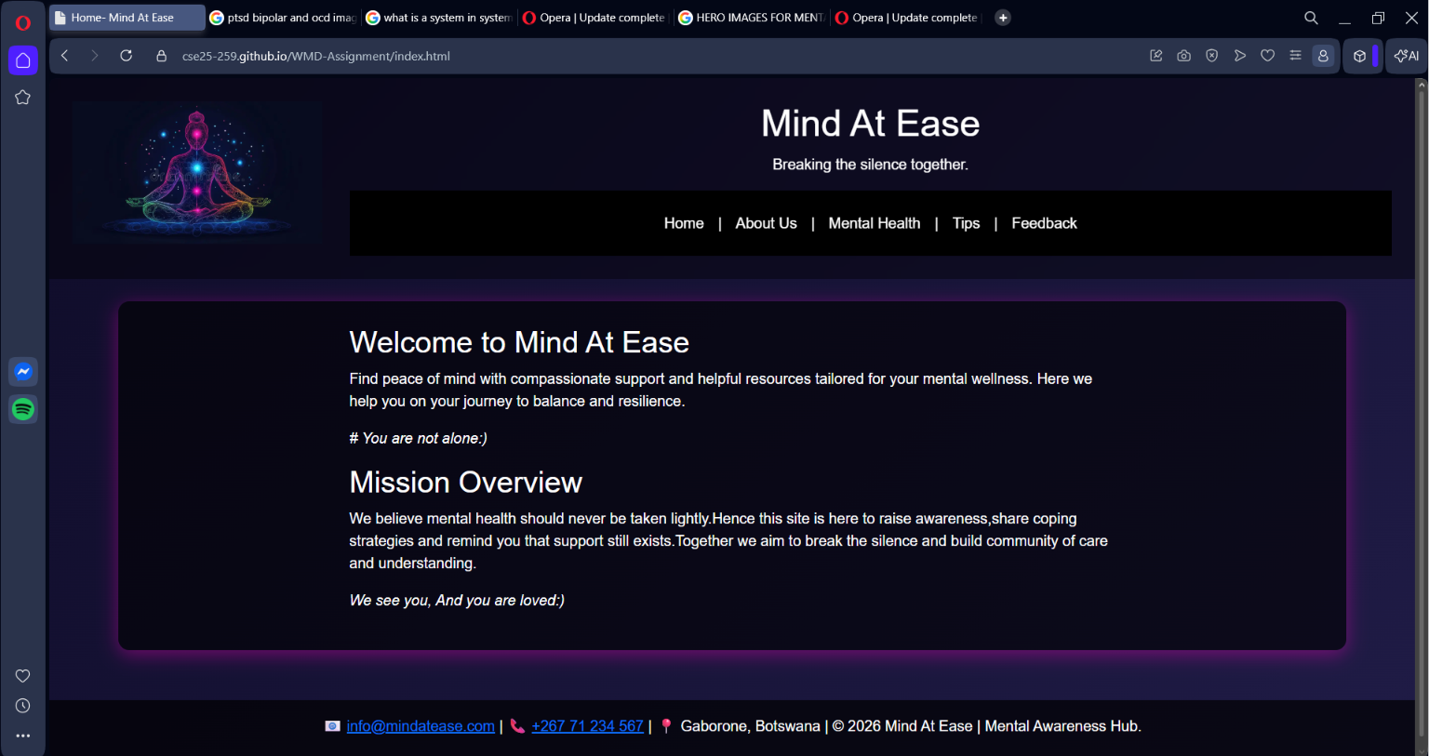

Using google chrome
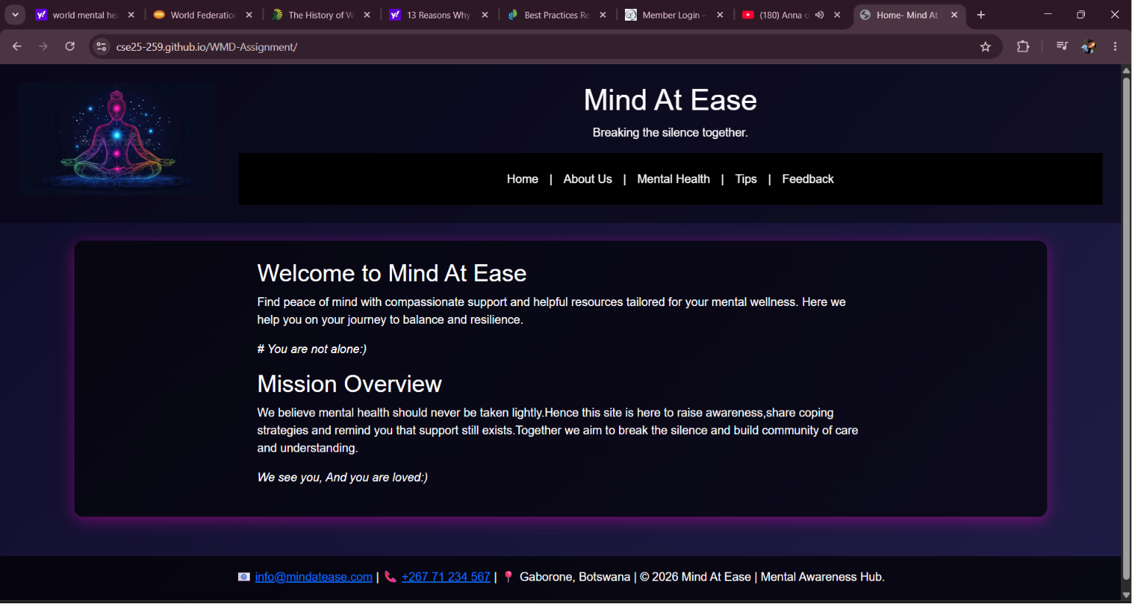
This quality testing was done on multiple browsers chrome, Microsoft edge and opera browsers. And as we can see the website have little to minimalistic differences on each web browser meaning I managed to make it as constant as possible by using different sematic elements
CONCLUSION
My previous submissions I had a different theme with more images which with time I change to the current theme due to less pictures added and theme was brought to life as I needed to grab attention of my users so text alone does not seem boring and my users actually return to my website as it is a base of providing people with helpful resources and tips of overcoming and living with their mental health issues as symptoms allow my users to stop avoiding what is really infront of them and assure them of not being alone in this journey.

