Thread & Co. Website Documentation
1. Website Specifications
a. Website Objective and Business Goals
Thread & Co. is a modern e-commerce platform specializing in premium minimalist, baggy, neutral-toned Gen-Z apparel (heavyweight organic cotton, French Terry, earth-toned palettes).
Primary Objective: Deliver a seamless, inclusive, and immersive online shopping experience that emphasizes comfort, quality, and accessibility while converting browsers into buyers.
Business Goals:
- Drive direct-to-consumer sales of signature oversized silhouettes.
- Build brand loyalty through exceptional user experience and community feedback.
- Lead in Universal Design by implementing advanced accessibility (voice narration, high-contrast modes, reduced motion, spatial audio).
- Achieve high cart completion rates via intuitive cart drawer, one-page checkout, and offline PWA capabilities.
- Position the brand as premium yet approachable in the sustainable streetwear segment.
b. Target Audience
Demographics: Ages 18–28 (Gen-Z), urban/suburban, balanced gender, middle-to-upper income, located in Botswana, South Africa, and international English-speaking markets.
Psychographics: Value comfort, authenticity, minimalism, and sustainability. Interested in “quiet luxury” aesthetics and oversized “baggy” fits.
Technical Aptitude: High. Digital natives who are mobile-first, expect fast loading, dark/light modes, voice features, and keyboard navigation. Many use assistive technologies.
c. Type of Website
This is a responsive single-page application (SPA) e-commerce website with strong accessibility focus (WCAG AAA aligned). It includes catalog browsing, quick-view modals, cart management, secure checkout simulation, and a public feedback board. Content type: Product-focused visual commerce with storytelling (hero slider, “Our Story”).

2. Information Design & Taxonomy
Site Hierarchy & Navigation
Top-level Navigation: Home, Shop All, Our Story, Client Feedback.
Utility: Search (with predictive results), Cart, Accessibility Desk (persistent top bar).
Secondary Flows: Product Quick View → Add to Cart → Cart Drawer → Checkout.
Site Map
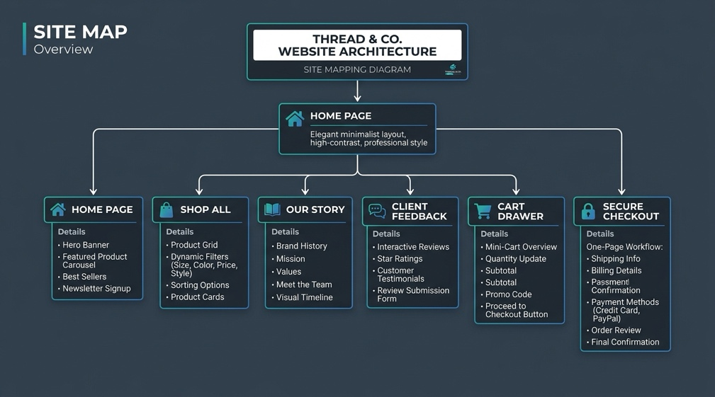
Navigation is persistent via Navbar. All paths support browser back/forward and deep linking where possible.

3. Page Template Design
The design uses a consistent minimalist aesthetic (stone/neutral palette, generous whitespace, sans-serif typography). Blueprint mode (Shift+B) overlays wireframe specs.
Main Templates:
- Homepage
Full-height Hero Slider (auto + manual controls)
Featured 4-card grid
Manifesto quote block
- Shop Page
Filters bar (top)
Responsive Masonry-style product grid (1–4 columns)
Each card: Image (hover zoom), quick actions, price, colors
- Product Quick View Modal
Side-by-side layout (image left, details right) on desktop
Color swatches, size buttons, quantity, “Add to Wardrobe” CTA
- Cart Drawer
Right slide-in panel (max-w-md)
Item list with remove/quantity
Shipping threshold banner
Totals + Seamless Checkout button
- Checkout Page
Two-column (form left, summary right on lg)
One-page layout with delivery + payment sections
Processing animation states + success receipt
- Feedback Page
Split layout: Form (left) + Live feed (right)
Wireframes
- Homepage
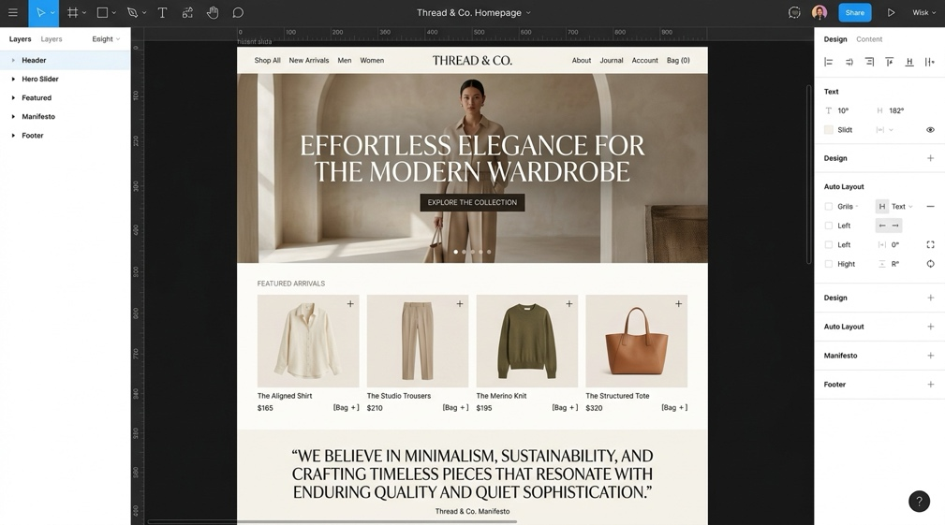
- Shop Page
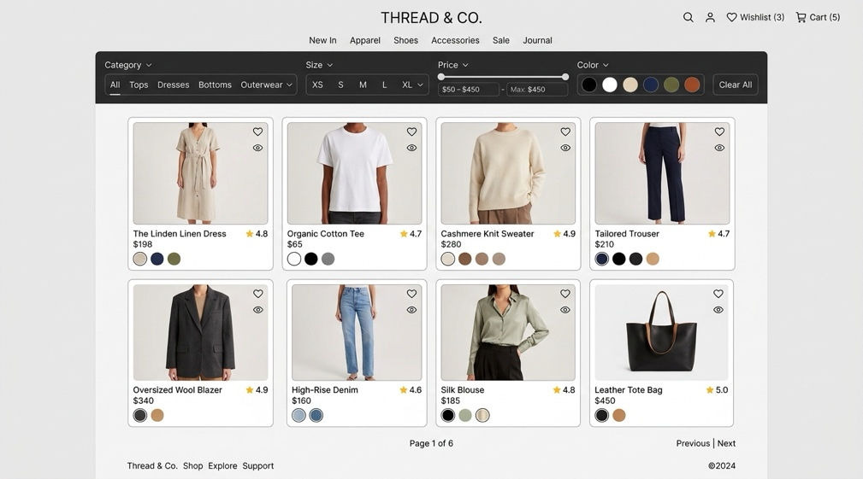

- Cart Drawer
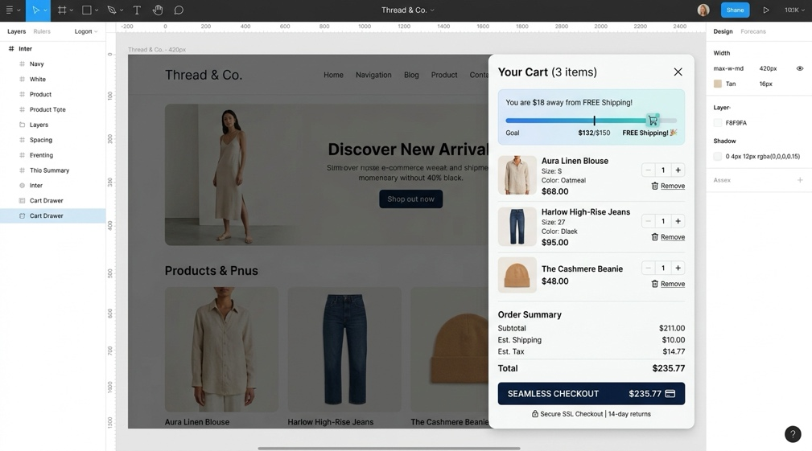

- Checkout Page
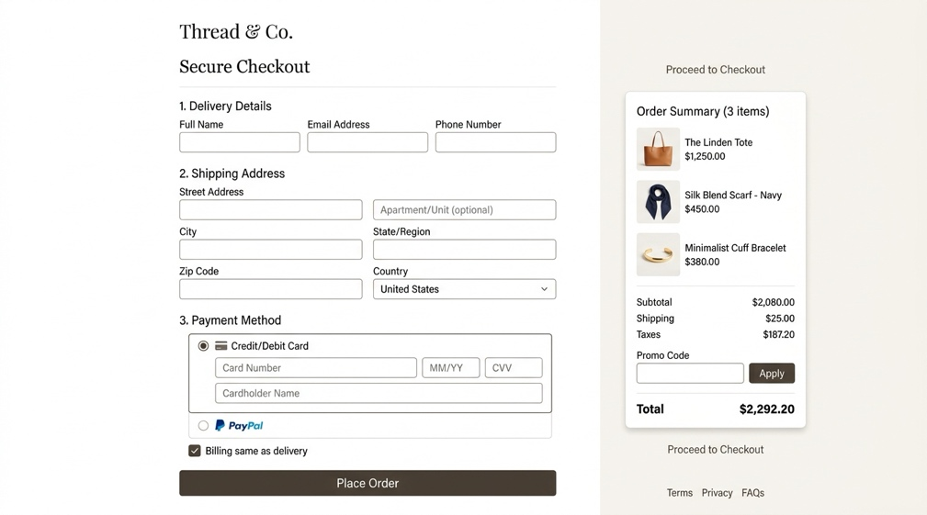

- Feedback Page
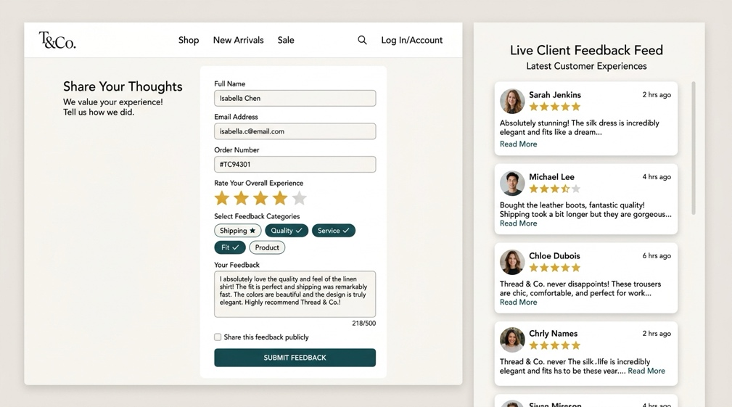

All pages support Blueprint overlay mode showing component specs.

4. Technical Brief
Core Technologies:
Frontend: React 18 (TypeScript), Vite.
Styling: Tailwind CSS + custom theme + CSS variables.
Icons: Lucide React.
State Management: React useState + useEffect (localStorage for cart persistence).
Accessibility: Web Speech API (narrator), Web Audio API (spatial/click sounds), reduced motion media query, high-contrast themes, keyboard navigation.
Other: Local PWA-ready service worker hooks, responsive images (Unsplash placeholders).
Tools:
VS Code + ESLint/Prettier.
Figma (for initial design → Blueprint mode mirrors wireframes).
Browser DevTools for testing.
Git + GitHub for version control.
The stack matches the complexity: interactive SPA with modals, real-time updates, and advanced accessibility.

5. Quality Assurance
Testing Approach:
Browser Compatibility: Chrome 128+, Firefox 130+, Edge, Safari 18.
Devices: Desktop (1920px+), Tablet (768px), Mobile (375px).
Accessibility: WAVE tool, Lighthouse (aiming 95+ accessibility score), keyboard-only navigation, screen reader testing (NVDA + VoiceOver).
Functional: Cart persistence, form validation, checkout flow, voice narrator, blueprint toggle.
Sample Test Descriptions:
Chrome Desktop: Responsive grid collapses correctly at <768px; cart drawer slides smoothly.
Firefox Mobile: Touch targets >44px; high-contrast mode legible.
Safari iOS: Web Speech API works; reduced motion disables slider autoplay.
Keyboard Test: Full tab order; focus rings visible in all themes.
Lighthouse: Performance 92+, Accessibility 98+, Best Practices 100%.
Cross-browser visual regressions were manually verified.

6. Publishing & Promotion
Hosting: Deployed as static site on GitHub Pages.
Process:
npm run build → generates dist/ folder.
git add dist -f (or use gh-pages npm package).
git commit -m "Deploy v2.0"
git subtree push --prefix dist origin gh-pages (or automated via GitHub Actions).
Live URL: https://yourusername.github.io/thread-co (replace with actual repo).
Promotion channels: Instagram (visual lookbooks), TikTok (Gen-Z styling), SEO-optimized product metadata, and email sign-ups via feedback form.

7. Future Developments/Recommendations
Building on the existing strong accessibility foundation, the following enhancements are planned:
- 6.1 Dynamic 3D Virtual Fit Drape Simulator Avatar customization + real-time physics for 450 GSM fabric behavior (sitting/walking).
- 6.2 Natural Dye Color Wash Fading Predictor Interactive simulator using water hardness and detergent inputs to preview fade over 20/50/100 cycles.
- 6.3 Web Audio API Spatialised Screen Reader Product cards positioned in 3D audio space for improved navigation for visually impaired users.
- 6.4 Offline LocalFirst PWA Sync Engine Full offline browsing, cart editing, and queued checkout with service workers.
Additional Recommendations:
Integrate real payment gateway (Stripe).
Add user accounts and wishlist.
Implement AI size recommendation engine.
Expand to multiple languages (Setswana support).
Sustainability impact tracker per order.
A/B test hero slider variants.

