Web Specifications

1. Website Purpose & Goals
Main Purpose:
“Whispers Of The Forest” aims to be Botswana’s digital gateway to its wilderness, serving both as an engaging travel showcase and a secure, FinTech-enabled travel planning platform.
Business Goals:
Make Luxury Travel Accessible: Implement a “Save-to-Travel” (Lay-by) system to allow middle-income locals and regional visitors to experience high-end destinations like the Okavango Delta.
Capture Long-Term Customers: Offer users the ability to create personalized Savings Profiles for trips planned 12–24 months in advance.
Promote Hidden Gems: Encourage travel to destinations like Makgadikgadi Pans, CKGR, and Tuli Block to reduce congestion in the Delta while offering a range of price options.
Build Trust & Credibility: Establish a reputation for reliability and financial security, which is critical when managing customer deposits.
2. Target Audience
Segment | Who They Are | Tech Comfort
Local Professionals | Batswana/SADC residents, 25–45, middle-income | High: mobile-first, familiar with banking apps and social media
International Travelers | North American/European, 30–65, high-income | Moderate–High: desktop users, expect secure payment systems and professional email communication
Budget Backpackers | Global/regional, 20–35, price-conscious | Very High: tech-savvy, seek fast-loading pages and instant chat support (e.g., WhatsApp)
Implications:
- Must prioritize mobile-first, responsive design.
- Financial features must be secure, transparent, and easy to use.
- Content should remain accessible for varying levels of tech experience.

3. Website Type & Content Approach
Website Structure:
A hybrid platform combining e-commerce functionality with an educational membership portal.
Transactional Features: Allow users to make recurring deposits with real-time balance tracking.
Content-Rich Guides: Educate users on wildlife, ecosystems, and safari planning to justify premium pricing.
Core Content Sections:
Interactive Destination Guides: Multimedia pages for Okavango, Chobe, Moremi, CKGR, Kgalagadi, Makgadikgadi, and Tuli Block.
Includes maps, itineraries, photos, and videos.
Savings Hub” Dashboard: Secure, password-protected user area.
Features:
Progress Tracker (visualize deposit completion).
Installment Calculator (plan monthly contributions).
Receipt Downloads (proof of payments).
“Wild-Blog”: Frequent updates on animal migrations, seasonal travel tips, and packing advice.
Keeps users engaged throughout their saving journey.
- Trust & Security Indicators:
Prominent display of SSL certificates, local tourism affiliations, and secure deposit guarantees.

2. Information Design & Taxonomy (5 marks)
Site Map (Structure)
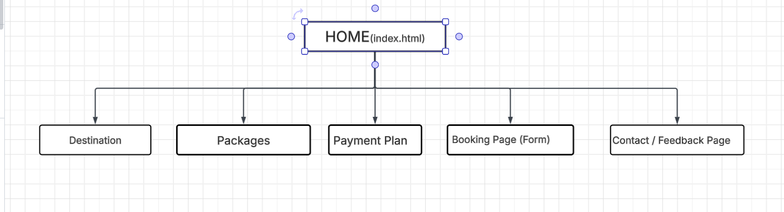
Navigation Flow
- Users land on Home
- Navigate using navbar:
  - Home → Destinations → View options
  - Home → Packages → Choose safari
  - Home → Payment Plan → Learn financing
  - Home → Booking → Make reservation
Design Rule Applied:
- 3-click rule (users reach any page within 3 clicks)

