DIME SUITS
Dime Suits is an e-commerce website designed to sell suits for men, women and children.
Web specification
Objectives
The objective of this website is to create a digital platform for selling suits for men, woman and children. Showcasing affordable suits, making it easy for customers to browse, select and buy suits online.

GOALS
- The goals of the DIME SUITS website in relation to the business Is to increasing brand awareness.
- improving customer experience and boosting sales.
- By offering an accessible online store, the business can reach a wider audience beyond physical locations.
- Its goal is to provide a well designed and easy to navigate website enhances user satisfaction and encourages repeat purchases.
Research indicates that online shopping offers significant benefits such as convenience and time saving, allowing customers to shop anytime and from any location (Al-Debei et al., 2015, p. 712). Therefore, this website aims to leverage these advantages to improve customer engagement and support business growth.

The target audience for the website includes:
Demographics:
- Men, women, and parents shopping for children.
- Age group: 18–50 years.
- Special Occasion Shoppers: People looking for wedding suits or formal wear.
- Location: Urban and semi-urban areas (e.g. Gaborone and surrounding areas).
- Income level: Middle to high income earners.

Technical Aptitude:
- Should be tech savvy.
- Familiar with smartphones and online shopping.
- Able to navigate websites, fill forms, and make online inquiries.

Type of Website
The website will be an Ecommerce website.

INFORMATION ARCHITECTURE
The website will be structured to allow users to easily navigate and find products within 3 clicks.
- Home – Landing page
- Popular Suits – Highlights best-selling or featured suits
- Categories
  - Men – Men’s suits
  - Women – Women’s suits
  - Kids – Children’s suits
- Accessories – ties
- Feedback – Contact form for customer inquiries
- Cart – Review and manage selected products before ordering

Site Map

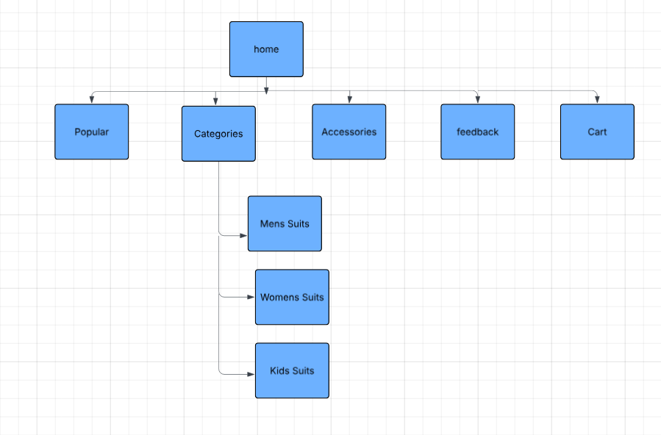

Technical Brief
Canva- To make page template
Pixabay – Photo visuals of the products
Visual Studio-code editor
Web Browsers (Google Chrome ,Safari, Microsoft Edge)-for testing website
GitHub Pages-hosting the website
HTML- create the structure of the website
CSS-used in styling and layout of the website
JAVASCRIPT-used in interactivity of the website
BOOTSTRAP FRAMEWORK-for responsive design

Publishing and Promoting
DIME SUITS was uploaded and hosted on GitHub Pages , a repository was crated to store all the website files. VS CODE was used to deploy it on GitHub Pages using GitHub commands.GitHub Pages was then enabled to make the website accessible on the internet.

Tools Used
Vs Code – for editing and manage project files
Git – for uploading and tracking changes
GitHub- for file management
GitHub Pages- for hosting the website

GitHub commands that were used:
git init
git add .
git commit -m "Initial commit - Dime Suits website"
git branch -M main
git remote add origin https://github.com/cse25-296/WMD-Assignment.git
git push -u origin main

Website link
https://cse25-296.github.io/WMD-Assignment/

Promotion
Sharing the website link on social media like WhatsApp , Instagram , X , Facebook and Tik Tok
Adding the link to business profile
Sharing through the word of mouth marketing

Future Development
Ai Automation – AI automation can be integrated in future development to improve user experience of the DIME SUITS website, Ai feature such as Ai chat box to guide users through the website and offer instant customer support.
Smart Search
Implement AI-based search that allows users to find products faster using keywords or natural language.
Recommendations
To improve the effectiveness and performance of the Dime Suits website, the following recommendations are proposed:
Improve Website Speed and Performance
Optimize images and code to ensure fast loading times, especially for mobile users.
Strengthen Security Features
Protect user data by implementing secure connections (HTTPS) and proper validation.

REFERENCES
Al-Debei, M.M., Akroush, M.N. and Ashouri, M.I. (2015) Consumer attitudes towards online shopping: The effects of trust, perceived benefits, and perceived web quality. Internet Research, 25(5), pp. 707–733.

