SLANGFIELD DOCUMENTATION
Slangfield landscape Services website provides Borehole drilling, Fencing Machinery rental and site analysis services to its clients.
Website Specifications
Website Objective
The primary objective of the SlangField Landscape Services website is to establish a professional online presence that effectively showcases the company's land development services to potential clients. The website serves as a comprehensive digital brochure that communicates the company's expertise in fencing, borehole drilling, machinery rental, and site analysis services.
GOALS
- The website is designed to achieve the following strategic goals for the business:
- Generate qualified leads through the contact form and service inquiry system
- Build brand credibility by showcasing completed projects and client testimonials
- Provide detailed information about services to reduce customer inquiry time
- Establish trust through professional design and comprehensive company information
- Enable 24/7 accessibility to company information and contact details
Target Audience
The website is designed to cater to a diverse audience with varying needs and technical capabilities. Understanding the target audience is crucial for creating an effective user experience that meets their expectations and facilitates conversion.

PRIMARY TARGET AUDIENCE

 | Demographics | Technical aptitude
Farm Owners | Mostly aged from 35 to 65 years, based at rural areas, have Agricultural background with medium to large land holdings. | Basic to intermediate, uses mobile devices frequently.
Property Developers | Aged between 30 to 55 years, found in Urban and semi-Urban areas. They are business professionals with multiple property investments. | Intermediate to advanced, expect professional design, uses desktops primarily with the mixture of mobile devices
Rural communities | Age varies widely, based on remote locations, Community-focused, Borehole and water needs. | Prefers local language, limited internet access,  Mobile device users
Construction Company | Aged between 25-50 years, Commercial focus, Industry experience, Project-based needs | Intermediate, seeks detailed specifications, Compares services efficiently

Type Of Website
SlangField Landscape Services website is classified as a corporate business website with services portfolio functionality. It falls under the category of informational and lead-generation websites, designed to present company information and converts visitors into potential clients.

INFORMATION DESING & TAXONOMY
Information Architecture
The website follows a hierarchical information architecture that organizes content into logical categories. This structure ensures that users can find information efficiently within three clicks, following the standard web usability guideline. The architecture is designed to guide users from general information to specific details progressively.
Website pages:
- Home ( services overview, statistics, testimonials)
- About (Detailed service descriptions with images and features )
- Services (Company story, mission, vision, team, credentials)
- Gallery (Project portfolio with filter, client testimonials)
- About (Contact form, company info, map placeholder, social links)

SITE MAP STRUCTURE
├Home
├Services
├Gallery
├About
├contact

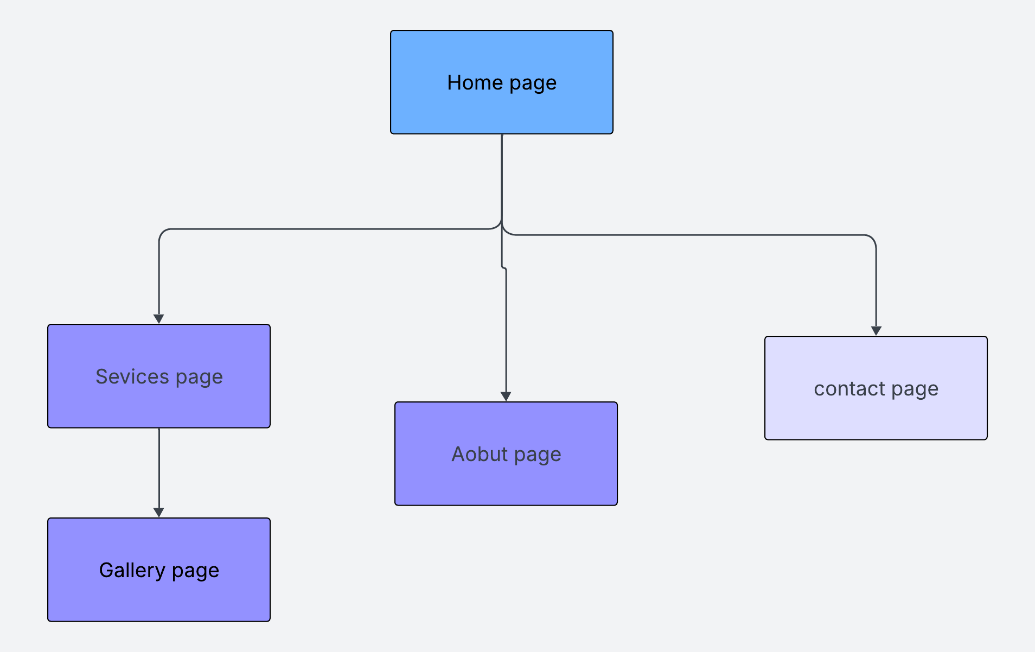

CONTENT TAXONOMY
Content is organized into a hierarchical taxonomy that categorizes information by type and purpose. This classification system ensures consistent organization across all pages and helps users understand the relationship between different content elements.
Home- Company details and website introduction of what the website provides.
Services- Borehole drilling, Fencing Machinery rental and site analysis, Project description,
Gallery- All projects that the company has made, and customer testimonials
About - Vision, About us and mission statement.
Contact-contact form, address, phone numbers, emails and working hours.

TECHNICAL BRIEF
Technologies used
The website is built using fundamental web technologies that ensure broad compatibility and ease of maintenance. The decision to use core technologies rather than frameworks was made to demonstrate a solid understanding of web development principles, which is essential for first-year students learning the foundations of web development.
- HTML5 -used for page structure, form elements and accessibility features
- JAVASCRIPT - Used for form validation, and interactivity of webpages.
- CSS3 -Styling, responsive design and layouts for webpages.
- Bootstrap 5.3- Frontend framework for responsive grid layout and components.

SOFTWARE TOOLS AND RESOURCES
Various software tools were utilized throughout the development process to create, edit, and test the website. These tools were selected based on industry standards and educational appropriateness for first-year students.
Development Tools
- Visual Studio Code: Primary code editor for writing HTML, CSS, and JavaScript files with syntax highlighting and live preview
- Google Chrome DevTools: Browser-based debugging and responsive design testing across multiple screen sizes
- GitHub/GitHub Pages: Version control and free web hosting for the live website deployment
Graphics and Design Tools
- GIMP: Image editing for creating and optimizing website graphics, logos, and banners
- Wireframe Tools: Planning and documenting page layouts before development
- Pinterest: for images to use on the website.

References
- W3Schools for javaScript tutorial : https://www.w3schools.com/js/:
- Web fundamentals, responsive web design basics : https://developers.google.com/articles/usability-101-introduction-to-usability/
- W3C web Accessibility initiative. Web Accessibility Tutorials : https://www.w3.org/WAI/tutorials/
- Bootstrap documentation. Get started With Bootstrap 5.3 : https://getbootstrap.com/docs/5.3/getting-started/

