1. Website Specifications
a) Website Objective
The objective of the UniCare website is to provide students with useful resources that promote mental wellness, healthy study habits, and positive motivation. Many students experience stress, anxiety, and academic pressure during their studies. This website aims to provide simple guidance and information that can help students manage these challenges.
b) Website Goals
The goals of the UniCare website include:
- Provide useful study techniques and productivity strategies
- Promote mental wellness awareness among students
- Encourage positive thinking through affirmations
- Provide basic psychology information related to student stress
- Offer a simple platform where students can access helpful resources
The website will help students develop better learning habits and improve their overall academic experience.
c) Target Audience
The main audience for the UniCare website is students who are looking for academic support and mental wellness information. This website targets all genders between the ages of 16 and 30 years who are students. They must have basic computer skills and must be familiar with using smart devices for browsing websites and searching for information online.
Type of Website
This is a publishing website that focuses on providing informative and education content to users. The website will present articles and resources related to student wellness, study techniques and mental health awareness.

2. Information Design & Taxonomy
The UniCare website will use a hierarchical structure, where the homepage acts as the main entry point and other pages are connected through navigation links.
Site Map
- Home
- Study Tips
- Time Management
- Exam Preparation
- Mental Wellness
- Managing stress
- Student Burnout
- Daily Affirmations
- Contact / Feedback
Navigation Flow
The website will include a navigation menu on every page allowing users to easily move between:
- Home
- Study Tips
- Mental Wellness
- Affirmations
- Contact
3. Page Template Design (WireFrame)
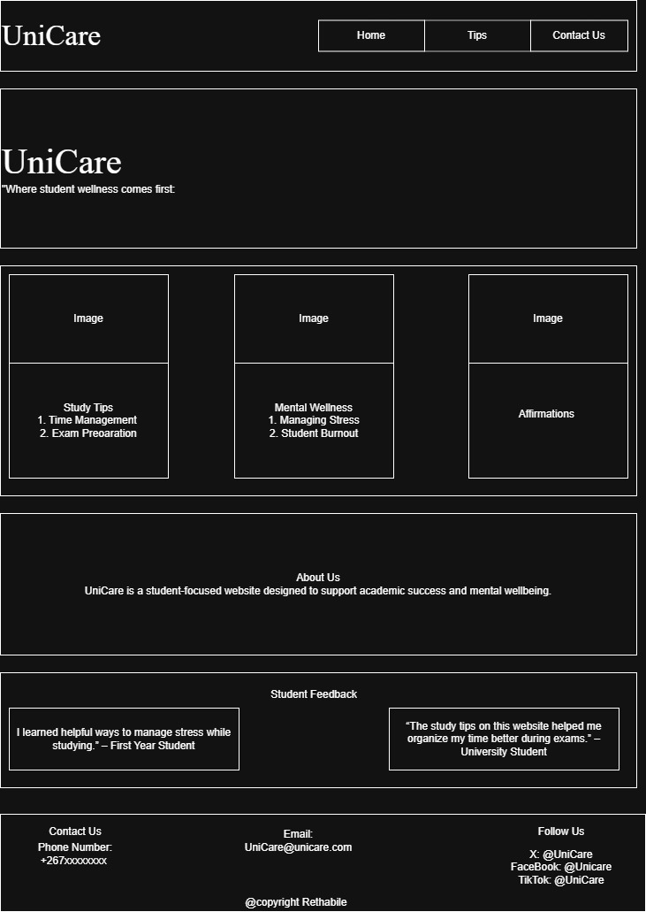

Website Layout Structure
- Header; Logo and Navigation menu
- Main Content Area; Page Title, Text content and images. Motivational quotes and tips
- Footer; Contact information, Copyright information, Social media links

4. Technical Brief
The development of the UniCare will require different tools to ensure that the website functions properly and meets web development standards.
Technologies Used
HTML: HTML will be used to create the structure of the web pages. It will define elements such as headings, paragraphs, images, and links.
CSS: CSS will be used to control the appearance and layout of the website, including colors, fonts, spacing, and responsive design.
JavaScript: JavaScript may be used to add interactive features, such as form validation or simple dynamic elements.
Bootstrap Framework: Bootstrap will help create a responsive design, allowing the website to display correctly on mobile devices, tablets, and desktop computers.
Software Tools
- Visual Studio Code (VS Code) – used for writing and editing website code
- Canva – used to create graphics, logos, and images for the website

5. Quality Assurance (Testing)
Several tests will be conducted to ensure that the website performs properly.
- Browser Compatibility Testing
The website will be tested on multiple browsers such as Google Chrome and Microsoft Edge.
This will ensure that the website layout and functionality will remain consistent across different browsers.
- Mobile Device Testing
The website will also be tested on mobile devices to ensure that the responsive design works correctly. It will be tested on devices such as Smartphones, Tablets and Laptops.
Responsive design will allow the layout to automatically adjust to different screen sizes.
- Link Testing
All navigation links will be tested to ensure that:
- All pages open correctly
- There are no broken links
- Navigation menus work properly

6. Publishing & Promotion
The UniCare website will be hosted using GitHub Pages, which allows developers to publish websites directly from a GitHub repository. Git commands will be used to upload and manage files in the repository.

7. Future Developments
Although the UniCare website will initially provide basic student wellness resources, several improvements could be implemented in the future.
Possible future developments include:
- Adding interactive mental health quizzes
- Creating a student discussion forum
- Providing video resources on study techniques
- Including professional counselling resources
- Adding a student blog section
These improvements would make the website more interactive and beneficial for students seeking mental wellness support.

