1. Website Specifications
a. Website objective and goals in relation to the business
The objective of the Best Breed Center website is to be the leading online resource for cattle farmers in Botswana, providing accurate information on the best cattle breeds, breeding practices, and professional breeding services. The primary goals are to educate farmers on breed selection, increase awareness of high-quality breeding stock, and generate more inquiries for breeding services and cattle sales. In relation to the business, the website aims to grow the centre’s client base by 40 % within the first year, reduce phone calls by allowing farmers to view breed details and schedules online, and position Best Breed Center as the top authority on cattle breeds suitable for Botswana’s climate and market conditions (drought-resistant and high-yield breeds).
b. Target audience (demographics and technical aptitude)
The primary target audience consists of livestock farmers and cattle breeders aged 25–60 years, mainly based in rural and peri-urban areas of Botswana (Gaborone, Francistown, Maun, and surrounding villages). The group is approximately 70 % male and 30 % female, with monthly incomes ranging from BWP 3 000 to BWP 15 000. They are small-to-medium scale farmers who keep 20–200 cattle and are looking for better breeds to improve meat/milk production and resilience to local conditions.
Technically, the audience has moderate to high digital aptitude: most own smartphones and use WhatsApp and Facebook daily; many already use online banking (Orange Money, Stanbic) and are comfortable filling simple online forms and viewing photo galleries.
c. Type of website / content
This is an informational and promotional website with light e-commerce elements. The content will focus on:
• Detailed profiles of cattle breeds (Tswana, Brahman, Nguni, Simmental, etc.)
• High-quality photos and videos of live animals
• Breeding services and consultation information
• Educational articles on breed selection and management
• Membership/registration form for newsletter and breeding inquiries
2.Information design and Taxanomy
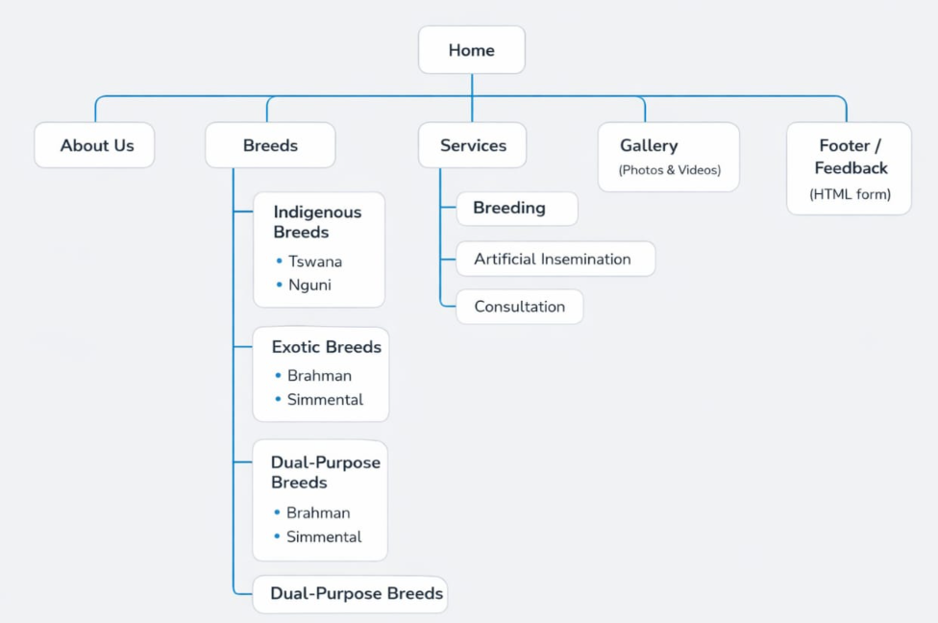
4. Technical Brief
Technologies and resources to be used
The website will be developed using modern, free, industry-standard tools that perfectly match the medium complexity of an educational cattle-breeds site (responsive design, photo gallery, interactive form, no database required).
Core web technologies
• HTML5 – semantic tags for accessibility and SEO (header, nav, main, section, footer)
• CSS3 – external stylesheet with Flexbox, Grid, and media queries for full mobile responsiveness
• Bootstrap 5 – for responsive grid, cards, navbar, and buttons
• JavaScript (vanilla) – for form validation, smooth scrolling, and image lightbox gallery
Software tools & resources
• Code editor: Visual Studio Code (with Live Server extension)
• Graphics & image editing: GIMP 2.10 – to create the logo, breed icons, banners, and edit all cattle photos
• Version control & hosting: Git + GitHub – full repository and GitHub Pages for live hosting
• Image optimisation: TinyPNG – to keep load times fast even on rural internet
• Testing: Google Chrome, Mozilla Firefox, Microsoft Edge, and Safari (mobile & desktop views)

