Website Overview
HEARUS is an online news and community platform built for women and LGBTQ+ individuals, two groups frequently underserved by mainstream media. The platform offers curated news and a space for user submitted personal stories.

Goals
- Central destination for news affecting women and LGBTQ+ communities
- Cover achievements, hard truths, and law changes without bias
- Safe, moderated space for community stories
- Track legal changes across countries for activists and researchers
- Offer support and give hope to those in need of it by allowing them a platform of people with similar stories.

Target Audience
Audience | Age and Technical aptitude | Key Needs
Women, LGBTQ+ & allies | 13+ with basic understanding of technology and how to access websites using a device connected to the internet. | Rights, safety, achievements, community, Legal info, representation

Content & Site Structure
The site has two top level sections (Women and LGBTQ+), each with four identical content categories:
Category | Content
Achievements & Good News | Milestones, legal wins, sporting victories
Hard Truths | Violence, hate crimes, rights rollbacks
Law Changes | Legislation and court rulings worldwide
Community Stories | First person accounts submitted by visitors

Pages (7 total)
- index.html - Cover page with Women / LGBTQ+ choice cards
- women.html -Women's news hub (4 content sections)
- lgbtq.html - LGBTQ+ news hub (same structure, purple theme)
- stories-women.html - Women's community stories and a submission form
- stories-lgbtq.html - LGBTQ+ community stories and a submission form
- feedback.html - General contact and feedback form
- All content is reachable within 3 clicks from the cover page.

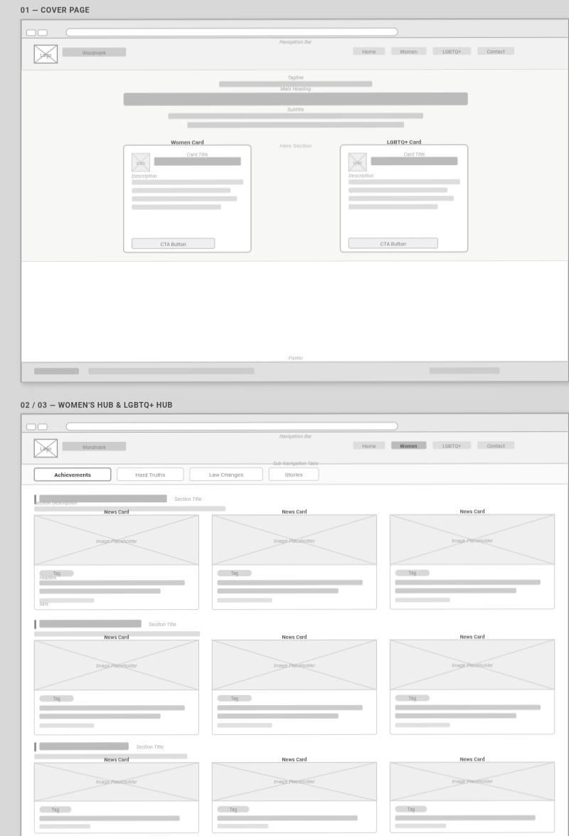
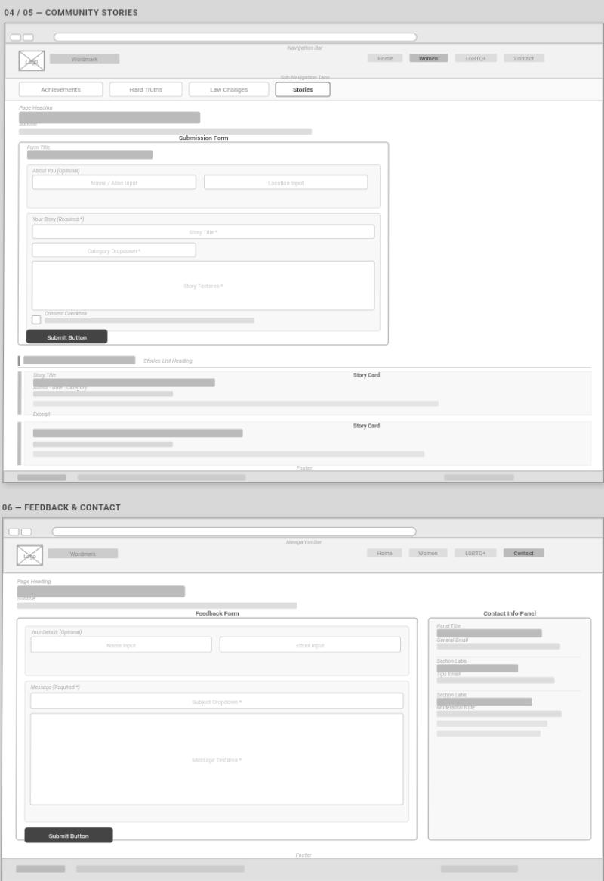

Tools used | Purpose
HTML5 | Semantic page structure (header, nav, section, article, form)
CSS3 | Styling Flexbox, Grid, media queries, custom properties
Bootstrap 5 | Responsive grid and mobile navigation (via CDN)
JavaScript | Smooth scrolling, form validation,
GIMP | Logo creation, image resizing and optimisation
Figma | Wireframes and page mockups (planning phase)
VS Code | Code editor with Live Server, Prettier, HTML CSS Support
Git & GitHub | Version control and remote repository
GitHub Pages | Free static hosting and live public URL

Future Improvements
Improvement | Description
Live News API | Automatically pull current stories via NewsAPI or GDELT instead of hardcoded HTML
Backend Database | Store and moderate community story submissions (MySQL)
User Accounts | Allow users to save articles, follow topics, receive notifications
Multilingual Support | Add French, Portuguese, Spanish, Setswana, Swahili, etc for global reach
WCAG Accessibility Audit | ARIA labels, contrast ratios, keyboard navigation, skip links

