WEBSITE SPECIFICATIONS
The objective of this site is to publish the latest news on the lgbtq+ community and women as well as everything remotely associated with them. It is to cover the good, the bad as well as the evil when it comes to women and the lgbtq+ community including but not exclusive to gay rights in 3rd world countries, equality in workplaces, women in male dominated fields, success stories, horror stories and the likes.

Objectives:
This will be a news-based website so its main focus is to spread the main news of the day with side articles on ‘minor news’ as well as important historical events that shaped the world of the lgbtq and women as we know it today.

Target audience:
The target audience for such a website is women, the lgbtq+ community and everyone interested in news regarding them including allies, human rights activists, politicians and so on. It is a main stream media source thus it will be in English as majority of the human race speaks English. It will make use of simple gestures to access news and dive deeper into articles provided.

INFORMATION DESIGN & TAXONOMY
The site will consist of a home page with attractive icons and articles that when tapped expand and allow the reader to go in depth about what they have clicked. It separates lgbtq+ and women news to allow for people to directly go to whatever it is they are intrigued by. After clicking the article it expands allowing the reader to read the article with minimal scrolling and even suggests more articles similar to the one they are currently reading.
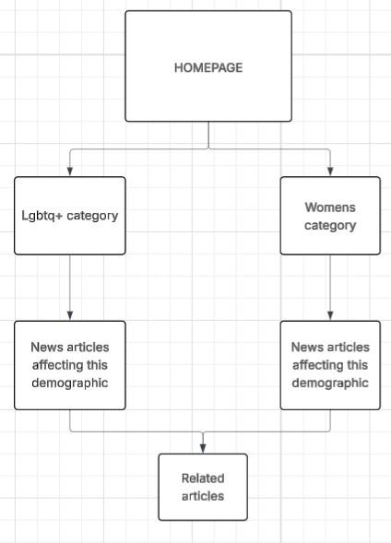

TECHNICAL SPECIFICATIONS
Developmemt tools:
- Javascript for imteractivity
- Bootstrap 5 for responsive grid
- CSS for presentation
Software tools:
- Visual studio for code writing and editing
- Canva for the logo, banner as well as overall graphics design
- Github pages for free web hosting
- Chrome devtools for debugging and testeng.

