

**CSE 299**

**PROJECT REPORT**

**ShopMart Shopping Ecommerce Website**

**Group Name : Team Dexter**

**Members :**

* **Md. Tanvir Hossain – 1521797642**
* **Tarak Mahmud – 1520198642**
* **Moddasir Ahmed Fahim- 1521463642**

**Section :**

**Submitted To :**

**Abstract :** In this era everything is online based. People love to have the comfort by sitting in the house. They don’t want to go out for buy everything. Now days the scenario of the market is changing and demand of online shopping has increased a lot. Explosion of e-commerce has changed the buying patterns and preferences of customers. The important brands are also moving towards e commerce technology for increased sale of their products. There is no doubt about it that ecommerce has made the transactions smooth, quick, faster and easier. Both the sellers and the buyers get benefited by his technology. As we all are aware that Commerce and Business are the backbones of a country’s development, if they were supported by the electronic technology and tools like e-commerce, it will make wonders in the economic growth of the country. An important part of e –commerce is online shopping. It helps in many ways both parties, the buyer as well as the seller. The e –commerce technology and the usage of online shopping has increased in tremendous ways in our country. Today almost every big company has adopted these technologies to increases sales, to make branding all over the globe. It has made easier for the user to buy and seller to promote his product by giving his product a proper view of his products. Now a days every kind of product can be found in the e-commerce website.

**Introduction:**

* **Project Idea:** Shopmart Shopping is basically an ecommerce Website where we can buy and sell goodies. We also can buy foreign products via foreign site. We can make live Product tracking. This is also a freelancing website for biker and cyclist where they can earn money from this site.
* **How it Works:** ShopMart Shopping is an ecommerce website. This is an amazing website where you can get all the Products you want. First of all this is a website where we can buy and sell goodies. The site holder will have their own premium products. Local seller can also sell their product by simple register. They can add their product on the website. They will get a log in portal where they need to register for became a seller membership. There is also a special feature called ‘Pre –Order’ where buyer can buy product from renowned website like Amazon, Alibaba, ALiexpress etc. In Bangladesh it is really hard to buy product from foreign website, all they need is master card and many more, but in this website they can buy product from us, where they don’t need any expensive master card. They just need to pay us from bkash or Bangladeshi card. There is also a special feature where they can be able to track foreign product. We will add another product tracking system where buyer can track our every product. Finally here we added an option where biker and cyclist can earn by freelancing. They just need to register. They can earn money from product delivery. They will get the maximum charge from here. Many people of our country are without job. This can a great site from them too.
* **Other things are in the rest of the parts :**

We will discuss about the **Background** where there will be some key topics like- what type of tools we used, where we got the idea and if the idea is collected than what is the resource or reference of the idea. There will be a part where we will discuss about our part of the project, we will discuss the contribution. We will also discuss about the future work or tool. Finally the report will end with the conclusion.

* **Background:** In this topic we will discuss about our tools and things we used in this project.

**Things we used:**

1. **HTML, CSS, SQL Alchemy, PYTHON (flask):** we used this for coding. In the front end we used HTML, CSS and bootstrap. In the back-end we used Python flask framework. We have also used database management system.
2. **Photoshop:** We used Photoshop for some basic reason. We needed some front end work and graphical work, that’s why we used Photoshop.
3. **PowerPoint:** we used PowerPoint for our project presentation slide.
4. **GitHub, Trello, Slack:** We uploaded our work and committed it on the GitHub. We faced a problem to commit with various account, so we used one account to commit all things. We used trello Board for the whole work details of the project and lastly we used slack for making our group conversation.

**Where did we get the idea:** In this project we made our own idea. In our regular life we are facing some major problem, like purchasing daily needed goodies. We are unable to order those. We want to give every product to every customer easily. If we say about taking idea, we can say we inspired from Amazon but we have some special features.

* **Work distribution :** We every members of our team members worked hard for building this project. First of all we started with front-end after that we route it and build functional logic. Then we build Database metadata machine and connect with functional routes. Then we create Tables and made forms in Front-end and connect it with Database. Which is Store, Delete, Update and Modify Data and Query possibilities.
* **Future Work:** We missed a very special tool which we want to add in the future. The tool is all about product live tracking. We already added tracking system but we want to add live tracing system, which will be the very first time of Bangladesh. The live tracking feature will show the the live location of your goodies. You don’t need to worry about your product or don’t need to wait to long for this.
* **Result and Simulation:** This is the screenshot of our website interface and some basic tools.

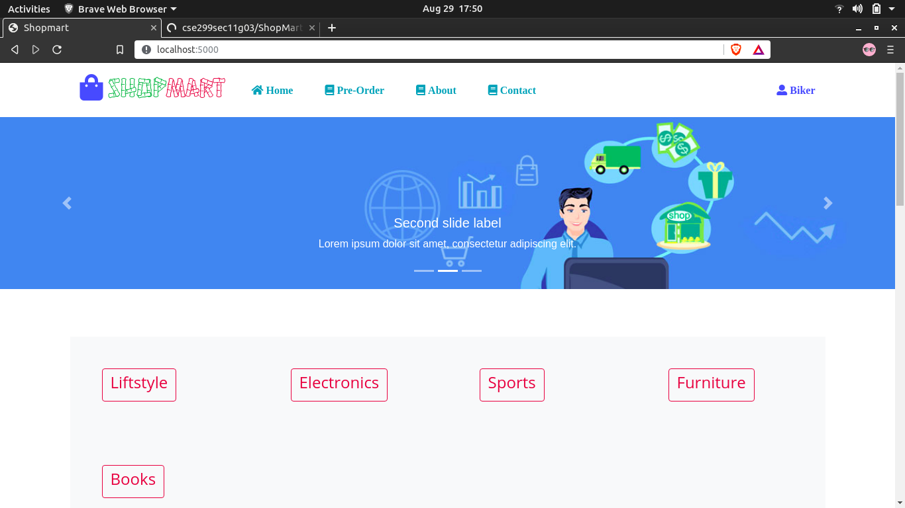

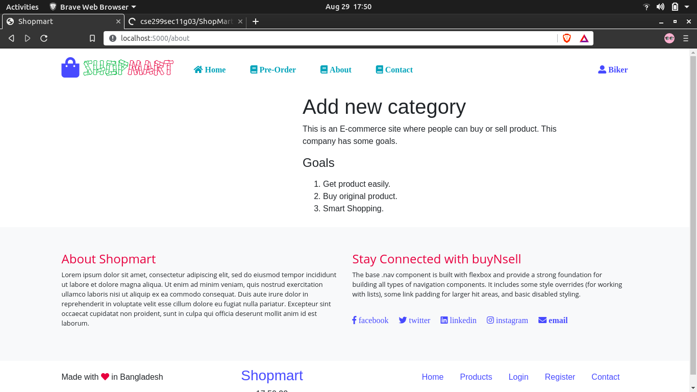

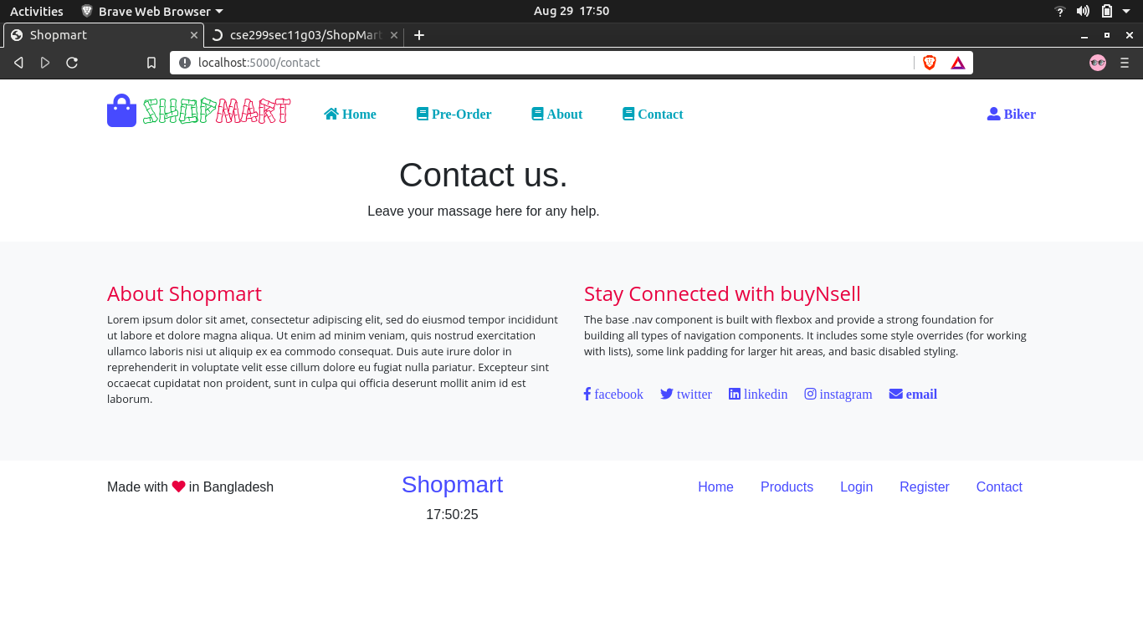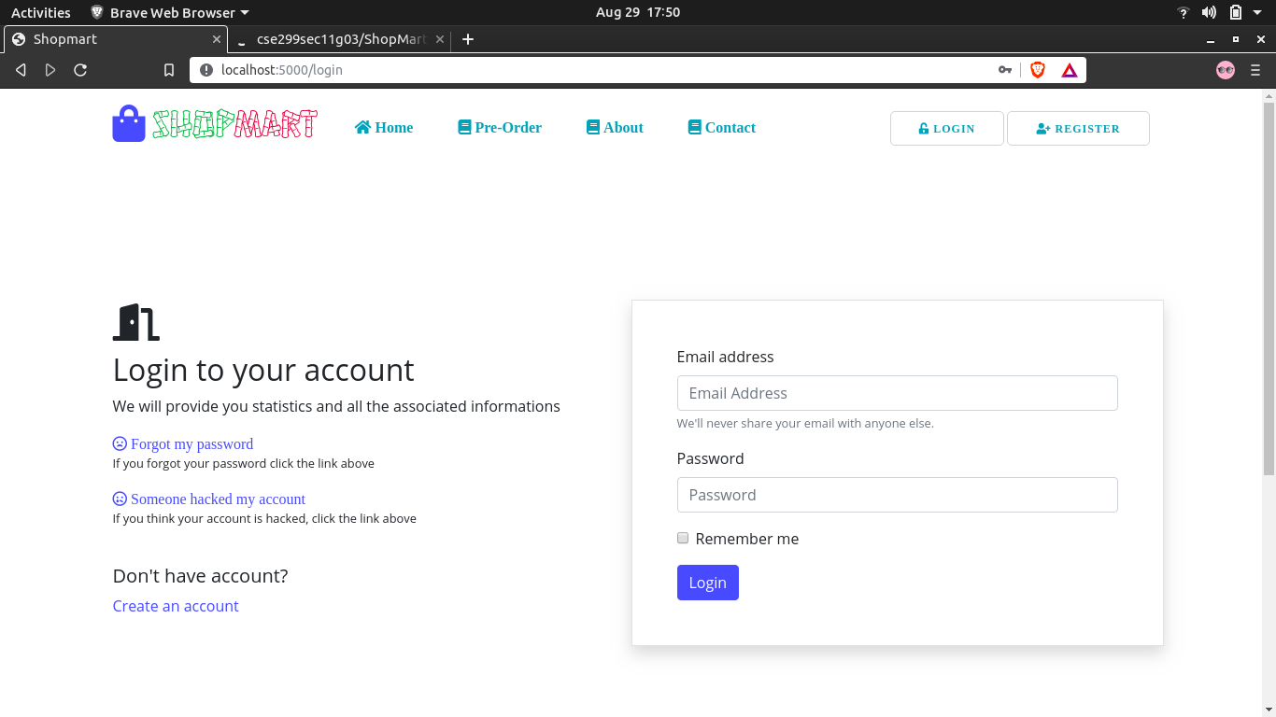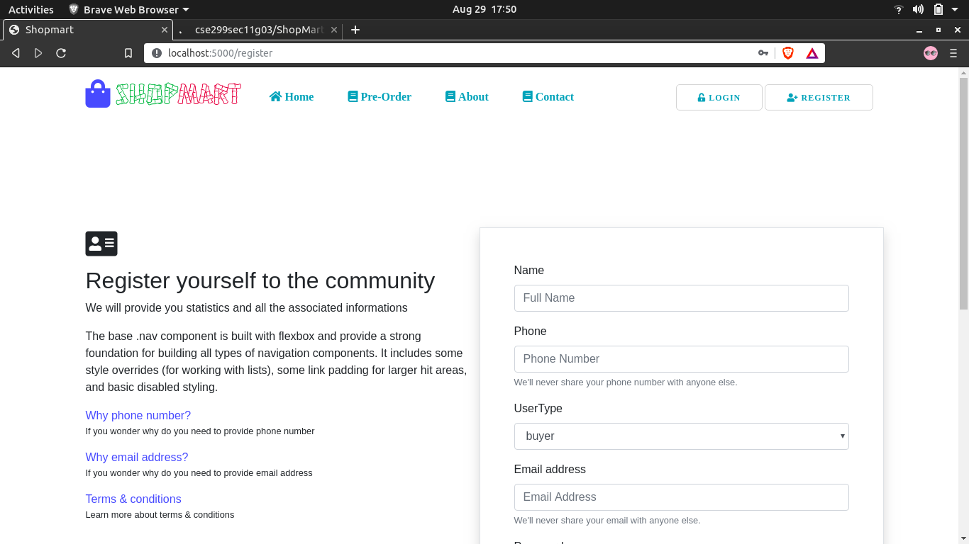

**Conclusion:** People who uses the online e-commerce website are around 21-30 ages. They are the most targeted audience in the market. They love to do shopping on the online website. While making the website for online shopping we designed it in a very planned and strategic way. The websites is mostly visited by the young age’s public. Mostly people prefer to shop buying clothes and accessories from online shopping website. Most of the customers prefer to pay on the delivery of the products at their places. Online shopping and e-commerce website are important part of the present life. There are several opportunities for online shopping websites and it is designed and processed in the quick, secure and qualitative way. We are trying to add all kind of new features in our website. We will always try to improve our website at regular interval.