CSE 30 – ARM function call and stack exercises

.cpu cortex-a53

.syntax unified

.arch armv6

Translate the following C code into assembly

#include <stdio.h>



#include <stdlib.h>



#include <string.h>



int x = 20;



short y[10];

int

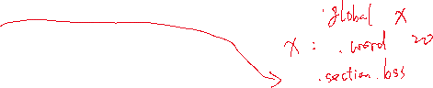

main(){

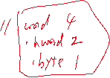

  int \*ptr = &x;//ptr maps to r0



  ptr++;

  fprintf(stderr, "%p\n", ptr);



  \*ptr = 30;

  short \*ptr2 = y;//ptr2 maps to r1

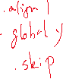

  fprintf(stdout, "%hd\n", \*(ptr2+1));



  int i = 0;//i maps to r2

  while(ptr2 < y + 10){

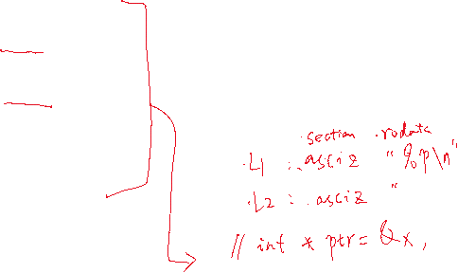

    i++;

    \*(ptr2++) = i;

    printf("%hd\n", \*(ptr2-1));

  }



}

