Predict the output of the following code. Assume we run the command as ./a.out BEEFFACE Pointers

#include <stdio.h>

#include <stdlib.h>

#include <string.h>



void



foo(char str1[], char* str2, char* str){

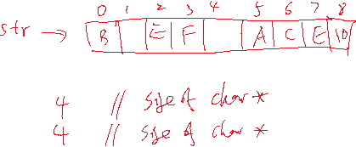

    //test the sizeof operations

    printf("%d\n", (int)(sizeof(str1))); ________________________________

    printf("%d\n", (int)s(sizeof(str2))); ________________________________

    //play with pointers

    char* ptr = str;

    printf("%c\n", ptr[3] + 1); ________________________________



    *(ptr+4) = 'A';



    printf("%c\n", *ptr++);________________________________



    printf("%c\n", *ptr--);________________________________



    printf("%c\n", *++ptr = *(ptr+2) + 3); ________________________________



    printf("%c\n", *(ptr+2)); ________________________________



    printf("%d\n", (ptr-str)); ________________________________



    printf("%s\n", str); ________________________________

}



int

main(int argc, char* argv[]){

    //test the sizeof operations



    char string[] = "ARMV7";

    printf("%d\n", (int)(sizeof(string))); ________________________________



    //test the command line args



    printf("%d\n", argc); ________________________________

    printf("%s\n", *argv); ________________________________



    printf("%s\n", *(argv+1)); ________________________________



    foo(string, string, *(argv+1));  
}