Complete the following exercises to build a LinkedList using structs.

#include <stdio.h>



#include <stdlib.h>



#include <string.h>



struct Node{



  int age;

  char *name;

  __________________ next;



};



struct Node*



insert_front(____________ head, int age, char* name){



//allocate space for a Node in heap using malloc

struct Node* tmp = ____________________________________;



if(__________________){//if malloc didn’t work

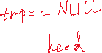

      return __________________;

}

//use the next three statements to initialize the Node pointed by tmp



__________________



__________________

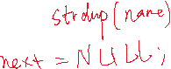

__________________



if(tmp->name==NULL){

free(tmp);



        return head;



}



//Complete the part to insert (pay attention to edge cases)

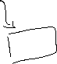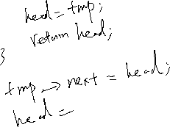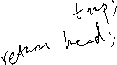

}

int

main(){

  struct Node* head = NULL;

  head = insert_front(head, 44, "Paul Cao");

  head = insert_front(head, 99, "Keith Muller");

head = insert_front(head, 33, "Christine Alvarado");

//Complete the code to print out the linked list

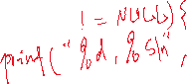



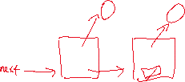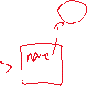



//Complete the code to free the memory allocated from heap



