19CSE461 - NET CENTRIC PROGRAMMING

Kaliki Sidhartha Reddy CB.EN.U4CSE19329

# Application name:

Attendance Management

GitHub URL : <https://github.com/cse99388/Attendance-Management>

# About the application in a paragraph:

It is a website which helps in managing the attendance of a students. This application is also useful for personal use also.

# Modules in the application:

Faculty and Student:

* Login
* Register
* Profile
* Update Profile
* Messenger
* Attendance Summary

Faculty:

* Add Course
* Take Attendance
* Edit Attendance
* Add Course
* Add Students
* Remove Course

Student:

* View Course
* View Attendance

# Breakdown Diagram for the application:

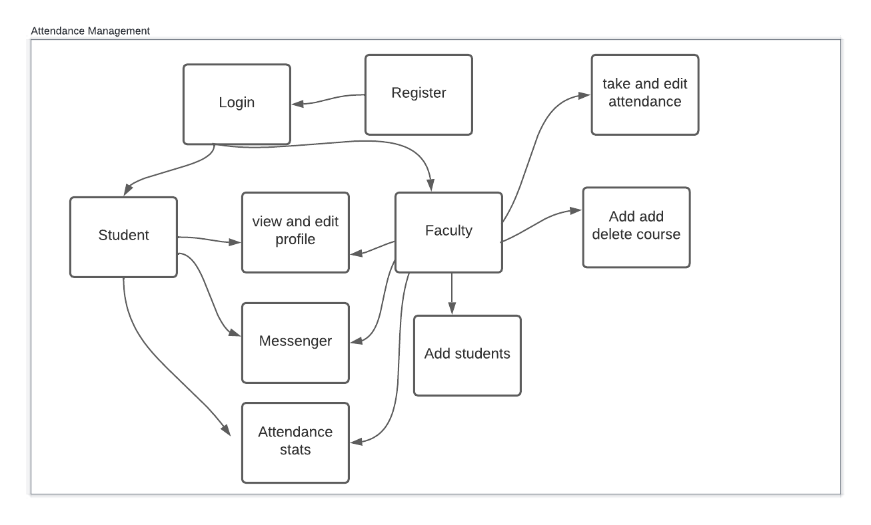

**Write in your own words how the application has used Mean Stack Development:**

In my application, I have used the following tools:

# MEAN

MongoDB:

* It is used as a database to store all the required content

ExpressJs:

* It is used to render the html content in efficient and easy way

Angular:

* It is used to validate the fields in real time and using functions to process the data in real time

NodeJs:

* It helps to interlink front end and database
* It helps in conditional rendering and also acts like a server by providing simple javascript syntax

# List of technologies/languages/framework/library used with purpose and version:

|  |  |
| --- | --- |
| Technologies/languages/framework/library | Purpose |
| Javascript | Full stack development (Frontend + backend) |
| MongoDB | NoSQL document database |
| ExpressJS | Web framework for the server application |
| NodeJS | A runtime environment for ExpressJS to run in the server |
| Angular | To develop the client-side application |
| Mongoose | NPM package to create data models and a simple API for MongoDB. |
| dotenv | To load environment variables into the application |
| JSON | The standard medium of data transfer between server and client |

**Write in your own words how the following concepts have been used in your application:**

|  |  |
| --- | --- |
| HTML5 | To develop basic UI components. |
| CSS | To style the UI components. |
| Angular | To develop the Client-side application. |

|  |  |
| --- | --- |
| NodeJS | As a runtime for JavaScript to run at server side. |
| ExpressJS | As a web framework to develop the server-side application and the REST API. |
| JSON | As a standard data transfer medium between the server and client. |
| MongoDB | A database for storing and retrieving JSON documents. |

|  |  |
| --- | --- |
| Number of Forms | 10 |
| What is unique in your application? | Single user can use it as a personal attendance manager |
| Form Names for Evaluating the concepts of AngularJS,NodeJS,ExpressJS | Login, register, update profile, take attendance, attendance, add course, Delete and search course |
| Tables for Evaluating the MongoDB concepts | Quick_regs, courses, attendances, student_courses |

# For the following tables refer the concepts provided for learning from internet resources and fill the table (Weightage : 5Marks)

|  |  |  |
| --- | --- | --- |
| Concept used from HTML5 | File Name | Additional Information |
| Form controls | Login, Register, update profile,  Add course, add students, Take attendance | Each form is validated |
| Table | Course List | Table to display data |
| Interactive design | Add students | Students are displayed automatically on adding |

**(Weightage : 10 Marks)**

|  |  |  |
| --- | --- | --- |
| Concept used from XML | File Name | Additional Information |
| XML | 329 | Done the implementation using XML. |

# (Weightage : 10 Marks)

|  |  |  |
| --- | --- | --- |
| Concept used from JavaScript | File Name | Additional Information |
| Const, let, var | * | Used in almost many |

|  |  |  |
| --- | --- | --- |
|  |  | JavaScript files. Used to create constants and variables |
| Arrays | Index.js | Used to store multiple objects of database information |
| CommonJS Imports | * | To import and export modules |
| Arrow functions | * | Used in place of functions |

|  |  |  |
| --- | --- | --- |
| Concept used from JSON | File Name | Additional Information |
| Array | Index.js | To provide configuration  information to the angular app |
| Object | Index.js | Config information to angular app |
| Array of objects | Index | To provide config info about multiple objects |

**(Weightage : 20 Marks)**

|  |  |  |
| --- | --- | --- |
| Concepts used from Angular | File Name | Additional Information |
| Angular html components | * | HTML components that will be rendered on the browser |
| Angular data models | * | Define the format of data that will be fetched from the server |

# (Weightage : 20 Marks)

|  |  |  |
| --- | --- | --- |
| Concepts used from ExpressJS | File Name | Additional Information |

|  |  |  |
| --- | --- | --- |
| Mongoose Models | Models folder | Creating data models to store in DB |
| Rendering and linking and displaying data | Views folder | Helps in displaying the content |

**(Weightage : 20 Marks)**

|  |  |  |
| --- | --- | --- |
| Concepts used from NodeJS | File Name | Additional Information |
| Path | Index.js | Used nodejs path parsing and handling libraries |
| Request and response | Index.js | Used the req and res objects to handle requests and responses |
| async | Index.js | To execute each and every route asynchronously |
| await | Index.js | To wait while fetching the data |

# (Weightage : 20 Marks)

|  |  |  |
| --- | --- | --- |
| Concepts used from MongoDB | File Name | Additional Information |
| Data Model | Db.js, attendance.js,  course_data.js, user_data.js, student_course.js | Using mongoose to create models of each entity in the database |
| Fetch | * | Fetch documents from the DB |
| Edit | Index.js | Update documents in the DB |
| Delete | Index.js | Delete documents from the DB |
| Filter | * | Filter documents based on the query |
| MongoDB Compass | db.js | Used mongoose to connect to MongoDB’s cloud database |

**Five features that can be added to application in future:**

* Messenger
* Edit Attendance
* Student view
* Attendance summary
* View peers profile

**The End**