SUSE Cloud Admin Appliance Walk Through

First before you proceed with deploying the Admin Appliance you must go through and answer the questionnaire to ensure you have an idea of the scope of the project and the proper settings defined in advance. It will help you bring together the right people to help answer the questions required before you go forward with a private cloud deployment.

You may download the SUSE Cloud Admin Appliance the following ways.

Now that you have your questionnaire filled out and are ready to go you can follow the steps below as you go through the installation of the SUSE Cloud Admin Appliance.

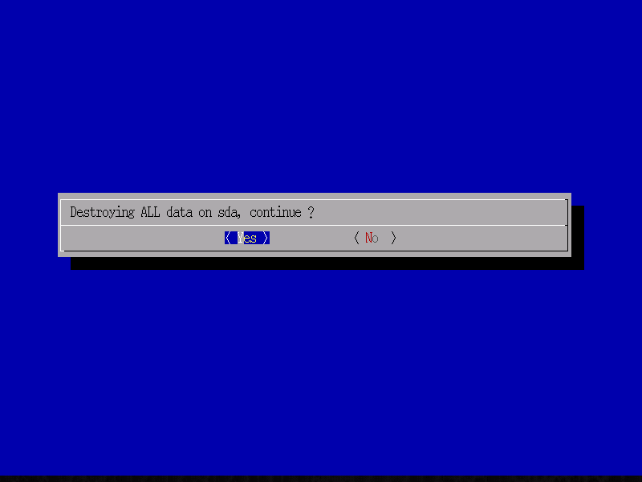
- Take the default boot option to Install SUSE Cloud Admin
- Destroy ALL data on your primary disk. In some cases you might get more than one disk showing. Be sure to select your root disk and select Yes to continue.

- Now you wait until the raw image is deployed to the disk you selected and then verified.
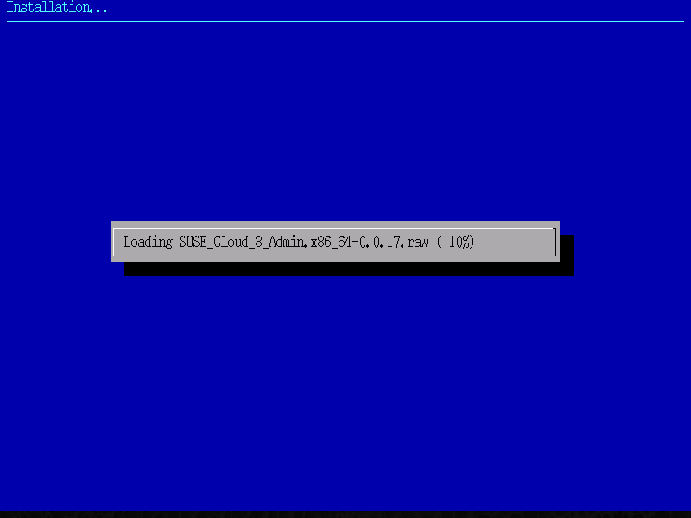

- Once the image is loaded then it will start booting it. The boot process may take a few minutes since it executes some first boot steps for the configuration of the SUSE Cloud Admin server. You will see it extracting ISO images to specific locations on disk and installing the proper software required.
- Select your Language and select Next.

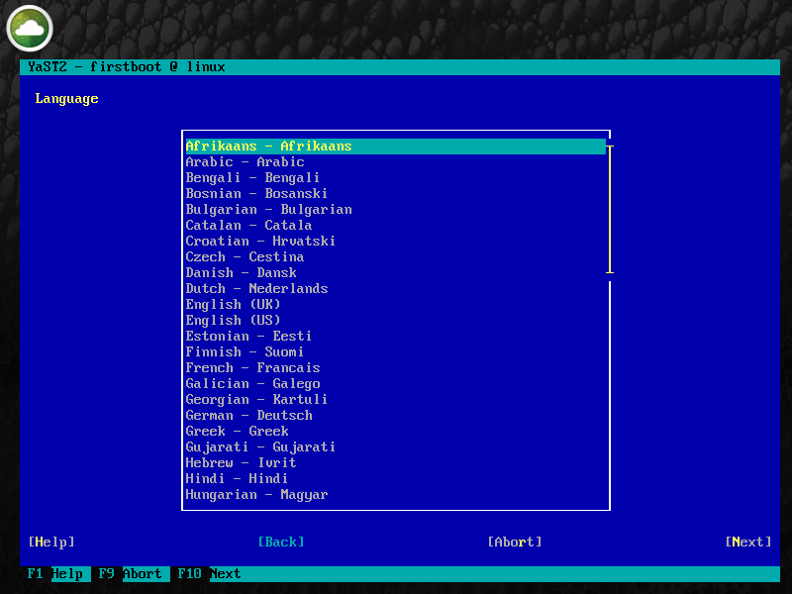

- Select your Keyboard Layout and select Next.

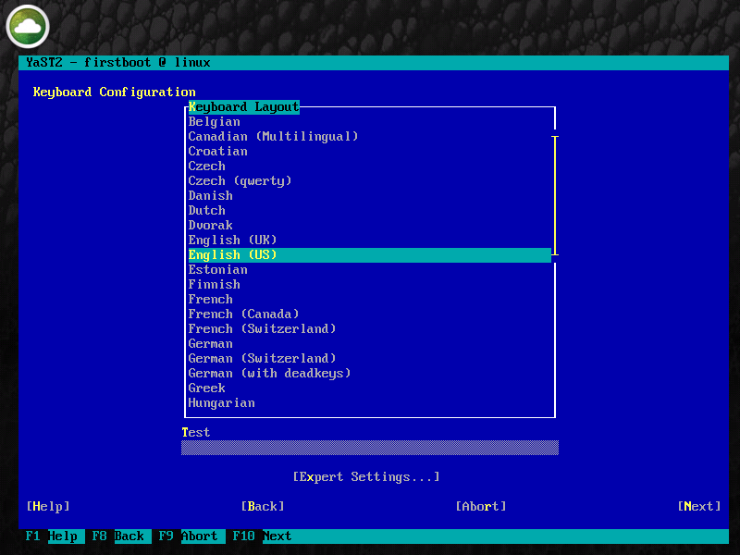

- Fill in your Hostname and Domain Name and select Next.

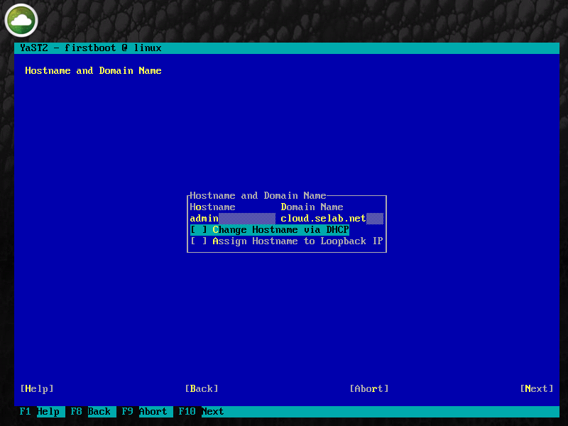

- Now for the Network Configuration. Select Change (Alt-C) Network Interfaces..

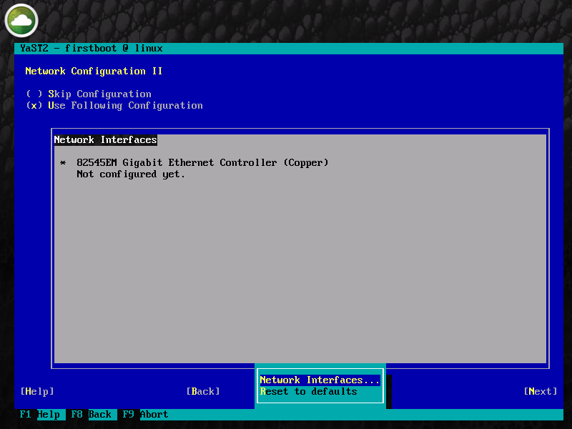

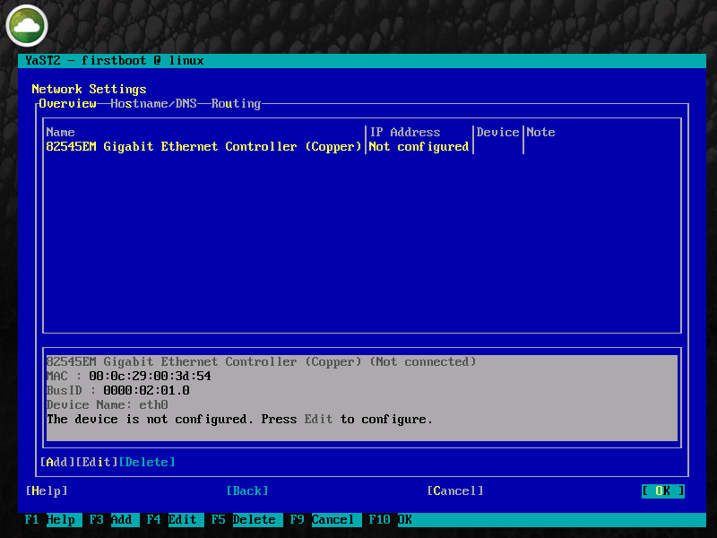
- Select Edit (Alt-i) to edit your network settings for eth0. You might have more than one network interface for your configuration. At this point in time its only necessary to configure eth0.

- Now Select either Dynamic or enter your IP address and Hostname and then select Next. The default configuration is to setup the SUSE Cloud Admin server with a static IP address of 192.168.124.10.
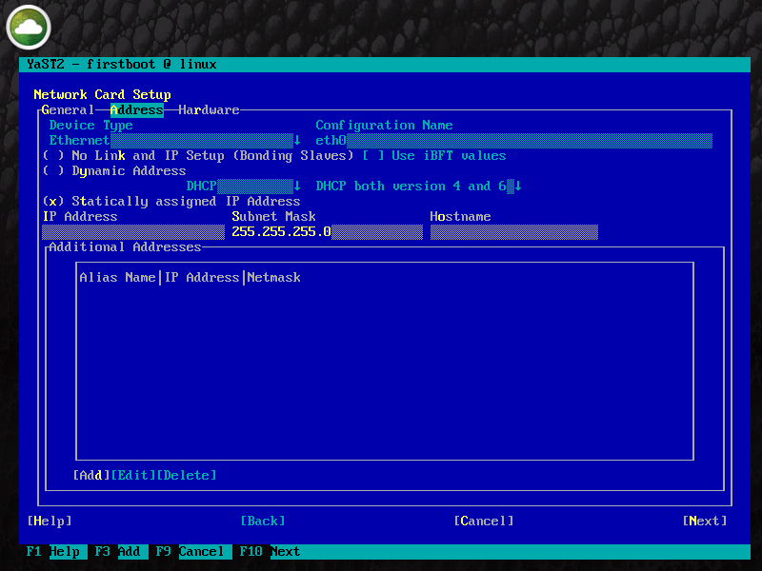

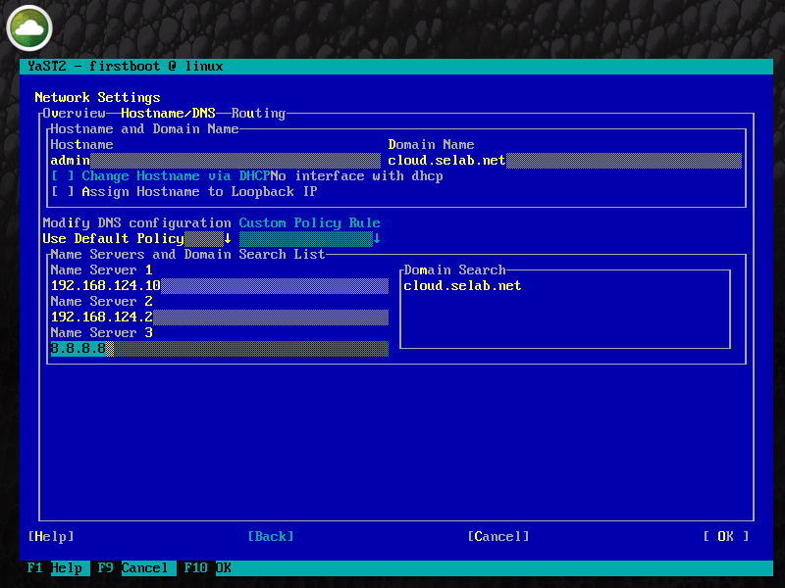
- Now select Hostname/DNS (Alt-s) and fill in the blanks. For the Name Servers I put in the IP address of the Admin Server since it eventually becomes a DNS server and also the gateway and the google DNS for externally routed DNS. You will have some internal DNS servers specific to your environment, however what you see here can be used for a lab setup.

- Select Routing (Alt-u) and fill in the Default Gateway if your settings are for a static IP configuration then select OK. I am using 192.168.124.2 since I am running under Vmware. Yours will be different depending on whether your implementing a development or production deployment.
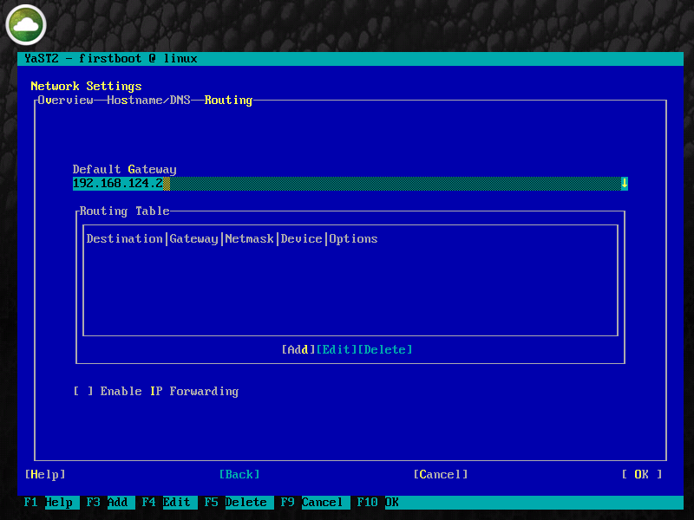

- Select Next to continue from the Network Configuration dialogue. It will now save the network configuration.
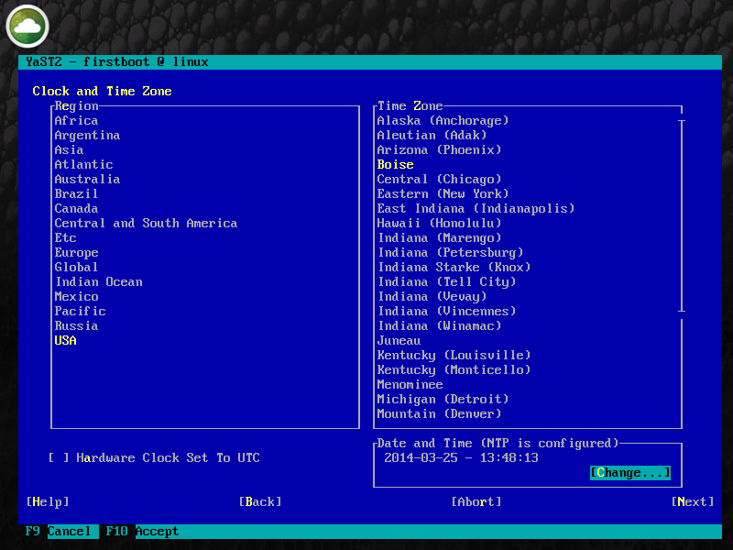
- Now to setup the Clock and Time Zone settings. Select your proper Time Zone and then select Change (Alt-c)

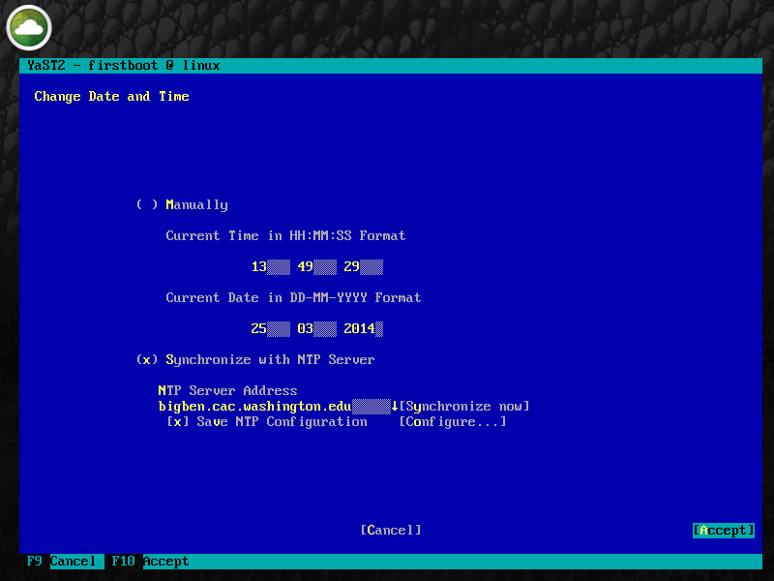
- Make sure we synchronize with an NTP Server. Select your NTP Server from the list or configure one manually if you have an internal NTP Server you like to use. Select Accept when your finished.

- Select Next on Clock and Time Zone
- Now you will see Proxy Configuration. If you don't have a proxy then just select Finish, but if you do then you will need to Enable Proxy (Alt-e), fill in the settings and then select Finish.
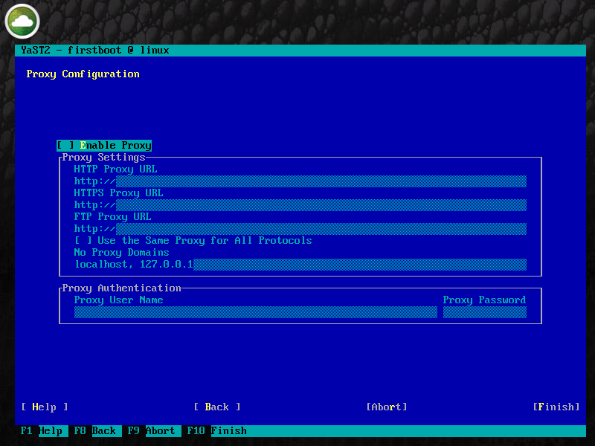

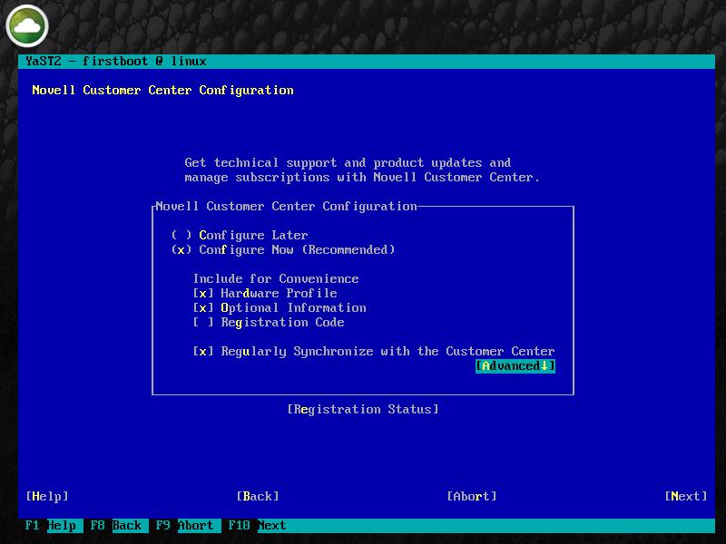
- Novell Customer Center Configuration. Select Next unless you have a local SMT Server you want to register with in which case you would select Advanced and setup the Local Registration Server settings.

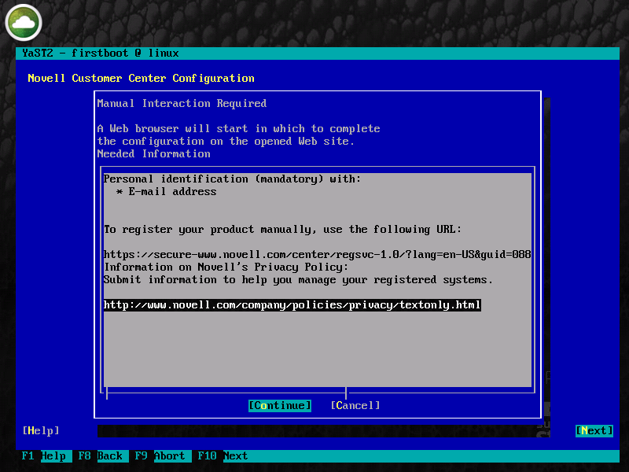
- At this point it will go forward with contacting the Novell Customer Center and then you will be asked for Manual Interaction. Select Continue.

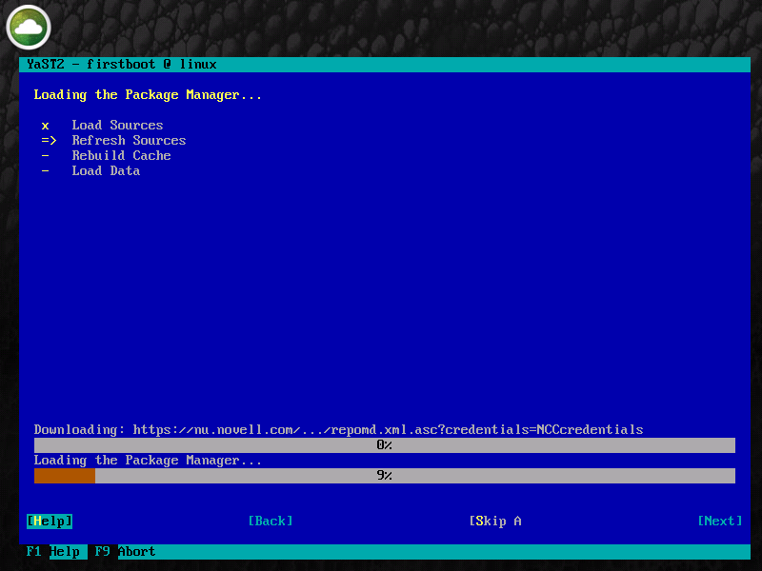
- You will now be presented with a W3M Browser. (Use Tab to skip between fields and Enter to type in a field) Put in your email address that’s used in the Novell Customer Center and also enter your activation code for SUSE Linux Enterprise Server 11 SP3 unless you want to use an evaluation key then just leave it blank. Tab down to Submit and hit Enter. Type q then y and it will go back to the curses menu and start adding the proper remote repositories to your system.

- Select OK on the successful configuration dialogue.
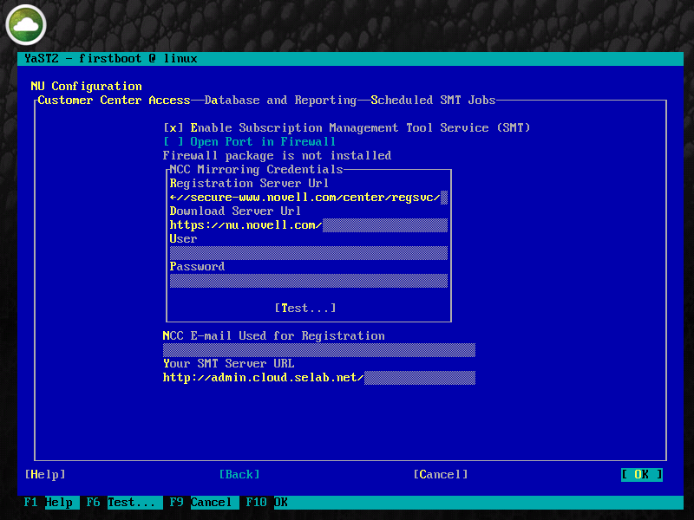
- NU (SMT) Configuration. Fill in the User and Password and Test your configuration. The User and Password that are required here are your mirroring credentials. To get your mirroring credentials follow the steps in this link below. Select OK when finished. https://www.suse.com/documentation/smt11/book_yep/data/smt_mirroring_getcredentials.html

- You will be asked for a MySQL Database root password in order to proceed. Enter the password in the fields provided and select OK.
- You will see a Missing Server Certificate dialogue. Select Run CA management. It will then ask for a CA password. Enter a password and select OK. Select Next. Now it will create the certificate and write your SMT configuration.
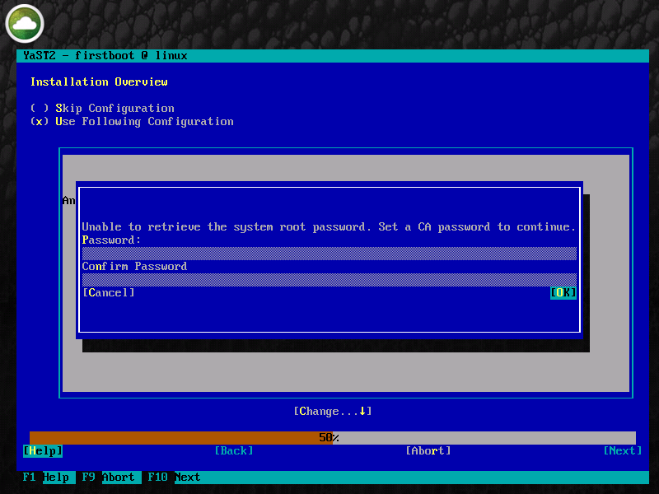

- Now its time for an Online Update. Select Accept (Alt-a) to continue. This will take a few minutes to complete.
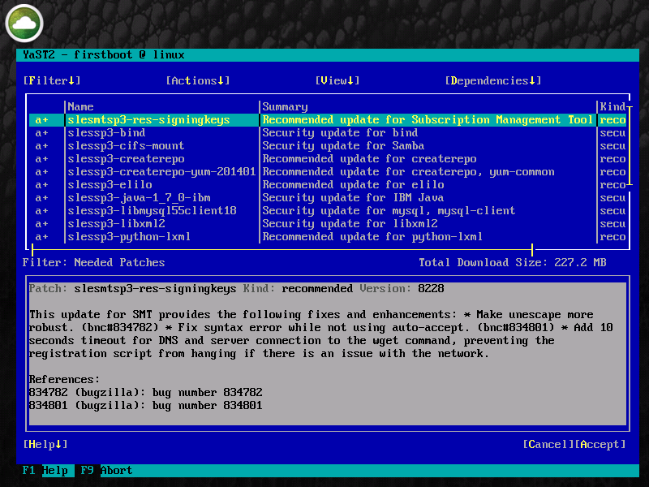

- Once the Online Update is complete then the appliance will finish booting up and will start the Preparation phase. This Phase will take several minutes to complete and will notify you along the way as it completes its various steps.
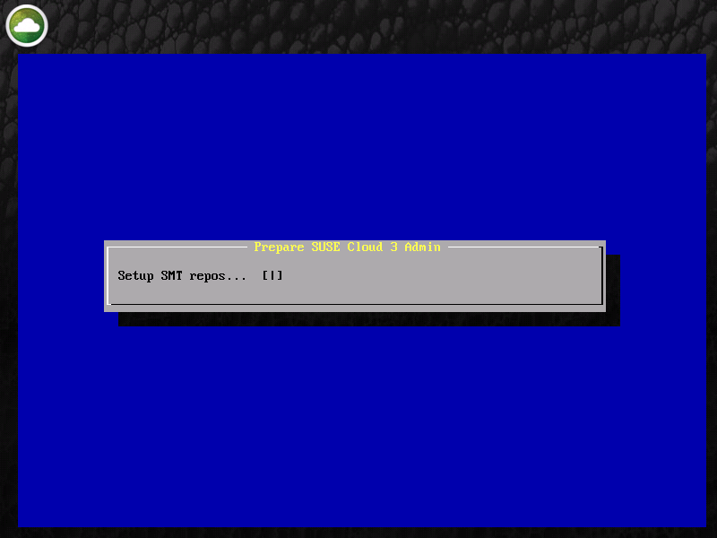

- Preparation Finished. Read the dialogue and follow the steps to complete the SUSE Cloud Admin Appliance Install. Here might be a good time to do a snapshot if your running this in a virtualized environment. Then you have a point in time before you deploy crowbar and setup the network.
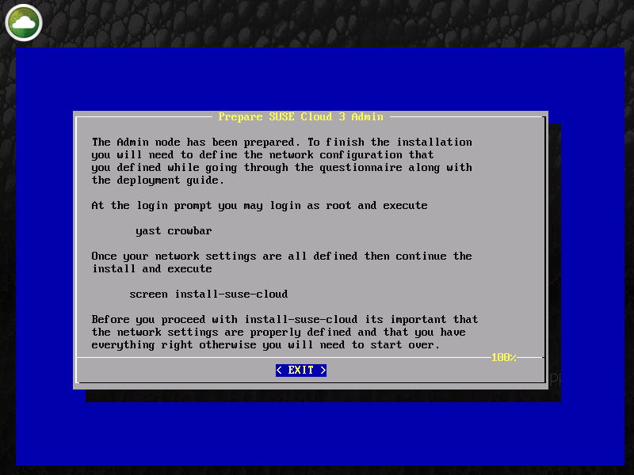

- Here is the message

The Admin node has been prepared. To finish the installation
you will need to define the network configuration that
you defined while going through the questionnaire along with
the deployment guide.

At the login prompt you may login as root and execute

yast crowbar

Once your network settings are all defined then continue the
install and execute

screen install-suse-cloud

Before you proceed with install-suse-cloud its important that
the network settings are properly defined and that you have
everything right otherwise you will need to start over.

Your now ready to deploy the various OpenStack parts using barclamps in crowbar.

