## **Wireless Transmission**

Wireless communication technology has developed significantly over the past few decades and has become one of the most important types of media transmission from one device to another. Without the use of wires or electronic conductors, information can be transmitted by using electromagnetic waves. The various types of wireless communication include radio broadcast (RF), Infrared (IR), satellite, microwave, and Bluetooth. Mobile phones, GPS, Wi-Fi, and cordless telephones are devices that use wireless transmission to exchange data and information.

## **Frequency Ranges**

Have you ever wondered how your television and mobile phone can work at the same time? Both receive signals via antenna in the form of electromagnetic waves but don't interfere with each other. The reason is that all wireless devices operate in their own frequency bands within which they transmit and receive signals. For example, television broadcast operates between 54-216 MHz, FM radio operates between 87.5-108 MHz and cell phones operate either between 824-894 MHz or 1850-1990 MHz.

Extremely Low Frequency (ELF) 3-30 Hz Underwater Communication

Super Low Frequency (SLF) 30-300 Hz AC Power

Very Low Frequency (VLF) 3-30 kHz For Navigation Alarms

Low Frequency (LF) 30-300 kHz AM Radio

Medium Frequency (MF) 300-3000 kHz Aviation

High Frequency (HF) 3-30 MHz Shortwave Radio

Very High Frequency (VHF) 30-300 MHz FM Radio

Ultra High Frequency (UHF) 300-3000 MHz Television, mobile phones, GPS

Super High Frequency (SHF) 3-30 GHz Satellite, Wireless Communication

Extremely High Frequency (EHF) 30-300 GHz Remote Sensing, Astronomy

#### **Satellite Communication**

Satellite communication is one type of self contained wireless communication technology, it is widely spread all over the world to allow users to stay connected almost anywhere on the earth. When the signal (a beam of modulated microwave) is sent near the satellite then, satellite amplifies the signal and sent it back to the antenna receiver which is located on the surface of the earth. Satellite communication contains two main components like the space segment and the ground segment.The ground segment consists of fixed or mobile transmission, reception and ancillary equipment and the space segment, which mainly is the satellite itself.

#### **Infrared Communication**

[Infrared wireless communication](https://www.elprocus.com/communication-using-infrared-technology/) communicates information in a device or systems through IR radiation . IR is electromagnetic energy at a wavelength that is longer than that of red light. It is used for security control, TV remote control and short range communications. In the electromagnetic spectrum, IR radiation lies between microwaves and visible light. So, they can be used as a source of communication

For a successful infrared communication, a photo LED transmitter and a photo diode receptor are required. The LED transmitter transmits the IR signal in the form of non visible light, that is captured and saved by the photoreceptor. So the information between the source and the target is transferred in this way. The source and destination can be mobile phones, TVs, security systems, laptops etc supports wireless communication.

#### **Broadcast Radio**

The first wireless communication technology is the open radio communication to seek out widespread use, and it still serves a purpose nowadays. Handy multichannel radios permit a user to speak over short distances, whereas citizen’s band and maritime radios offer communication services for sailors. Ham radio enthusiasts share data and function emergency communication aids throughout disasters with their powerful broadcasting gear, and can even communicate digital information over the radio frequency spectrum.

Mostly an audio broadcasting service, radio broadcasts sound through the air as radio waves. Radio uses a transmitter which is used to transmit the data in the form of radio waves to a receiving antenna([Different Types of Antennas](https://www.elprocus.com/different-types-of-antennas-with-properties-and-thier-working/)). To broadcast common programming, stations are associated with the radio N/W’s. The broadcast happens either in simulcast or syndication or both. Radio broadcasting may be done via cable FM, the net and satellites. A broadcast sends information over long distances at up to two megabits/Sec (AM/FM Radio).

Radio waves are electromagnetic signals, that are transmitted by an antenna.These waves have completely different frequency segments, and you will be ready to obtain an audio signal by changing into a frequency segment.

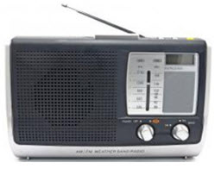Radio

For example, you can take a radio station. When the RJ says you are listening to 92.7 BIG FM, what he really means is that signals are being broadcasted at a frequency of 92.7megahertz, that successively means the transmitter at the station is periodic at a frequency of 92.700,000 Cycles/second.

When you would like to listen to 92.7 BIG FM, all you have to do is tune the radio to just accept that specific frequency and you will receive perfect audio reception.

#### **Microwave Communication**

[Microwave wireless communication](https://www.elprocus.com/introduction-to-types-of-microwave-antennas-in-communication-systems/) is an effective type of communication, mainly this transmission uses radio waves, and the wavelengths of radio waves are measured in centimeters. In this communication, the data or information can be transfers using two methods. One is satellite method and another one is terrestrial method.

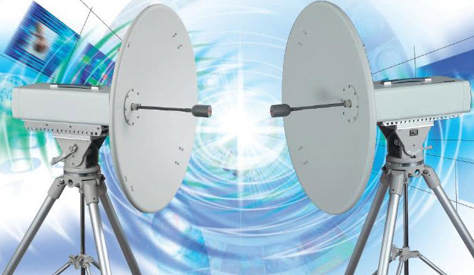Microwave Communication

Wherein satellite method, the data can be transmitted though a satellite, that orbit 22,300 miles above the earth. Stations on the earth send and receive data signals from the satellite with a frequency ranging from 11GHz-14GHz and with a transmission speed of 1Mbps to 10Mbps. In terrestrial method, in which two microwave towers with a clear line of sight between them are used, ensuring no obstacles to disrupt the line of sight. So it is used often for the purpose of privacy. The frequency range of the terrestrial system is typically 4GHz-6GHz and with a transmission speed is usually 1Mbps to 10Mbps.

The main disadvantage of microwave signals is, they can be affected by bad weather, especially rain.

#### **Wi-Fi**

[Wi-Fi is a low power wireless communication](https://www.elprocus.com/how-does-wifi-work/), that is used by various electronic devices like smart phones, laptops, etc.In this setup, a router works as a communication hub wirelessly. These networks allow users to connect only within close proximity to a router. WiFi is very common in networking applications which affords portability wirelessly. These networks need to be protected with passwords for the purpose of security, otherwise it will access by others

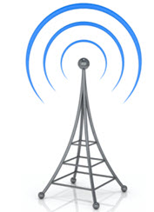Wi-Fi Communication

#### **Mobile Communication Systems**

The advancement of mobile networks is enumerated by generations. Many users communicate across a single frequency band through mobile phones. Cellular and cordless phones are two examples of devices which make use of wireless signals. Typically, cell phones have a larger range of networks to provide a coverage.But, Cordless phones have a limited range. Similar to GPS devices, some phones make use of signals from satellites to communicate.

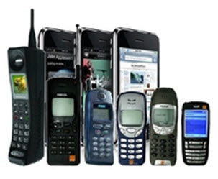Mobile Communication Systems

#### **Bluetooth Technology**

The main function of the Bluetooth technology is that permits you to connect a various electronic devices wirelessly to a system for the transferring of data.Cell phones are connected to hands free earphones, mouse, wireless keyboard. By using Bluetooth device the information from one device to another device. This technology has various functions and it is used commonly in the wireless communication market.

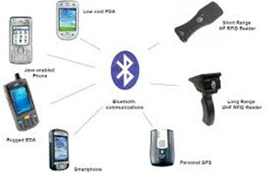Bluetooth Technology

#### **Advantages of Wireless Communication**

* Any data or information can be transmitted faster and with a high speed
* Maintenance and installation is less cost for these networks.
* The internet can be accessed from anywhere wirelessly
* It is very helpful for workers, doctors working in remote areas as they can be in touch with medical centers.

#### **Disadvantages of Wireless Communication**

* An unauthorized person can easily capture the wireless signals which spread through the air.
* It is very important to secure the wireless network so that the information cannot be misused by unauthorized users

2. Consider a directional Antenna of 60 DB over a reference Antenna and that radiates 600 volt.how much power must the reference Antenna radiate to G=60Db provide the same signal power P1=700w, in the preferred direction.

P1=700W

G=60dB

G= 10 log (P2/P1)

60 = 10log P2/700

6 = log P2/700

64=P2/700

P2 = 44800W