Employee Management System

Course Title: Software Engineering Sessional
Course Code: CSI332

Submitted By
Team Unity

Introduction:Employee Management System is a automated system to track employees information and providing more facility. We have just built an Employee Management Software with basic feature having a plan of giving it a complete structure within the next 2 years.

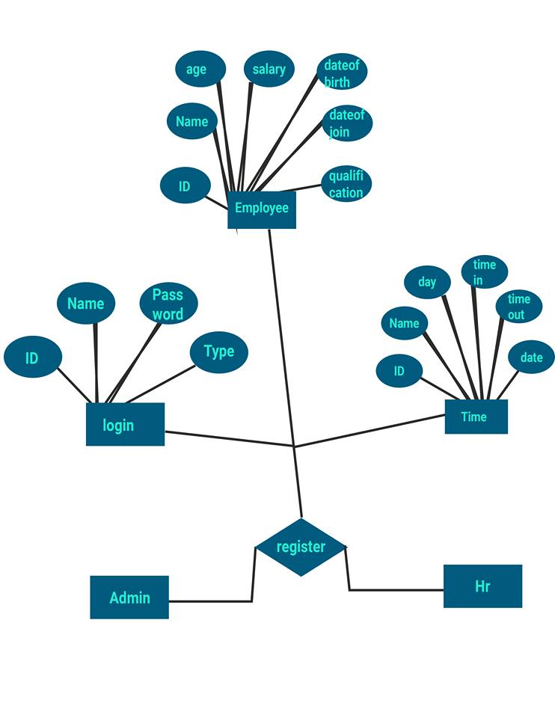
Database:
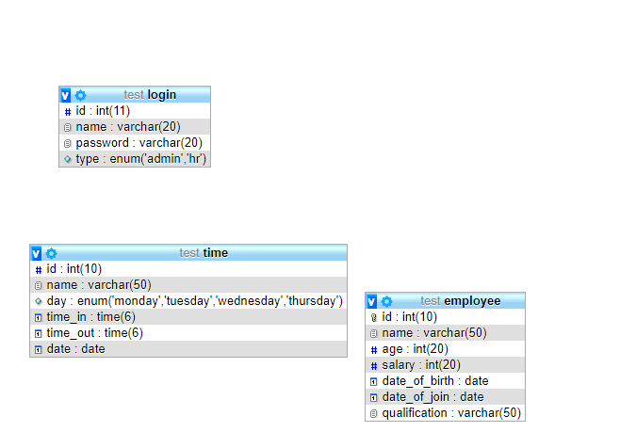

Website:
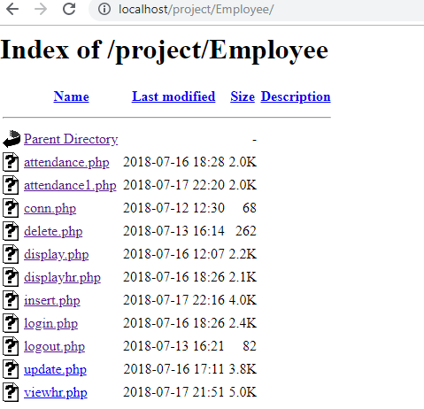

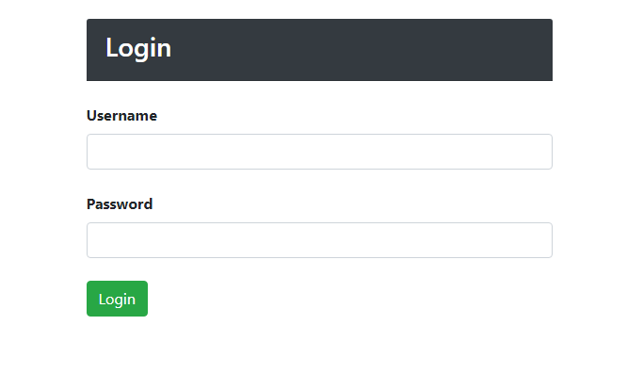

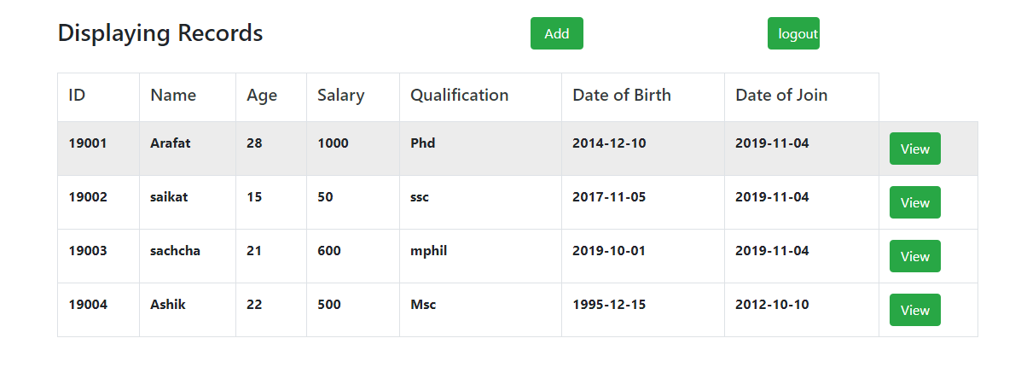

For Admin login:
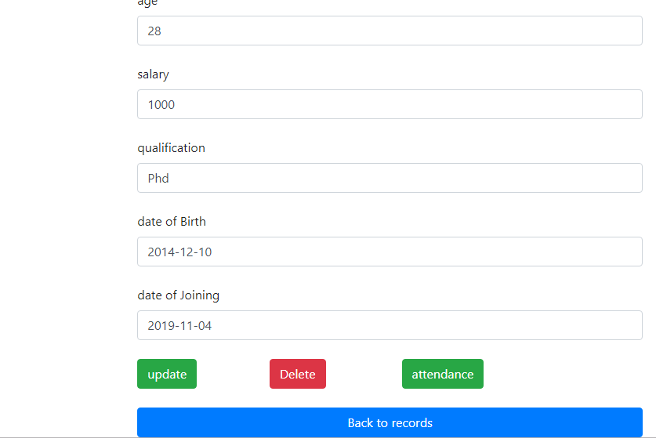

For HR login:

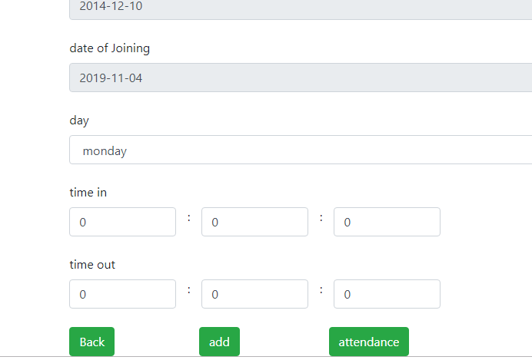

Admin can update or delete anything where hr can only add new employee information.

Contribution:

cse06307434 | 35%
cse06307451 | 35%
cse06307459 | 30%

