

**Introduction:**

This report has covered **Data Flow Diagram.** Data Flow Diagram is a graphical representation of System’s data and how the process transform data. It's easy to understand the flow of data through systems with the right **data flow diagram** software. This is the most common way of documenting the process of current and required System.

**Data Flow Diagram (DFD):**

**Activity List:**

|  |  |  |
| --- | --- | --- |
| Administration | Payroll | Attendance |
| Content Modification (add/delete/modify) | Pay for Employee | Login |
| Task assignment for Employee | Employee Salary Calculation |  |
| Keeping Track of Employees’ Work | Work rate of Employee |  |

**Main Process**: Employee Management System

**Sub Process**: Administration, Attendance, Payroll

**Entity**: Admin, Employee

**Database**: Admin, Employee Info, Content info, Login Info, Time Working, Employee Salary.

**DFD Context level**

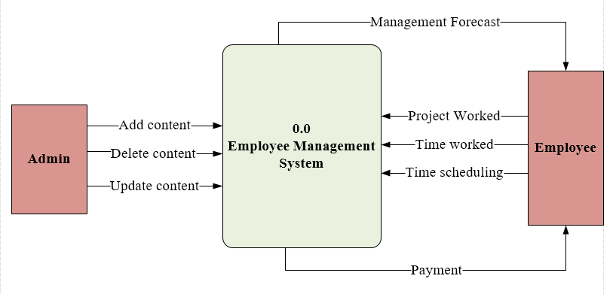

**DFD-Level-0:** 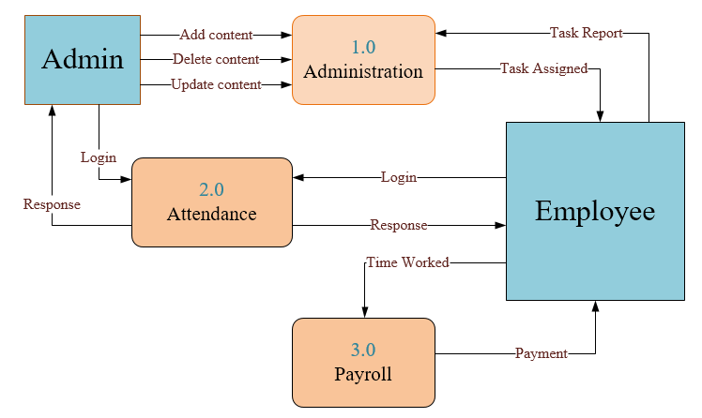

**DFD-Level-1:** 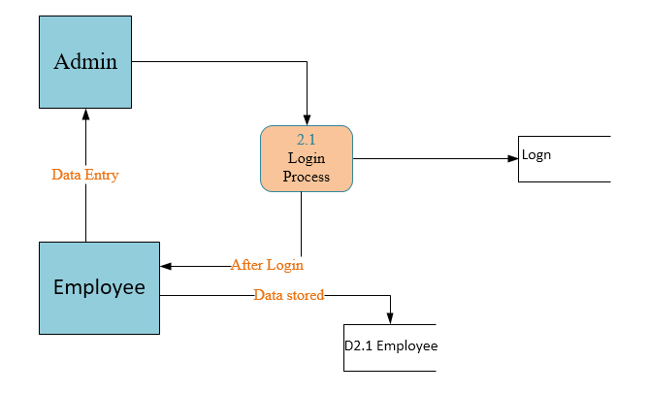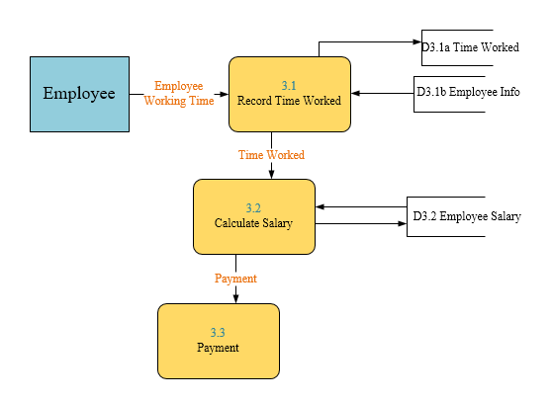

**Process Decomposition:**

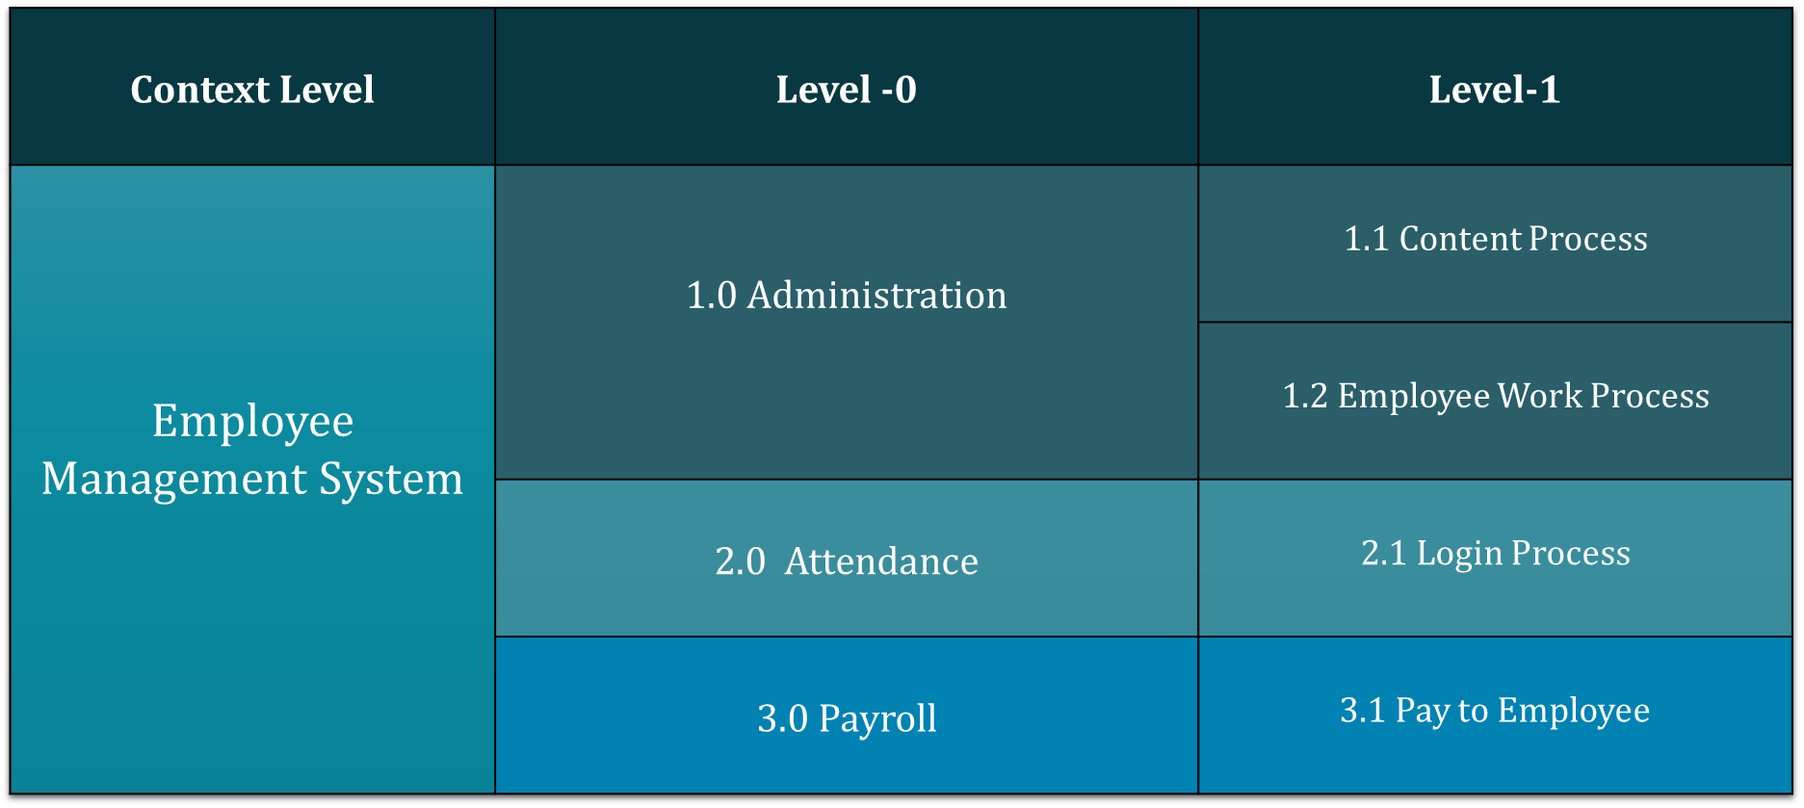

**Decomposition of DFD**

*7*

**Conclusion:**

This concludes the Data Flow Diagram. This report deals with how data are being processed.Itprovides a detailed representation of system components. This also helps to create clear view of usage of this software for different actors for different purposes.