**Program:**

**Exp1.l:**

%{

#include <stdio.h>

#include <stdlib.h>

#include <string.h>

#define MAX_IDENTIFIER_LENGTH 50

typedef struct {

char name[MAX_IDENTIFIER_LENGTH];

} Symbol;

Symbol symbol_table[100];

int symbol_count = 0;

void addtosymboltable(const char* identifier){

if(symbol_count < 100){

strncpy(symbol_table[symbol_count].name, identifier, MAX_IDENTIFIER_LENGTH-1);

symbol_table[symbol_count].name[MAX_IDENTIFIER_LENGTH-1] = '\0';

symbol_count++;

printf("Identifier '%s' is entered in the symbol table\n", identifier);

} else {

printf("Symbol table is full. Cannot add more identifiers.\n");

exit(0);

}

}

%}

%option noyywrap

%option yylineno

%%

[\t]+ ; /* ignore tabs */

\n ; /* ignore newline */

\/\*([^*]|\*+[^*/])*\*+\/ ; /* ignore comments */

[0-9]+ { printf("Constant: %s\n", yytext); }

= { printf("'%s' is an Assignment Operator\n", yytext); }

[\*\+\-] { printf("'%s' is an Operator\n", yytext); }

[a-zA-Z][a-zA-Z0-9]* { printf("Identifier: %s\n", yytext); addtosymboltable(yytext); }

. { printf("Invalid token: %s\n", yytext); }

%%

int main() {

yylex();

return 0;

}

**Output:**

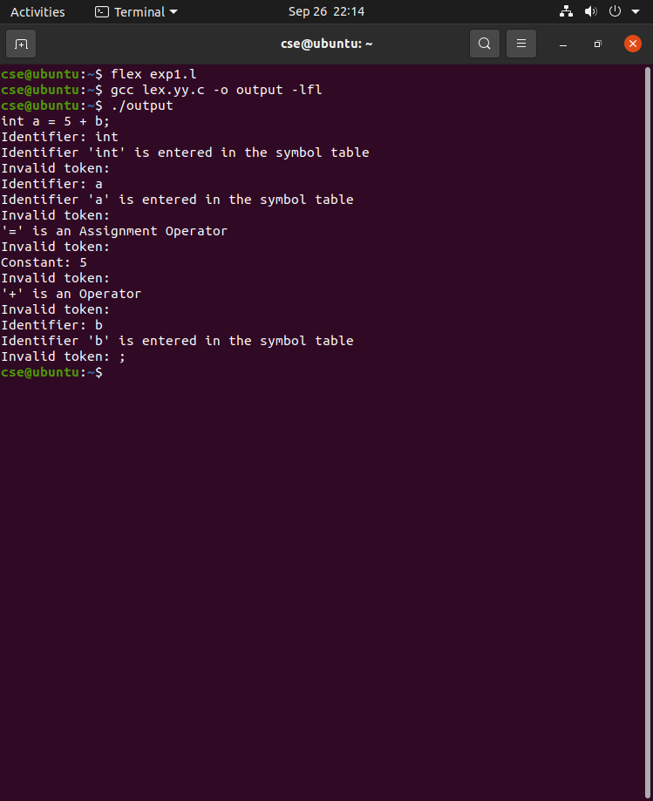

**Program:**

**Exp2.l:**

%{

#include <stdio.h>

#include <string.h>

#include <stdlib.h>

#define MAX_SYMBOLS 100

char* symbol_table[MAX_SYMBOLS];

int symbol_count = 0;

void add_symbol(char* id) {

for (int i = 0; i < symbol_count; i++) {

if (strcmp(symbol_table[i], id) == 0)

return;

}

if (symbol_count < MAX_SYMBOLS)

symbol_table[symbol_count++] = strdup(id);

else

fprintf(stderr, "Symbol table full: %s\n", id);

}

%}

%%

[ \t\n]+ ;

"/*"([^*]*|\*+[^*/])*"*"+"/" ;

"//".* ;

[0-9]+ { printf("Constant: %s\n", yytext); }

[_a-zA-Z][_a-zA-Z0-9]* {

if (

strcmp(yytext, "auto") == 0 ||

strcmp(yytext, "break") == 0 ||

strcmp(yytext, "case") == 0 ||

strcmp(yytext, "char") == 0 ||

strcmp(yytext, "const") == 0 ||

strcmp(yytext, "continue") == 0 ||

strcmp(yytext, "default") == 0 ||

strcmp(yytext, "do") == 0 ||

strcmp(yytext, "double") == 0 ||

strcmp(yytext, "else") == 0 ||

strcmp(yytext, "enum") == 0 ||

strcmp(yytext, "extern") == 0 ||

strcmp(yytext, "float") == 0 ||

strcmp(yytext, "for") == 0 ||

strcmp(yytext, "goto") == 0 ||

strcmp(yytext, "if") == 0 ||

strcmp(yytext, "inline") == 0 ||

strcmp(yytext, "int") == 0 ||

strcmp(yytext, "long") == 0 ||

strcmp(yytext, "register") == 0 ||

strcmp(yytext, "restrict") == 0 ||

strcmp(yytext, "return") == 0 ||

strcmp(yytext, "short") == 0 ||

strcmp(yytext, "signed") == 0 ||

strcmp(yytext, "sizeof") == 0 ||

strcmp(yytext, "static") == 0 ||

strcmp(yytext, "struct") == 0 ||

strcmp(yytext, "switch") == 0 ||

strcmp(yytext, "typedef") == 0 ||

strcmp(yytext, "union") == 0 ||

strcmp(yytext, "unsigned") == 0 ||

strcmp(yytext, "void") == 0 ||

strcmp(yytext, "volatile") == 0 ||

strcmp(yytext, "while") == 0

) {

printf("Keyword: %s\n", yytext);

} else {

printf("Identifier: %s\n", yytext);

add_symbol(yytext);

}

}

"+"|"-"|"*"|"/"|"="|"=="|"<"|">"|"!="|"<="|">=" { printf("Operator: %s\n", yytext); }

"("|")" {printf("Paranthesis");}

. { printf("Unknown character: %s\n", yytext); }

%%

int main() {

printf("Start lexical analysis...\n\n");

yylex();

printf("\nSymbol Table:\n");

for (int i = 0; i < symbol_count; i++)

printf("%s\n", symbol_table[i]);

return 0;

}

Text.txt:

int main() {

printf("Hello, World");

}

**Output:**

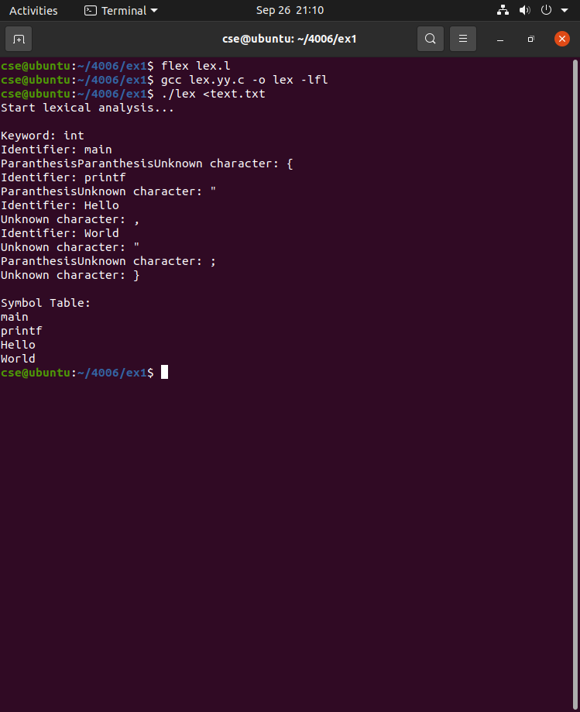

**Program:**

**Ex3a.l**

%{

#include "y.tab.h"

%}

%%

[0-9]+ { return NUMBER; }

[a-zA-Z][a-zA-Z0-9]* { return ID; }

[+\-*/] { return yytext[0]; }

[ \t\n] ; /* ignore spaces and newlines */

. { return yytext[0]; }

%%

int yywrap() { return 1; }

**Ex3a.y**

%{

#include <stdio.h>

#include <stdlib.h>

int yylex();

int yyerror(const char *s);

%}

%token NUMBER ID

%%

expr:

expr '+' expr

| expr '-' expr

| expr '*' expr

| expr '/' expr

| expr '=' expr

| NUMBER

| ID

;

%%

int main() {

printf("Enter expression: ");

if (yyparse() == 0) { // parsing success

printf("Valid!\n");

}

return 0;

}

int yyerror(const char *s) {

printf("Invalid!\n");

exit(1);

}

**Output:**

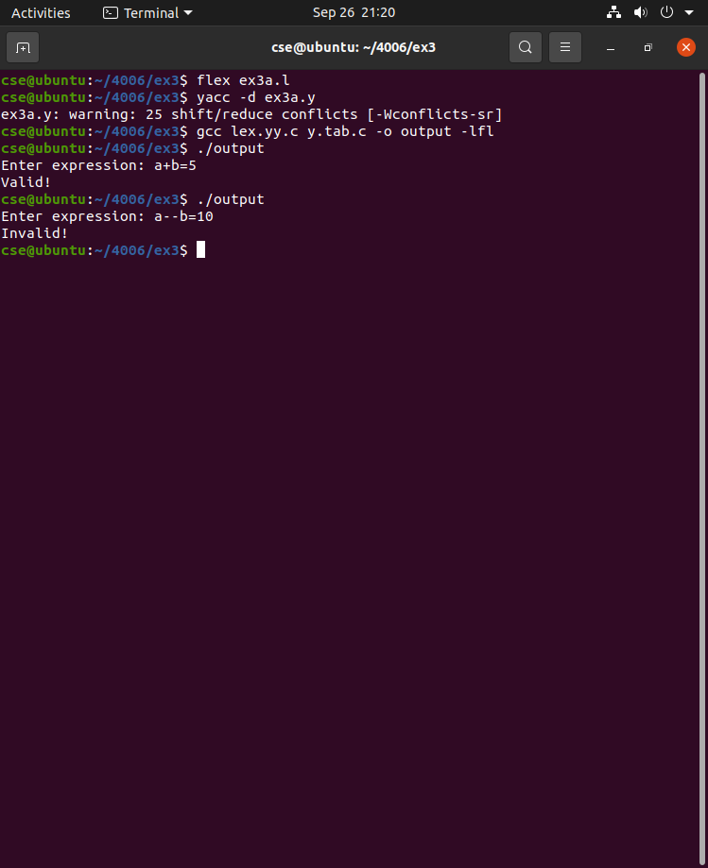

**Program:**

**Ex3b.l:**

%{

#include "y.tab.h"

%}

%%

[a-zA-Z][a-zA-Z0-9]* { return ID; }

\n { return '\n'; }

. { return yytext[0]; }

%%

int yywrap() { return 1; }

**Ex3b.y**

%{

#include <stdio.h>

#include <stdlib.h>

int yylex();

int yyerror(const char *s);

%}

%token ID

%%

line:

ID '\n' { printf("Valid variable!\n"); }

| '\n' { /* ignore empty line */ }

;

%%

int main() {

printf("Enter a variable name: ");

yyparse();

return 0;

}

int yyerror(const char *s) {

printf("Invalid variable!\n");

return 0;

}

**Output:**

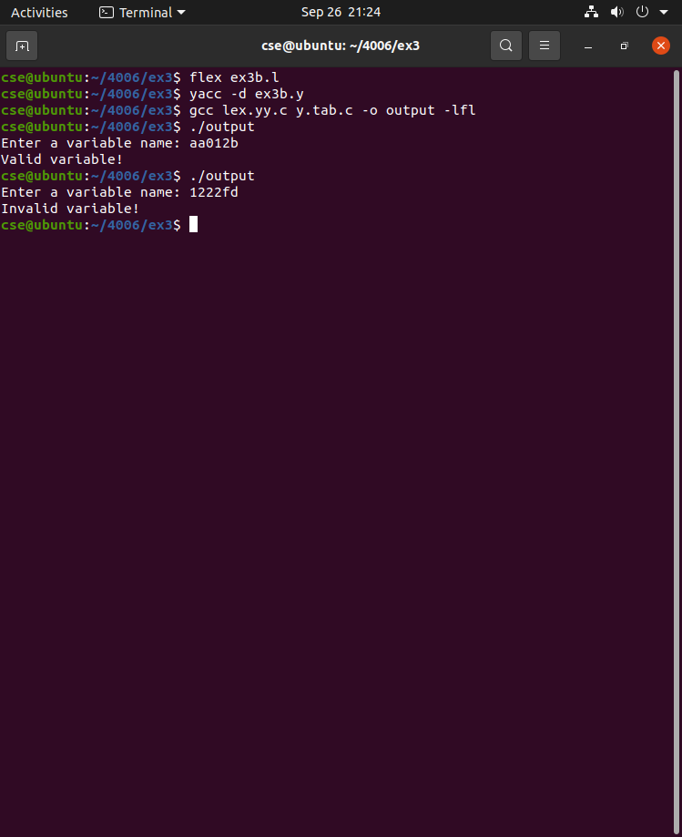

**Program:**

**Exp3c.l:**

%{

#include "y.tab.h"

%}

%%

"for" { return FOR; }

"while" { return WHILE; }

"if" { return IF; }

"else" { return ELSE; }

"switch" { return SWITCH; }

"case" { return CASE; }

"default" { return DEFAULT; }

"(" { return LPAREN; }

")" { return RPAREN; }

"{" { return LBRACE; }

"}" { return RBRACE; }

";" { return SEMICOLON; }

":" { return COLON; }

[a-zA-Z_][a-zA-Z0-9_]* { return ID; }

[0-9]+ { return NUMBER; }

[ \t\n]+ ; /* ignore spaces */

. { return yytext[0]; }

%%

int yywrap() { return 1; }

**Exp3c.y:**

%{

#include <stdio.h>

#include <stdlib.h>

int yylex();

int yyerror(const char *s);

%}

%token FOR WHILE IF ELSE SWITCH CASE DEFAULT

%token ID NUMBER LPAREN RPAREN LBRACE RBRACE SEMICOLON COLON

%%

stmt:

FOR LPAREN ID SEMICOLON ID SEMICOLON ID RPAREN LBRACE RBRACE

{ printf("Valid FOR loop\n"); }

| WHILE LPAREN opt_id RPAREN LBRACE RBRACE

{ printf("Valid WHILE loop\n"); }

| IF LPAREN opt_id RPAREN LBRACE RBRACE

{ printf("Valid IF statement\n"); }

| IF LPAREN opt_id RPAREN LBRACE RBRACE ELSE LBRACE RBRACE

{ printf("Valid IF-ELSE statement\n"); }

| SWITCH LPAREN opt_id RPAREN LBRACE CASE NUMBER COLON DEFAULT COLON RBRACE

{ printf("Valid SWITCH statement\n"); }

;

opt_id:

| ID

;

%%

int main() {

printf("Enter control structure:\n");

yyparse();

return 0;

}

int yyerror(const char *s) {

printf("Invalid syntax!\n");

return 0;

}

**Output:**

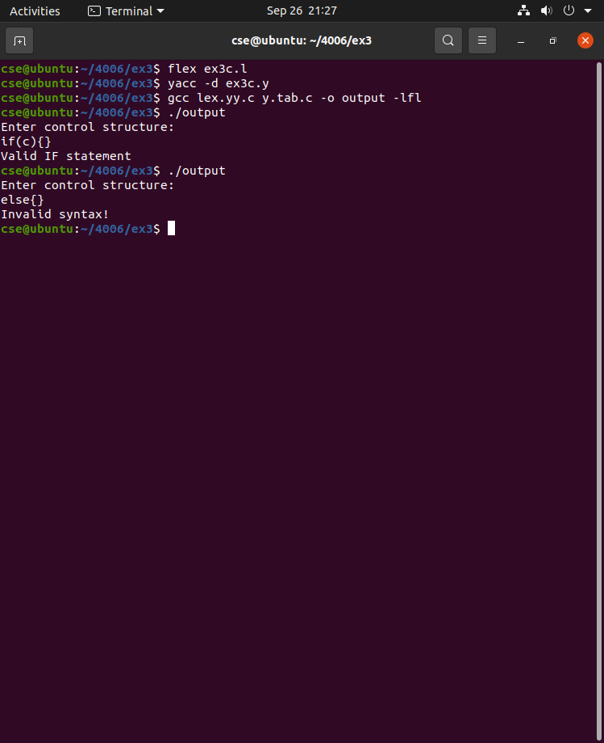

**Program:**

**Exp3d.l:**

%{

#include "y.tab.h"

%}

%%

[0-9]+ { yylval = atoi(yytext); return NUMBER; }

[+\-*/()] { return yytext[0]; }

[ \t] ; /* ignore spaces */

\n { return '\n'; }

. { return yytext[0]; }

%%

int yywrap() { return 1; }

**Exp3d.y:**

%{

#include <stdio.h>

#include <stdlib.h>

int yylex();

int yyerror(const char *s);

%}

%token NUMBER

%%

input:

/* empty */

| input expr '\n' { printf("Result = %d\n", $2); }

;

expr:

expr '+' expr { $$ = $1 + $3; }

| expr '-' expr { $$ = $1 - $3; }

| expr '*' expr { $$ = $1 * $3; }

| expr '/' expr { $$ = $1 / $3; }

| '(' expr ')' { $$ = $2; }

| NUMBER { $$ = $1; }

;

%%

int main() {

printf("Enter expression: ");

yyparse();

return 0;

}

int yyerror(const char *s) {

printf("Invalid expression!\n");

return 0;

}

**Output:**

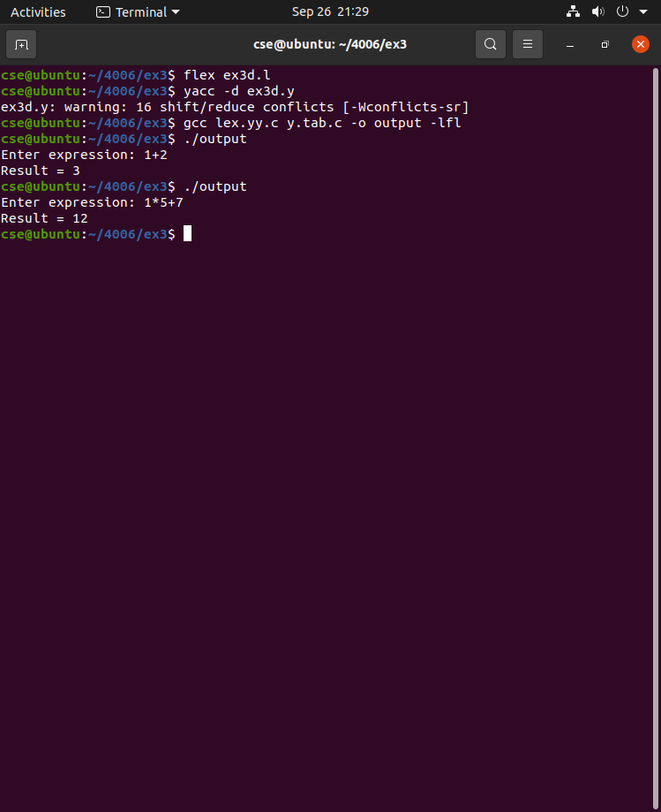

**Program:**

**Exp4.l:**

%{

#include "y.tab.h"

#include <stdlib.h>

%}

%%

[0-9]+ { yylval.ival = atoi(yytext); return NUMBER; }

[a-zA-Z][a-zA-Z0-9]* { yylval.sval = strdup(yytext); return ID; }

"=" { return '='; }

"+" { return '+'; }

"*" { return '*'; }

";" { return ';'; }

[ \t\n] ; // ignore spaces

. { return yytext[0]; }

%%

int yywrap(){

return 1;

}

**Exp4.y:**

%{

#include <stdio.h>

#include <stdlib.h>

#include <string.h>

int tempCount = 0;

char* newTemp() {

static char buf[32];

sprintf(buf, "t%d", tempCount++);

return strdup(buf);

}

extern char* yytext;

int yylex(void);

int yyerror(const char *s);

%}

%union {

int ival;

char* sval;

}

%token <ival> NUMBER

%token <sval> ID

%type <sval> expr term factor

%left '+'

%left '*'

%%

stmt: ID '=' expr ';' {

printf("%s = %s\n", $1, $3);

}

;

expr: expr '+' term {

char* t = newTemp();

printf("%s = %s + %s\n", t, $1, $3);

$$ = t;

}

| term { $$ = $1; }

;

term: term '*' factor {

char* t = newTemp();

printf("%s = %s * %s\n", t, $1, $3);

$$ = t;

}

| factor { $$ = $1; }

;

factor: ID { $$ = $1; }

| NUMBER {

char buf[20];

sprintf(buf, "%d", $1);

$$ = strdup(buf);

}

;

%%

int main() {

return yyparse();

}

int yyerror(const char *s) {

printf("Error: %s\n", s);

return 0;

}

**Output:**

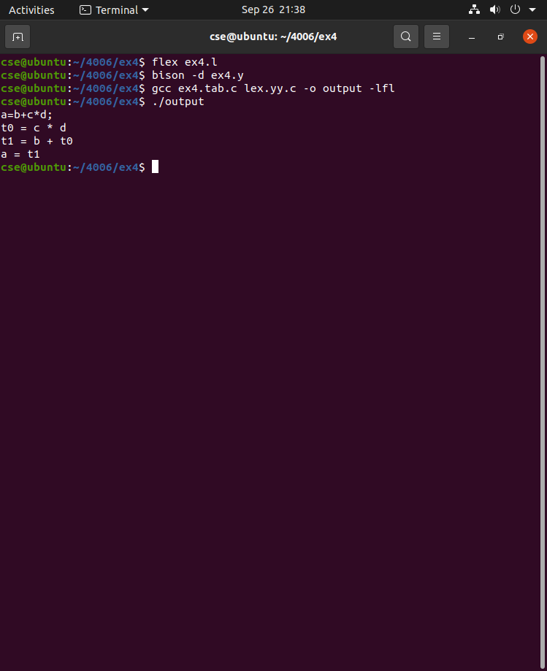

**Program:**

**Exp5.l:**

%{

#include "y.tab.h"

#include <stdlib.h>

%}

%%

int { return INT; }

[a-zA-Z][a-zA-Z0-9]* { yylval.sval = strdup(yytext); return ID; }

[0-9]+ { yylval.sval = strdup(yytext); return NUMBER; }

"=" { return '='; }

";" { return ';'; }

[ \t\n] ; // ignore whitespace

. { return yytext[0]; }

%%

int yywrap() { return 1; }

**Exp5.y:**

%{

#include <stdio.h>

#include <stdlib.h>

#include <string.h>

typedef struct {

char* name;

char* type;

} sym;

sym table[100];

int table_index = 0;

void insert(char* name, char* type) {

table[table_index].name = strdup(name);

table[table_index].type = strdup(type);

table_index++;

}

char* lookup(char* name) {

for(int i=0;i<table_index;i++)

if(strcmp(table[i].name,name)==0) return table[i].type;

return NULL;

}

extern char* yytext;

int yylex(void);

int yyerror(const char *s) { printf("Error: %s\n", s); return 0; }

%}

%union { char* sval; }

%token <sval> ID NUMBER

%token INT

%type <sval> expr

%%

program: declarations statements ;

declarations:

| declarations decl

;

decl: INT ID ';' {

insert($2,"int");

}

;

statements:

| statements stmt

;

stmt: ID '=' expr ';' {

char* t = lookup($1);

if(t==NULL) printf("Error: %s not declared\n",$1);

else if(strcmp(t,$3)!=0) printf("Type Error: %s and %s mismatch\n",$1,$3);

}

;

expr: NUMBER { $$ = "int"; }

| ID {

char* t = lookup($1);

if(t==NULL) { printf("Error: %s not declared\n",$1); $$ = "int"; }

else $$ = t;

}

;

%%

int main() { return yyparse(); }

**Output:**

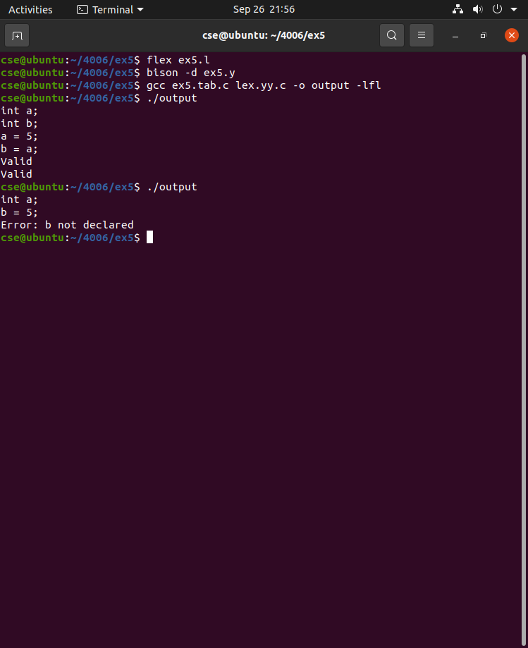

**Program:**

**Exp7.c:**

#include <stdio.h>

#include <string.h>

int main() {

FILE *tacFile;

char line[100], op[10], arg1[10], arg2[10], result[10];

// Open TAC input file

tacFile = fopen("tac.txt", "r");

if (tacFile == NULL) {

printf("Error: Cannot open TAC file\n");

return 1;

}

printf("; 8086 Assembly code generated from TAC\n");

printf("MOV AX, 0\n"); // initialize AX

// Read TAC line by line

while (fgets(line, sizeof(line), tacFile) != NULL) {

if (sscanf(line, "%s = %s + %s", result, arg1, arg2) == 3) {

printf("MOV AX, %s\n", arg1);

printf("ADD AX, %s\n", arg2);

printf("MOV %s, AX\n", result);

} else if (sscanf(line, "%s = %s - %s", result, arg1, arg2) == 3) {

printf("MOV AX, %s\n", arg1);

printf("SUB AX, %s\n", arg2);

printf("MOV %s, AX\n", result);

} else if (sscanf(line, "%s = %s * %s", result, arg1, arg2) == 3) {

printf("MOV AX, %s\n", arg1);

printf("MUL %s\n", arg2);

printf("MOV %s, AX\n", result);

} else if (sscanf(line, "%s = %s / %s", result, arg1, arg2) == 3) {

printf("MOV AX, %s\n", arg1);

printf("DIV %s\n", arg2);

printf("MOV %s, AX\n", result);

} else if (sscanf(line, "%s = %s", result, arg1) == 2) {

printf("MOV %s, %s\n", result, arg1);

}

}

fclose(tacFile);

return 0;

}

**Tac.txt:**

t1 = a + b

t2 = t1 * c

d = t2

**Output:**

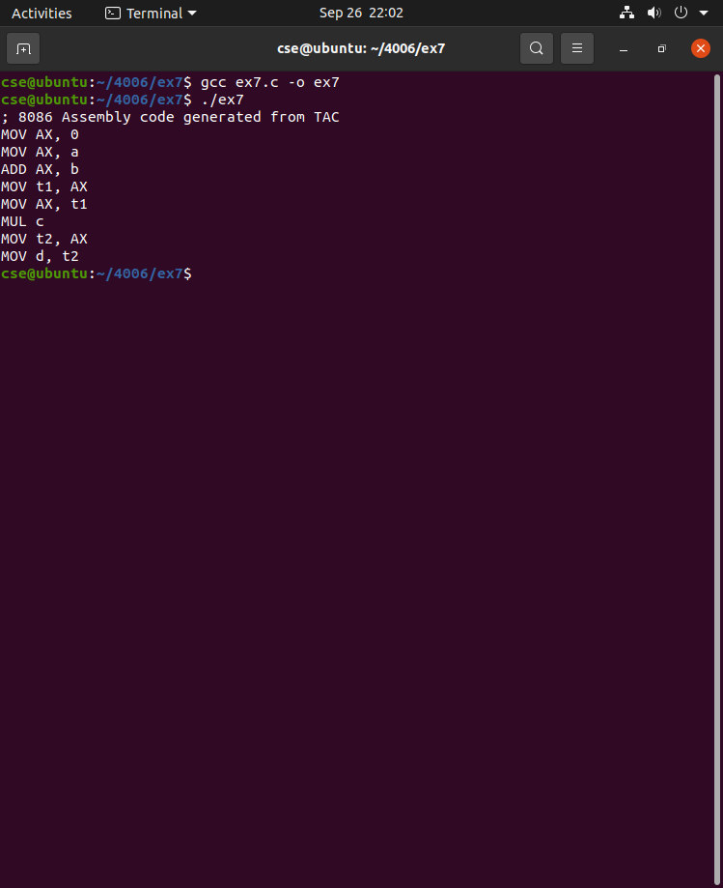

**Program:**

#include <stdio.h>

#include <string.h>

struct op {

char l;

char r[20];

} op[10], pr[10];

int main() {

int a, i, k, j, n, z = 0, m, q;

char *p, *l;

char temp, t;

char *tem;

printf("Enter the Number of Values: ");

scanf("%d", &n);

for(i = 0; i < n; i++) {

printf("left: ");

scanf(" %c", &op[i].l);

printf("right: ");

scanf("%s", op[i].r);

}

printf("\nIntermediate Code:\n");

for(i = 0; i < n; i++) {

printf("%c = %s\n", op[i].l, op[i].r);

}

// Dead Code Elimination

for(i = 0; i < n-1; i++) {

temp = op[i].l;

for(j = 0; j < n; j++) {

p = strchr(op[j].r, temp);

if(p) {

pr[z].l = op[i].l;

strcpy(pr[z].r, op[i].r);

z++;

}

}

}

pr[z].l = op[n-1].l;

strcpy(pr[z].r, op[n-1].r);

z++;

printf("\nAfter Dead Code Elimination:\n");

for(k = 0; k < z; k++) {

printf("%c = %s\n", pr[k].l, pr[k].r);

}

// Common Subexpression Elimination

for(m = 0; m < z; m++) {

tem = pr[m].r;

for(j = m+1; j < z; j++) {

p = strstr(tem, pr[j].r);

if(p) {

t = pr[j].l;

pr[j].l = pr[m].l;

for(i = 0; i < z; i++) {

l = strchr(pr[i].r, t);

if(l) {

a = l - pr[i].r;

pr[i].r[a] = pr[m].l;

}

}

}

}

}

printf("\nAfter Common Subexpression Elimination:\n");

for(i = 0; i < z; i++) {

printf("%c = %s\n", pr[i].l, pr[i].r);

}

// Remove duplicate expressions (simple version)

for(i = 0; i < z; i++) {

for(j = i+1; j < z; j++) {

q = strcmp(pr[i].r, pr[j].r);

if((pr[i].l == pr[j].l) && !q) {

pr[i].l = '\0';

}

}

}

printf("\nOptimized Code:\n");

for(i = 0; i < z; i++) {

if(pr[i].l != '\0') {

printf("%c = %s\n", pr[i].l, pr[i].r);

}

}

return 0;

}

**Output:**

