Chad Sebesta

Mechatronics 90

Term project, MECHANIMATION

I have a great love for animation and technology. The stories told can be emotionally stirring, and the technologies behind them are fascinating. Disneyland is a favorite place and a great example of technology and animation coming together to produce captivating experiences. For my term project I wish to combine the technical aspects of mechatronics with the magic of animation.

Animatronics technology has progressed much within the last century. From simple automata to complex figures like Abraham Lincoln, this field has rapidly progressed. The advent of robotics has accelerated it even further to create amazing machines imbued with the illusion of life. A unique aspect of this field is that it has developed somewhat independently of the field of animation. The toolsets used to animate an animatronic character and virtual ones are often strikingly different. This gap can be bridged by pairing the modeling and animation capabilities of common software with an external microcontroller. Regardless of whether a character appears on screen or in a theme park, the tools to animate them can be the same.

My proposed project demonstrates computer control of servos with modern animation software. I will utilize Blender, a free and open-source animation program, to model and animate my servos. A Python program will fetch the positional data of these models and send them to a PICAXE microcontroller. The microcontroller will convert this data into pulses which will adjust the position of the real servos.

The Python code I am creating captures the positional data of virtual models on a given frame. In animation, a frame is essentially a snapshot of an objects attributes at a given point in time. This snapshot includes information such as location, rotation, and scale. The code written works by taking the rotational state of the objects within the animation software, and sending selective pieces of this information to the PICAXE. To allow the PICAXE to respond quickly to this information, most of the intensive processing happens within this program.

The PICAXE chip itself possesses a significant hardware limitation to the purposes of this project. Because the serial in and servo commands share the same timer, the servo positioning must be off for a small amount of time while the device receives new data. This can be overcome by using two chips, but requires one of these be an X2 part. A more practical solution for the purposes of this project is to limit the number of servos being used and use PULSOUT commands within a structured loop instead of various servo commands. This mitigates both interference between the two commands and increases smoothness. In this instance a microcontroller without these limitations may be more practically appropriate. However, the time and resources required to learn the nuances of another microcontroller outweigh the benefits.

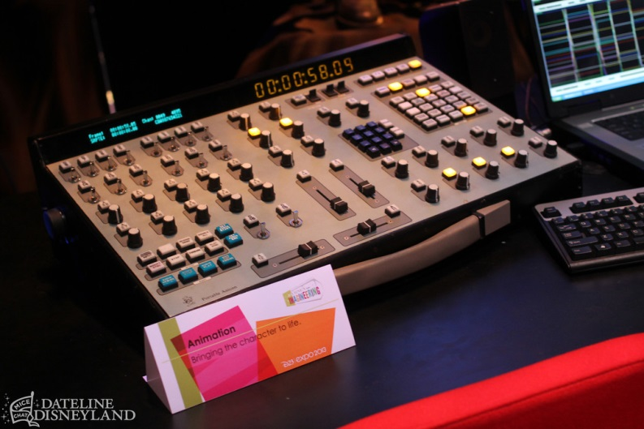Control boards, like this one, are used to program complex audio-animatronics.

<http://disneyandmore.blogspot.com/2013/08/d23-expo-parks-and-resorts-pavilion_11.html>

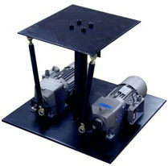A simple two servo motion platform, like this one designed by Servo and Simulation Inc. could be a practical controlled device.

<http://servos.com/iWeb%20Site%20-%20Backup/Motion_Bases/Two_Axis_Seat.html>

<https://www.youtube.com/watch?v=WAuB96riySE&list=PLBD0575903B9ADBA7>



Convincing animation relies on simple principles pioneered by such as Frank Thomas and Ollie Johnston. These principles can be difficult to express given simplistic control schemes.

<http://www.fastcodesign.com/3030106/disneys-12-principles-of-animation-in-a-cartoon>

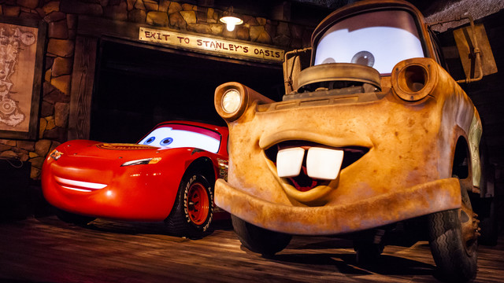The animatronics of Radiator Springs Racers are among the most convincing and impressive such examples yet devised.

<https://www.youtube.com/watch?v=UAKIcJibhy8>