MANAGEMENT OVERVIEW
Assessment Date Manager
A screen-by-screen guide to the application

About this document
This document provides a screen-by-screen overview of the Assessment Date Manager application. Each screen is shown with a screenshot, a description of its purpose, who uses it, and its key features.

The app is a web-based tool hosted on Microsoft SharePoint. Teachers log in with their existing school Microsoft 365 accounts — no additional software, new passwords, or separate logins are required.

What problem does this solve?
Assessment scheduling is currently managed through spreadsheets, emails, and informal agreements. This leads to class groups being overloaded with multiple assessments on the same day, students receiving insufficient notice to prepare, and management having no visibility over the school-wide calendar. The Assessment Date Manager centralises this process with automatic rule enforcement, a shared real-time calendar, and a formal teacher confirmation workflow.

Key features
- Grade-scoped, term-limited calendar — each grade has its own calendar for the current term only, giving every teacher full situational awareness before booking
- Automatic rule enforcement — prevents more than 2 assessments per class per day and blocks bookings during formal exam periods
- Study requirement tracking — assessments marked Requires Study or No Study Required; formal assessments automatically locked
- Teacher confirmation workflow — teachers confirm their schedule grade by grade; confirmed assessments are locked; Management sees who has and has not confirmed
- Management controls — rules, dropdown values, term windows, and public holidays maintained through the app without developer involvement
- End-of-term archiving — guided workflow exports assessment data to Excel and clears lists for the new term
- Student assessment report — printable PDF grouped by subject and class for distribution to students
- Microsoft 365 integration — uses existing school accounts, hosted on SharePoint, no new infrastructure required

Three access levels
Role | Who | What they can do
Teacher | All teaching staff | View grade calendar, book assessments for own classes, confirm their schedule, manage own bookings, complete their profile
Admin | HODs, coordinators, deputies | Everything teachers can do, plus manage formal exam periods, view all assessments across all teachers, override rule violations
Management | Principal, deputy principal, bursar | Everything admins can do, plus Policy Manager, Reference Data Manager, School Calendar Manager, Term Archive Manager, and Confirmation Report

Screen-by-screen walkthrough

1. Mock Login
Who uses this: Developers during local testing before Azure is configured

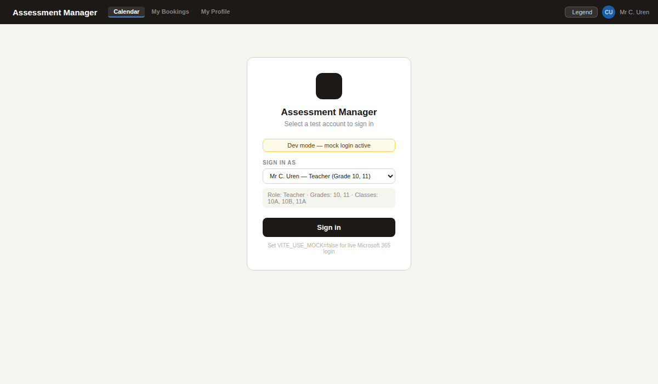
During development the app runs in mock mode with no Azure connection required. A dropdown selects any test user to verify all role-based screens without Microsoft 365 credentials.
- Six test users cover all roles: three teachers with different grade combinations, one new teacher with incomplete profile, one Admin (HOD), one Management (Principal)
- The amber dev-mode banner ensures no one mistakes the mock login for production
- Switching to live login requires one change: set VITE_USE_MOCK=false in the .env file

2. Teacher Profile Setup
Who uses this: All Teachers — completed on first login before accessing the calendar

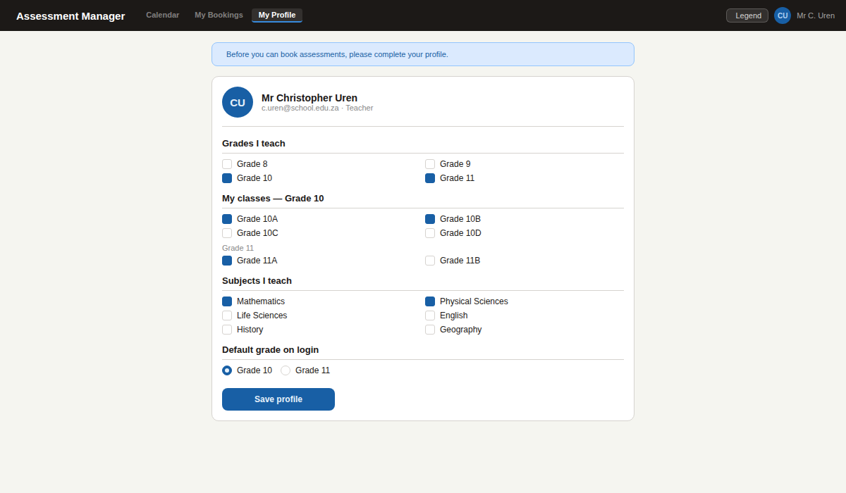
New teachers are automatically redirected here before accessing the calendar. They select the grades they teach, their specific class groups, and their subjects. This scopes the booking form so teachers only see their own classes and subjects.
- Teachers who teach multiple grades select a default grade which opens first on every login
- Profile can be updated at any time via My Profile in the navigation bar
- Profile data is stored in SharePoint — no separate account or password required

3. Calendar View
Who uses this: All Teachers, Admins, and Management

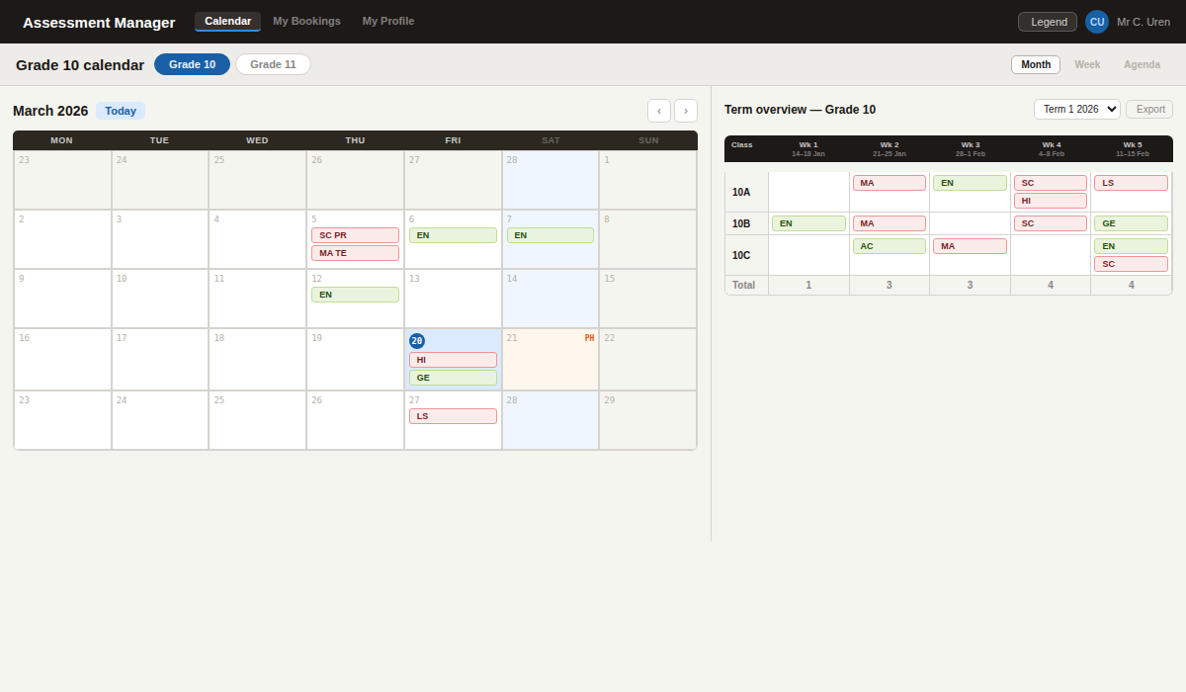
The main screen uses a split layout. The left panel shows the grade-scoped monthly calendar — every assessment for every class in the selected grade is visible. The calendar is limited to the current term only — navigation arrows are disabled at the term boundaries.
- Red badge with book icon means the assessment requires study. Green badge means no study required
- The month label shows the term name e.g. "March 2026 — Term 1" so teachers always know which term they are viewing
- A green banner below the grade switcher shows when a grade has been confirmed by the teacher
- Date colours: blue = today | peach = public holiday | rose = formal exam period | grey = outside term

4. Term Assessment Grid
Who uses this: All Teachers, Admins, and Management

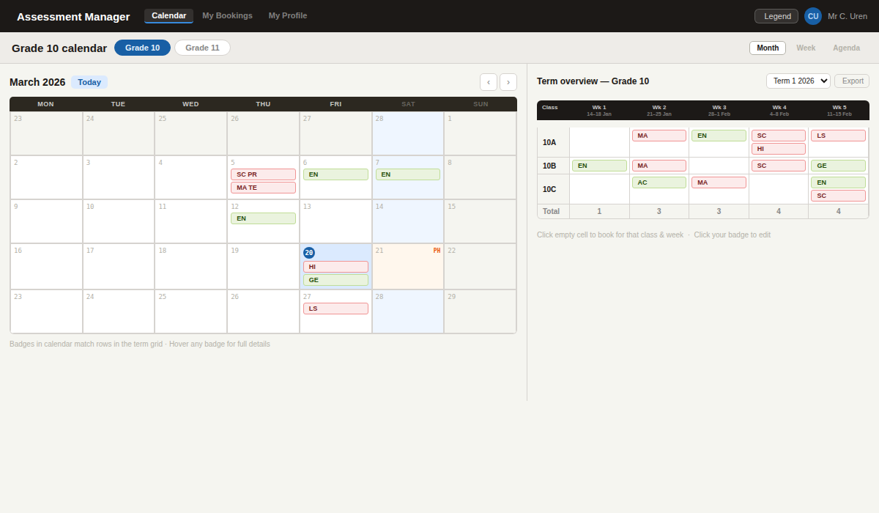
The right panel permanently shows the full term grid for the selected grade. Rows are class groups and columns are weeks of the current term. This gives every teacher a week-by-week overview of the assessment load before booking.
- Totals row at the bottom shows assessment count per week — useful for spotting overloaded weeks
- Current week column is highlighted with a subtle cobalt border
- Clicking an empty cell pre-fills the booking form with the class group and week
- Export button downloads the entire grid as Excel for HOD or management review

5. Booking Form
Who uses this: Teachers (own classes only) | Admins and Management (all classes)

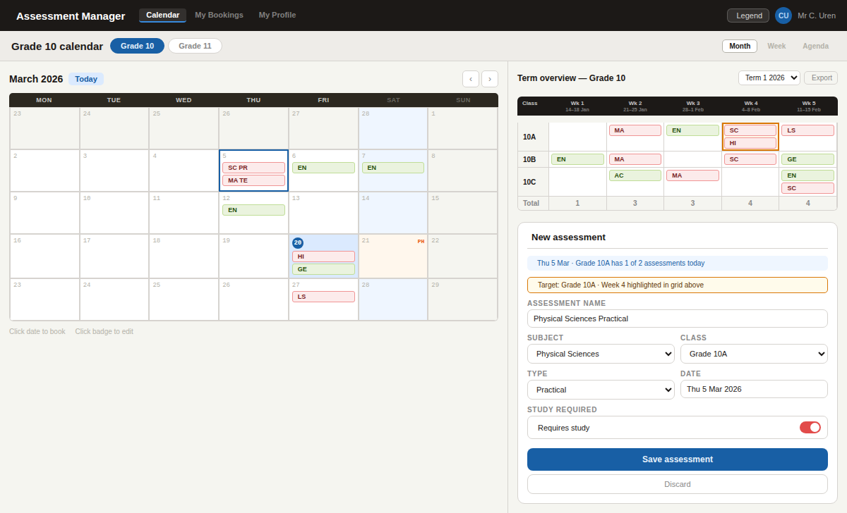
Clicking any available date or empty grid cell opens the booking form. The form is scoped to the teachers own subjects and classes. As the class and date are filled in, the target grid cell highlights in amber — a live preview before saving.
- The daily limit counter shows how many assessments that class already has on the selected day
- Study Required defaults to ON (requires study) and can be toggled off for assignments or projects requiring no preparation
- Notes field supports up to 300 characters with a live counter that turns amber at 250 and red approaching 300
- Confirmed assessments are locked — the booking form shows a banner and the save button is disabled

6. Conflict Warning
Who uses this: All Teachers — blocked | Admins and Management — can override

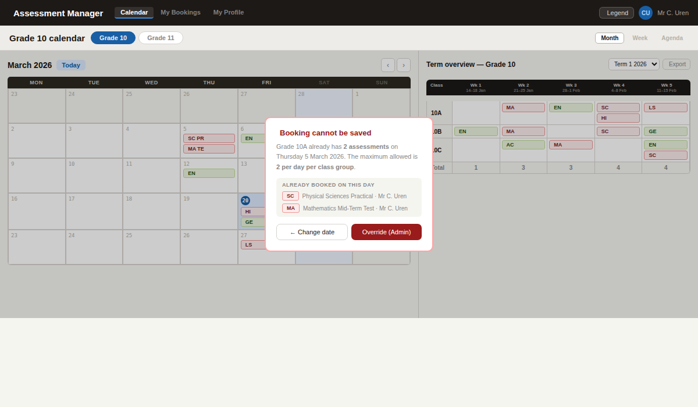
If a teacher tries to book a third assessment for the same class on a day that already has two, the system blocks the save and names the conflicting assessments.
- The daily limit (default: 2 per class per day) is configurable by Management in the Policy Manager
- Admins and Management can override rule violations — the override is recorded in the audit log
- The Change Date button returns the teacher to the booking form for easy correction

7. Formal Assessment Date Selected
Who uses this: All Teachers — blocked | Admins and Management — can add formal periods

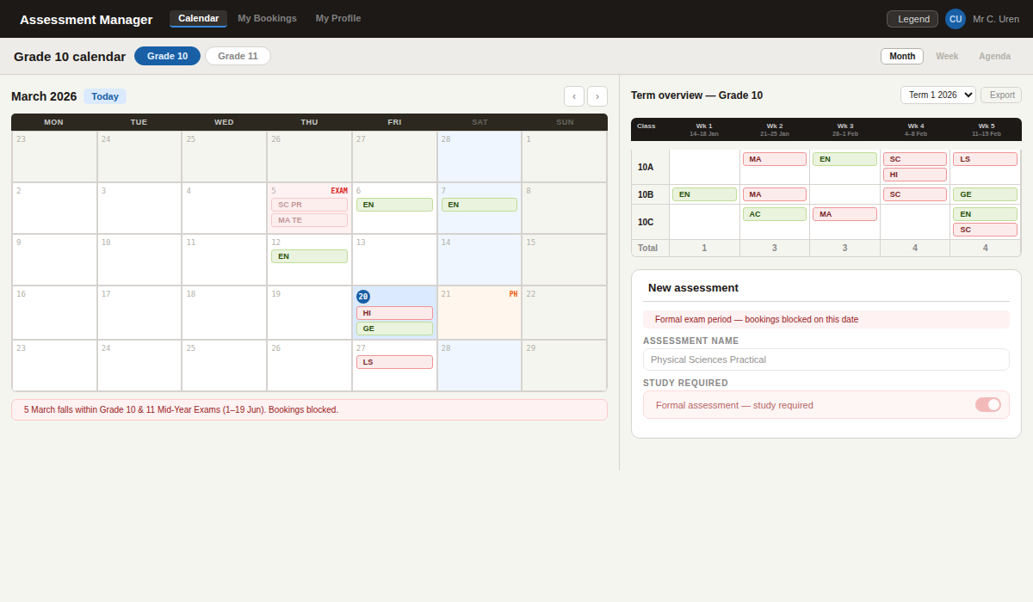
When a teacher selects a date within a formal exam period, the calendar cell turns rose with an EXAM label and the booking is blocked. The Study Required toggle is automatically locked to Requires Study.
- The Study Required lock ensures students are always notified to prepare during exam periods
- Formal periods are entered by Admins and Management via the Formal Dates Manager
- The scope of the block is configurable in the Policy Manager

8. Legend Flyout
Who uses this: All users — accessible from the Legend button in the navigation bar

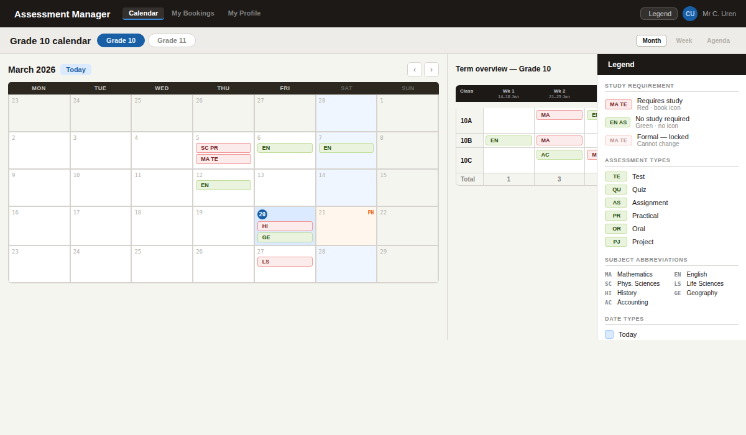
The Legend button in the navigation bar slides in a reference panel from the right explaining all badge types, assessment type icons, subject abbreviations, and date colour codes.
- Study requirement: red + book icon = requires study | green = no study | faded + lock = formal locked
- Assessment types: Pencil = Test | Bolt = Quiz | Clip = Assignment | Microscope = Practical | Mic = Oral | Ruler = Project
- Close by clicking the X or clicking the dimmed background

9. Confirm Schedule — Teacher View
Who uses this: All Teachers — own grades only

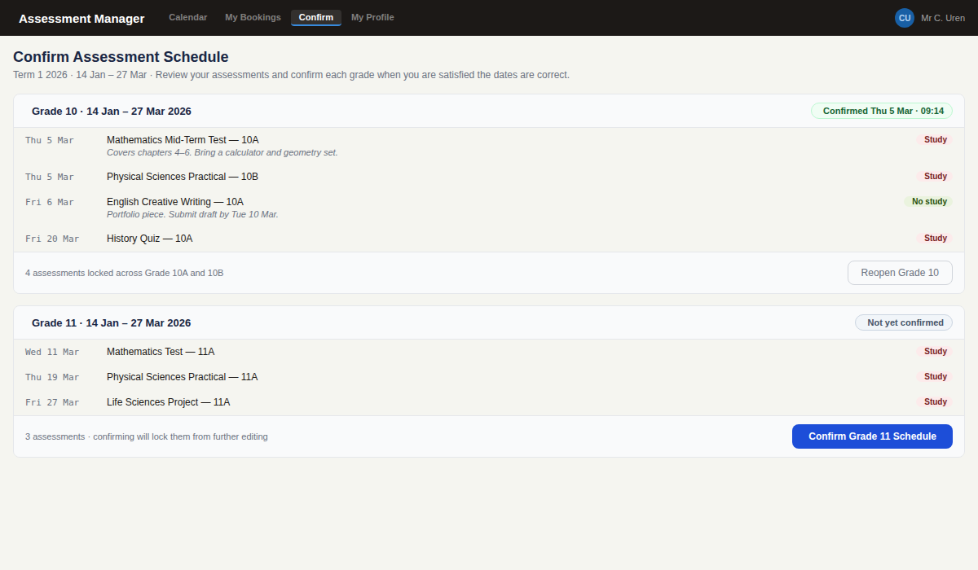
The Confirm Schedule screen lets each teacher review and confirm their assessment schedule grade by grade. Once confirmed, all their assessments for that grade are locked from editing until they choose to reopen.
- Each grade shows a read-only list of all the teacher's Scheduled assessments with dates, types, and study requirement
- A teacher confirms per grade — one confirmation action per grade per term
- Once confirmed, a green badge shows on the Calendar View for that grade: "Grade 10 schedule confirmed"
- Reopening unlocks all assessments and resets the confirmation — Management can see this in the report

10. Confirm Schedule — Stale State
Who uses this: All Teachers — when schedule changes after confirmation

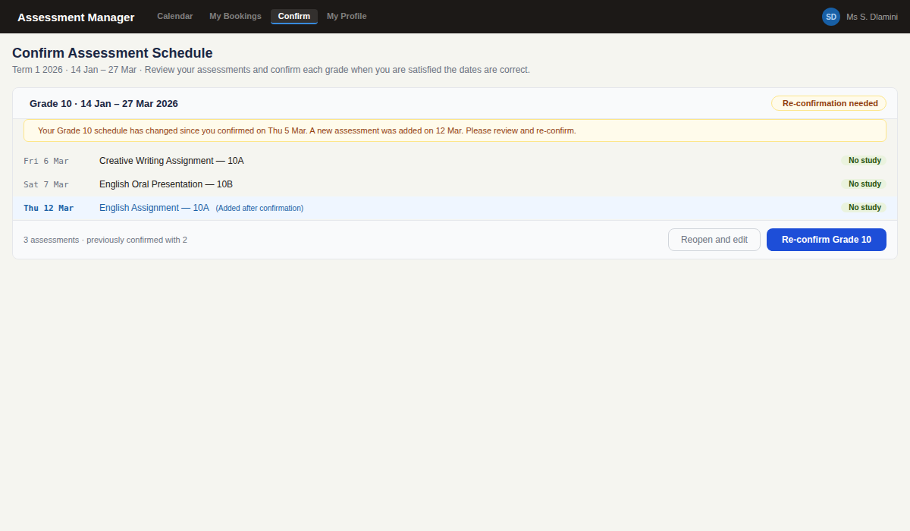
If a new assessment is booked for a grade the teacher has already confirmed, the confirmation is marked stale. An amber banner prompts the teacher to review the change and re-confirm. Newly added assessments are highlighted in blue to make the change obvious.
- IsStale is set automatically whenever an assessment is added, edited, or cancelled for a confirmed grade
- Management can see stale confirmations in the Confirmation Report — these appear in a separate "Stale" section
- The teacher can either re-confirm directly (locking the new state) or reopen to make further edits first

11. Confirmation Report
Who uses this: Management Team only

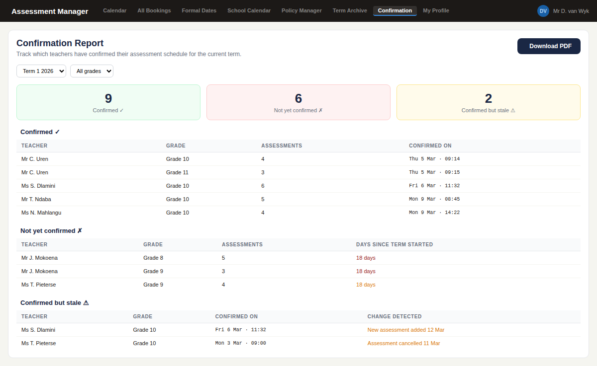
The Confirmation Report gives Management a real-time overview of which teachers have confirmed their schedule for the current term. A Download PDF button produces a formatted report for records or distribution.
- Three summary cards show the count of confirmed, not-yet-confirmed, and stale teachers at a glance
- Section 1 (Confirmed): teacher name, grade, assessment count, and exact confirmation timestamp
- Section 2 (Not yet confirmed): teacher name, grade, assessment count, and how many days since the term started
- Section 3 (Stale): confirmed teachers whose schedule has changed — shows what changed and when
- PDF filename: Confirmation_Report_Term1_2026.pdf

12. Policy Manager
Who uses this: Management Team only

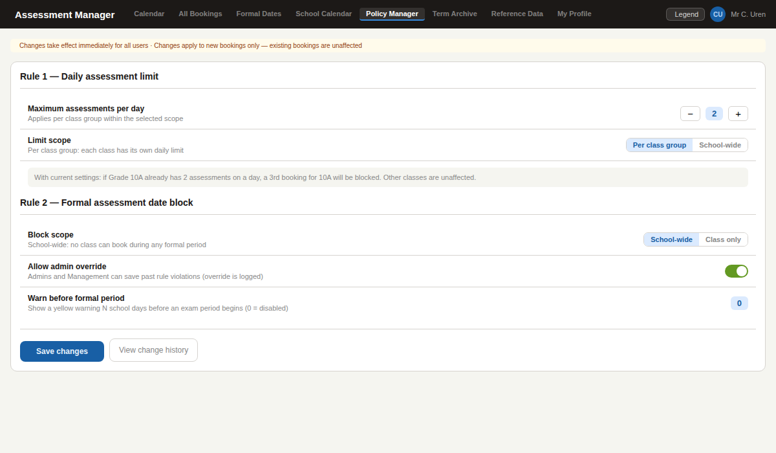
The Policy Manager allows Management to edit the two core booking rules in real time without developer involvement. Rule 1 controls the maximum assessments per class per day. Rule 2 controls whether formal exam periods block all bookings school-wide or only the affected class.
- Changes take effect immediately for all users — no restart or redeployment needed
- All changes are logged with the editor's name, previous value, and new value
- Admin override can be toggled off so no one — including Management — can bypass any rule

13. Reference Data Manager
Who uses this: Management Team only

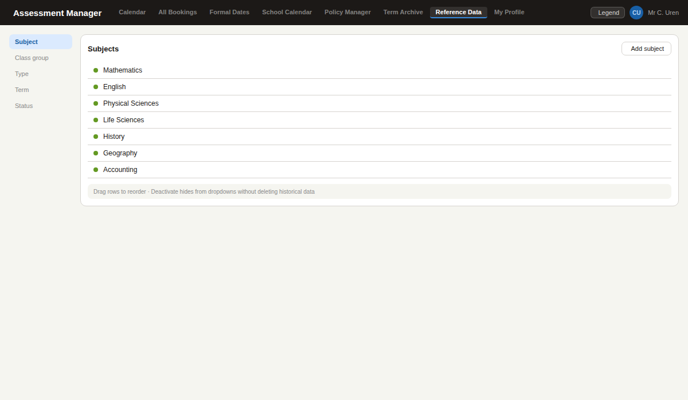
All dropdown values throughout the app — subjects, class groups, assessment types, terms, and statuses — are managed here. Management can add new values, reorder them, and deactivate old ones without affecting historical records.
- Adding a new subject or class group immediately makes it available in the booking form
- Drag-to-reorder controls the order values appear in dropdowns throughout the app
- All changes are logged in the audit trail — deactivation is fully reversible

14. School Calendar Manager
Who uses this: Management Team only

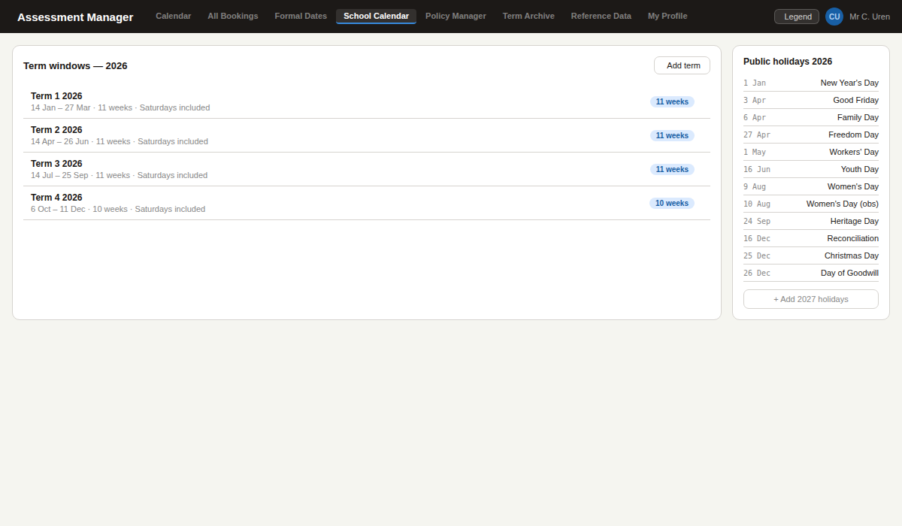
Management defines the school term date windows here. The app uses these to determine which dates are bookable — the calendar is limited to the current term only, consistent with the term-by-term archive workflow.
- Adding a term window makes all weekdays and Saturdays in that range bookable
- Dates outside all defined term windows are greyed out and cannot be selected
- South African public holidays for 2025 and 2026 are pre-loaded and can be extended

15. Formal Dates Manager
Who uses this: Admins and Management

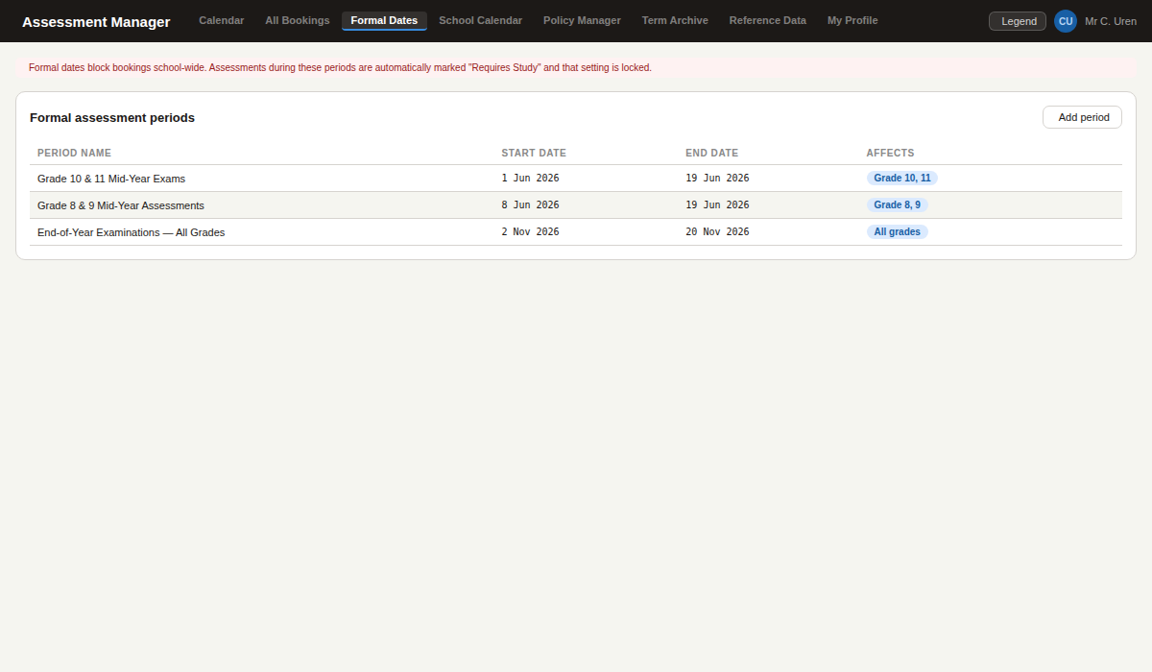
Admins and Management enter the school's formal assessment periods here. These are colour-coded red on the calendar and automatically lock Study Required to Requires Study for any assessment within the period.
- Each period has a name, start date, end date, and optional grade filter
- Periods can be edited or deleted at any time
- Block scope (school-wide or class-only) is controlled in the Policy Manager

16. Term Archive Manager
Who uses this: Management Team only

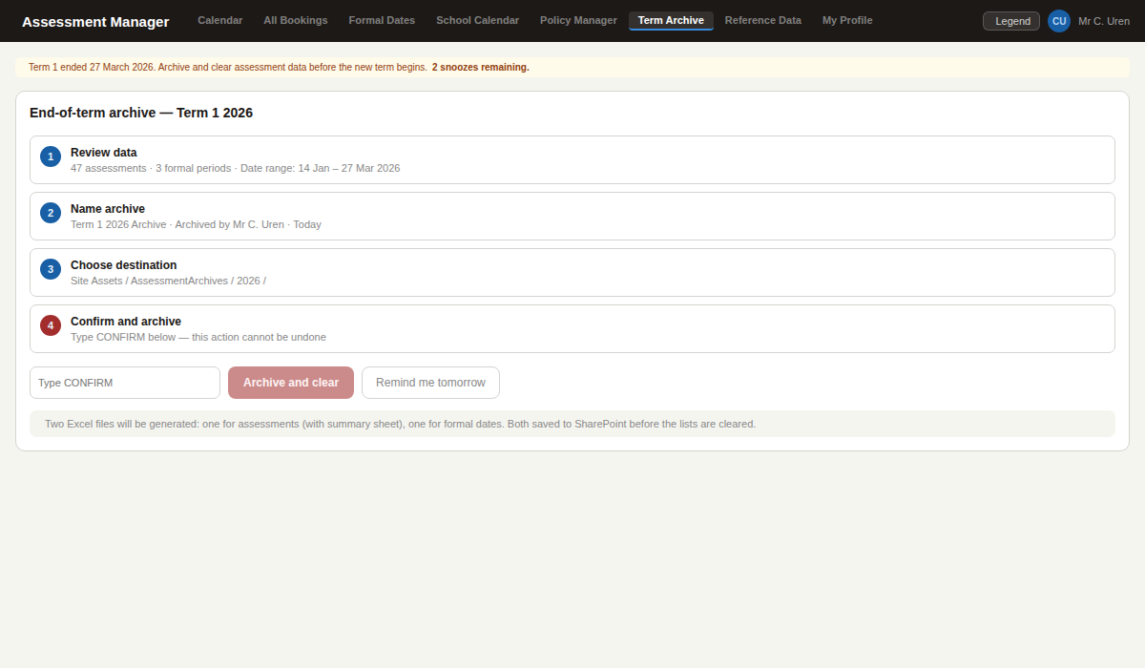
At the end of each term, Management is prompted to archive and clear the assessment data. The process exports two Excel files to SharePoint then clears both lists. A CONFIRM text gate prevents accidental execution.
- The amber banner appears automatically when a term ends and archive has not been completed
- Lists are ONLY cleared after the file upload is confirmed successful — data is always protected
- All archive operations are permanently logged with user name, timestamp, and file paths

17. Assessment List View
Who uses this: Teachers (own assessments) | Admins and Management (all assessments)

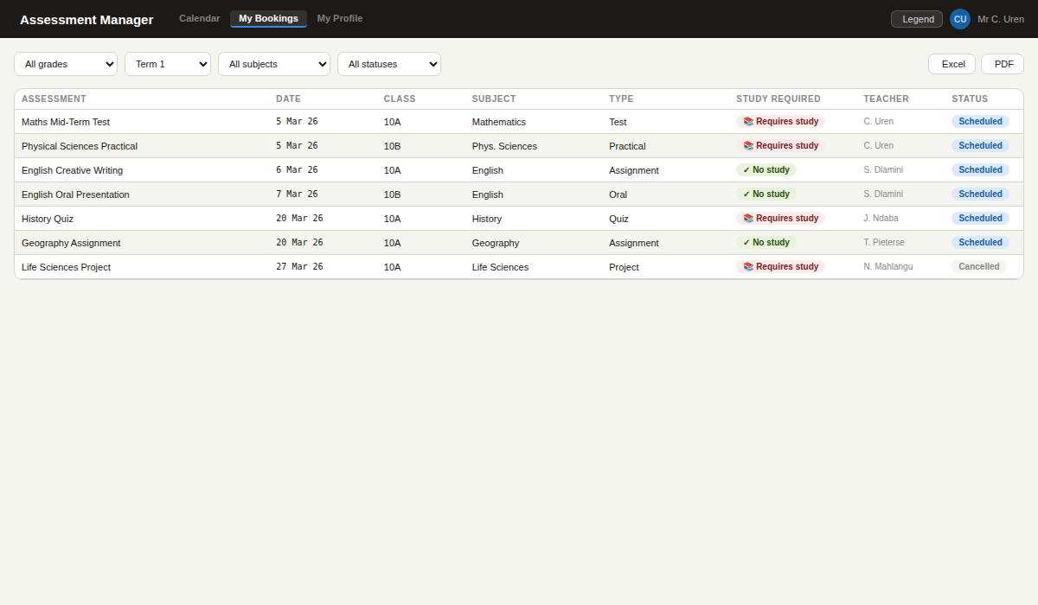
The My Bookings screen shows all assessments in a filterable table. Teachers see their own assessments. Admins and Management see all assessments across all teachers and grades. Export to Excel or PDF for planning meetings.
- Study Required shown as a colour pill — amber for requires study, green for no study required
- Excel and PDF export download the currently filtered view
- The Student Assessment Report export (PDF) groups assessments by subject then class for student distribution

Next steps
The app is ready for local testing
All 17 screens shown in this document are fully functional in mock mode — no Azure registration or SharePoint access is required at this stage.

To move from local testing to school-wide deployment:
- IT admin completes the Azure App Registration — a standard 30-minute Microsoft 365 process
- The automated SharePoint setup script creates all 10 lists and the document library in a single command
- Management configures term windows, formal dates, and reference data through the app itself
- Pilot with 3 to 4 teachers, then roll out to all staff via a SharePoint navigation link
- Teachers access the app at the SharePoint page URL — no installation, no download, no new password

Questions?
For technical questions contact the developer. For questions about assessment rules and access levels, contact management. Most ongoing maintenance is self-service for the management team with no developer involvement required.

