**Farmer’s Diary**

Course Title: Distributed Database Management System Lab (CSE418)

Program: B.Sc. in CSE

Semester: Fall, 2022-23

Intake: 35/1

**Developed by**

|  |  |
| --- | --- |
| **ID** | **Name** |
| 19202203001 | Md. Jobaer Hossain[Leader] |
| 19202203010 | Md. Galib Hossain |
| 19202203104 | Shariful Islam Shanto |
| 19202203109 | Md. Alamin |

**Supervised By**

Sweety Lima

Lecturer

Department of Computer Science and Engineering

**Date of Submission: March 10, 2023**



**Mirpur, Dhaka-1216**

**TABLE OF CONTENTS**

|  |  |  |
| --- | --- | --- |
|  |  | Page no |
| Abstract |  | i |
| List of content |  | ii |
| List of figures |  | iii |
| List of tables |  | iv |
| **CHAPTER I** | **INTRODUCTION**  1.1 Introduction  1.2 Background  1.3 Motivation  1.4 Objective  1.5 Organization of the report  1.6 Conclusion | 6  6  7  7  8  8 |
| **CHAPTER II** | **LITERATURE REVIEW**  2.1 Introduction  2.2 Existing System | 9  9 |
| **CHAPTER III** | **PROPOSED SYSTEM**  3.1 Introduction  3.2 Software Engineering process model  3.2 Model Architecture | 10  10  12 |
| **CHAPTER IV** | **IMPLEMENTATION** | 17 |
| **CHAPTER V** | **TESTING**  Functional Testing  Non-Functional testing | 19  20 |
| **CHAPTER VI** | **CONCLUSION** | 22 |

**LIST OF FIGURE**

|  |  |  |
| --- | --- | --- |
|  |  | Page no |
| **CHAPTER III** | **PROPOSED SYSTEM**  Figure-3.1: Agile Model  Figure-3.2: Use-case diagram  Figure-3.3: Activity diagram for proposed system  Figure-3.4: Schema Diagram for proposed system  Figure-3.5: Class diagram for Farmer’s Diary  Figure-3.6: Entity relation diagram for proposed system | 11  13  14  14  15  15 |
| **CHAPTER V** | Figure-5.1: Applied test approaches.  Figure-5.2: Non-function testing. | 39  41 |

**LIST OF TABLE**

|  |  |  |
| --- | --- | --- |
|  |  | Page no |
| **CHAPTER IV** | Table-4.1: Technical details of the system. | 24 |

**ACKNOWLEDGEMENT**

We, the undergraduate students of the Bangladesh University of Business and Technology, Department of Computer Science and Engineering (CSE) 9th Semester, do hereby acknowledge our gratefulness towards all the persons associated in the completion of this Project.

First of all, we would like to pay our thanks to our respected teacher Sweety Lima madam who has chosen us for this topic and also provided us help with knowledge, inspiration and information. It would not be possible for us to complete the same without his sincere and affectionate help.

Secondly, we again would like to thank our department who has provided us appropriate environment with lab and library facility to gather the information which needed for the project.

Lastly, we pay our thanks to our parents, friends who contributed to some extent to

Complete the same.

**N: B:** *We will be the responsible if any mistake found there.*

Date: March 10, 2023

Group Leader

Md. Jobaer Hossain

Dept. of Computer Science and Engineering

Mirpur, Dhaka.

Supervised by

Sweety Lima

Lecturer Department Of CSE

Bangladesh University of Business & Technology

***Abstracts:*** For sustainable development and its continuation, there is a need to spread the spread of technology at all levels of national and international levels. Along with the first class countries, Bangladesh has been playing a big role in this matter. On the other hand, a large part of a country's economy is involved in agriculture. So revolutionary change in the economy of the country is possible through the touch of technology in the agricultural sector. Moreover, Agriculture in Bangladesh is vital for people's livelihood, employment, and contribution to GDP we all know that. Its contribution has reduced over the last decade, going from 17 percent in 2010 to 12.6 percent in 2020. The reason for the deterioration of the agriculture sector is that the farmers are not getting proper product prices and they are not able to prepare product as per requirement. The proposed scheme has such a solution where the farmer can understand his owed. And can predict from all previous information when the product should be produced.

**INTRODUCTION**

**1.1 INTRODUCTION**

Agriculture is considered the backbone of the economy of different country. However, it is possible to further strengthen this resource through technological development. When we think about technological development, we first think about software. Software is so important for agricultural development. If an important but previously not much attention has been paid to this matter. Considering all the contemporary issues, it is seen that the Farmer’s Diary will play an important role in agriculture and business. Not that long ago, farmers were being told to plant crops based on what they thought would be successful. Today, there's an entire industry of data analytics that is revolutionizing agriculture. Did you wonder what agricultural software is and do we need it? Farming has been around for centuries, but the way farmers are using big data to improve their farming practices is groundbreaking. Agricultural software can help farmers in every aspect of their farming business, from planting and harvesting crops to preventing disease outbreaks. As a result, farmers are able to produce better crops and earn more revenue. We looked at a few ways in which agriculture can utilize farm management software to enhance planning, speed decisions, and most importantly, improve outcomes. After reading this article you will become familiar with agricultural technology and all there is to know about it. Monitoring the development of agricultural products and efficient sell and buy management in product and agricultural products is critical to ensure product safety. The growing concerns about product safety and contamination risks have renewed the focus for enhanced traceability across the application system [1], [2]. In addition agricultural products being traded across several areas require precise tracking and conformance to districts specific regulations [3], [4]. Traceability of products in agricultural systems requires the collection, communication and management of critical information by precisely identifying the origin, various information exchange in the Farmer's diary system.

**1.2 BACKGROUND**

The reality is, by year 2050 food production will need to double in order to satisfy global food consumption demands. Alongside the need to feed rising populations, modern farm operations have to cope with changes in climate, fluctuations in nature, pest and disease attacks, eroding soil health and depleting resources. To be able to compete on a global scale, farmers are making the switch from using spreadsheets to storage the data or not using any approach to storage the data.

**1.3** **MOTIVATION**

Agriculture is the only industry that is never going to perish in the future and beyond. It is one of the oldest and effective traditional practices that have been taken into consideration by human beings for feeding themselves. However, this industry is moving towards a vast up-gradation due to technological dominance. As per Statista, the market of smart agriculture is forecast to reach around $26.76 billion by the end of 2022. Nowadays, farmers are open to new innovative and productive technologies to support their agriculture business. There’re some of the best agriculture development company that are currently offering agriculture software solutions for farmers that enables their agricultural business to make a solid online presence. Having exceptionally talented and experienced developers on-board, these companies have aced the management of the agriculture industry for many years and continue to do so in the future as well. In this blog, we are going to discuss the benefits driven by agriculture software solutions. Without wasting more time, let’s get back to business. The main motive of the farming apps is to optimize the overall farming process. Though most of the features are available over a smart device such as computer or mobiles but helps farmers to strategize their farming accordingly. Migrating these technical features from desktop to mobile can be pretty handy because this helps farmers to use the technologies wherever they want to. Here, I’ve mentioned different benefits that farmers get sells and buy management system solutions. The important thing is to ensure the quantity of goods produced and stockpiled to control the cost of goods [5]. This may be the best way to control the price of third party products.

**1.4 OBJECTIVE**

Data is a valuable asset for businesses as we as agriculture. As a business grows, the amount of data it collects also grows. The common data businesses collect include client data, vendor data, financial data, analytical data, and similar others. But does your business have a proper system in place for collecting and storing data? Knowing that how crucial data is today for businesses, having a proper data storage system is a mandatory step every business should take. But this does not mean setting up a traditional paper-based data storage system. The present era is the digital era, which requires proper digital data storage systems in place for enhanced operations, accessibility, and data security. However, Agricultural data collection has become so important nowadays that there is no way to avoid it.

**1.5 ORGANIZATION OF THE REPORT**

This paper is organized as follows. In Section 2, we represent the literature review. we present constructivism and Project-Based Learning on which our model is based. Our proposed Web-Based Project-Based Data storage model for the farmers introduced in Section 3. Section 4 describes how the proposed model is implemented. In Section 5 represent the testing strategy for the proposed system. Finally, we give conclusions and further research issues in Section 6.

**1.6 CONCLUSION**

In this article, we have proposed a solution and technical details to build the farmer's diary. We have presented details and aspects related to the system information, design, entity-relation diagram, interactions, activity diagrams, and implementation procedure. We showed how our solution can be applied for tracing and tracking product details that a user sold or bought.

**LITERATURE REVIEW**

**2.1 INTRODUCTION**

In this section, we review and highlight related work found in the literature on web-based applications for the agricultural product sells and buys system. While the literature on web-based applications in banking, finance and insurance industries has been increasing steadily, the literature on food and agriculture is scant and just started to gain popularity.

**2.2 EXISTING SYSTEM**

It is the study of farmer as a producer of food and other raw materials, who occupies a strategic position in the economic life of a country. Farm management investigations give thrust and direction to farm business improvement by providing useful information to planners, farmers and extension workers. Better understanding of the sequential flow of new technology is provided by farm management research that contributes to more realistic projection potential. Again, basic information by farm management studies on specific farm projects such as land reclamation, irrigation and drainage, serves as an aid to formulate national policies. We got different firm management system. To our knowledge, no such project has been implemented yet. This is a new project that works with farmers and buyers. To our knowledge no such project has been implemented yet. This is a new project that works with farmers and buyers sellers.

**PROPOSED SYSTEM**

**3.1 INTRODUCTION**

The software development models are the various processes or methodologies that are being selected for the development of the project depending on the project’s aims and goals. There are many development life cycle models that have been developed in order to achieve different required objectives. The models specify the various stages of the process and the order in which they are carried out. The selection of model has very high impact on the testing that is carried out. It will define the what, where and when of our planned testing, influence regression testing and largely determines which test techniques to use.

In our proposed system we have the provision for adding the details of the buyer by themselves. Another advantage of the system is that it is very easy to edit the details of the data and delete a data when it found unnecessary. The prices and cost of product may added in the database and so seller can also view the detail whenever they want.

**Our proposed system has several advantages:**

* User friendly interface
* Fast access to database
* Less error
* More Storage Capacity
* Search Individual product
* Look and Feel Environment
* Quick transaction

**3.2 SOFTWARE PROCESS MODEL**

The proposed project has used the Agile model. "Agile process model" refers to a software development approach based on iterative development. Agile methods break tasks into smaller iterations, or parts do not directly involve long term planning. The project scope and requirements are laid down at the beginning of the development process. Plans regarding the number of iterations, the duration and the scope of each iteration are clearly defined in advance. Each iteration is considered as a short time "frame" in the Agile process model, which typically lasts from one to four weeks. The division of the entire project into smaller parts helps to minimize the project risk and to reduce the overall project delivery time requirements. Each iteration involves a team working through a full software development life cycle including planning, requirements analysis, design, coding, and testing before a working product is demonstrated to the client.

Figure-3.1: Agile Model

**Phases of Agile Model:**

1. *Requirements gathering:* In this phase, you must define the requirements. You should explain business opportunities and plan the time and effort needed to build the project. Based on this information, you can evaluate technical and economic feasibility. For requirement monitoring we first recorded all the expected things from the farmer. Later, it has been verified by recording the necessary features through observation. Besides the feasibility of the project and the implementation cost have been considered.
2. *Design the requirements:* When you have identified the project, work with stakeholders to define requirements. You can use the user flow diagram or the high-level UML diagram to show the work of new features and show how it will apply to your existing system. The proposed project is used for demonstration of diagrams. Among them are task-diagrams, class-diagrams, activity-diagrams. Also design a entity relationship diagram for representing database structure of the system.
3. *Construction/ iteration:* When the team defines the requirements, the work begins. Designers and developers start working on their project, which aims to deploy a working product. The product will undergo various stages of improvement, so it includes simple, minimal functionality.
4. *Testing:* In this phase, the Quality Assurance team examines the product's performance and looks for the bug. Functional-testing and non-functional testing are used in the proposed system. This topic is discussed in detail in the Testing section.
5. *Deployment:* In this phase, the team issues a product for the user's work environment.
6. *Feedback:* After releasing the product, the last step is feedback. In this, the team receives feedback about the product and works through the feedback.

**Agile Testing Methods:**

* Scrum
* Crystal
* Dynamic Software Development Method(DSDM)
* Feature Driven Development(FDD)
* Lean Software Development
* eXtreme Programming(XP)

*Scrum:*SCRUM is an agile development process focused primarily on ways to manage tasks in team-based development conditions.

There are three roles in it, and their responsibilities are:

*Scrum Master:* The scrum can set up the master team, arrange the meeting and remove obstacles for the process

*Product owner:*The product owner makes the product backlog, prioritizes the delay and is responsible for the distribution of functionality on each repetition.

*Scrum Team:* The team manages its work and organizes the work to complete the sprint or cycle.

*eXtreme Programming(XP):* This type of methodology is used when customers are constantly changing demands or requirements, or when they are not sure about the system's performance.

*Crystal:* There are three concepts of this method-

1. *Chartering:* Multi activities are involved in this phase such as making a development team, performing feasibility analysis, developing plans, etc.
2. *Cyclic delivery:* under this, two more cycles consist, these are:

* Team updates the release plan.
* Integrated product delivers to the users.

1. *Wrap up:* According to the user environment, this phase performs deployment, post-deployment.

**3.3 UNIFIED MODELING LANGUAGE**

*i. Use-case Diagram:* A use case diagram is a graphical depiction of a user's possible interactions with a system. A use case diagram shows various use cases and different types of users the system has and will often be accompanied by other types of diagrams as well. The use cases are represented by either circles or ellipses.

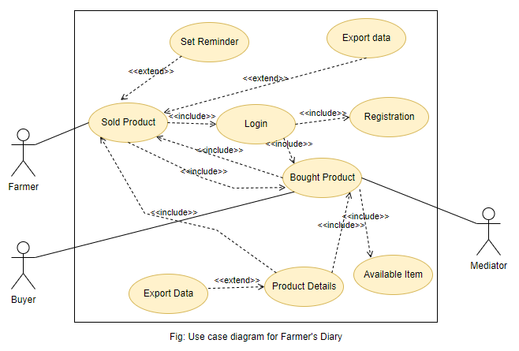

Figure-3.2: Use-case diagram

The proposed project use-case diagram are showed in given figure-3.2. The diagram constructed for the proposed project shows how the system will work. The project has three types of users. However, here are some guidelines and obstacles for every user. As each user must work through login by their own account. Every user can buy and sell their products through the proposed System.

*ii. Activity diagram:* An activity diagram visually presents a series of actions or flow of control in a system similar to a flowchart or a data flow diagram. Activity diagrams are often used in business process modeling. They can also describe the steps in a use case diagram. The proposed project activities are showed in given figure-3.3.

*IV. Entity relationship diagram for the proposed model:* An Entity Relationship (ER) Diagram is a type of flowchart that illustrates how “entities” such as people, objects or concepts relate to each other within a system. ER Diagrams are most often used to design or debug relational databases in the fields of software engineering, business information systems, education and research. Also known as ERDs or ER Models, they use a defined set of symbols such as rectangles, diamonds, ovals and connecting lines to depict the interconnectedness of entities, relationships and their attributes. They mirror grammatical structure, with entities as nouns and relationships as verbs. In the given figure-3.4 represent Entity Relationship Diagram for proposed system. It has six entity and six relationship between the tables of database management system.

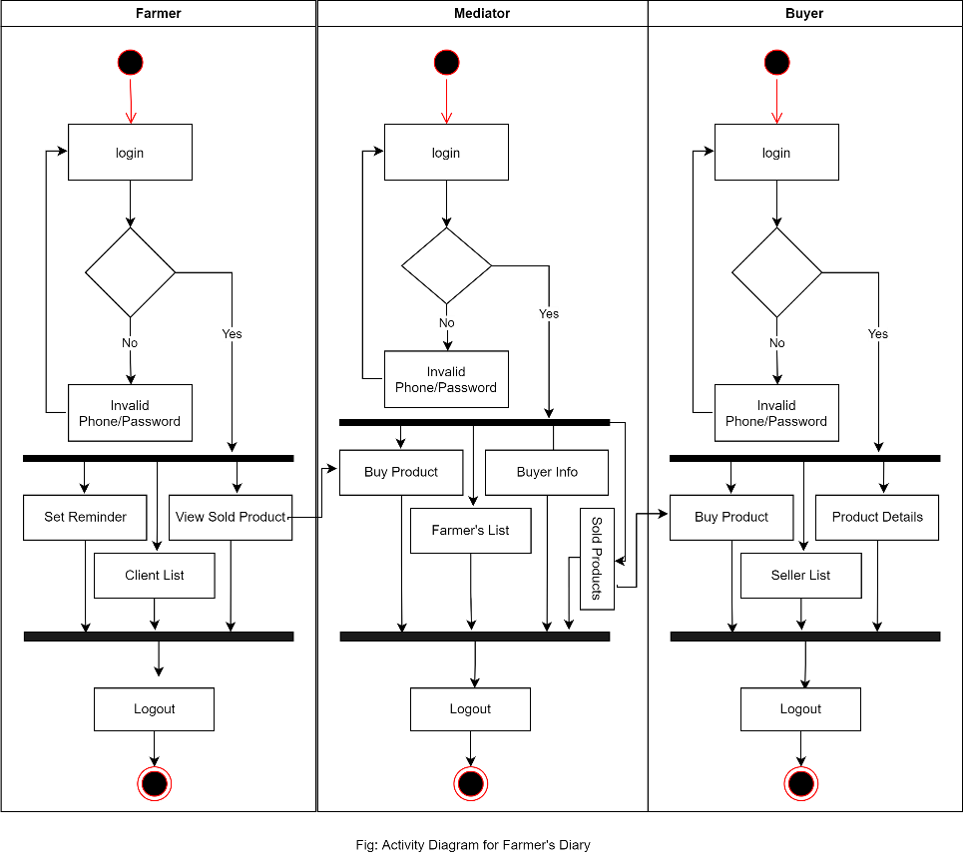

Figure-3.3: Activity diagram for proposed system

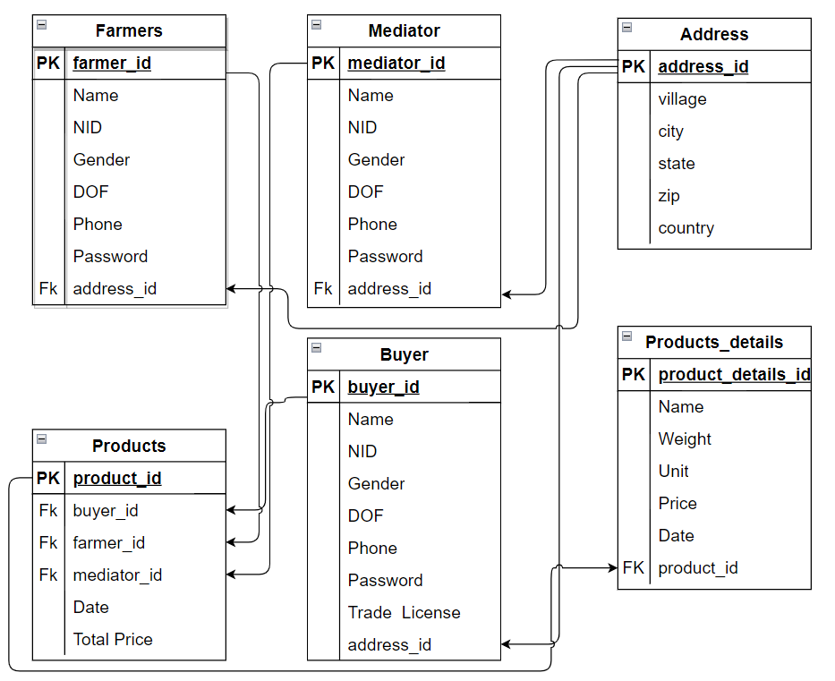

Figure-3.4: Schema diagram for proposed system

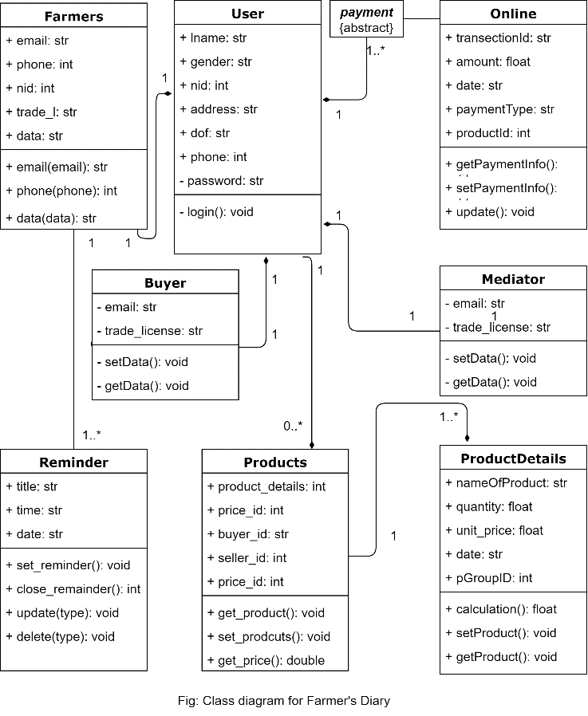

Figure-3.5: Class diagram for Farmer’s Diary

Figure-3.6: Entity relation diagram for proposed system

**IMPLEMENTATION**

Implementation is the execution or practice of a plan, a method or any design, idea, model, specification, standard or policy for doing something. As such, implementation is the action that must follow any preliminary thinking for something to actually happen. Farmer's diary is managed by buyers rather than farmers, creating it challenging to get data from different profiles. Thus, farmers required to focus on returning control of their selling data details and their buying data details[6], [7].Rest of the bottom discuss the implementation details step by step.

1. First, to create the profile, Farmer needs to create an account with a phone number. Enter his National Identity Card number for future security purpose.
2. By providing the necessary information, the user can login through the phone number and password after creating his profile.
3. After the user enters the dashboard, he can see all his information.
4. After entering your profile, all the data of purchases and sales will be displayed.
5. When purchasing a product from the firm, add the product to the purchase list. The profile of the person from whom the product is purchased will be automatically added.
6. You can see the details of the purchased products from individual products. There is complete information of the seller.
7. A user can create reminder notes as needed.

|  |  |
| --- | --- |
|  | |
| Required Application | XAMPP, VSCode |
| Database | MySQL |
| Programming Language | PHP(OOP), JavaScript |
| Library | BS, jQuery, jQueryUI |

Table-4.1: Technical details of the system

*Login:*If the user wants to get his information, he has to login. Each carrier will need to login to his own profile with his phone number and a password. The minimum length that can be used in the case of passwords is six. But the line will be possible only when the user's profile is registered

*Registration:* Each user must provide the required information for registration. And the status of the information will be verified in the case of each input. If the necessary data is provided correctly, permission will be given for further activities or for login. It is worth mentioning that multiple accounts cannot be created with the same phone number. However, a separate table has been used to store the information of registered users in the database.

*User Dashboard:* Fiugre-4.3, Each user can view this data by logging in with a phone number and password. When an user logged in into the system, then the system represent the dashboard page. In dashboard page we keep four segment which show number of customer, number of seller, and number of sold product and bought product as well as show the ratio of each segment.

*Sold or Bought items:* In our proposed system we keep all the sold product list and bought list to inform the details of the product to seller and buyer. Every user may update, delete as per-requirement.

*Delete Item:* If you want to delete any other information according to the user's needs, you have to click on the cross button. After that a new window will appear and must be confirmed for deletion. If ‘**yes’** pressed then the file will be successfully deleted from the list.

**TESTING**

**Introduction:**

Software Testing is a method to check whether the actual software product matches expected requirements and to ensure that software product is Defect free. It involves execution of software/system components using manual or automated tools to evaluate one or more properties of interest. The purpose of software testing is to identify errors, gaps or missing requirements in contrast to actual requirements. Some prefer saying Software testing definition as a White Box and Black Box Testing. In simple terms, Software Testing means the Verification of Application Under Test (AUT).

**Testing Strategy**

FUNCTIONAL TESTING is a type of software testing that validates the software system against the functional requirements/specifications. The purpose of Functional tests is to test each function of the software application, by providing appropriate input, verifying the output against the Functional requirements.

Functional testing mainly involves black box testing and it is not concerned about the source code of the application. This testing checks User Interface, APIs, Database, Security, Client/Server communication and other functionality of the Application Under Test. The testing can be done either manually or using automation.

**What do you test in Functional Testing?**

The prime objective of Functional testing is checking the functionalities of the software system. It mainly concentrates on –

* **Mainline functions**:  Testing the main functions of an application
* **Basic Usability**: It involves basic usability testing of the system. It checks whether a user can freely navigate through the screens without any difficulties.
* **Accessibility**:  Checks the accessibility of the system for the user
* **Error Conditions**: Usage of testing techniques to check for error conditions.  It checks whether suitable error messages are displayed.

**How to do Functional Testing**

Following is a step by step process on **How to do Functional Testing**:

* Understand the Functional Requirements
* Identify test input or test data based on requirements
* Compute the expected outcomes with selected test input values
* Execute test cases
* Compare actual and computed expected results

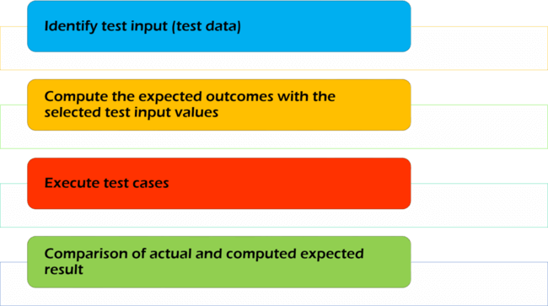

Figure-5.1: Applied test approaches.

NON-FUNCTIONAL TESTING is defined as a type of Software testing to check non-functional aspects (performance, usability, reliability, etc) of a software application. It is designed to test the readiness of a system as per nonfunctional parameters which are never addressed by functional testing.

An excellent example of non-functional test would be to check how many people can simultaneously login into a software.

Non-functional testing is equally important as functional testing and affects client satisfaction.

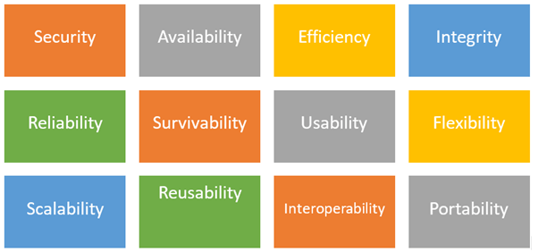

Figure-5.2: Non-function testing

## Objectives of Non-functional testing:

* Non-functional testing should increase usability, efficiency, maintainability, and portability of the product.
* Helps to reduce production risk and cost associated with non-functional aspects of the product.
* Optimize the way product is installed, setup, executes, managed and monitored.
* Collect and produce measurements, and metrics for internal research and development.
* Improve and enhance knowledge of the product behavior and technologies in use.

## Characteristics of Non-functional testing

* Non-functional testing should be measurable, so there is no place for subjective characterization like good, better, best, etc.
* Exact numbers are unlikely to be known at the start of the requirement process
* Important to prioritize the requirements
* Ensure that quality attributes are identified correctly in Software Engineering.

## Non-functional testing Parameters

## *Security:* The parameter defines how a system is safeguarded against deliberate and sudden attacks from internal and external sources. This is tested via Security Testing.

## *Reliability:* The extent to which any software system continuously performs the specified functions without failure. This is tested by Reliability Testing

## *Survivability:* The parameter checks that the software system continues to function and recovers itself in case of system failure. This is checked by Recovery Testing

## *Availability:* The parameter determines the degree to which user can depend on the system during its operation. This is checked by Stability Testing.

## *Usability:* The ease with which the user can learn, operate, prepare inputs and outputs through interaction with a system. This is checked by Usability Testing

## *Scalability:* The term refers to the degree in which any software application can expand its processing capacity to meet an increase in demand. This is tested by Scalability Testing

## *Interoperability:* This non-functional parameter checks a software system interfaces with other software systems. This is checked by Interoperability Testing

## *Efficiency:* The extent to which any software system can handles capacity, quantity and response time.

## *Flexibility:* The term refers to the ease with which the application can work in different hardware and software configurations. Like minimum RAM, CPU requirements.

## *Portability:* The flexibility of software to transfer from its current hardware or software environment.

## *Reusability:* It refers to a portion of the software system that can be converted for use in another application.

**CONCLUSTION**

In this article, we have proposed a solution and technical details to build the farmer's diary. We have presented details and aspects related to the system information, design, entity-relation diagram, interactions, activity diagrams, and implementation procedure. We showed how our solution can be applied for tracing and tracking product details that a user sold or bought. Through the proposed project, the overall sustainable development of food is possible through the use of purchased and sale.

References

1. M. M. Aung and Y. S. Chang, ‘‘Traceability in a food supply: Safety and quality perspectives,’’ Food Control, vol. 39, pp. 172–184, May 2014
2. T. Bosona and G. Gebresenbet, ‘‘Food traceability as an integral part of logistics management in food and agricultural supply chain,’’ Food Control, vol. 33, no. 2, pp. 32–48, 2013.
3. J. Hobbs, ‘‘Liability and traceability in agri-food supply* chains,’’ in Quantifying the Agri-Food Supply Chain. Springer, 2006, pp. 87–102.
4. D. Mao, Z. Hao, F. Wang, and H. Li, ‘‘Novel automatic food trading system using consortium blockchain,’’ Arabian J. Sci. Eng., vol. 44, no. 4, pp. 3439–3455, Apr. 2018.
5. Hao, J., Yan Sun, and Hong Luo. "A safe and efficient storage scheme based on blockchain and IPFS for agricultural products tracking." *Journal of Computers* 29.6 (2018): 158-167.
6. Sun, Jin, et al. "Multi-keyword searchable and data verifiable attribute-based encryption scheme for cloud storage." *IEEE Access* 7 (2019): 66655-66667.
7. Kumar, Adarsh, and Saurabh Jain. "Proof of game (PoG): a game theory based consensus model." *International Conference on Sustainable Communication Networks and Application*. Springer, Cham, 2019.