Written code for search a word in a files using regex, brute force method and implemented the code

For indexing the content in datastructures like hashmap.

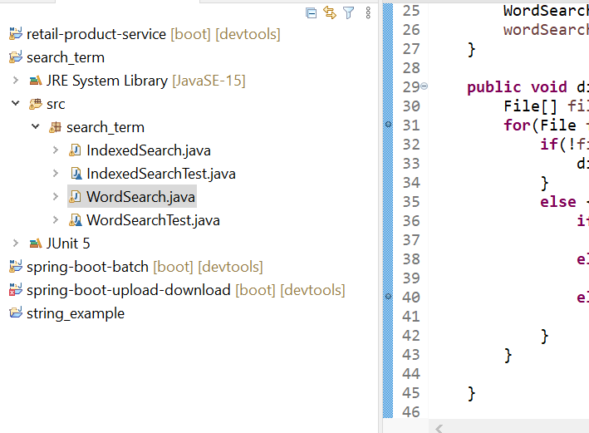

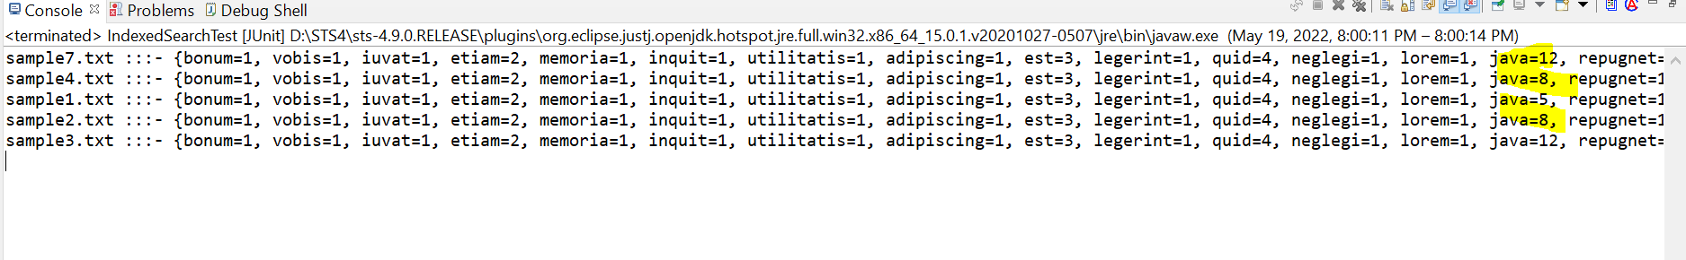

Written code in IndexedSearch.java where I read all the files data and stored in Hashmap and File object as key.

