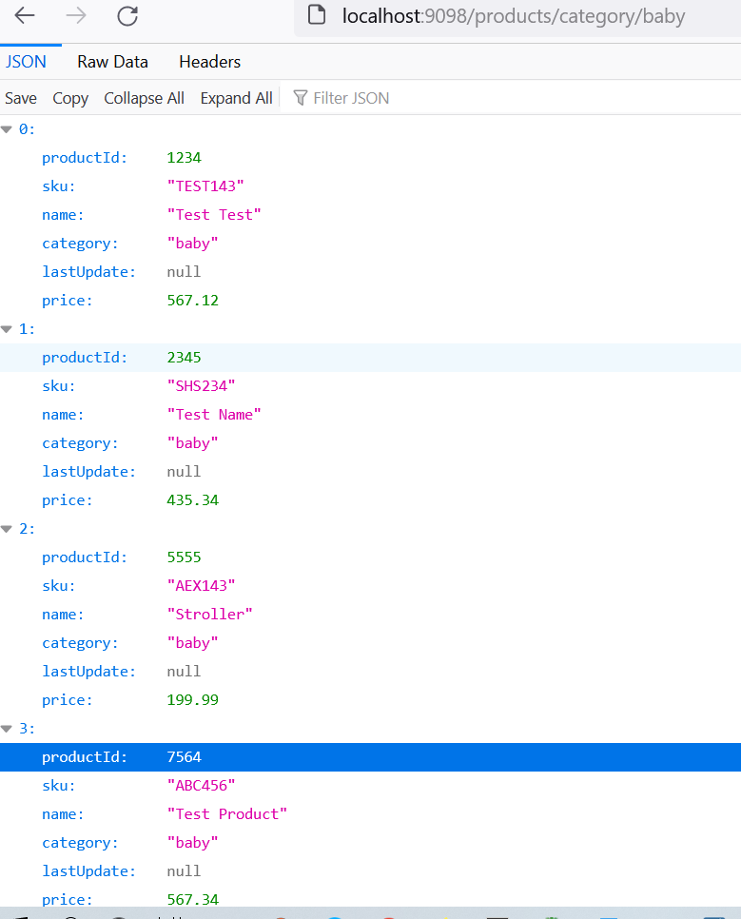

Above screen shot is for fetch product details whose category is “baby”

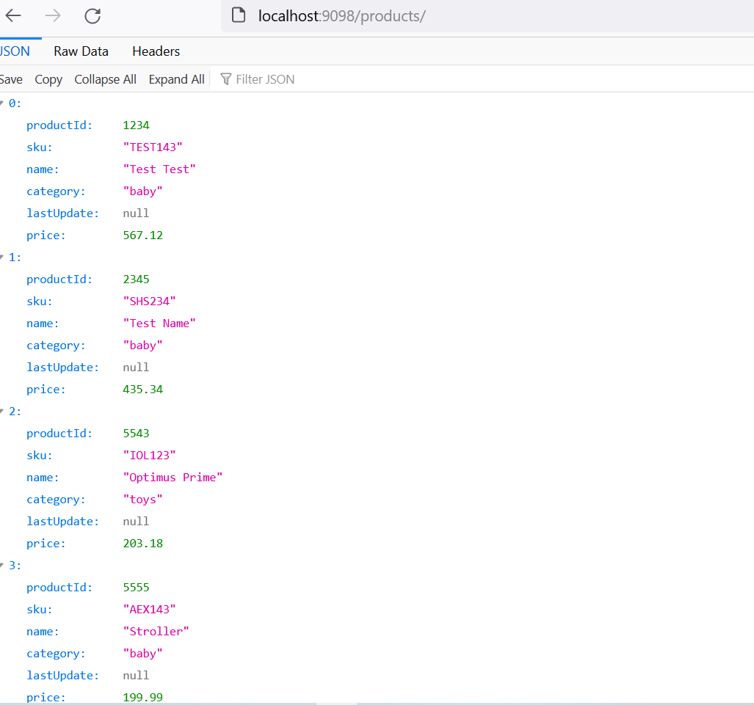

Above screen shot to load all the product details along with price.

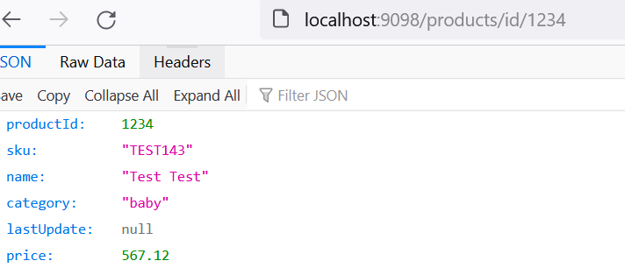

Above screenshot indicates load product from db based on input product Id

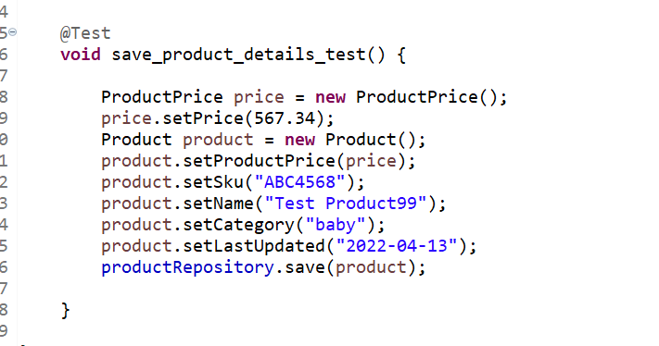

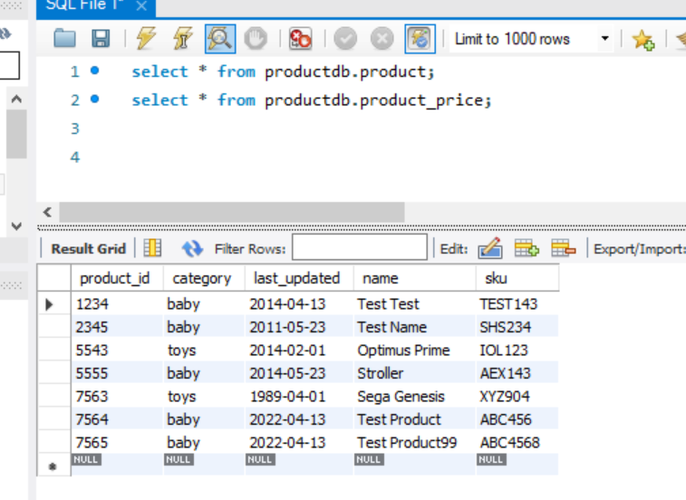

The above piece of code is used to write the data into database.

Those details with product_id 7565 are saved to mysql db . Please see the above db screenshot.