**Problem Statement**

LinkedIn has proven to be a great tool for hiring for small and mid-sized companies. The biggest pain point we have found while using LinkedIn is after making a job post and shortlisting candidates - there is a lot of time that gets wasted in coordinating available time slots, back and forth with regards to contact details (mobile , skype handle, etc.) and using different communication channels like LinkedIn, mobile and email.

**Solution Overview**

The complete end-to-end workflow from application to short-listing and the initial screening interview should ideally be conducted on LinkedIn itself. The UI/UX should allow shortlisting candidates that applied, coordinate the scheduling of the interview and also do the initial screening interview on LinkedIn itself.

**Assumption:**

1. LinkedIn uses independent application “Hire Me” for posting job to the front-end.
2. Process of Hiring:

Application-> 1st Level of Shortlisting -> 2nd Level of Shortlisting -> Interview scheduling for F2F final

**1st Level of Shortlisting**

This will be done **by an intelligent algorithm**. This algorithm with screen the resume and match with the job posting . The parameters of matching will be :

1. % of keywords text matching
2. % of skill matching
3. Experience matching

According to the above criteria every application will have matching percentage . Assuming if 60% or more matching occurs, then application will be shortlisted.

**2nd Level of Shortlisting**

All the selected candidate will be sent mail with 3-4 time slot for taking an online test as per the major skill requirement of job. And candidates will be provided **by the Online test link** ( third party or in-build online test can be used)

Based on the candidate ranking (Top10) will directly called for F2F interview.

**Interview Scheduling**

After selecting the Top 10 candidate, Candidate and Interviewer will be given an email with Day and time slot for interview based on Interviewer calendar availability which our system will check and confirm from both .

Thereafter on confirmation from candidate, f2f interview will be scheduled.

**Approach:**

A new feature to improve the initial hiring process. This feature is called “Hiring best in the crowd”.

In order to achieve this, we need to improve and add intelligent feature in “Hire Me” Platform that will provide :

1. Shortlisted Candidate .
2. Automated Interview Scheduling.
3. Review Comments by Interviewer

**Feature need to Implemented:**

1. Smart Algo for 1st level is shortlisting
2. Notify Candidate and send them link to online test
3. Generate Score for above candidate and as per acceptance criteria, shortlisted candidate
4. Automated/Manual scheduling for F2F interview.

**Wire Frames:**

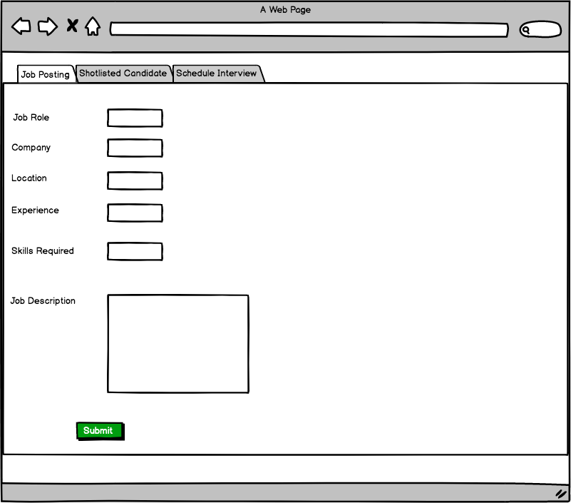

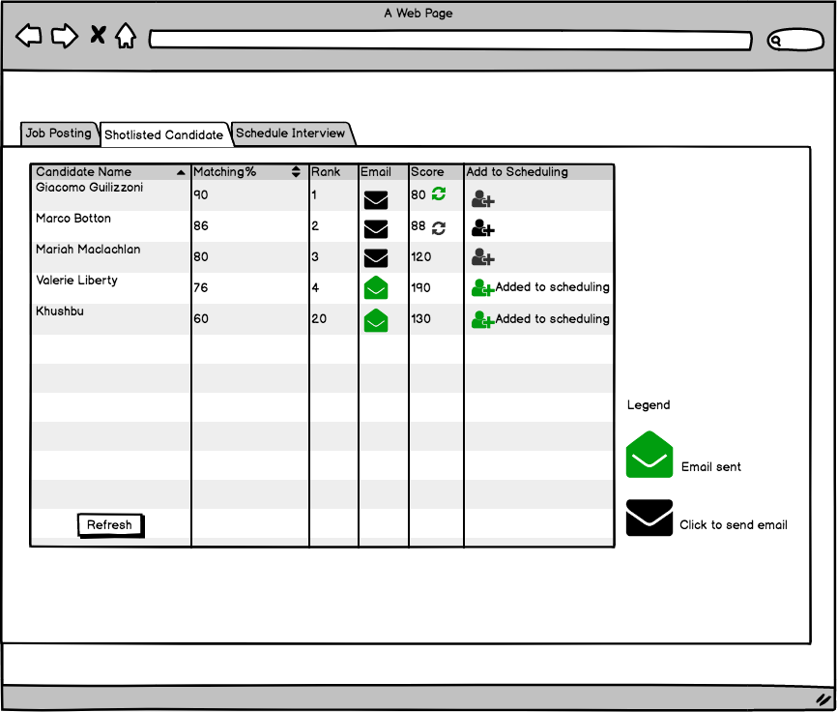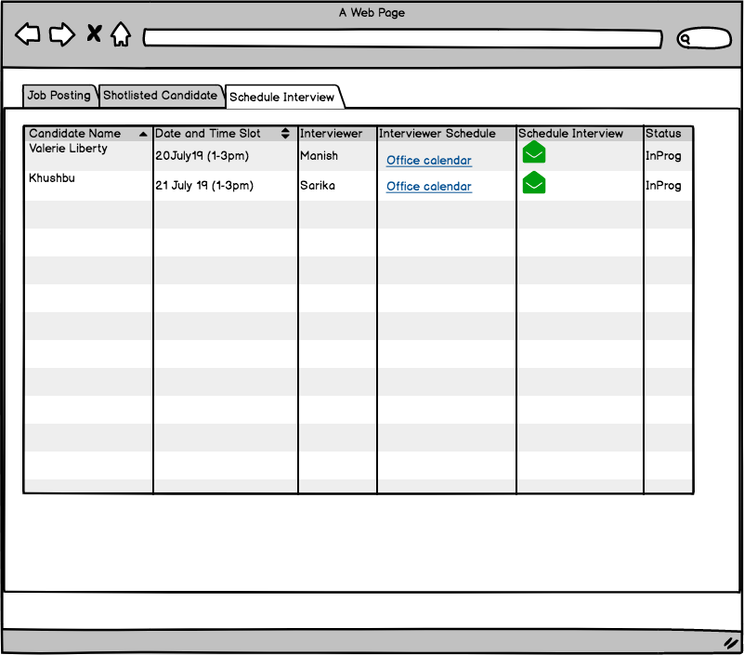

**Work Flow Diagram**:

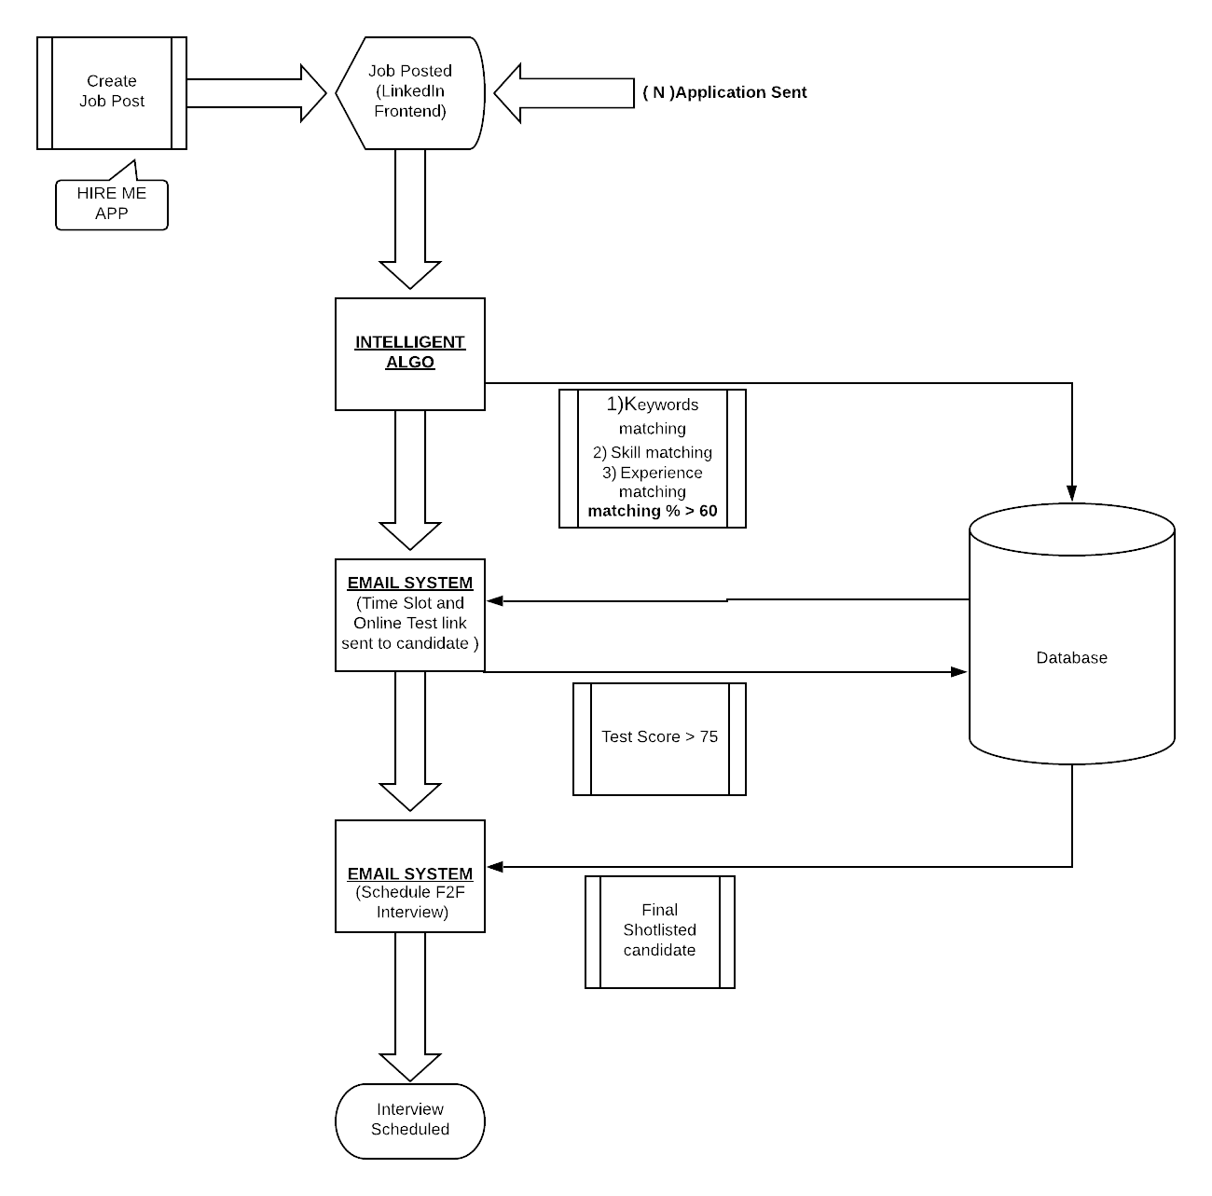

EPICS:

1. Implement Intelligent Algorithm to filter relevant applications.
2. Mailing System which send Online Test Link to candidates.
3. Mailing System to schedule Face to Face Interview.
4. Improvement HIRE ME