

Library Management System

User Manual



December 12, 2019

Khulna University

Khulna – 9208, Bangladesh

Contents

1. Introduction: 3

2. Objectives: 3

3. Entity Relationship Diagram: 4

4. Site Tree: 5

5. Description: 6

**Admin Panel** 6

**Liberian Mode** 9

**User Mode** 19

6. Dependencies: 24

Library Management System User Manual

# 1. Introduction:

Library management system is software developed with SimTire framework to handle the basic functions of a library.

It keeps a track of book issued, returned and added to the library.

It helps to provide information on any book present in the library to the user as well as staff Member.

It helps to provide a trustworthy transaction management between the students and the university librarian authority with proper understanding.

# 2. Objectives:

* To eliminate the paper work in the library.
* Simplify search/discovery of library resources.
* Simplify payment system.
* Build Digital Library infrastructure.
* Build and manage library collections in support of academic programs.
* Managing multiple library simultaneously.
* Managing library facilities simply.
* Managing multiple users in different libraries.

# 3. Entity Relationship Diagram:

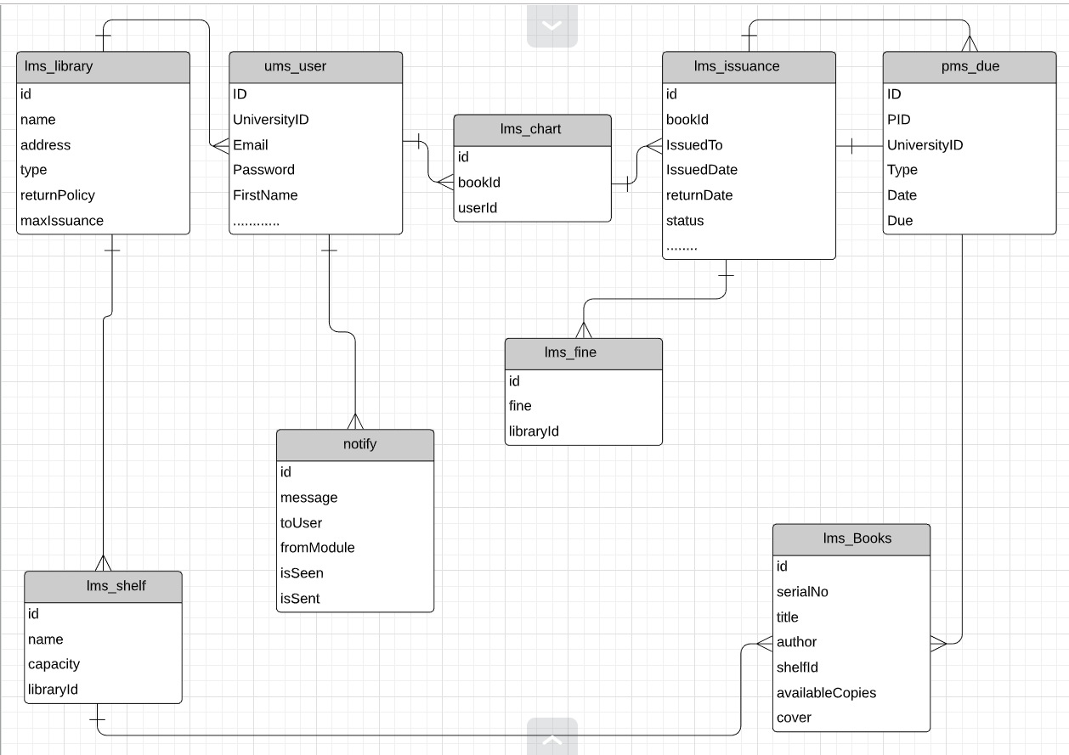

Figure : E-R Diagram of LMS

# 4. Site Tree:

In the Library Management System, there are three characters. Admin, Librarian, User. Each has a unique view and their own functionalities. A simple site tree can show what this character can view.

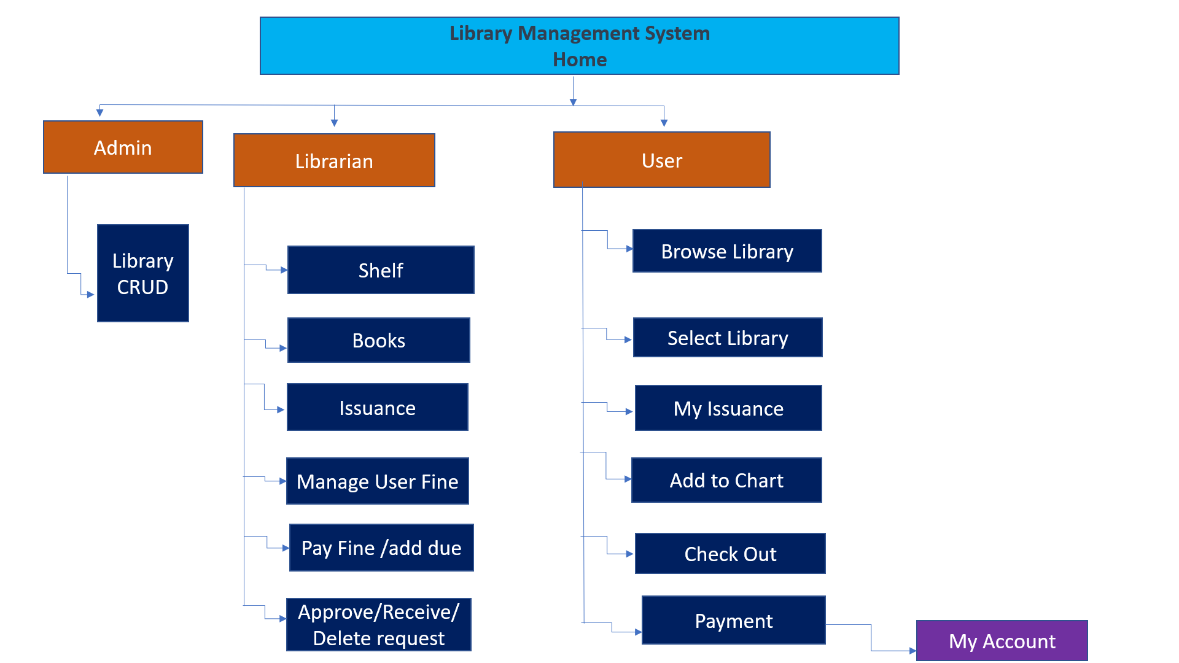

Here we can see each character has his own functions. Below all these functions are described according to their presence.

# 5. Description:

## **Admin Panel**

After login, the admin can view the homepage of the Khulna University

Automation system as follow.

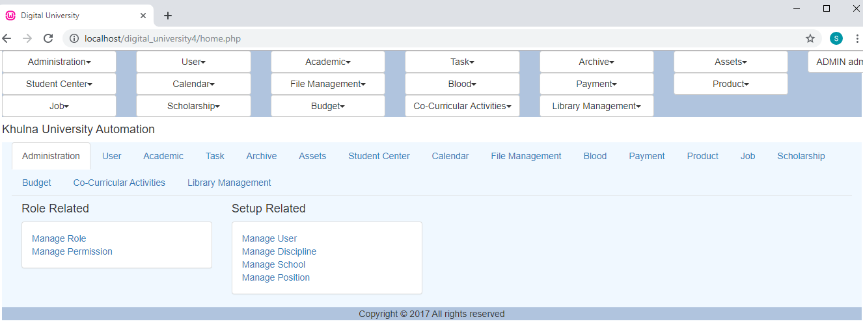

In this page, an admin can view and add the library to the system. He appoints a librarian to manage it properly.

After Clicking the **Library Management** button the admin will view this following page.

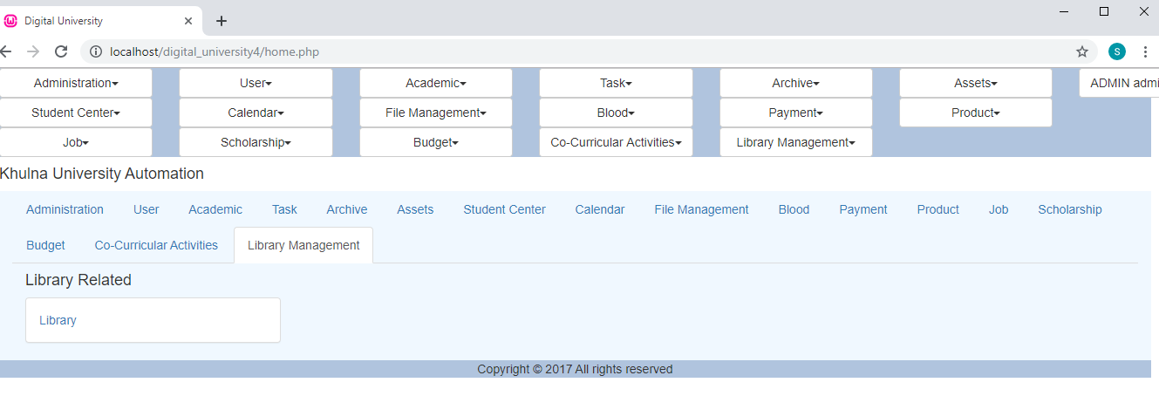

After Clicking the **Library** button which is shown in the previous picture, the admin will view this following page.

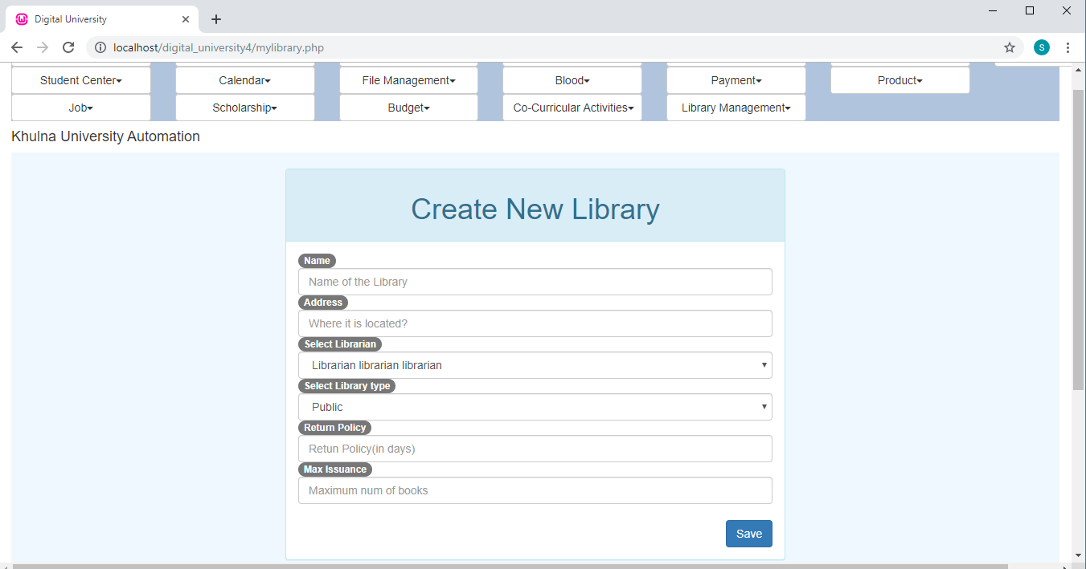

In this page, admin can create a library by filling the required fields. He has to fill the required fields and press Save button. By doing so he can create a library, assign a librarian, fix the return policy and maximum issuance one library can make.

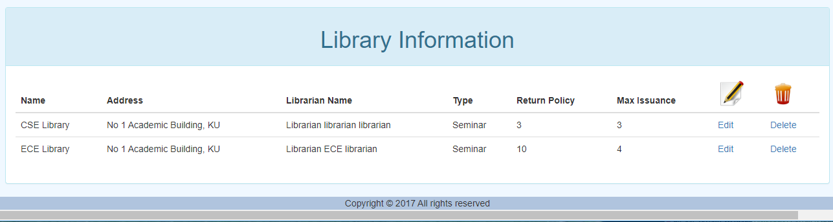

In the lower portion of the page admin can also see which libraries he/she has created and all the information about it. It has also an Edit and Delete button. By clicking these buttons admin can edit the information about his created library and also can delete them.

## **Liberian Mode**

After login, the librarian can view the homepage of the Khulna University Automation system as follow.

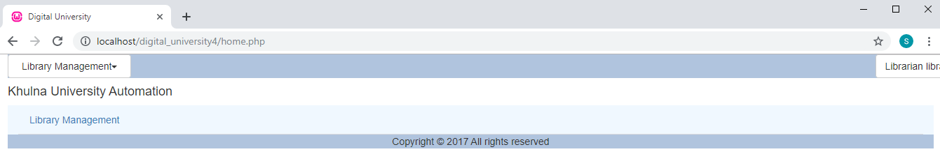

This is librarian home page. In this page a librarian will see two panels.

1. Library Operations

2. Library Cost Info

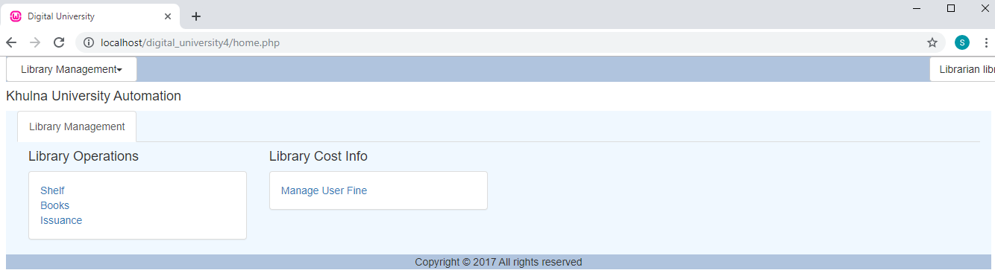

In the **Library Operations** panel librarian can insert shelf in the library and view them by clicking **Shelf**, insert books in the shelf and browse all the books of his library, can edit and delete them there. He can also check which book from his library is issued by users.

In the **Library Cost Info** panel librarian can set the amount of fine per day due to delay according to the instruction of the admin.

After clicking the **Shelf** button the librarian can view the following page .

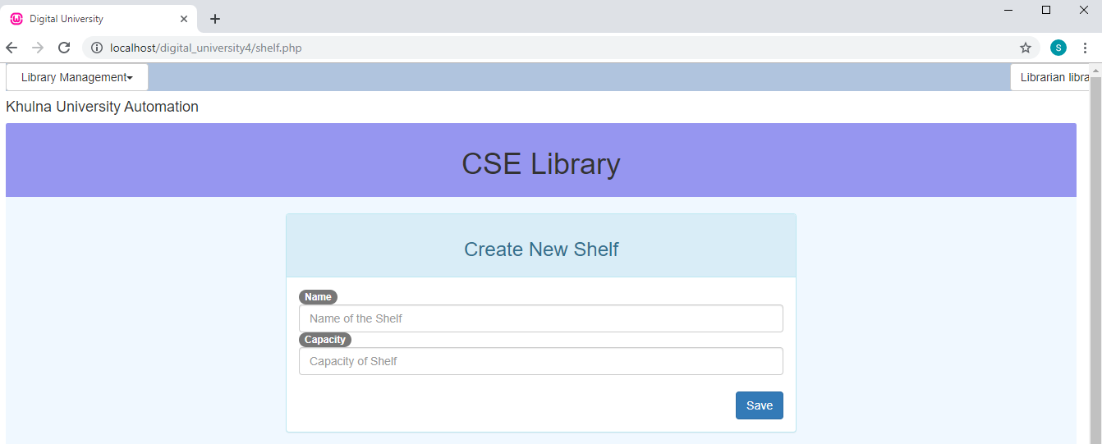

In this page, librarian can create a shelf by filling up the required fields. And after clicking the “save” button the librarian can see all the shelves.

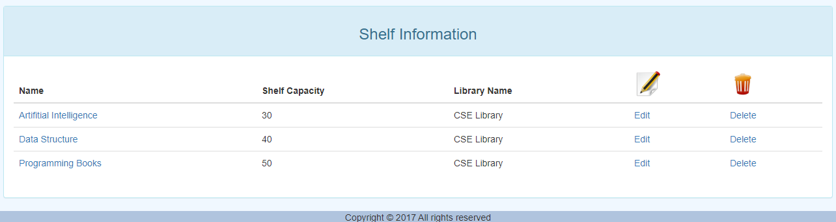

The librarian can edit or delete the stored data when it is necessary by clicking the **Edit** and **Delete** button.

The librarian can also create, edit, delete new books. The functionality of books is managed under themenu **Books**. After clicking the menu librarian can view the following page.

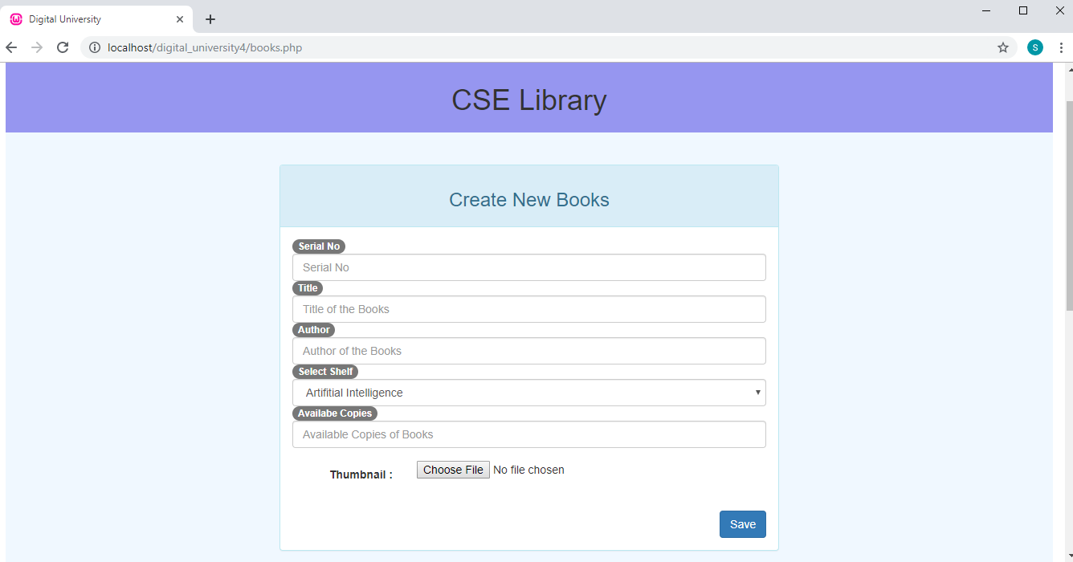

In this page, librarian can create a book by filling up the required fields. And after clicking the “save” button the librarian can see all the books in the library. The librarian has also the search option.

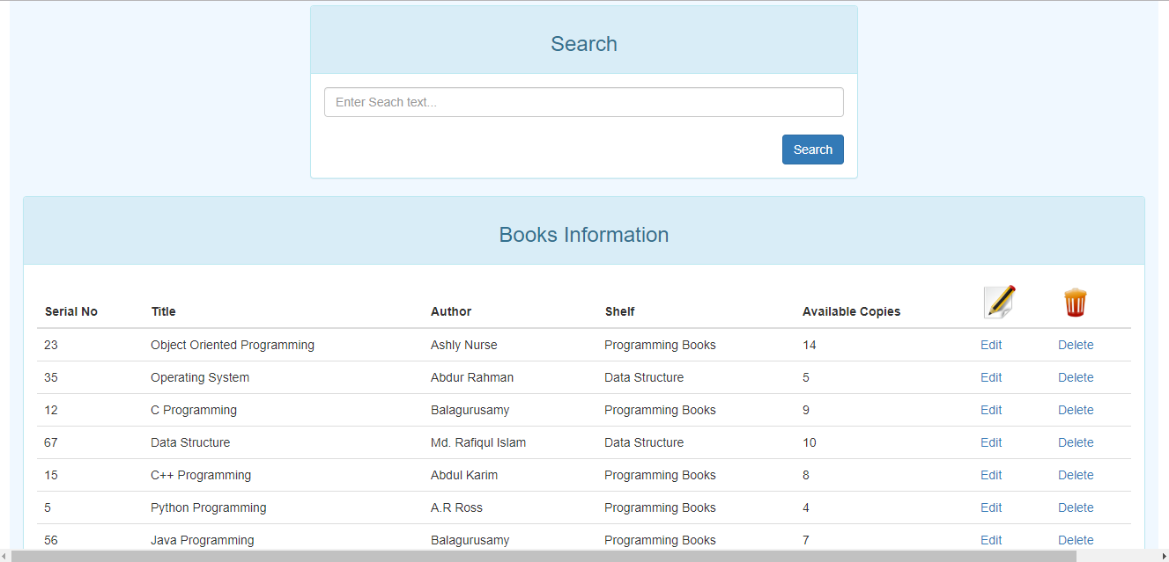

The librarian can edit or delete the stored data when it is necessary by clicking the **Edit** and **Delete** button.

The most important part for the librarian is the issuance part. All the issuances of books are managed under the **Issuance** menu. By clicking the menu the librarian can view the following page.

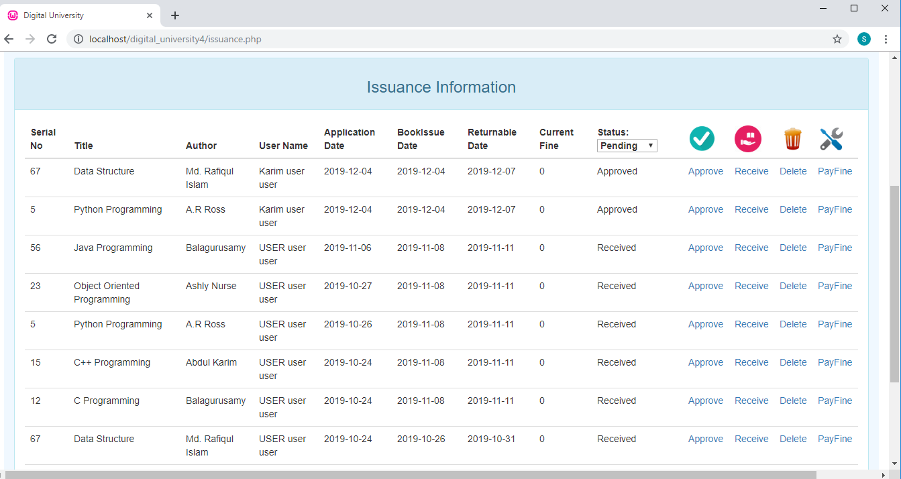

When a user requests for books, the information will come forward to the concerned librarian to approve or delete the request. The issuance page can have the such kind of following form with the status **Pending**.

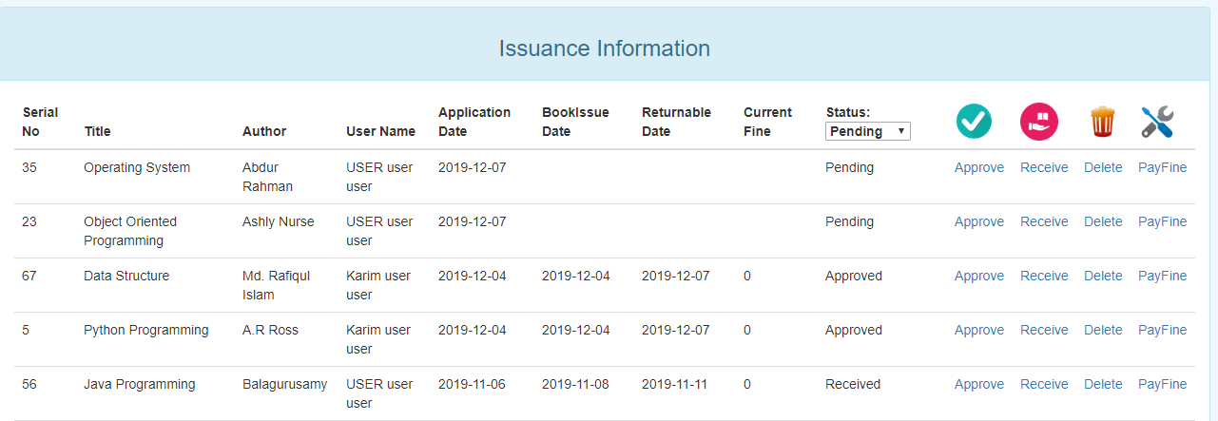

The librarian can approve the pending request simply by clicking the **approve** button.

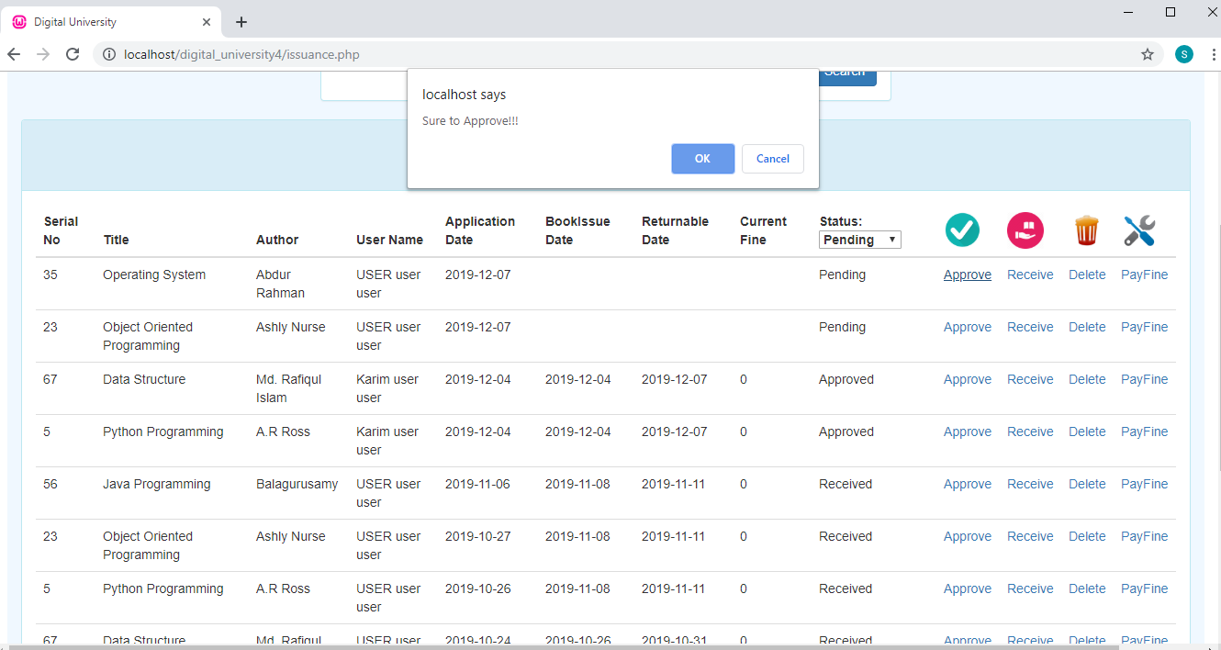

After the confirmation the status will be changed to approved. At the same time the BookIssue Date and Returnable Date will be set according to the library return policy. And Initially the fine will be zero.

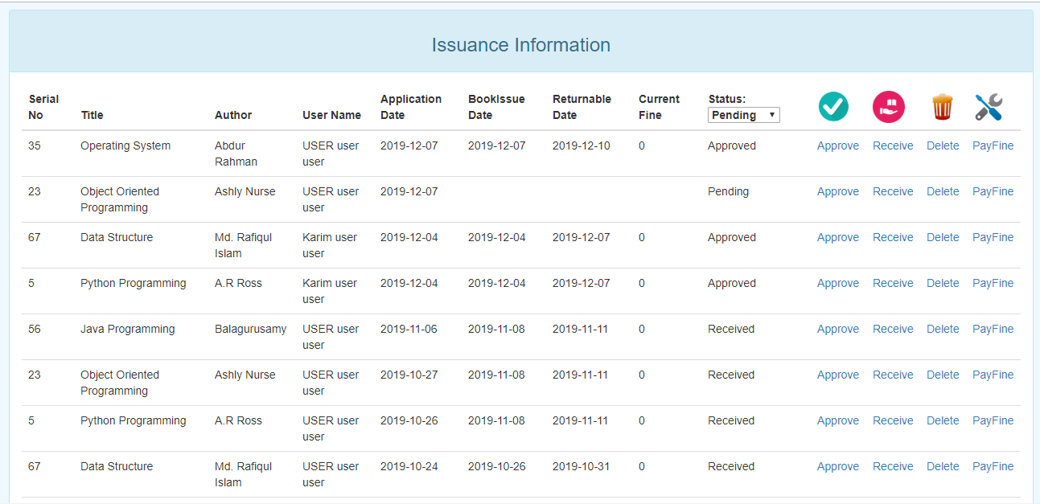

There is a feature for transferring the library fine to that particular user’s account as due amount. Previously the issuance page look like

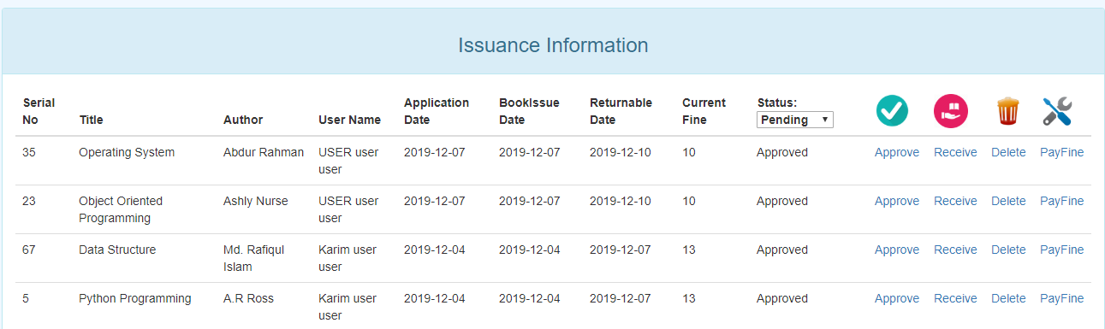

The librarian can update the due table of particular user by just clicking the **PayFine** button.

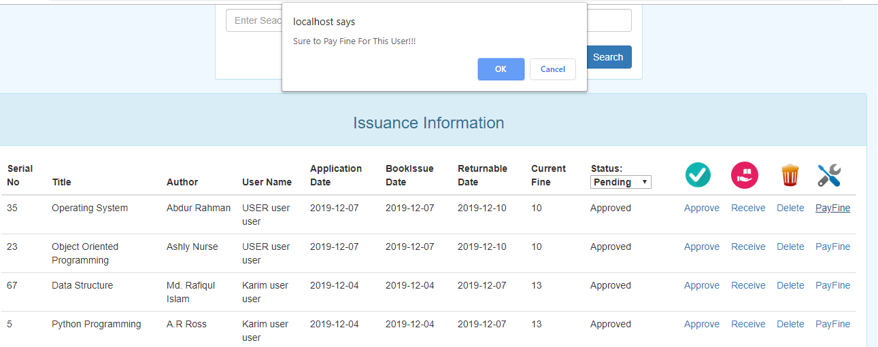

After the confirmation the due table will be updated and the Current Fine will be set to zero. Then the page looks like

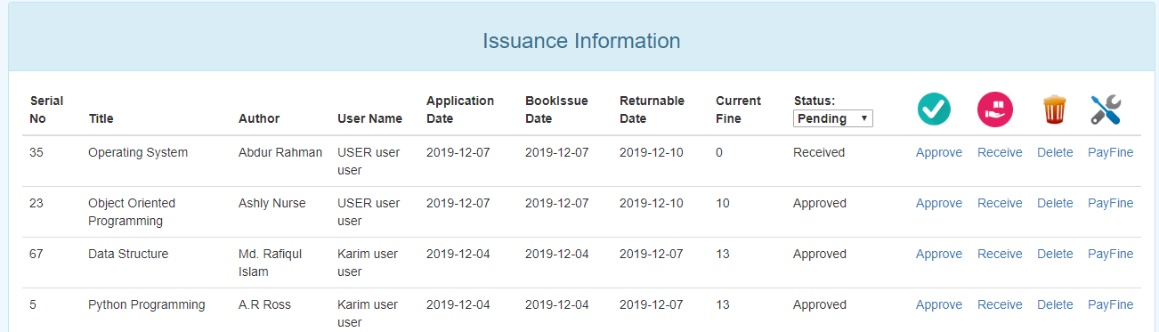

There is also a feature for setting up the fine per day due to delay. This operation can also be done by the librarian by the menu **Manage User Fine**

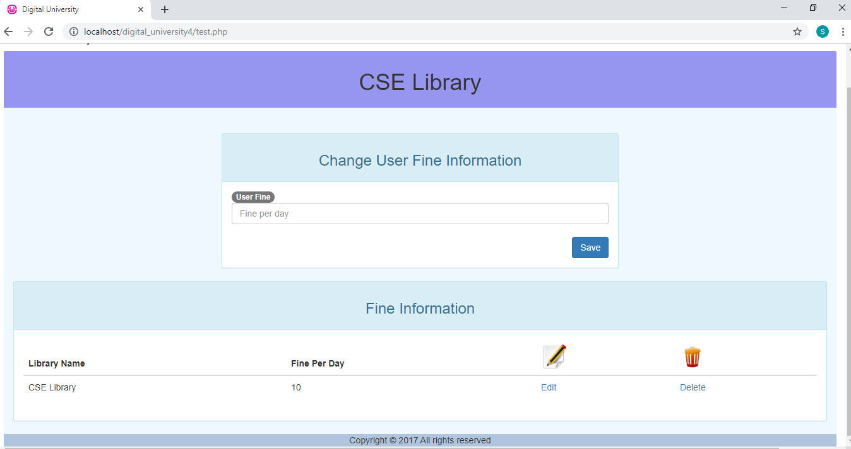

This is the basis for updating the due amount. The due amount for all the users are evaluated according to the fine per day. This is a fixed entity for a particular library.

## **User Mode**

After login, the user can view the homepage of the Khulna University Automation system as follow.

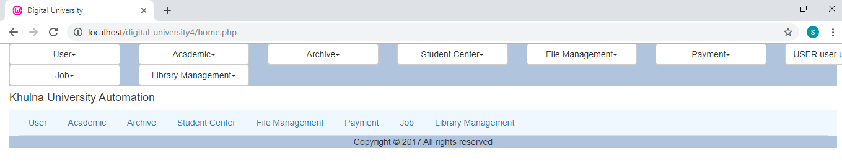

From the homepage the user can perform such functionalities. These are

1.Browse

2.Select Library

3.My Issuance

To observe these functionalities the user has to click the **Library Management** button.

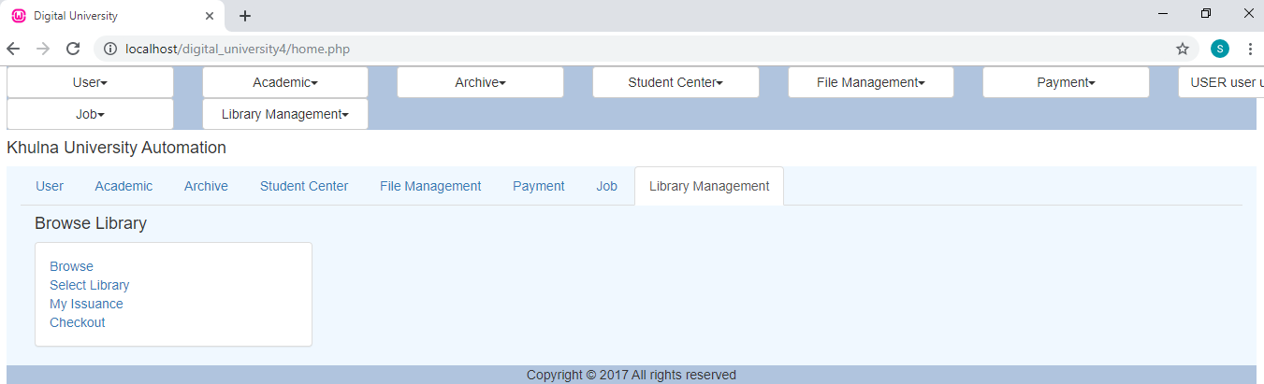

This is the user home page. From here he can browse for the desired books. Select the library from where he wants to issue a book. And from my issuance option he can see which books he has issued and their status. After clicking the **Browse** button the user can see the following page.

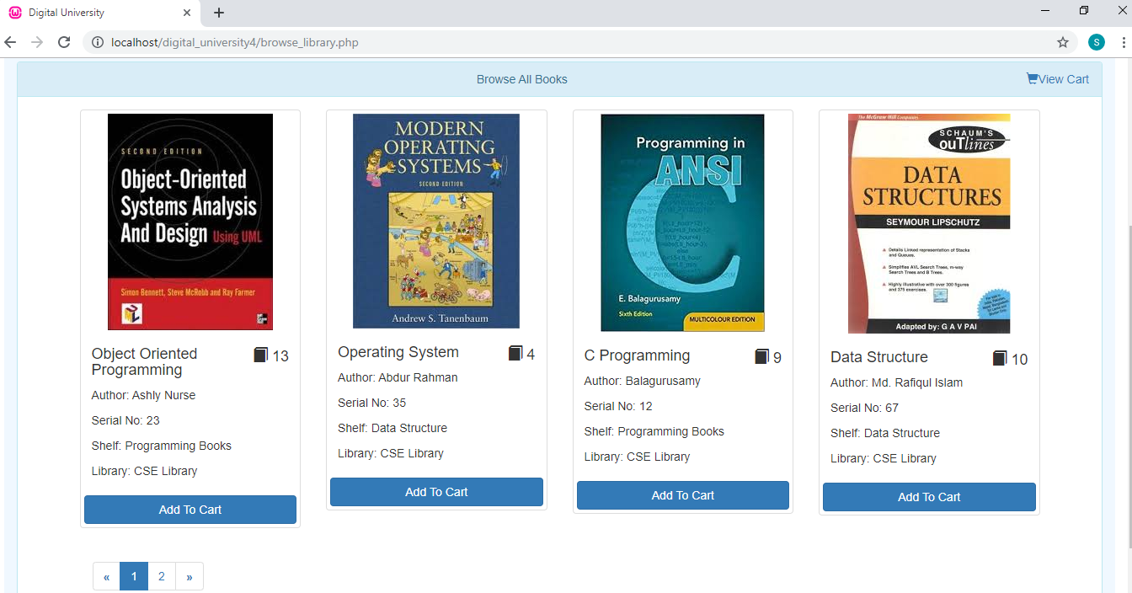

This is the browse option from home page of the user. Here he can search for his desired books and also some suggested books by the system. Every book has an **Add To Cart** button. By clicking that button that book will be added to his cart. When the user select some books by clicking the Add To Cart button , then he needs to click the **View Cart** button to confirm for the books request to a library. For this purpose there is a **Checkout** button. The user has then the following view

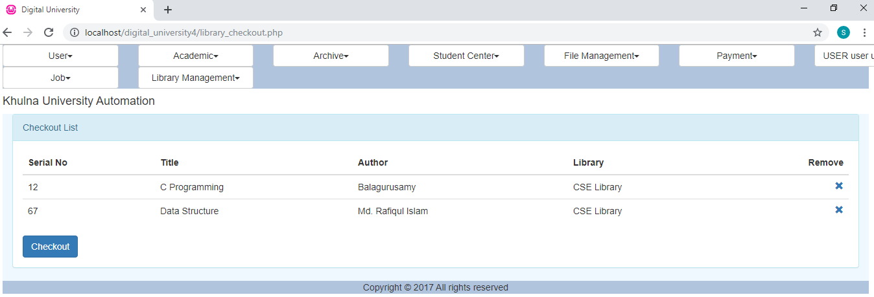

The user can remove any book from the selected books by simply clicking the **Remove** button.

There is a feature for the user to select a specific library and then browse. This is under the button **Select Library**.

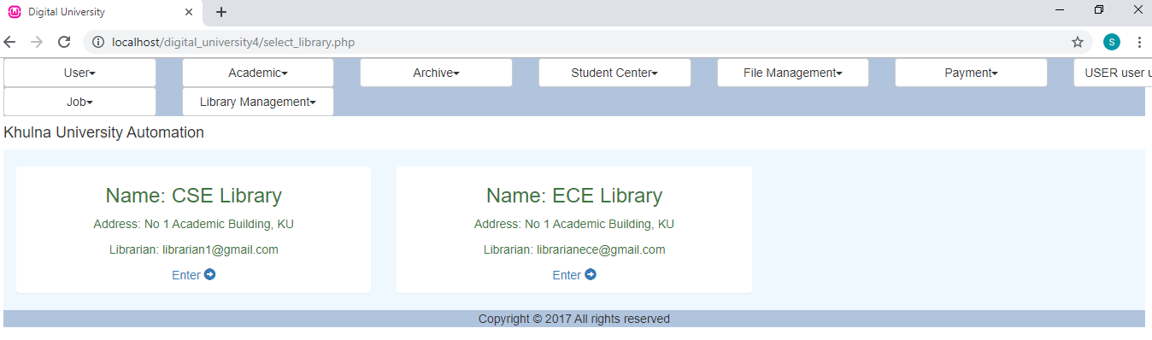

The user can also see his previous issuance history by just clicking the button **My Issuance** where different book having various status.

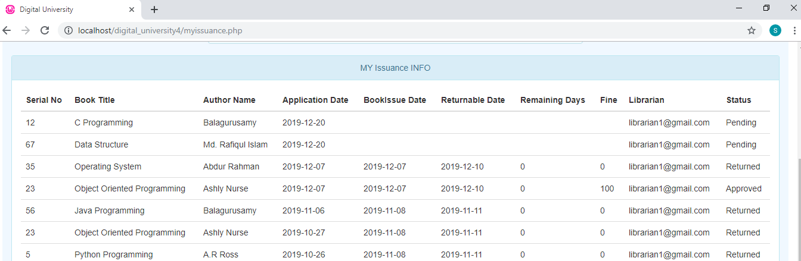

The user can see his payment section to observe if any due is added to his account by just clicking **My Account** from the **Payment** module.

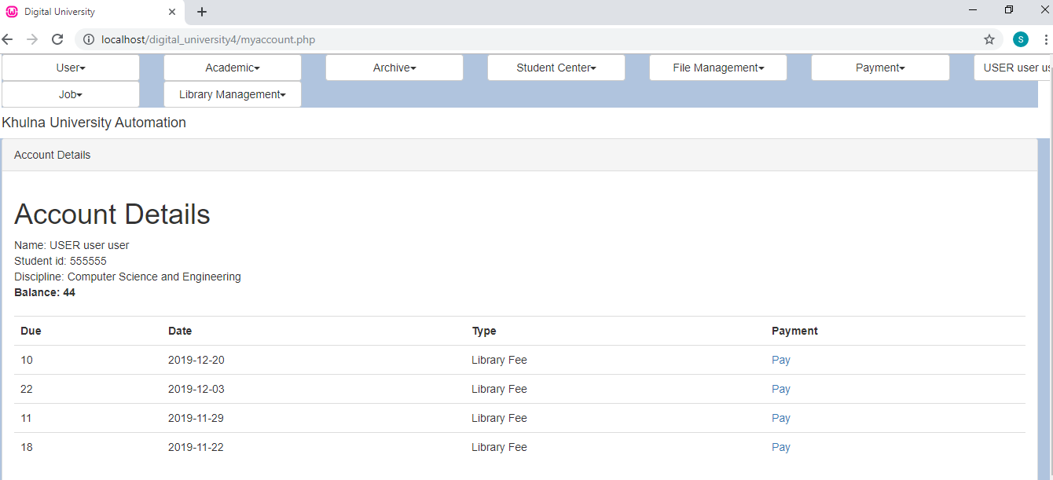

# 6. Dependencies:

1. SimTire: The Library Management System (LMS) is built on SimTire framework. So SimTire framework is needed to run this system properly.
2. User Module: SimTire’s built in “User Module” is needed to run LMS properly. Also notification class and other configurations is need to set the notification of various actions.
3. Payment Module: SimTire’s built in “Payment Module” is needed to run LMS properly.

**Special Thanks to:**

Dr. Kazi Masudul Alam

Associate Professor

CSE Discipline

Khulna University, Khulna

**Developed by:**

Md. Shymon Islam

Student Id: 170202

A.K.Z Rasel Rahman

Student Id: 170216

Ragib Mehedi

Student Id: 170208

CSE Discipline

Khulna University, Khulna