MAHMUDUL HASAN KHAN | 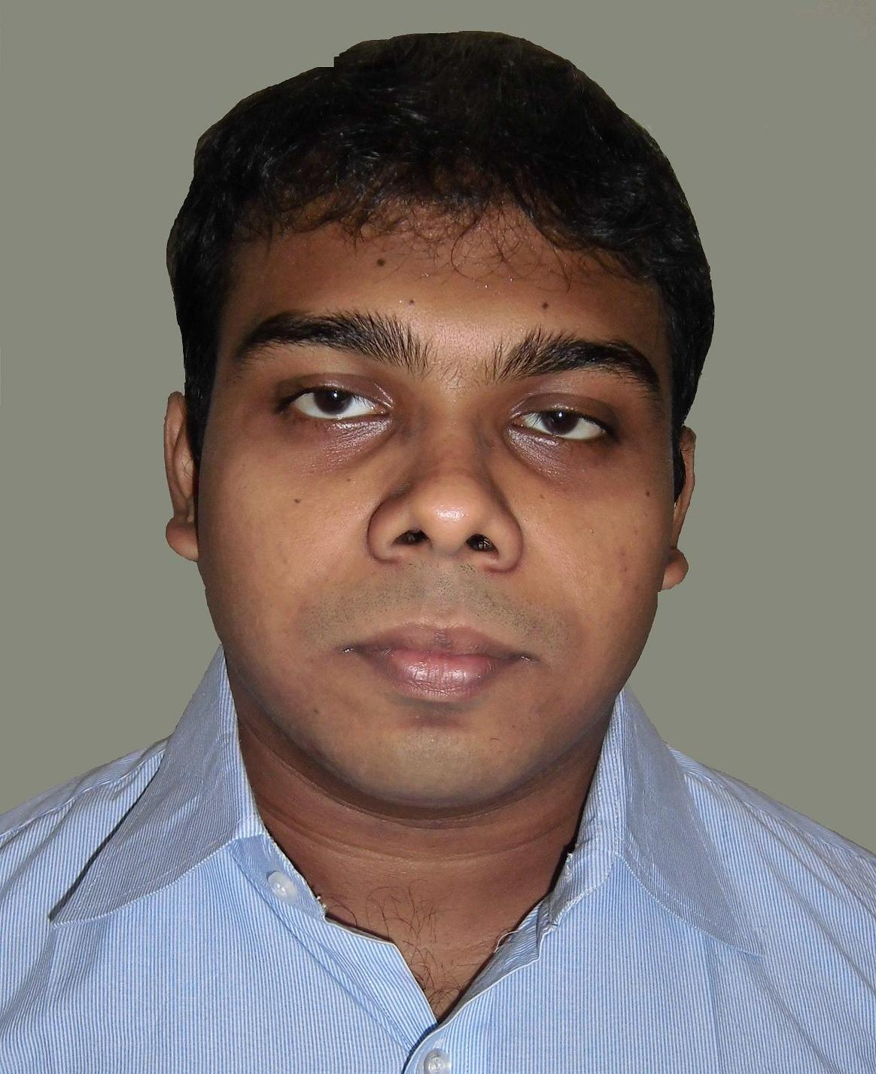
Address: New-Market City Complex, C – Tower, Floor no:- 12, Flat no:- 12/C-1, Biswas Builders Limited, 44/1 Rahim Square, New-Market, Dhaka :- 1205, Bangladesh
Mobile : +8801916931410
+8801193107686
Home Phone: +8801191793354
e-mail: cse.mahmud@yahoo.com

Career Objective:
To become an excellent software and web developer as well as to take the institution to its goal and the society towards development, indeed.

Academic Qualification:
Exam Title | Concentration/Major | Institute | Result | Pas.Year | Duration
Bachelor of Science (Engineering) | Computer Science and Engineering | Mawlana Bhashani Science and Technology University | CGPA:3.2  out of 4 | 2013 | 4 years
Higher Secondary School Certificate | Science | Udayan Bidyalaya | CGPA:4.6  out of 5 | 2007 | 2 Years
Secondary School Certificate | Science | Uadayan Uchcha Madhyamik Bidyalaya | CGPA:5.00  out of 5 | 2005 | 10 years

Training Summary:
Training Title | Topic | Institute | Location | Year | Duration
PHP with CodeIgniter Framework Advanced | HTML5, CSS3, JavaScript, PHP (with C.I.), OOP, MySQL | BASIS Institute of Technology & Management | 12 – Kawran Bazar, Dhaka – 1215, Bangladesh | 2014 | 120 Hours
HTML5, CSS3, Joomla 2.5, WordPress | HTML5, CSS3, Joomla 2.5, WordPress | BASIS Institute of Technology & Management | 12 – Kawran Bazar, Dhaka – 1215, Bangladesh | 2013 | 17 Days

Special Qualification:
Attended ACM programming contests [(i.) NCPC: - 2010, SUST, Sylhet and (ii.) ICPC: - 2010, NSU, Dhaka]
Technical Skills:
- Programming Language: PHP ( Framework CodeIgniter ), C, C++ and C #
- Web Development: Joomla 2.5, WordPress, ASP.NET (WITH MVC) HTML5, CSS3, JavaScript, JQuery.
- Database: MySQL, MS SQL server and Oracle.

Academic Projects:
- University Management System with ASP.Net (MVC) using Microsoft Visual Studio 2012
- Notepad with C++ using Turbo C++.

Language Proficiency:
Language | Reading | Writing | Listening | Speaking
Bengali | High | High | High | High
English | High | High | High | High

Extra Curricular Activities:
(1) Executive Member of Computer club of CSE Department in MBSTU, (2) Solving puzzle, quiz, analytical & mathematical problem, (3) Reading and writing story, poem & drama, (4) Watching and playing sports and body-building.

Personal Details:
Father's Name | : | M. A. QAIYUM KHAN
Mother's Name | : | HAFIZA KHATUN
Date of Birth | : | December 31, 1990
Gender | : | Male
Marital Status | : | Unmarried
Nationality | : | Bangladeshi
Religion | : | Islam
Permanent Address | : | 22/Chha Dhakeswari Road, Polashi, P.O. : - Posta, Thana : - Lalbag, Dhaka : - 1211, Bangladesh .

Reference (s):
 |  | Reference: 01 | Reference: 02
Name | : | A S M Delowar Hossain | Md. Belayet Ali
Organization | : | MBSTU | MBSTU
Designation | : | Assistant Professor | Assistant Professor
Address | : | Santosh,Tangail. | Santosh,Tangail.
Mobile | : | 01713585542 | 01722410844
E-mail | : | uzzal35@yahoo.com | belayet.040008@yahoo.com
Relation | : | Academic | Academic

