Gyula Henrik Csendes

ONE-stop shop for volunteering

Advanced web development, A non-profit web application

Table of Contents

Introduction 2

Project concept and motivation 2

Literature review 3

Introduction 3

Evaluation of previous work and available analysis of volunteering 3

United states billion-dollar disaster events 3

Volunteering and Civic Life in America 4

A Closer Look at nonprofits 5

A Closer Look at volunteers 6

American Red Cross’s volunteer page evaluation 7

Techniques and methods 10

Hardware 10

Software 10

Conclusion of the literature review 10

Project Design 10

Project overview 10

Domain and users 11

Justification of design choices 11

Software architecture 12

Core application features 13

Implementation plan 14

Testing and evaluation 14

Conclusion of design section 15

Feature Prototype 15

Feature 1, infrastructure 15

Feature 2, file storage in the database 15

Conclusion of prototype 16

References 16

List of Figures 17

# Introduction

## Project concept and motivation

In recent years, natural disasters have occurred more frequently than before. These disasters have also increased in the value of damages. After these events, in the United States volunteers are needed to help people recover from their loss.

This comes from a personal experience as well. I am visiting the United States frequently and unfortunately, I was in Fort Myers that was directly hit by Hurricane Ian – a category 5 hurricane – in 2022. Two years later there are still ruins of stone buildings and empty lands that were demolished by the storm surge. Hurricane Milton – a category 3 hurricane – that also created 46 tornadoes in a single day I was in Tampa, just 60 miles above the center of the hurricane. I have seen the devastation of the wind and the storm surge here as well.   
  
However, I have also seen the unity and the strength of the community to work together and help those in need. Organizations set up shelters and sent their volunteers to the area to help people from the evacuation zones, handing out blanket, food and water.

As I will demonstrate it under the literature review section, while these natural disaster events are increasing, the number of volunteers or events they participate are decreasing.

If I want to volunteer, I should register to individual sites and browse through their needs separately. This is not effective and it is likely that volunteers lose their motivation if they can’t find anything on the first 1-2 sites they are registered.

From the organization standpoint they can only reach out to people registered on their site or they can run social media campaigns to find new volunteers for their cause but there is no way for targeting individuals who have already volunteered and so they will more likely be open to join a given event if they hear about it.

I want to increase the chance to connect these individuals by providing a single website where all organizations can register and post their events. This way individuals need to search on a single place and find opportunities from organizations they are not already partnered with. It would also be beneficial for organizations as they could reach out and gain visibility to new individuals. It will also provide a reverse search option for organizations to find skilled volunteers, but only if the volunteer opts in to be visible to them. If not, their information would remain private. Additionally, users could track statistics about their efforts, such as the number of organizations they’ve worked with, hours spent on tasks, and more. The search functionality will be extended to allow filtering by organization, distance, required skills, or event date. I will try to implement an event-based chat feature, so volunteers participating in the same event can communicate and discuss it on a common platform.

This project is covered under the “Advanced web development, A non-profit web application” template of the final project document.

# Literature review

## Introduction

With the increasing number of natural disasters, the demand for volunteers is increasing. Organizations struggle to find new volunteers and to keep existing ones. I will create a website focusing on the United States where both nonprofits and volunteers can register their profile. Nonprofits can register their events while individuals can send their applications. This allows multiple organizations to browse volunteers based on their skills and other criteria. It will also enable volunteers search and find different opportunities from multiple organizations with a single access. This way individuals may partake in more events and organizations can reach out to a bigger population to highlight their cause and attract more help.

## Evaluation of previous work and available analysis of volunteering

### United states billion-dollar disaster events

Based on NOAA’s (National Oceanic and Atmospheric Administration U.S. Department of Commerce) National Centers for Environmental Information Climate Monitoring site, the billion-dollar disaster events in the United States has been increased significantly in the last decades. “The 1980–2023 annual average is 8.5 events; the annual average for the most recent 5 years (2019–2023) is 20.4 events.”[1]. The authors collected and analyzed 400 weather disaster events which exceeds $1 billion in damage in the U.S. between 1980 and 2024. This can be seen on Fig. 1 provided by the report.

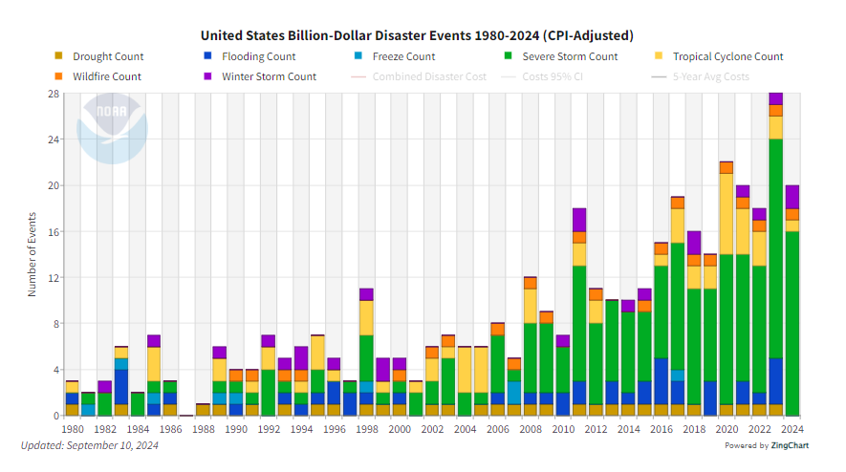

Fig. 1, United States Billion-Dollar Disaster Events 1980-2024

Based on the dataset provided by NOAA, I created a different chart (Fig. 2) to highlight the main tendency over decades and the last 1-3-5 year period. In the 1980s (1980-1989) the average billion-dollar event was 3.3 yearly, and the cost was $21.9B. During the time it has been increasing and in 2010s the average yearly number was almost doubled compared to the prior decade. The last 5/3/1 year periods are extremely high. This constant increase is a clear indicator that volunteer work will be needed in the future.

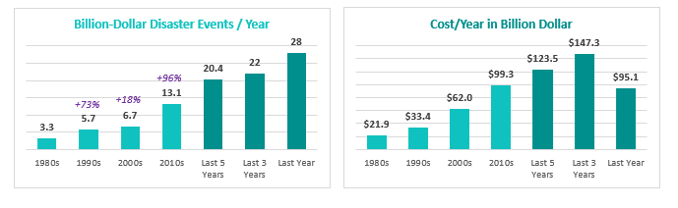

Fig. 2, United States Billion-Dollar Disaster Events per Year and Cost per Year

In the time of disaster volunteers help in various ways: clean up demolished homes and debris, take a role in making and distributing food, shelter management, mental health supporter, serve in logistics, healthcare, communication, rescue team, etc.

I’d like to demonstrate the need of a better approach to find and recruit volunteers as a nonprofit, as well as find events and opportunities as a volunteer. The upcoming analysis and reviews of different studies/articles/researches shows the challenges and narrows down the needs.

### Volunteering and Civic Life in America

According to the United States Census Bureau and the AmeriCorps research from 2023- the research comes out every 2 years -, more than 124 million people helped their neighbors informally between 2020 and 2021. It represents nearly 51% of the US population. It also says that “those who formally volunteered gave more than 4.1 billion hours of service with an estimated economic value of $122.9 billion”.[2]   
  
The main problem is that all statistics shows a decrease in volunteer numbers. The AmeriCorps research reported significant drop in the formal volunteering rate from 30% to 23.2%. These findings are based on data collected in September of 2017, 2019, and 2021. They reflect weighted state-level rates of four key measures of civic engagement. According to AmeriCorps’s research [2], these are:

* Formal Volunteering: the share of state residents who formally volunteered through organizations
* Informal Helping: the share of state residents who informally helped others by exchanging favors with their neighbors
* Organizational Membership: the share of state residents who belonged to an organization
* Charitable Giving: the share of state residents who donated $25 or more to charity.

[2]

On Fig. 3. I represent their findings on charts so that the decline is more visible.

Fig. 3, Decline in Volunteering based on AmeriCorps’s data

The United States Census Bureau holds the largest collection of demographic and economic data in the nation, and its data can be trusted in a study because it is collected through rigorous, standardized methods and produced by a reputable government agency dedicated to providing accurate, comprehensive national statistics.

### A Closer Look at nonprofits

Based on the 2024 Nonprofit Leadership Impact Study by NonProfit Pro, nonprofits struggle with recruiting dedicated volunteers. It says that “a third of respondents indicated they are unable to find and retain motivated volunteers who are passionate about their cause”. [3] According to the research the key challenges are shown on Fig. 4.

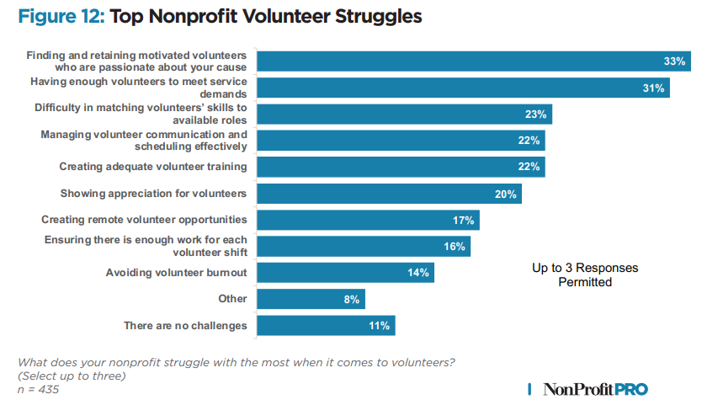

Fig. 4, Top Challenges of Nonprofits by NonProfit Pro

The top four categories clearly highlight nonprofit needs to find and retain the right volunteers. In my project, with every new registration the user signals their willingness to partake in volunteering for some cause. On a unified platform, organization demands can be satisfied as more people are available with a single registration. Volunteers will be able to provide their skills and organizations can find them which helps them to reach out to the right people. I plan to create a chat feature for each event separately which could address the communication challenge, but I’m not yet committed to implement it.

### A Closer Look at volunteers

Rosterfy is a volunteer management solution provider that connects their interface to the nonprofit’s own volunteer system. Their Volunteer Survey in March 2024[4] is a fresh research about volunteer motivation. Results are shown on Fig. 5.

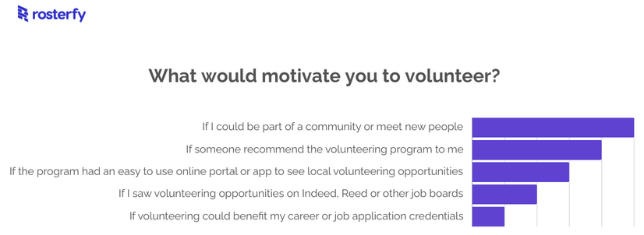

Fig. 5, Rosterfy’s March 2024 Survey for Volunteer Motivation

According to their result, volunteers prefer recommendation and an easy-to-use online portal with local opportunities. My implementation will support these requirements by providing searching opportunities based on distance as well as other factors. It will also have a recommendation feature where organizations and users will be able to send a given event to certain volunteers.

### American Red Cross’s volunteer page evaluation

American Red Cross (ARC) is one of the top 15 most trusted organizations out of 1.8 million nonprofits in the U.S. according to Morning Consult’s report of most trusted nonprofits 2024[5]. However, as their website is not designed only for their volunteer work, the application process for volunteering is not simple. Fig. 6, Fig. 7 and Fig. 8 shows that it is a three-step process to get to the basic search page.

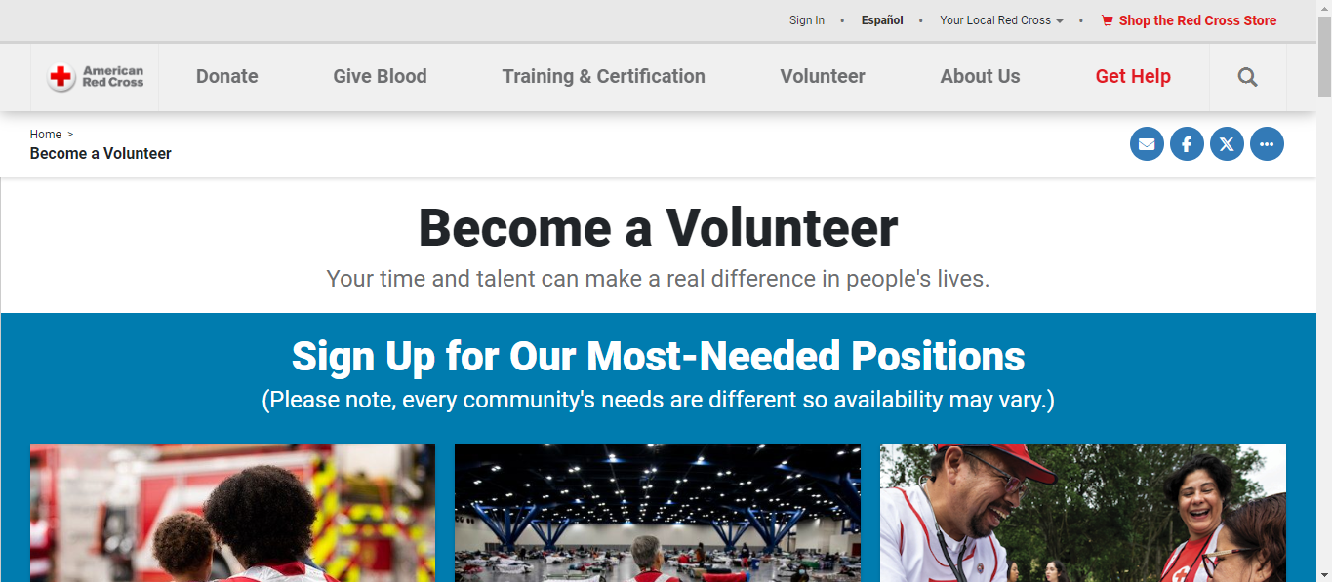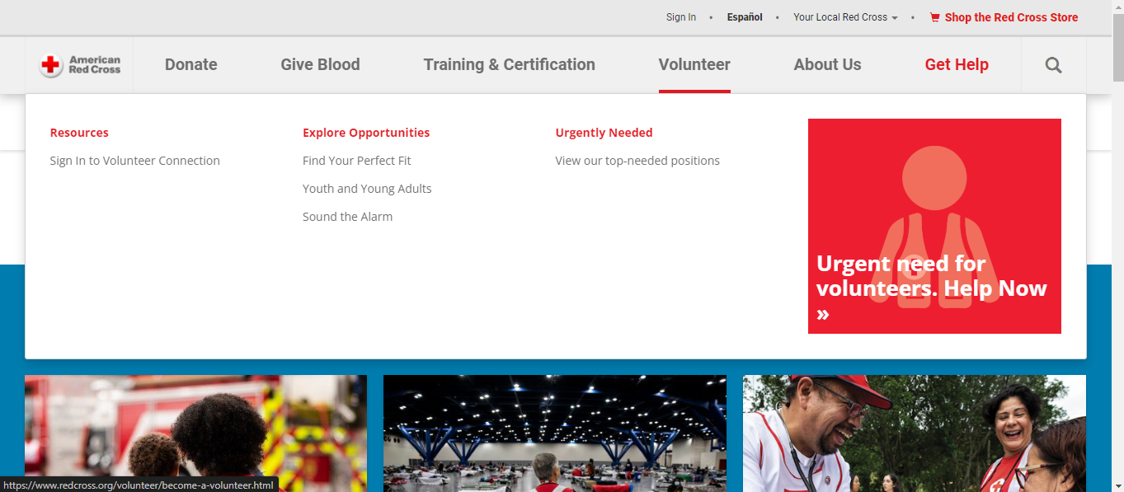

Fig. 6, ARC Home Page, Clicked on “Volunteer” Option

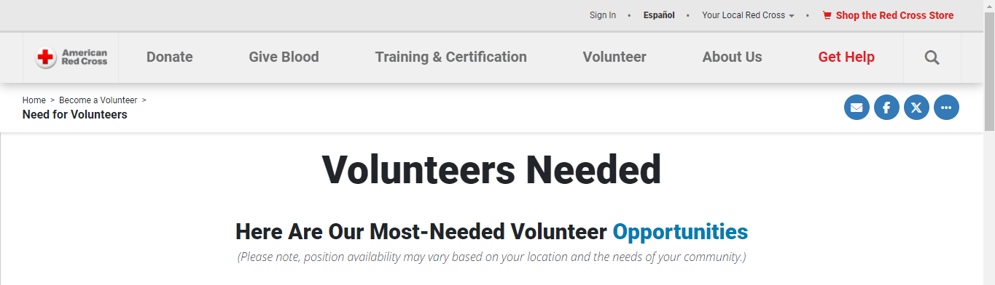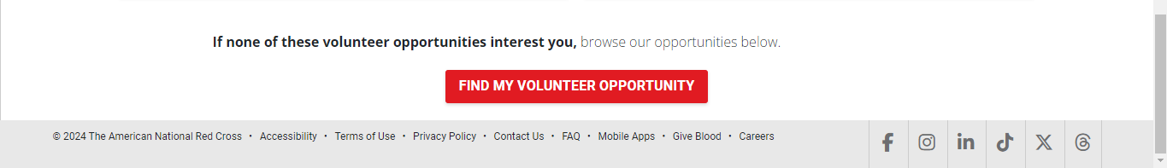

Fig. 7, ARC Site After Clicking on “Urgent need for volunteers. Help Now” Shown on Fig. 6.

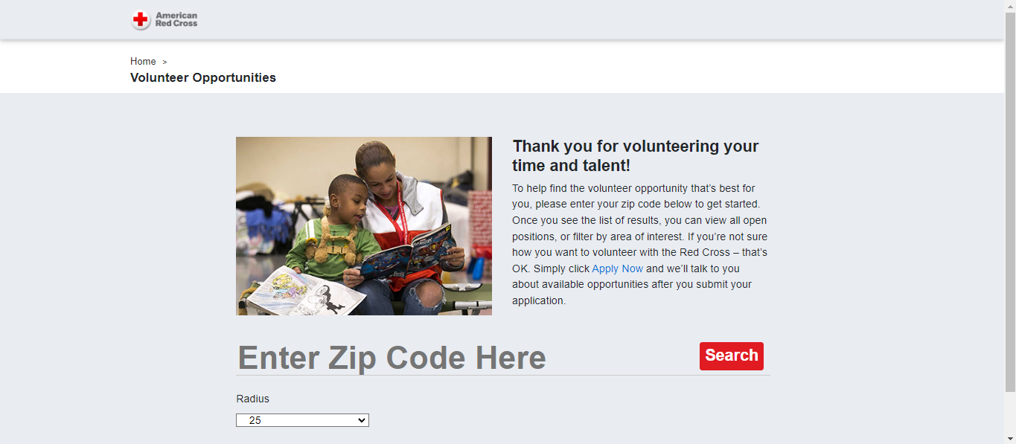

Fig. 8, ARC Site After Clicking on “Fing My Volunteer Opportunity” Shown on Fig. 7.

After following through these steps, the user still only can provide their Zip code and a radius within the opportunities are searched. Only after the first search new filter options are listed as shown on Fig. 9.

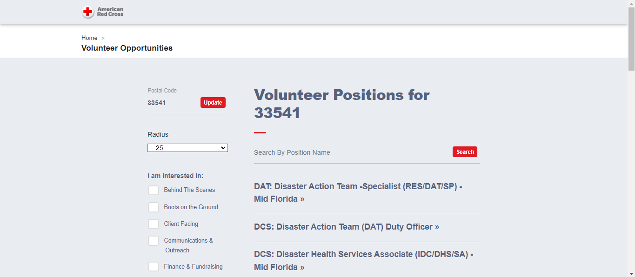

Fig. 9, ARC Page with Additional Filters After Search Was Pressed on Fig. 8.

Now there are a few causes are shown which would further limit the search result. If a user selects one, it shows more details about the given opportunity.   
However, at this point the missing parts are visible:

* It does not provide the recommendation option referred in Rosterfy’s report.
* Again, from Rosterfy the ease-of-use criteria is also questionable because of the multi-step and the limited search options.
* Similarly, as it does not support skill-based search, it also highlights the difficulty to match volunteer opportunities with volunteer skills from the NonProfit Pro study mentioned earlier.

Finally, the most obvious fact is that it only lists opportunities provided by American Red Cross. This means that if a volunteer is really determined to help, they might need to register to this site and others and go through the search process separately as one entity may not present a given opportunity while another can. That requires more time and effort from the volunteer. The more steps required, the more likely that the volunteer will just stop looking. This can be a reason why there is a decline in the number of volunteers and why organizations are struggling to find or retain them mentioned in earlier reviews.   
  
With a unified platform I propose, this can be resolved. While it requires organizations to register their events on my page, it simplifies the process from the volunteer’s perspective. They can search for events based on their skills or distance or cause, or even on event date and the results would include events from multiple organizations simplifying the search process. Organizations would benefit as well as they could get visibility from volunteers they not yet onboarded to their specific site. Also, with the reverse search – if user opts in - and recommendation system, they could reach out to the volunteers recommending certain events based on skills or distance that could help meet their demands.

## Techniques and methods

### Hardware

The project will be implemented on Oracle’s always free infrastructure. This includes a Linux virtual machine where I can host the server. It will be also relying on Oracle’s autonomous cloud database which is a reliable RDBMS that does not need separate infrastructure and is also part of the always free tier. It also supports various indexing and table partitioning options that allows scalability if the amount of data increase with the increasing number of organization and volunteer registrations and new events.

### Software

The project will be implemented using Django python framework that simplifies coding with its many built-in functions including database interactions and user authentications and security. It may be used with Nginx so that static files can be handled more effectively as well as handling multiple sessions more securely. Gunicorn will be used to as a Web Server Gateway Interface enhancing parallel requests. If I will be implementing the chat feature, then I will be relying on Redis to provide live, message-based chat features for the events. Pages may also contain vanilla JavaScript to enhance front-end experience.

## Conclusion of the literature review

The review process highlighted the increasing needs of volunteers as natural disasters keep increasing. It also showed organization struggles to reach out to more volunteers while volunteers prefer a simplified online platform with the ability to belong to a cause and keep up with the communication. A simple-to-use website that presents opportunities from multiple organizations with its recommendation system and chat can meet these criteria for both parties. Organizations can reach out to new volunteers mitigating their needs while volunteers have a one-stop-shop for more opportunities and can communicate with others partaking on the same events.

# Project Design

## Project overview

I’m building a website where multiple organizations can register and add volunteer opportunities. This way registered volunteers can browse multiple organizations on a single website. The benefit of browsing a single site is advantageous for volunteers as they do not have to register on multiple sites to see opportunities across multiple organizations. This has the benefit for organizations as well, because each organization can bring in their volunteer base and once registered and opted in, organizations can look for volunteers based on location or skill. It will also provide event recommendation and event chat. These options and features answers problems mentioned in reports during the discovery phase.

## Domain and users

The domain of the project is volunteering and how to connect more people to more organizations in a way that simplifies search for both parties and increase engagement through communication and reference. Also to find better candidates for an event based on different search categories.   
  
The current implementation is focusing on volunteers in the U.S. as distance search will be based on zip codes within the U.S., but a later implementation that replaces zip with a country and zip filter would further extend the users who could benefit from this application.

## Justification of design choices

During literature review multiple reports and surveys highlighted an increasing demand for volunteers while the number of volunteers decreased. Organizations reported issues finding new and retaining existing volunteers. They also reported that finding skilled volunteers is an issue. To them the unified platform can bring new volunteers as people can add their skills and opt-in to appear in searches conducted by the organizations.   
  
For the volunteers finding events they would participate becomes easier as they do not need to visit different sites. This can increase the number of events they participate as they don’t lose motivation as they move from site to site to find opportunities they are interested in. The event recommendation and chat feature also were mentioned in the surveys that can help increase volunteer engagement and increase the sense of belonging. By providing that feature my site could keep the engagement.  
  
I created the following S.W.O.T analysis that considers the findings of the literature review and the opportunity highlights what my site will aim to answer.

**Threats**

Competition between nonprofits

Increasing number of disasters

Volunteer burnout

Government policy changes

**Weaknesses**

Decreasing number of volunteers  
Long and complicated application process  
Can’t find skilled volunteers  
Lack of continuous communication

**Strengths**

Existing database of volunteers at nonprofit level  
Media highlight  
Constant communication of changing climate

**Opportunities**

Finding new volunteers out of network  
Find volunteers by skill  
Simplify sending application for event  
Volunteer engagement boost with event chat  
Event recommendation  
Monitoring volunteer trends

## Software architecture

1. Frontend: HTML, CSS and possibly JavaScript via Django templates.
2. Backend: Django views, models and URLs.
3. Web server: NGINX as a reverse proxy and Gunicorn to connect NGINX with the Django framework.
4. Messaging: Redis server will support an event chat feature so event participants can connect real time. Chat history will also be implemented.
5. Database: Oracle Autonomous Database for Transaction Processing. It requires the cx_Oracle package for connection and will be relying on this package for data operations as well.

This will be implemented on an Oracle Cloud Infrastructure (OCI). The design can be supported by the always free tier provided by Oracle so there is no cost relation. Points 1 to 4 will be implemented on a cloud Oracle Linux 9 server within the given OCI instance.   
  
For the database itself I will be using Oracle’s autonomous database within the same OCI instance. It has the advantage of not needing manual installation, only a few clicks on the OCI interface and I have a reliable RDBMS that does not need a dedicated database administrator as patches are applied automatically and it also creates backups.   
  
Figure 10 shows the planned infrastructure. This infrastructure has the potential to scale up by adding more resources if needed, however at a certain point that might require an upgrade to a paid tier, however Oracle also provides discounts and other benefits for nonprofits.

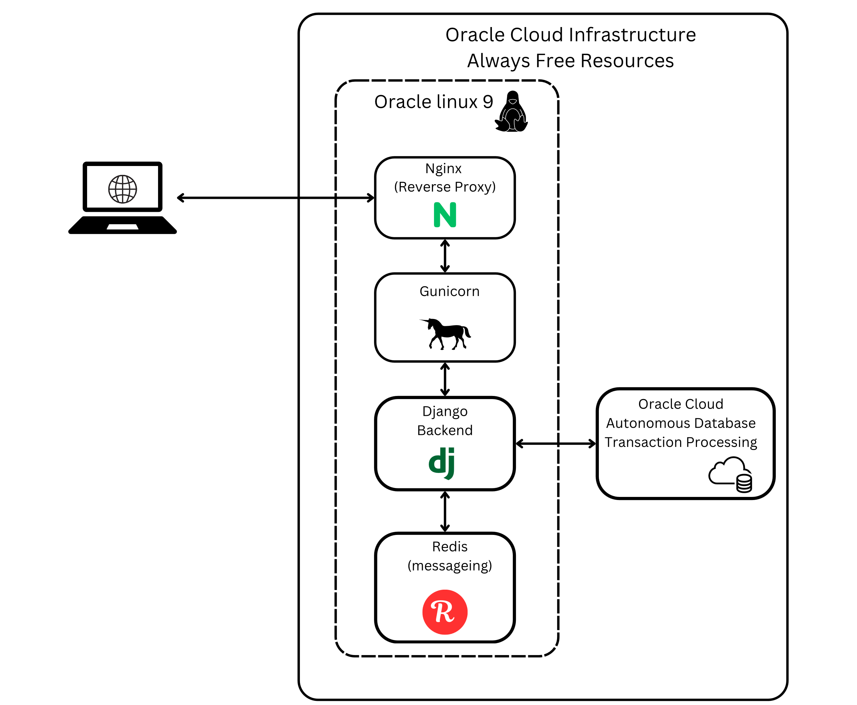

Fig. 10, Implementation on the Oracle Cloud Infrastructure free resources

Code change management is on GitHub. Changes will be committed using GitHub Desktop application.

## Core application features

* User and Organization registration: profile setups. Organization profiles need to be approved by site admin before they can access volunteers or create events
* Event creation: organizations to create events with appropriate details
* Event registration: volunteers to request joining an event
* Event search: volunteers to search events based on different criteria
* Volunteer search: organizations to search for volunteers who opted in to be visible and send events to them
* Volunteer event recommendation: volunteer to send an event recommendation to another volunteer if they are opted in to receive recommendations
* Event chat: volunteers and organizations have a chat room for every event to help build community and simplify communication. Chat is restricted to approved volunteers for the given event

## Implementation plan

Figure 11 shows the planned schedule of the implementation.

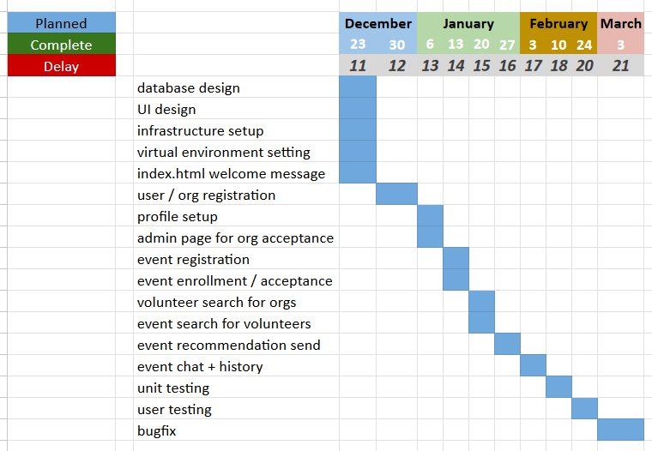

Fig. 11, Scheduled implementation plan

The day represents the planned end day of the given phase. The chart will be updated weekly and will be updated on GitHub, highlighting any delays or if possible, tasks completed ahead of time.

## Testing and evaluation

During development I will be creating unit tests to test functionalities of the site. I will also manually test each feature by creating dummy accounts for both organizations and volunteers.

Since I’m implementing this on the OCI infrastructure and the Linux server’s IP address will be open to public, I’m planning to requests some users to try out the page and will provide a survey for the participants. If modifications are required based on the feedback, I will try to implement them.

The evaluation will be considered a success if the webpage allows the following:

* User can register
* User can update profile information
* User can send event recommendations to other users
* User can sign up to an event
* User can join and use chat related to the event
* User can search events
* User can restrict visibility in search against organizations
* More than one organization can register
* Site admin can approve Organization to prevent fake Organization registration
* Only approved Organizations have access to any features of the site
* Organizations can create events
* Organizations can accept User application to event
* Organizations can search Users based on criteria if user opted in

## Conclusion of design section

After evaluating multiple literatures, the above structure defines a feasible path to implement a website that supports volunteering in the United States. Based on the Gantt chart there is sufficient time to implement the above steps on an infrastructure that is beyond the scope of the University and can reasonably support a nonprofit website without any cost.

# Feature Prototype

## Feature 1, infrastructure

As I have shown on Figure 10, the implementation infrastructure is complex and was not taught during the degree. I set up the necessary infrastructure using OCI. First the database and the Linux needed configuration. Then I installed NGINX and added it to the firewall. I also needed to install GUNICORN. Finally, I implemented a basic Django web application that does nothing else, but to reaches out to the database and queries the system time from it using this setup.

While the frontend is not highlighting any important application feature from the final project, the entire infrastructure is tested to see if the planned website is deliverable at all as I planned.   
  
I needed to configure NGINX to pick up the static files properly. I modified the settings.py with the detailed dns parameters to the cloud database. When querying the systimestamp from the database, I’m using cx_Oracle package to make the connection and get the data, but the connection string is built from the settings.py.  
  
The fact that the site loads, the time is displayed from the database and the favicon also appears proves that the infrastructure works and there will not be any problem storing the project related data in the Oracle cloud database.

## Feature 2, file storage in the database

Users and Organizations will have the possibility to upload pictures to their profile and for the event they organized. For this, on the same infrastructure I added another section to upload an image, and also a section where the images are displayed. The extra mile here is that files will not be stored on the Linux environment, but directly in the Oracle database, reducing the work of file operations on Linux. Oracle provides a BLOB (binary large object) datatype that can store up to 2 GB of varying-length binary data which is ideal for storing the images. These images then can be queried and decoded in python using base64 so that the images will appear on the page.   
  
This way the database backups will contain not just the normal data generated by the usage, but also profile and event images. It also turns the update or remove of an image to a simple database operation.

## Conclusion of prototype

After testing the features, I have the evidence that the infrastructure supports the design concept and planned features can be implemented. It also confirms that I will not be losing time on the implementation schedule because of unforeseen infrastructural difficulties and I can work on the database design in a way that files will be stored within certain tables.

# References

1. National Oceanic and Atmospheric Administration (NOAA), National Centers for Environmental Information (NCEI). Accessed 2024. U.S. Billion-Dollar Weather and Climate Disasters (2024). <https://www.ncei.noaa.gov/access/billions/state-summary/US>
2. Tim J. Marshall (U.S. Census Bureau), Erin Schneider (AmeriCorps).  
   Accessed 11/11/2024.   
   Volunteering in America: New U.S. Census Bureau, AmeriCorps Research  
   <https://www.census.gov/library/stories/2023/01/volunteering-and-civic-life-in-america.html>
3. Amanda L. Cole (NonProfit PRO)  
   Accessed 11/11/2024.   
   40 Nonprofit Trends for 2024   
   2024 Nonprofit Leadership Impact study  
   <https://nonprofitpro.tradepub.com/free/w_nonp31&ch=ADNB> (PDF download)
4. Rosterfy  
   Accessed 11/11/2024.   
   Volunteer Survey Results: What Motivates Volunteers to Choose Your Program?  
   <https://www.rosterfy.com/blog/rosterfy-community-motivation-survey>
5. Morning Consult  
   Accessed 11/11/2024.   
   Most Trusted Nonprofits 2024  
   The Most Trusted Nonprofits in the U.S.  
   <https://pro.morningconsult.com/analyst-reports/most-trusted-nonprofits-2024>

# List of Figures

Fig. 1: National Oceanic and Atmospheric Administration (NOAA), National Centers for Environmental Information (NCEI).   
United States Billion-Dollar Disaster Events 1980-2024  
Accessed 11/11/2024.  
Retrieved from: <https://www.ncei.noaa.gov/access/billions/state-summary/US>

Fig. 2: Author is self, based on data on reference [1]  
United States Billion-Dollar Disaster Events per Year and Cost per Year  
Data accessed on 11/11/2024

Fig. 3: Author is self, based on data on reference [2]  
Decline in Volunteering based on AmeriCorps’s data  
Data accessed on 11/11/2024

Fig. 4: Amanda L. Cole (NonProfit PRO)  
Accessed on 11/11/2024.   
40 Nonprofit Trends for 2024   
2024 Nonprofit Leadership Impact study   
Top Challenges of Nonprofits by NonProfit Pro  
<https://nonprofitpro.tradepub.com/free/w_nonp31&ch=ADNB> (PDF download)

Fig. 5: Rosterfy  
Accessed 11/11/2024.   
Rosterfy’s March 2024 Survey for Volunteer Motivation  
<https://www.rosterfy.com/blog/rosterfy-community-motivation-survey>

Fig. 6: American Red Cross  
Accessed on 11/11/2024.   
ARC Home Page, Clicked on “Volunteer” Option  
<https://www.redcross.org/>

Fig. 7: American Red Cross  
Accessed on 11/11/2024.   
ARC Site After Clicking on “Urgent need for volunteers. Help Now” Shown on Fig. 6.  
<https://www.redcross.org/volunteer/become-a-volunteer/urgent-need-for-volunteers.html>

Fig. 8: American Red Cross  
Accessed on 11/11/2024.   
ARC Site After Clicking on “Fing My Volunteer Opportunity” Shown on Fig. 7.  
<https://volunteerconnection.redcross.org/?nd=rco_opportunity_browse_list>

Fig. 9: American Red Cross  
Accessed on 11/11/2024.   
ARC Page with Additional Filters After Search Was Pressed on Fig. 8  
<https://volunteerconnection.redcross.org/?nd=rco_opportunity_browse_list&postal_code=33541&op_search_radius=25>

Fig. 10: Author is myself  
Implementation on the Oracle Cloud Infrastructure free resources  
Created on 11/29/2024  
Created on canva.com with PRO subscription

Fig. 11: Author is myself  
Scheduled implementation plan  
Created on 11/29/2024  
Created in MS Excel