**Line Follower Rules & Regulation**

The Challenge

 The challenge of the competition is to make a robot that can move on black lines on a white background and reach the finish as soon as possible.  
The competition area has is a special place defined for the robot’s operation (hereafter COMPETITION FIELD).  
The participants must create an autonomous vehicle (hereafter ROBOT), that will move on the COMPETITION FIELD and do certain tasks.  
The ROBOT which will start on the START tile and reach the FINISH tile block by following the black lines in the shortest time will be nominated the winner.  
   
1.1. Definitions  
      
      1.1.1. Race clock  
      There are optical sensors that detect the robot’s start and stop movement. When   the robot starts off from the START tile, the timer automatically starts to count the race time. As the robot reaches the FINISH tile, the timer automatically stops and the recorded time value is saved.  
     1.1.2. Trials  
     Every team will have 3 trial runs. After the trials are over, the fastest time achieved during those trials will be chosen for the team. One trial should not last more than five minutes. After the trial time is over, the TIME-UP BUZZER will sound and the team will be asked to remove the robot from the COMPETITION FIELD. If the robot is on the field half way and operating during the TIME-UP BUZZER sound, the team will be given 2 more minutes so the robot operation is not interrupted.  
   
1.2    Team Members

        1.2.1. Maximum 4 members are allowed in a team  
        1.2.2. Multiple bots are allowed from the same team

2.    The Field

2.1.    Field specifications

         2.1.1. The COMPETITION FIELD consists of 250mm x 250mm TILES (blocks) with different patterns mentioned in section 2.2. The final arrangement of the tiles will not be revealed until the competition day.  
        2.1.2. The number of TILES used in the COMPETITION FIELD will be between 20 ~ 60.  
        2.1.3. All measurements and dimensions have 10% tolerance.  
        2.1.4. The background color for each TILE is white with lines and signs in black.  
        2.1.5. Lines to be followed are 20mm in width and are black.  
        2.1.6. The organizing committee will make every possible attempt to ensure that there are no ‘bumps’ between the tiles although there may be slight deviations in height and width of up to 3mm. Competitors must be prepared to deal with these slight imperfections.  
        2.1.7. There will be one START tile and one FINISH tile in the entire field.  
  
2.2. Tiles  
Below are the tiles that will be used in the competition

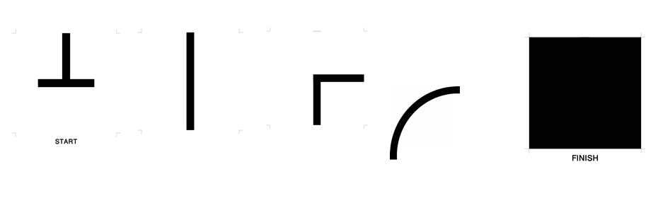

3.    The Robots  
  
3.1. Dimensions  
  
The following size limitations apply for each robot  
    Width – 200mm max  
    Length – 200mm max  
    Height – no limit  
  
3.2. Control  
      3.2.1. The robot must be controlled autonomously with no human aid.  
      3.2.2. The controller unit should be embedded in the robot and cannot be placed outside the robot.  
     3.2.3.  The robot must be started manually with a start button. The start button should have the word written near the button. The button is pressed by a judge.  
  
3.3. Power Source  
      3.3.1. The robot must be powered by a power source such as a battery or adapter of maximum 24v.  
      3.3.2. The Robot can be powered by a stationary power source connected to the robot by a cord.

3.4. Construction  
Any robot kit or building material may be used, as long as the robot fits the above specifications and as long as the design and construction are primarily the original work of the team.   
  
4. Game Play  
  
    4.1. Pre-Game setup  
    On the day of the competition each team has PREPARATION TIME which is 30 minutes. All the preparation should be done during this time (adjusting the sensors, reprogramming the robot…etc).

   4.2. Game Zone  
   An area around the field will be designated as the GAME ZONE. No one is allowed inside the game zone except for the robot handlers and the referees.

   4.3. Start and Restarts  
         4.3.1. One team member is elected as the robot handler. Only that team member is permitted to handle the robot during the game. All other team members must remain outside the game zone.  
        4.3.2. The robot will be placed at the START tile and checked by one of the referees.  
        4.3.3. A robot may restart the run as the handlers deem necessary within the TRIAL TIME. The restart can be requested only if the robot doesn’t follow the line, has stopped on half way or has lost the directions. If the robot has reached the FINISH, the time is saved for that current TRIAL and the team cannot request another run.  
       4.3.4. At any restart, the robot must be positioned back at the start tile and started by the referee.  
      4.3.5.  It is not allowed to reprogram the robot or to add/remove parts on the robot during the trial but it is allowed to adjust the sensors.  
      4.3.6.  The RACE CLOCK will reset to zero on every restart. The COMPETITION CLOCK and the TRIAL CLOCK will keep running during all restarts.  
      4.3.7.  There is no limit for the number of restarts within the TRIAL period.  
      4.3.8.  A robot must restart if:  
             - The robot does not start after pressing the Start Button for 1 minute.   
             - The robot is touched by a human.  
             - The robot moves off the field.  
             - The referee orders to restart.   
  
4.4.    Following the line  
  
4.4.1.    For the purposes of determining if the ROBOT has left the line or left the tile, the referee will use the CONVEX HULL of the robot. This measure is done by stretching an imaginary rubber band around the extremities of the robot, and using the enclosed space as a silhouette.  
4.4.2.    A team’s robot must remain at the field until it has completed its game including the 5 seconds freezing at the FINISH tile.  
  
5.    Scoring  
RACE TIME is the time considered for tracing the route from START to FINISH. RACE TIME is calculated automatically by the on-field optical sensors that detect the robot’s movement. The robot that will have the fastest run will win the competition.  
  
6.    Rules & Fouls  
6.1.    The robot violating any of the rules described below will be disqualified from the competition or forced to restart the robot from the START tile.  
6.2.    Any kind of touch by a human which affects the robot direction or speed will cause a fault state and force the team to restart from the START tile.  
  
7.    Code of Conduct  
  
7.1. Fair Play  
      7.1.1. Robots that cause deliberate interference with other robots or damage to the field will be disqualified.  
     7.1.2.  Humans that cause deliberate interference with robots or damage to the field will be disqualified.  
     7.1.3.  It is expected that the aim of all teams is to play a fair and clean game.