SMOKE Test Case

Very Brief Installation Instructions 1
Import SMOKE Case 1
Update SMOKE Case 2
Case 2
Jobs 2
Inputs 3
Parameters 5
Run SMOKE Case 6
Jobs 6
Important Note 7
History 7
Outputs 15
Trouble Shooting 20

Very Brief Instructions
- Import SMOKE Case
- Update SMOKE Case
- Run SMOKE Case

Import SMOKE Case
- Download the SMOKE test case (SMOKE_test_case.tar.gz) from the EPA's ftp site:
FTP address: scienceftp.epa.gov
login: emfbeta
password: 4aXqKhhu
- Extract file:
$ tar xvfz SMOKE_test_case.tar.gz
- Import the Case files into the EMF.
- Once the case is imported, you should see a new case named “2005ak Beta Test” under the Case category “Demo”. The Case should have:
  - 54 Jobs
  - 282 Inputs (Note: To see all the inputs, you will need to select “All” from the Sector pull-down and select the Show All checkbox)
  - 174 Parameters (Note: To see all the inputs, you will need to select “All” from the Sector pull-down and select the Show All checkbox)
  - 2 Regions (on the Summary tab):
    - Continental US 36km (36US1)
    - Eastern US 12km (12EUS1)

Update SMOKE Case

Case
Under the current EMF import process, the Case’s Base Year is not set. You will need to set the value of the Base Year field to “2005”.

Jobs
While there are 54 Jobs defined in the Case, not all the Jobs have the requisite Inputs to run completely. Once the Case is configured for your system, the following 9 jobs should run:
- Annual ag 36US1
- Annual alm_no_c3 36US1
- Annual afdust 36US1
- Annual ptfire onetime steps 36US1
- Annual ptnonipm onetime steps 36US1
- Annual ptnonipm Q1 36US1
- Daily ptfire Q1 36US1
- Sector merge Jan-Jun 36US1
- Annual afdust 12EUS1
As with the previous test Cases, you will need to update the following fields to match your system. (Hint: Select All the Jobs and use the Modify button to modify all the Jobs at once):
- Host
- Queue Options
In addition to the individual Jobs, you will need to modify the value of the Output Job Scripts Folder to match your system. For example:
/data4/smoke_emf/subsys26/smoke26/scripts/cases/$CASE

Inputs
For each of the 9 Jobs that are configured to run properly with this test Case, it is necessary to have all the Inputs defined for the Job’s Sector, as well as all the Inputs for “All Sectors”. If the names of the Datasets were named properly prior to the import of the Case, the “linking” should be performed automatically. Below is a list of all the Inputs that will be needed to run the Jobs.
Input | Dataset | Sector
Inventory afdust CAP | afdust_2002ad_xportfrac | afdust
Report configuration, ag inventory | repconfig_ag_inv | ag
Inventory ag CAP | ag_cap2002nei | ag
surrogate ratios USA 12km | USA 12km surrogates | All sectors
surrogate ratios MEX 36km | MEX 36km surrogates | All sectors
surrogate ratios USA 36km | USA 36km surrogates | All sectors
surrogate ratios MEX 12km | MEX 12km surrogates | All sectors
surrogate ratios CAN 12km | CAN 12km surrogates | All sectors
surrogate ratios CAN 36km | CAN 36km surrogates | All sectors
Grid Description List | griddesc_lambertonly | All sectors
Country, State, County Information | costcy_for_2002 | All sectors
Inventory Table - HAPCAP integration but no toxics | invtable_hapcapintegate_cb05soa_nomp | All sectors
emf job header | emf_jobheader_generic | All sectors
surrogate descriptions (works for all grids) | srgdesc_36km_revised | All sectors
nonpoint & nonroad surrogate xref | amgref_us_can_allmex3 | All sectors
GSPRO speciated MOVES PM | gspro_speciated_pm | All sectors
GSREF speciated PM | gsref_speciated_pm | All sectors
Report configuration, nonpoint default gridded | repconfig_area_invgrid_caphap | All sectors
Report configuration, nonpoint default inventory | repconfig_area_inv_caphap | All sectors
Report configuration, nonpoint default VOCprof | repconfig_area_inv2 | All sectors
Elevation Configuration File for Point Sources | pelvconfig_inline_allpts | All sectors
Temporal xref, point default | amptref_v3_3 | All sectors
Smkmerge representative dates files | smk_merge_dates_2005 | All sectors
Speciation profiles speciated VOC | gspro_speciated_voc | All sectors
Speciation xref HG | gsref_hg | All sectors
Speciation xref for Integrate-HAPs static | gsref_static_integratehap_emv4 | All sectors
Speciation xref for NONHAPVOC, year-specific | gsref_nonhapvoc_2005 | All sectors
Speciation xref for NONHAPVOC, not year-specific | gsref_nonhapvoc_general_update | All sectors
Speciation xref for VOC, year-specific | gsref_voc_2005 | All sectors
Speciation xref for VOC, not year-specific | gsref_voc_general | All sectors
Speciation profiles for INTEGRATE HAPS | gspro_integratehaps_cb05_tx_pf4 | All sectors
Speciation profiles for NOX | gspro_nox_hono_pf4 | All sectors
Speciation profiles for HG | gspro_hg | All sectors
List of sectors for mrggrid | sectorlist_2005ak_test | All sectors
Speciation profiles for NONHAPTOG | gspro_nonhaptog_cb05_tx_pf4_pretier2 | All sectors
Speciation xref for PM2.5 diesel SCCs but do not produce diesel | gsref_no_dieselpm | All sectors
Speciation xref for PM2.5 non-diesel SCCs | gsref_pm25_pf4_nondiesel | All sectors
Speciation xref for SO2-SULF | gsref_sulf | All sectors
Speciation xref static NOX -- HONO for mobile sources | gsref_static_nox_hono_pf4 | All sectors
Speciation xref CAP static | gsref_static_cap_pf4 | All sectors
Speciation profiles for TOG | gspro_tog_cb05_soa_pf4_pretier2 | All sectors
Speciation profiles for SO2-SULF | gspro_sulf | All sectors
Speciation profiles for PM2.5 | gspro_pm25 | All sectors
Speciation profiles static | gspro_static_cmaq | All sectors
NAICS descriptions | naicsdesc | All sectors
MACT Description | mactdesc_2002v3 | All sectors
Combination profiles | gspro_combo_2005 | All sectors
Temporal profiles, all point | amptpro_2005_us_can | All sectors
Temporal xref, onroad mobile default | amptref_v3_3 | All sectors
Temporal profiles, onroad default | amptpro_2005_us_can | All sectors
onroad surrogate xref default | amgref_us_can_allmex3 | All sectors
SIC descriptions | sic_desc | All sectors
Stack replacement | pstk | All sectors
ORIS Description | orisdesc | All sectors
Mobile codes file default | mcodes | All sectors
GSCNV - pollutant to pollutant conversions | gscnv_cmaq_cb05_tx_pf4 | All sectors
Holidays table | holidays | All sectors
Area-to-point data | artopnt_2002detroit | All sectors
Temporal xref, all nonpoint and nonroad | amptref_v3_3 | All sectors
Temporal profiles, all nonpoint and nonroad | amptpro_2005_us_can | All sectors
SCC descriptions | sccdesc_pf31 | All sectors
Report configuration, alm_no_c3 inventory | repconfig_alm_inv_caphap | alm_no_c3
NHAPEXCLUDE alm_no_c3 | nhapexclude_alm_no_c3_pf4 | alm_no_c3
Inventory alm_no_c3 CAP | lm_no_c3_cap2002v3 | alm_no_c3
Inventory alm_no_c3 HAP | lm_no_c3_hap2002v4 | alm_no_c3
Inventory fire list | ptfire_2005ag_tox | ptfire
Inventory daily fires 12 Dec, CAP/HAP last day | ptfire_nov_lastdayonly_2005ag_tox_nonhapvoc | ptfire
Inventory daily fires 06 Jun, CAP/HAP last day | ptfire_may_lastdayonly_2005ag_tox_nonhapvoc | ptfire
Inventory daily fires 03 Mar, CAP/HAP last day | ptfire_feb_lastdayonly_2005ag_tox_nonhapvoc | ptfire
Inventory daily fires 04 Apr, CAP/HAP last day | ptfire_mar_lastdayonly_2005ag_tox_nonhapvoc | ptfire
Inventory daily fires 07 Jul, CAP/HAP last day | ptfire_jun_lastdayonly_2005ag_tox_nonhapvoc | ptfire
Inventory daily fires 05 May, CAP/HAP last day | ptfire_apr_lastdayonly_2005ag_tox_nonhapvoc_txt | ptfire
Inventory daily fires 08 Aug, CAP/HAP last day | ptfire_jul_lastdayonly_2005ag_tox_nonhapvoc | ptfire
Inventory daily fires 09 Sep, CAP/HAP last day | ptfire_aug_lastdayonly_2005ag_tox_nonhapvoc | ptfire
Inventory daily fires 10 Oct, CAP/HAP last day | ptfire_sep_lastdayonly_2005ag_tox_nonhapvoc | ptfire
Inventory daily fires 11 Nov, CAP/HAP last day | ptfire_oct_lastdayonly_2005ag_tox_nonhapvoc | ptfire
Inventory daily fires 02 Feb, CAP/HAP last day | ptfire_jan_lastdayonly_2005ag_tox_nonhapvoc | ptfire
Inventory daily fires 12 Dec, CAP/HAP | ptfire_dec_2005ag_tox_nonhapvoc | ptfire
Inventory daily fires 11 Nov, CAP/HAP | ptfire_nov_2005ag_tox_nonhapvoc | ptfire
Inventory daily fires 10 Oct, CAP/HAP | ptfire_oct_2005ag_tox_nonhapvoc | ptfire
Inventory daily fires 09 Sep, CAP/HAP | ptfire_sep_2005ag_tox_nonhapvoc | ptfire
Inventory daily fires 08 Aug, CAP/HAP | ptfire_aug_2005ag_tox_nonhapvoc | ptfire
Inventory daily fires 07 Jul, CAP/HAP | ptfire_jul_2005ag_tox__nonhapvoc | ptfire
Inventory daily fires 06 Jun, CAP/HAP | ptfire_jun_2005ag_tox_nonhapvoc | ptfire
Inventory daily fires 05 May, CAP/HAP | ptfire_may_2005ag_tox_nonhapvoc | ptfire
Inventory daily fires 04 Apr, CAP/HAP | ptfire_apr_2005ag_tox_nonhapvoc | ptfire
Inventory daily fires 03 Mar, CAP/HAP | ptfire_mar_2005ag_tox_nonhapvoc | ptfire
Inventory daily fires 02 Feb, CAP/HAP | ptfire_feb_2005ag_tox_nonhapvoc | ptfire
Inventory daily fires 01 Jan, last day CAP/HAP | ptfire_dec_lastdayonly_2005ag_tox_nonhapvoc | ptfire
Inventory daily fires 01 jan, CAP/HAP | ptfire_jan_2005ag_tox_nonhapvoc | ptfire
Inventory Table - noHAPuse sectors, no toxics | invtable_hapcapnohapuse_cb05soa_nomp | ptnonipm
Report configuration, ptnonipm gridded | repconfig_point_invgrid_caphap | ptnonipm
Report configuration, ptnonipm inventory | repconfig_point_inv_caphap | ptnonipm
Report configuration, ptnonipm VOCprof | repconfig_point_inv2 | ptnonipm
Inventory ptnonipm CAP | ptnonipm_xportfrac_cap2005v2 | ptnonipm
Inventory ptnonipm HAP | ptnonipm_hap2005v2 | ptnonipm
If any of the above Inputs do not have a dataset in the imported Case, you should manually match the dataset to the Input by editing the specific Input. This mismatch is likely due to a slight inconsistency in the names. The sectors that you are not running will have missing Inputs.
In addition to the individual Inputs, you will need to modify the value of the Input Folder field to match your system. For example:
/data4/smoke_data/inputs/$CASE

Parameters
Some of the parameters will need to be modified to match your system:
- SMK_HOME: Should point to the location of the smoke_emf directory referred to in the “Setup SMOKE_EMF Directories” section of the SMOKE Test Cast Part 1 document. For example:
/data4/smoke_emf
- IMD_ROOT: Should point to the location of SMOKE's intermed directory. For example:
/data4/smoke_data/intermed
- DAT_ROOT: Should point to the location of the smoke_data. For example:
/data4/smoke_data
- OUT_ROOT: Should point to the location of the SMOKE's output directory. For example:
/data4/smoke_data/output
- SRGPRO_PATH (multiple): Should point to the location of your spatial surrogates (and should match the path to the sources for your surrogate Inputs). For example:
/data4/smoke_data/inputs/ge_dat/36km_surg/
Note: The trailing slash is required!
- EMF_QUEUE_OPTIONS: Modify this parameter as in the previous test Case. As a reminder: If you are using a real process queue, select the parameter and click Edit. If you are using the fake queue, the value of the 'EMF queue options' does not matter because it should not be used by your Jobs.

Run SMOKE Case

Jobs
We recommend running the 9 Jobs in the following order:
- Annual ag 36US1
- Annual alm_no_c3 36US1
- Annual afdust 36US1
- Annual ptfire onetime steps 36US1
- Daily ptfire Q1 36US1
- Annual ptnonipm onetime steps 36US1
- Annual ptnonipm Q1 36US1
- Sector merge Jan-Jun 36US1
- Annual afdust 12EUS1
Some of the reasoning behind this is:
- The “Annual ag 36US1” Job is relatively simple and fast to run
- The “Annual afdust 36US1” Job simulates a full year, unlike the other Jobs that simulate one month
- The “Daily ptfire Q1 36US1” Job depends on the “Annual ptfire onetime steps 36US1” Job
- The “Annual ptnonipm Q1 36US1” Job depends on the “Annual ptnonipm onetime steps 36US1” Job
- The “Sector merge Jan-Jun 36US1” Job depends on all the 36km Jobs
- The “Annual afdust 12EUS1” Job depends on the “Annual afdust 36US1” Job
In actuality, the following 5 Jobs can be run in parallel (simultaneously) if you choose and your system can handle the load:
- Annual ag 36US1
- Annual alm_no_c3 36US1
- Annual afdust 36US1
- Annual ptfire onetime steps 36US1
- Annual ptnonipm onetime steps 36US1

Important Note
After running the first Job (e.g.,” Annual ag 36US1”), the EMF will have created the Job folder (e.g., /data4/smoke_emf/subsys26/smoke26/scripts/cases/2005ak_test). Before running any of other jobs (especially the point Sector Jobs), copy the run_settings_2005ak_test.txt file contained in the new additional_datasets.tar.gz file into the Job folder.
This file controls which parts of SMOKE are not run for a specific Sector and grid. For example, this file turns off Smkinven for all 12EUS1 Jobs.

History
Below are screenshots of the expected messages from each o f the 9 Jobs:
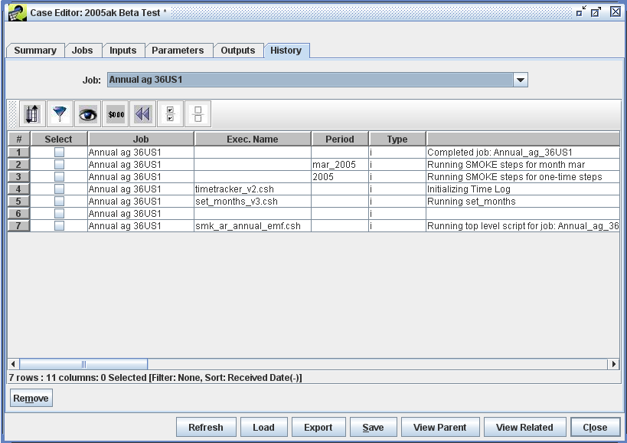
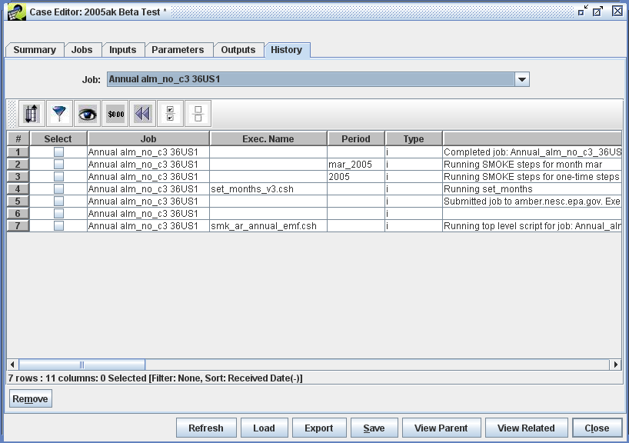
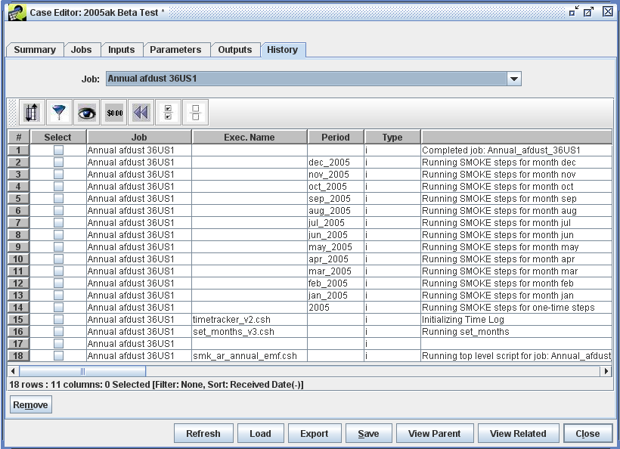
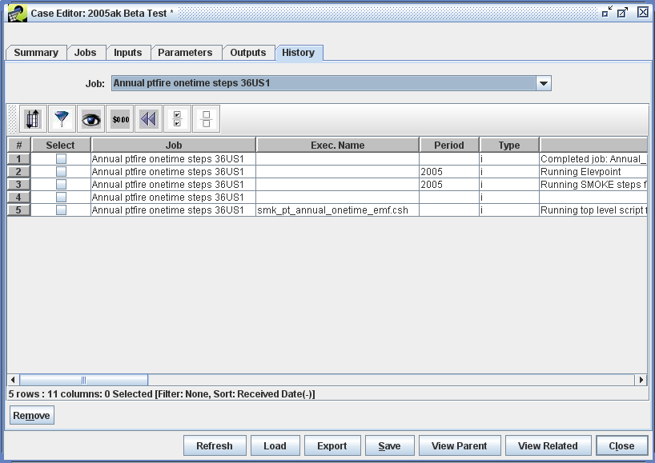
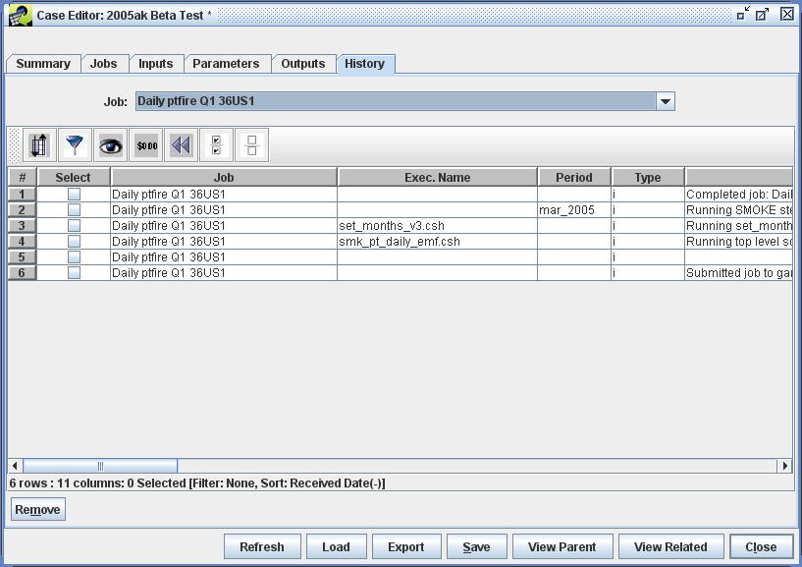
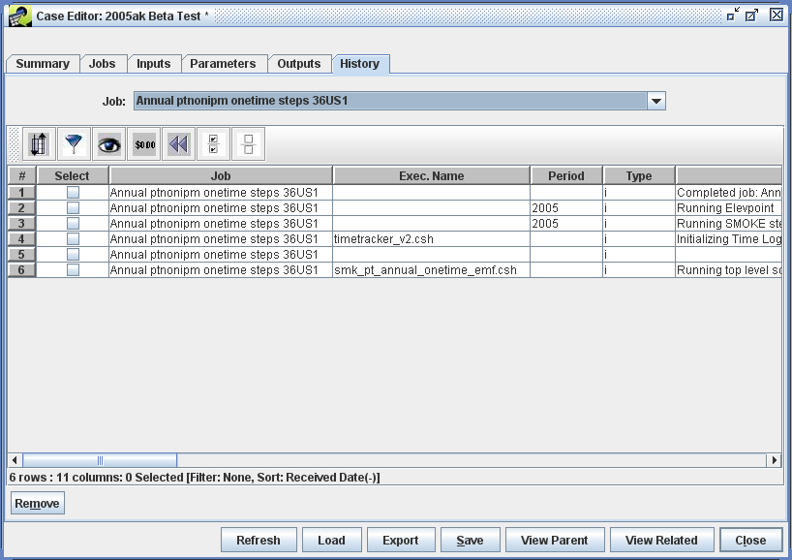
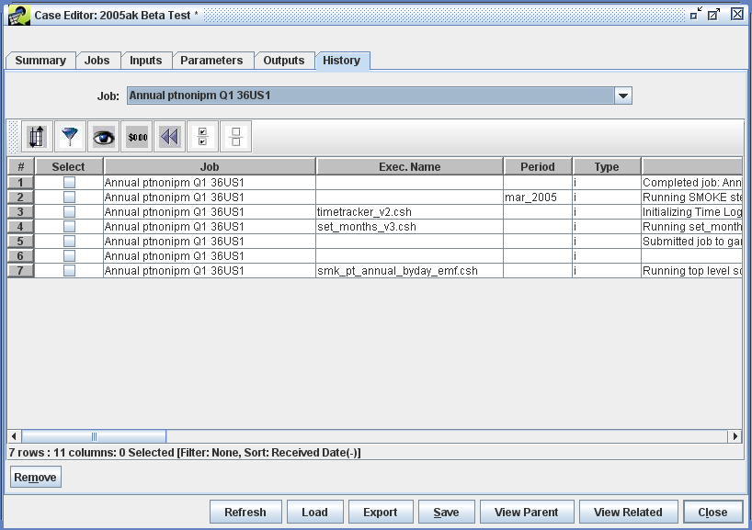
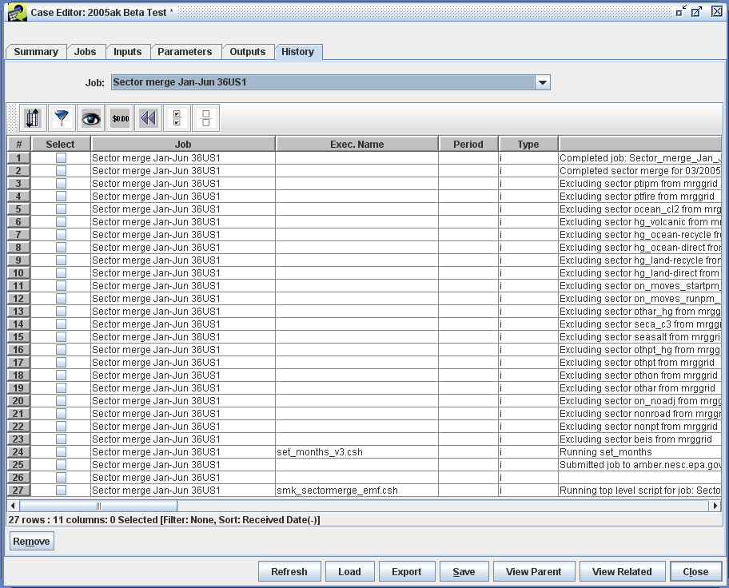
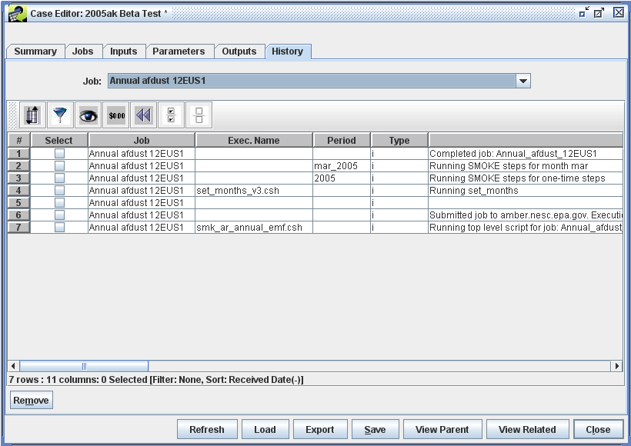

Outputs
Below are screenshots of the expected outputs from each o f the 9 Jobs:
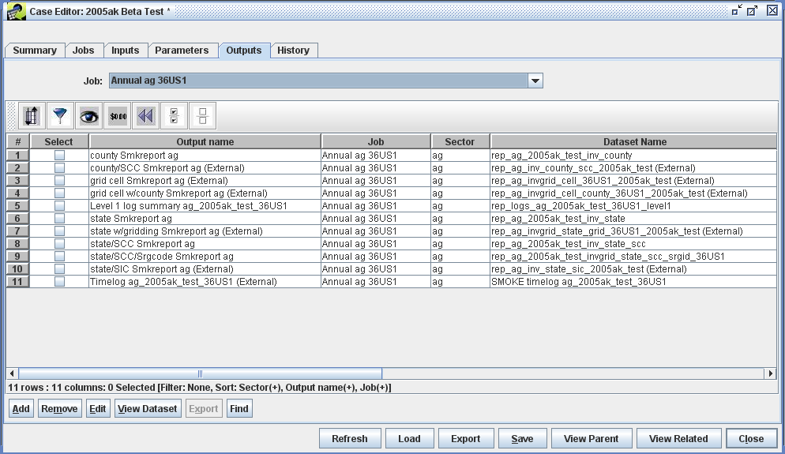
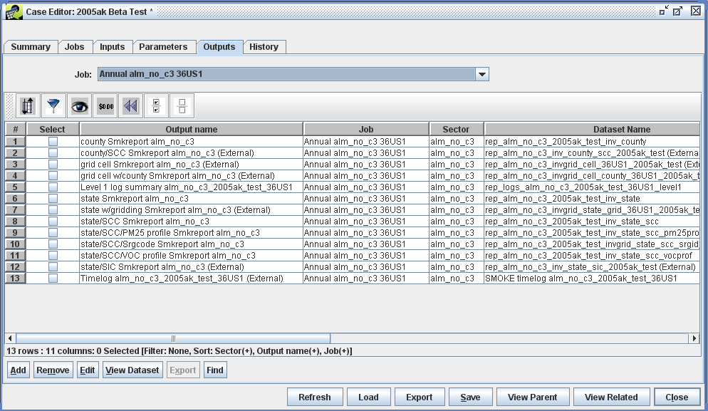
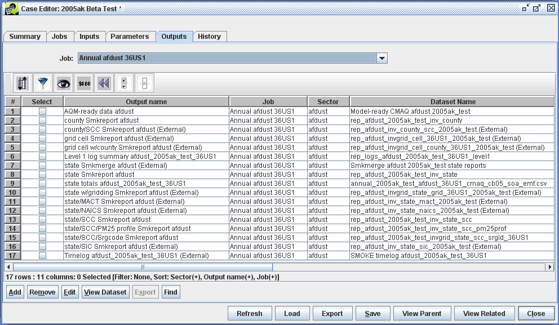
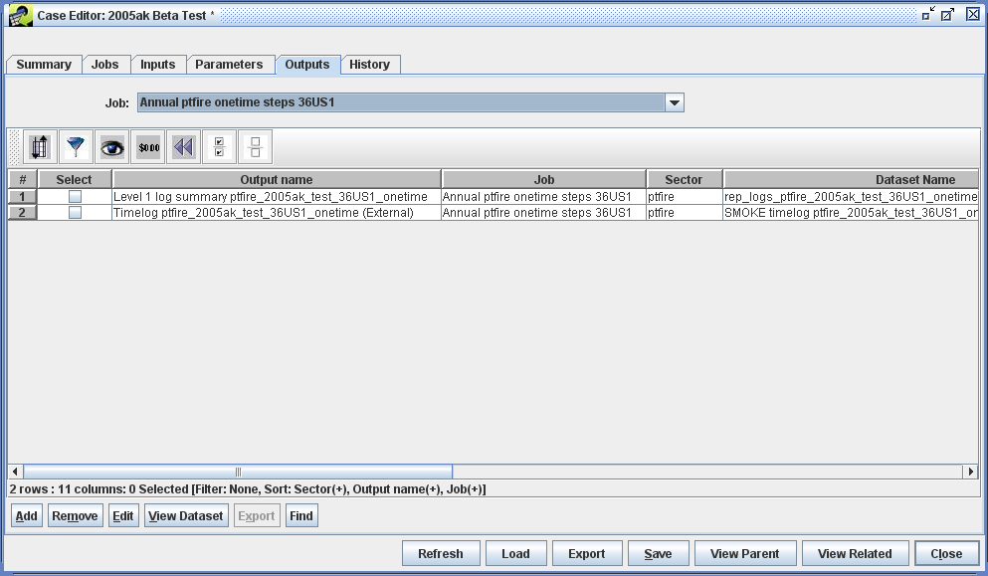
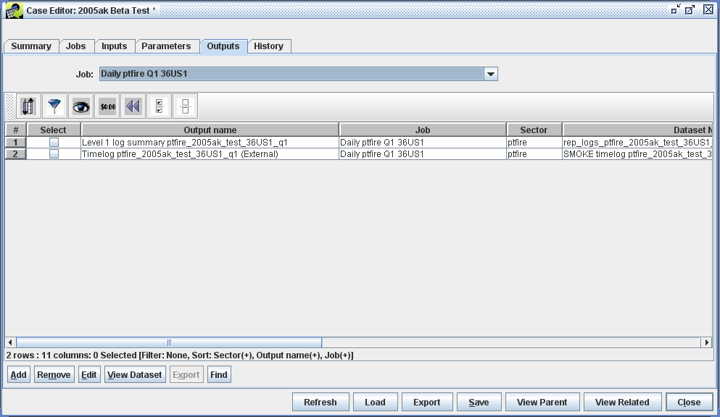
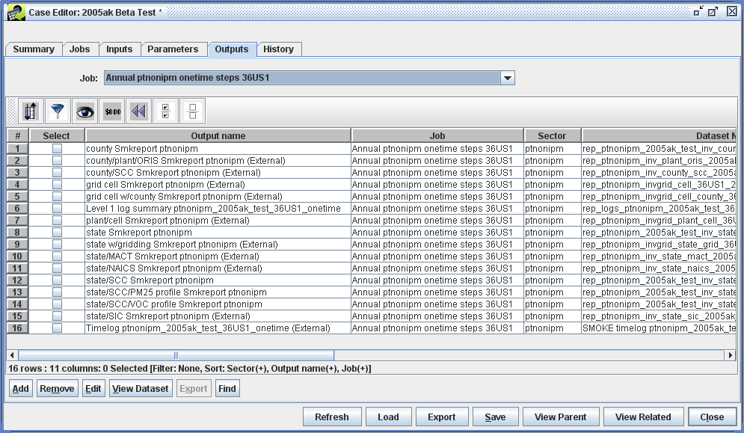
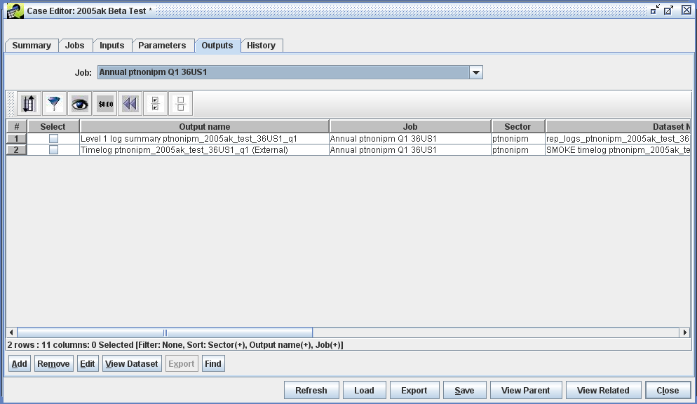
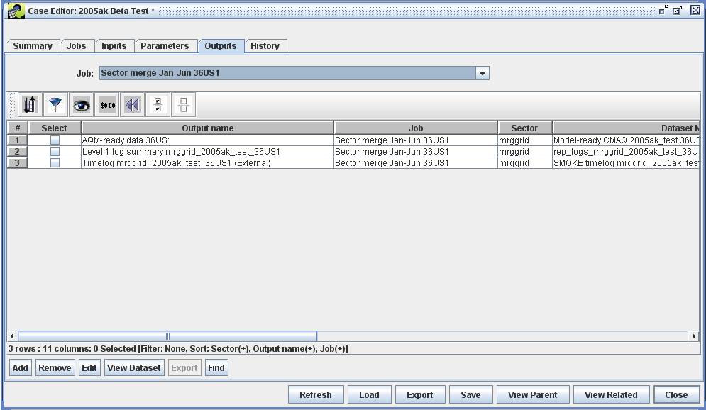

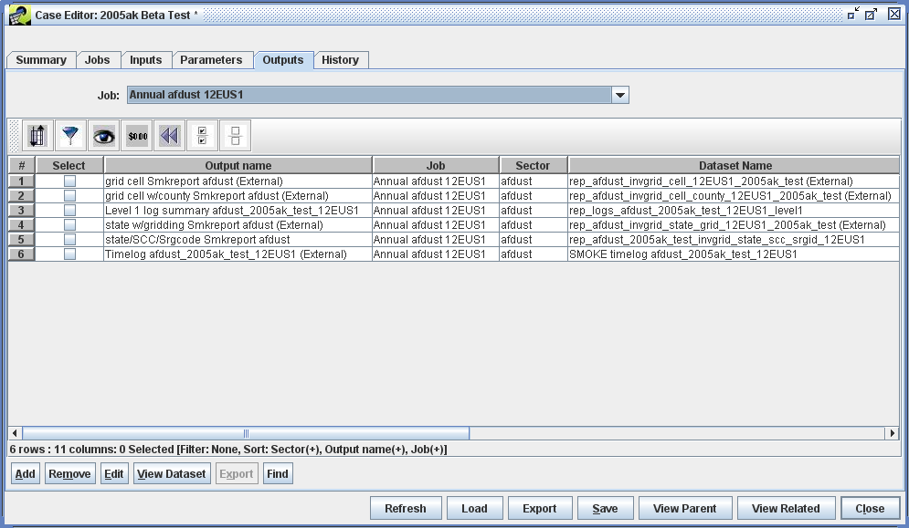

Trouble Shooting
If a Job fails (i.e., Run Status is “Failed”) or did not produce the expected Outputs, the first place to look is in the History tab of the Case. For some errors, the EMF wrapper scripts will send back meaningful error messages.
If the History doesn't adequately diagnose the problem, look at the EMF Job log file corresponding to the specific run (Note: Each run of a Job is distinct and has a unique timestamp in the name). Think of these Job logs as the stdout/stderr from a SMOKE run. This is a good place to diagnose both script errors and SMOKE executable errors. The Job log file is located in (using our directory structure):
/data4/smoke_emf/subsys26/smoke26/scripts/cases/2005ak_test/logs
If a Job has been run more than once, older Job logs will be located in:
/data4/smoke_emf/subsys26/smoke26/scripts/cases/2005ak_test/old_logs
Another resource for identifying SMOKE errors is the "Level 1 log summary <Job name>" Output. This Job specific dataset summarizes the warnings and errors from all the SMOKE logs. For more information on this Output, see the README under:
/data4/smoke_emf/subsys26/smoke26/scripts/log_analyzer
As with earlier Cases, other possible errors are a mismatch of the EMF client user and the SMOKEServer user and too restrictive permissions for the various SMOKE directories or files (see Directory Permissions).

