EMF Surrogate Tool Case

Surrogate Tool Case Overview
The Surrogate Tool Case is a relatively simple Case that encapsulates all the information necessary to run an installation of the Surrogate Tool, allowing an EMF user to create and QA surrogates. This is the main paradigm employed by the EMF: through the use of Jobs, Inputs, Parameters, and scripts, an EMF user is able to integrate with and run external applications (e.g., the Surrogate Tool, SMOKE, etc.).
The Surrogate Tool Case predefines 4 Jobs:
- 2 “Create Surrogates” Jobs for creating surrogates using a 16km (coarse) grid and an 8km (fine) grid
- 2 “QA Surrogates” Jobs for QAing already created surrogates using a 16km (coarse) grid and an 8km (fine) grid

Install Spatial Allocator (contains the Surrogate Tool)
Use Surrogate Tool User Guide to download and install the Surrogate Tool (Section 2), noting the directory that is referred to as SA_HOME. You do not need to modify your .cshrc file to include SA_HOME because these environmental variables will be dealt with by the EMF Case. This directory should be available from both the EMFServer and the SMOKEServer.
In addition to the Spatial Allocator application, you will need to download the “Sample Emission Surrogate Data Shapefiles” from the CMAS website, extracting the tar.gz file into the same location as the Spatial Allocator tar.gz. Here is an example directory structure:
$ mv sa_03_2009.tar.gz /data4/surg_tool/
$ mv sample_srgtools_data.tar.gz /data4/surg_tool
$ cd /data4/surg_tool
$ tar xvzf sa_03_2009.tar.gz
$ tar xvzf sample_srgtools_data.tar.gz

In this example, SA_HOME is:
/data4/surg_tool/sa_03_2009

Make sure that SA_HOME and the rest of the directory tree have the proper permissions (see Directory Permissions).

Create New Dataset Type
For the Surrogate Tool Case, two new Dataset types will need to be created (Note: This step requires the EMF client user to have administrative privileges).
- From the EMF client, launch the Dataset Type Manager (Manage > Datasets from the main menu)
- From the Dataset Type Manager window, click the New button.
- In the Create New Dataset Type window:
  - Enter “Surrogate Code Mapping” in the Name field. The name needs to match this exactly.
  - Select “Line-based File” from the Derived From field
  - Click the Save button
- From the Dataset Type Manager window, click the Refresh button. You should now see a new Dataset Type “Surrogate Code Mapping”:

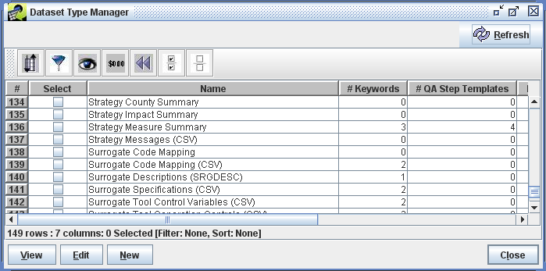

- From the Dataset Type Manager window, click the New button again.
- In the Create New Dataset Type window:
  - Enter “Surrogate Tool QA Reports (External Multifile)” in the Name field. The name needs to match this exactly.
  - Select “External File” from the Derived From field
  - Click the Save button
- From the Dataset Type Manager window, click the Refresh button. You should now see a new Dataset type “Surrogate Tool QA Reports (External Multifile)”.
- Now we are going to add some keywords that control the behavior of the datasets when they are exported.
  - Select the dataset type "Surrogate Code Mapping" and click the Edit button.
  - Click the Add button at the bottom-of the keywords section
  - In the ‘Keyword’ cell of the new table row, select the ‘EXPORT_COLUMN_LABEL’ from the pull-down
  - In the ‘Value’ cell, enter ‘ALL_CAPS’
  - Click the Add button again
  - In the ‘Keyword’ cell of the new table row, select the ‘EXPORT_HEADER_COMMENTS’ from the pull-down
  - In the ‘Value’ cell, enter ‘false’. Your Edit Dataset Type window should now look like this:
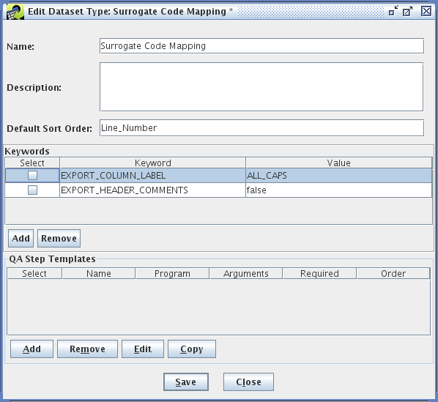
  - Click the Save button

Configuring the Case
- Download surgtool_EMF.tar.gz and untar the file.

$ tar xvzf surgtool_EMF.tar.gz

- Move (or copy) and extract the additional shapefiles to the shapefiles data directory under the SA_HOME directory:

$ cp surgtool_EMF/addl_shapefiles/* /data4/surg_tool/sa_03_2009/data/emiss_shp2003/us
$ cd /data4/surg_tool/sa_03_2009/data/emiss_shp2003/us
$ unzip pophu2k_tnnc.zip
$ unzip tnnc_usrds_2000.zip

- Move (or copy) the surgtool_EMF/scripts/emf directory and contents to your shared disk (so that they can be accessed by both the EMFServer and SMOKEServer). Make sure the emf directory and the individual scripts are 'rx' for the emiss group. These are the surrogate tool driver scripts that have been EMF enabled. An example directory for these scripts is:

/data4/surg_tool/scripts/emf

- Move (or copy) the case to be imported, surgtool_EMF/surgtool_case_setup, to your import directory on the EMFServer. An example directory for the case imports is:

/data3/imports/cases/surgtool_case_setup

- As with the previous case when the EMF job header was imported, this Case requires the import of some additional input files. You may need to move the files to an import area so that they can be read on the EMFServer (e.g. /data3/imports). Use the Dataset Manager to import the following files:
  - surgtool_EMF/in/surrogate_generation_grid.csv should be imported as dataset type “Surrogate Tool Generation Controls (CSV)”, changing the dataset name to “surrogate_generation_grid_beta”
  - surgtool_EMF/in/GRIDDESC.txt should be imported as dataset type “Grid Description (Line-based)”, changing the dataset name to “GRIDDESC_beta”
  - surgtool_EMF/in/shapefile_catalog.csv should be imported as dataset type “Shapefile Catalog (CSV)”, changing the dataset name to “shapefile_catalog_beta”
  - surgtool_EMF/in/surrogate_codes should be imported as dataset type “Surrogate Code Mapping”, changing the dataset name to “surrogate_codes_beta”
  - surgtool_EMF/in/surrogate_specification.csv should be imported as dataset type “Surrogate Specifications (CSV)”, changing the dataset name to “surrogate_specification_beta”

- Use the Case Manager to import the Surrogate Tool Case. The files to import are:

surgtool_case_setup/Surrogate_Tool_Example_Inputs.csv
surgtool_case_setup/Surrogate_Tool_Example_Jobs.csv
surgtool_case_setup/Surrogate_Tool_Example_Summary_Parameters.csv

Once the import has completed, you should see a new Case under the “Demo” category called “Surrogate Tool Example”. You may need to refresh the manager to see the new Case.

Select the new Case and click Edit, which will launch the Case Editor. You should see, among other things;
- 4 Jobs (2 “Create Surrogates” Jobs and 2 “QA Surrogates” Jobs):
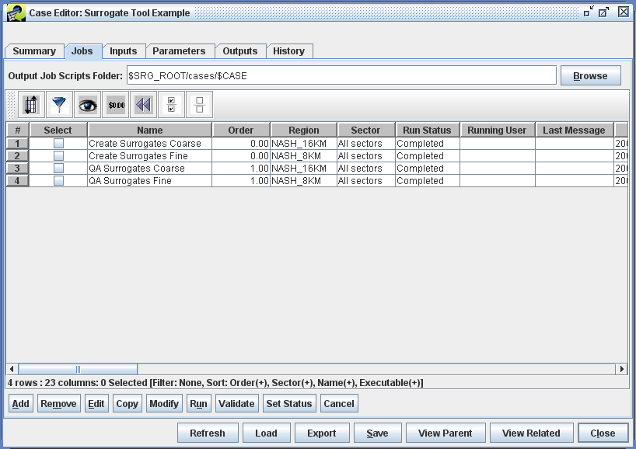

- 6 Inputs:
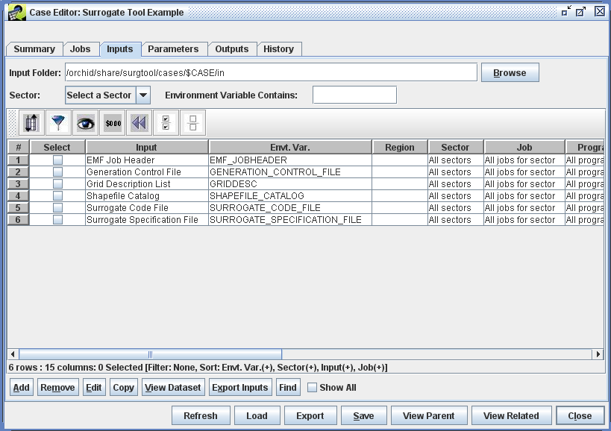

- 16 Parameters:
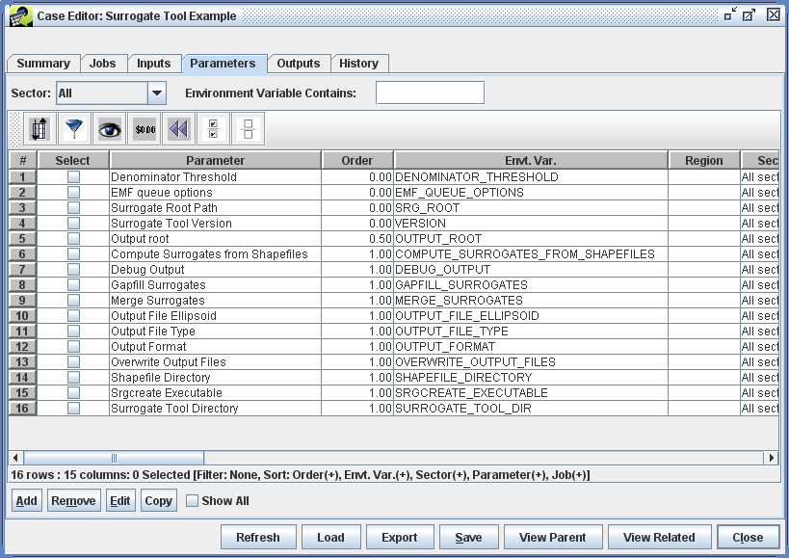

- As with the previous test Case, you will need to modify the imported case to match your system:

From the Jobs tab:
  - Modify the Output Job Scripts Folder field. An example directory is:

/data4/surg_tool/scripts/cases/$CASE

The EMF server will replace the variable $CASE by the case abbreviation. It will create this subdirectory when the first job is run. Make sure that the rest of the directory tree has been created and has the proper permissions (see Directory Permissions).

  - For each Job, you will need to change the Host and Queue Options field. Note that you can do all of them simultaneously by selecting the jobs and then click the Modify button.
  - For each “Create Surrogates” Job, you will need to change the Executable field to point to the surrogate_wrapper.csh script on your system. This can be done with the Modify button.
  - For each “QA Surrogates” Job, you will need to change the Executable field to point to the surrogate_qa_wrapper.csh script on your system. Again, this can be done with the Modify button.

From the Inputs tab:
- Modify the Input Folder field. An example directory is:

/data4/surg_tool/inputs/$CASE

The EMF server will replace the variable $CASE by the case abbreviation. It will create this subdirectory when the first job is run. Make sure that the rest of the directory tree has been created and has the proper permissions (see Directory Permissions).

- During the import of the Case, each Input should have found a matching dataset. In other words, the Dataset and Version columns should be filled in for each Input. If they are not filled in, the importer could not find a dataset the exactly matched the name and version in the import files. If your Inputs are missing any datasets, follow the appropriate step below:
  - Modify the “EMF Job Header” Input to use the same emf job header dataset from the previous test Case. Select the Input and click Edit.
  - Modify the “Generation Control File” Input to use the “surrogate_generation_grid_beta” (from above)
  - Modify the “Grid Description List” Input to use the “GRIDDESC_beta” (from above)
  - Modify the “Shapefile Catalog” Input to use the “shapefile_catalog_beta” (from above)
  - Modify the “Surrogate Code File” Input to use the “surrogate_codes_beta” (from above)
  - Modify the “Surrogate Specification File” Input to use the “surrogate_specification_beta” (from above)
  - Click the Refresh button to see the changes:

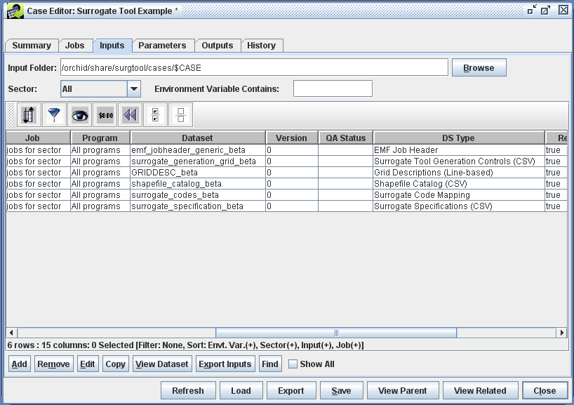

From the Parameters tab:
- Select “All” from the Sector pull-down near the top of the tab
- A few parameters will need to be modified to match your system:
  - Modify the ‘EMF queue options’ parameter as in the previous test Case. Select the parameter and click Edit.
  - Modify the “Surrogate Root Path” parameter to match the path to the Surrogate Tool (referred to as SA_HOME above). For example:

/data4/surg_tool/sa_03_2009

Running the Case
The Jobs can be run as they were in the previous test Case, with the exception that the each “QA Surrogates” Job depends on the output from its “Create Surrogates” partner. What this means, for example, is that prior to running the “QA Surrogates Coarse” Job, there will need to have been a successful run for the “Create Surrogates Coarse” Job.

Messages
A successful run of the “Create Surrogates Coarse” will produce message similar to the following:
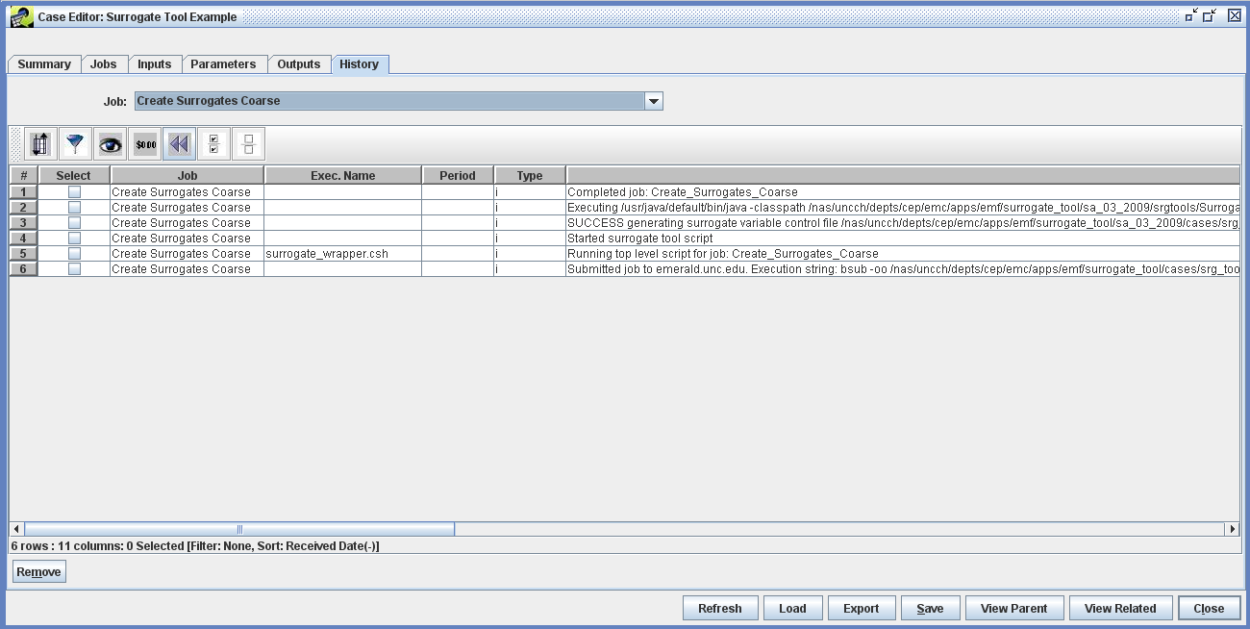
A successful run of the “QA Surrogates Coarse” will produce message similar to the following:
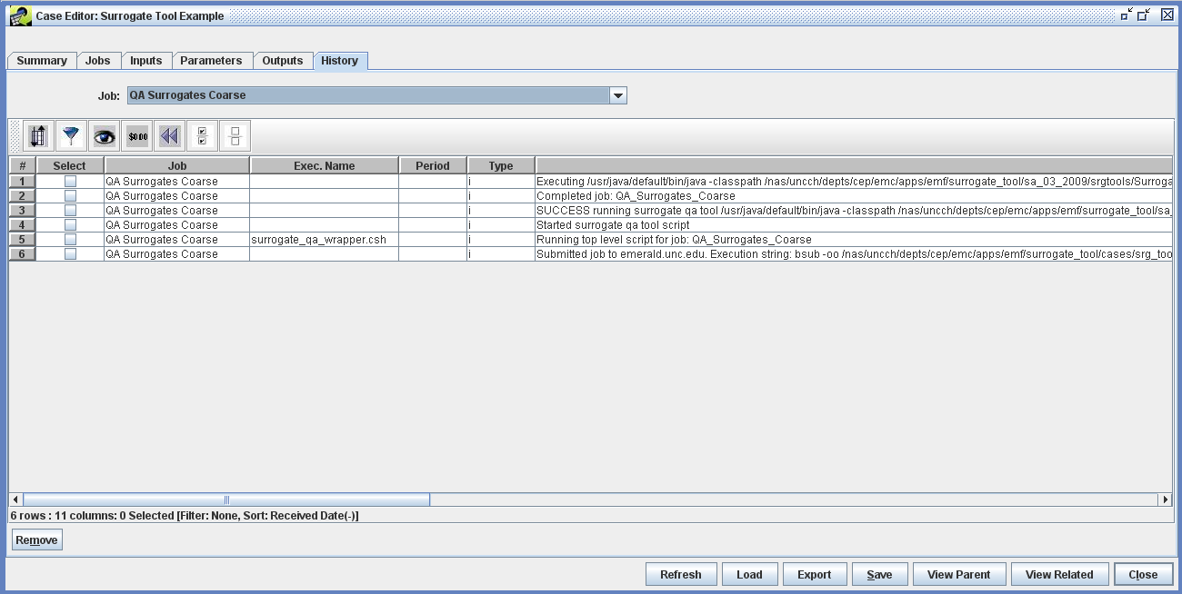

Outputs
A successful run of the “Create Surrogates Coarse” will produce the following outputs:
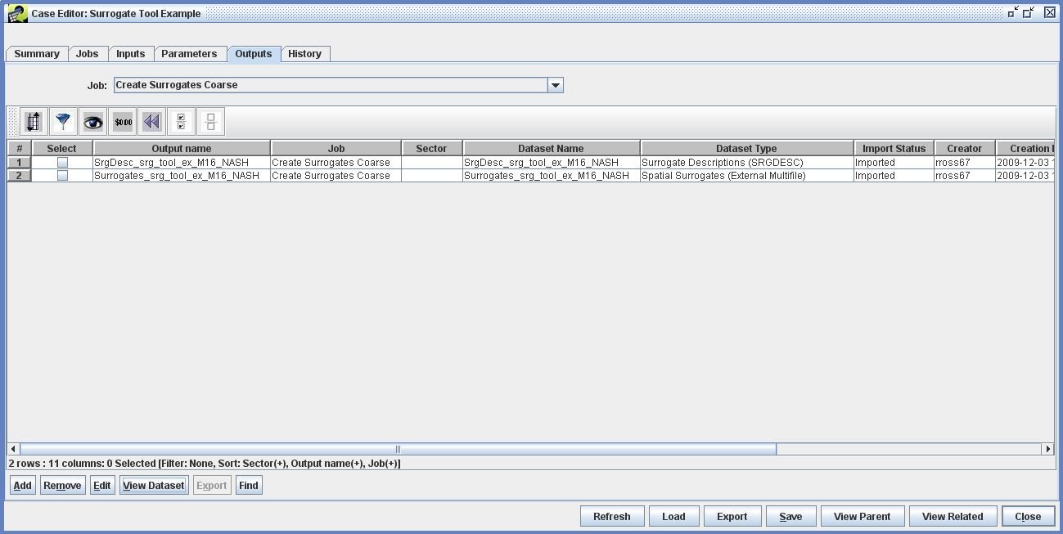
A successful run of the “QA Surrogates Coarse” will produce the following output:
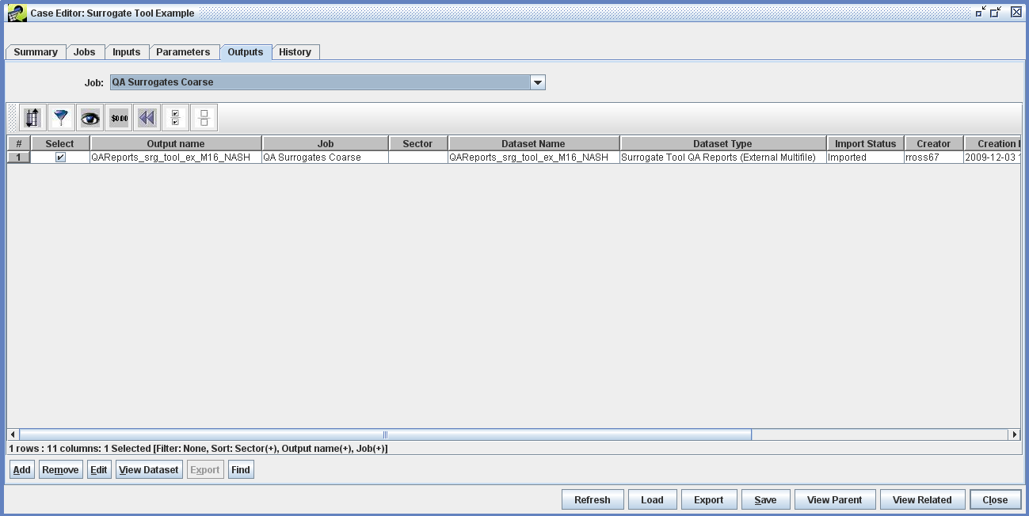

Logs
In addition to the EMF logs that are located in <Output Job Scripts Folder>/logs and the Tomcat catalina.out log file located in <tomcat home>/logs, the Surrogate Tool will produce logs in $OUTPUT_ROOT/$OUTPUT_GRID_NAME/logs, where $OUTPUT_ROOT and $OUTPUT_GRID_NAME are defined Case Parameters. These three locations will be invaluable in troubleshooting this test Case.

Trouble-shooting
If a Job fails (i.e., Run Status is “Failed”) or did not produce the expected Outputs, the first place to look is in the History tab of the Case. For some errors, the EMF wrapper scripts will send back meaningful error messages. If the History doesn't adequately diagnose the problem, look at the EMF job log file corresponding to the specific run (Note: Each run of a Job is distinct and has a unique timestamp in the name. If no other jobs have been run since the failure, use ls –lrt to get a time-ordered listing of the log files, the one you are looking for being the last one listed).
If the Job fails and there is a series of messages in the EMF Job log file similar to:
EMF cmd client: Python client done Wed Dec 2 12:49:59 2009
Your Operating system is: linux

Using Java version of gapfilling and merging

Run Date: Wed Dec 02 12:49:59 EST 2009

End Date: Wed Dec 02 12:49:59 EST 2009

Elapsed time in minutes: 0.0011833333333333333

ERROR -- The Program Run Stopped. See log file for details.

EMF cmd client: python client starting: Wed Dec 2 12:49:59 2009

This means that the script successfully launched the Surrogate Tool, but the Surrogate Tool failed for some reason. You will now want to look in the Surrogate Tool log file. A successful run of the Surrogate Tool will have “SUCCESS -- The Program Run Completed” as the last line of the log file.
If an error cannot be found in either the EMF or the Surrogate Tool log files, you should look for errors in the Tomcat catalina.out log file.

