Student Grading System
Database Project Report
CodTech IT Solutions | May 2025

1. About This Project
This project is a simple Student Grading System built using SQL. The goal is to store student information and their subject marks, and then find out their grade using basic queries.

Detail | Info
Project Name | Student Grading System
Tool Used | MySQL
Tables Created | 2 (students, marks)
Total Students | 8
Subjects | Maths, Science, English
Made By | [Your Name]

2. Database Tables
Students Table
Column | Type | Description
id | INT (PK) | Auto-generated student ID
name | VARCHAR | Student full name
roll_no | VARCHAR | Roll number
class | VARCHAR | Class (e.g. 10th)
gender | VARCHAR | Male / Female

Marks Table
Column | Type | Description
id | INT (PK) | Auto ID
student_id | INT (FK) | Links to students table
subject | VARCHAR | Subject name
marks | INT | Marks out of 100

3. Student Data
Roll No | Name | Maths | Science | English | Avg | Grade
101 | Rahul Sharma | 78 | 82 | 74 | 78.0 | B
102 | Priya Mehta | 92 | 88 | 95 | 91.7 | A
103 | Aman Verma | 55 | 60 | 50 | 55.0 | B
104 | Sneha Patel | 85 | 79 | 88 | 84.0 | A
105 | Rohan Das | 40 | 45 | 38 | 41.0 | C
106 | Kavya Iyer | 91 | 94 | 89 | 91.3 | A
107 | Arjun Nair | 67 | 72 | 65 | 68.0 | B
108 | Divya Singh | 88 | 85 | 90 | 87.7 | A

Grade Logic:
- A = 80 marks and above
- B = 60 to 79 marks
- C = 40 to 59 marks
- Fail = below 40 marks

4. SQL Queries Used
Query 1 — Student Results with Grade
SELECT s.name, SUM(m.marks) AS total,
ROUND(AVG(m.marks),1) AS avg_marks,
CASE WHEN AVG(m.marks)>=80 THEN 'A'
WHEN AVG(m.marks)>=60 THEN 'B'
WHEN AVG(m.marks)>=40 THEN 'C' ELSE 'Fail' END AS grade
FROM students s JOIN marks m ON s.id=m.student_id
GROUP BY s.id ORDER BY avg_marks DESC;

Query 2 — Subject Average
SELECT subject, ROUND(AVG(marks),1) AS avg,
MAX(marks) AS highest, MIN(marks) AS lowest
FROM marks GROUP BY subject;

Query 3 — Top 3 Students
SELECT s.name, ROUND(AVG(m.marks),1) AS avg
FROM students s JOIN marks m ON s.id=m.student_id
GROUP BY s.id ORDER BY avg DESC LIMIT 3;

5. Charts & Graphs
Chart 1 — Student Average Marks
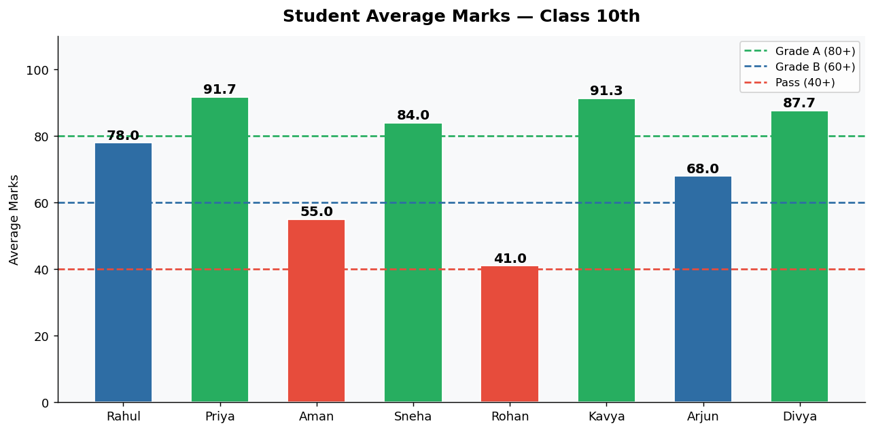

Chart 2 — Grade Distribution
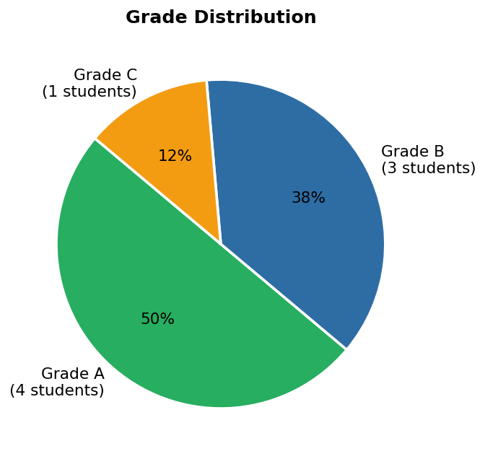

Chart 3 — Subject-wise Average
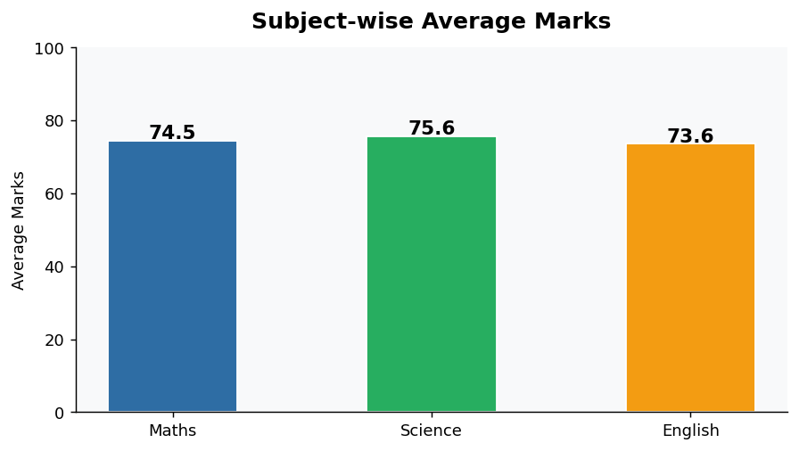

6. What I Found
- Kavya Iyer scored the highest average — 91.3 marks (Grade A)
- Rohan Das scored the lowest — 41.0 marks (Grade C)
- 4 students got Grade A, 3 got Grade B, 1 got Grade C
- No student failed in this class
- Science had the highest average marks among all subjects

7. Conclusion
This project shows how SQL can be used to manage student records easily. I created 2 tables, added data for 8 students, and used JOIN and GROUP BY queries to find each student's grade. I also made 3 charts to show the results visually. This helped me understand how databases work in real life.

