Ethics Across the Curriculum for Biochemical Engineering

Yoshio KATAKURA, Ph.D.
Department of Biotechnology,
Graduate School of Engineering,
Osaka University
2-1 Yamadaoka, Suita, Osaka 565-0871, JAPAN
E-mail: katakura@bio.eng.osaka-u.ac.jp
Tel/Fax: +81-6-6879-7436

[Grade 3—advanced undergraduate course]
Exercises and homework are held in the 4th class.

The title of the each class
Week | Title
1st | Microorganisms and foods.
2nd | Utilization of microorganisms.
3rd | Growth of microorganisms.
4th | Productions by microorganisms.
5th
...
15th | Examination

Points for grading
Did the student investigate the poisonous properties (the amount of enterotoxin that develops poisoning)?
There are many reports about the toxicity and there are various values about the toxicity. If the student compares a number of the values and adopts the most safety value, add extra point.
Are the data obtained from reliable source(s)?
Is the source of the data described in her/his report?
How did the student assume the intake of the drink?
Did she/he consider unexpected intake, for example, drink 1 L at a time?
Did the student give consideration to weak people?
Babies and aged persons are more sensitive to the toxin.
Did the student consider the temperature management at store and marketing distribution channel?
If the student defines the expiration date in summer and winter individually, add extra point.
If the student takes refrigeration into consideration, add extra point in the following cases:
The student considers the possibility that the drink is kept at room temperature by mistake.
The student defines expiration date based on the datum at 5°C as promises for the distribution at dependable stores such as manufacturer's retail store.

Acknowledgements: The author thanks Prof. N. Kurata (Hokkaido Univ.), Prof. K. Sakamoto (Kanazawa Institute of Technology) and Prof. M. Yasui (Muroran Institute of Technology) for their helpful advice.

Exercises
Q1. In the process of growing a microorganism in a liquid culture, the change in the cell concentration is given as 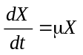, where X is cell concentration (cells⋅ml⁻¹) and μ is the specific growth rate (h⁻¹). Introduce the equation that gives the cell concentration at time t (h). Suppose that the initial cell concentration is X₀ (cells⋅ml⁻¹).

Q2. Table 1 shows the specific growth rates of a bacterium at various conditions. Calculate the cell concentration after 24, 48 and 72 h at 20°C and pH 5. Suppose that the initial cell concentration is 10² cells⋅ml⁻¹.

Q3 When the initial cell concentration is 10² cells⋅ml⁻¹, calculate the time required for the cells to propagate to the concentration of 10⁸ cells⋅ml⁻¹ at 35°C and pH 7.

Q4 A microorganism can produce useful or toxic material (defined as a product) in the culture. The change in the product concentration is given as 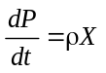, where P is the product concentration (g⋅l⁻¹) and ρ is the specific production rate (g-product⋅g-cell⁻¹⋅h⁻¹). Introduce the equation that gives the product concentration at time t (h). Suppose that the initial product concentration is P₀ (g⋅l⁻¹).

Q5 The specific production rates of a product at various growth conditions are shown in Table 1. When the microorganism is grown under a condition at 20°C and pH 7, and under a condition at 35°C and pH 5, compare the product concentrations after 12 h of incubation.

Table 1 Values for the specific growth and production rates
Temperature  (°C) | pH 7 |  | pH 5
Temperature  (°C) | μ | ρ | μ | ρ
Temperature  (°C) | (h⁻¹) | (ng⋅10⁶-cells⁻¹⋅h⁻¹) | (h⁻¹) | (ng⋅10⁶-cells⁻¹⋅h⁻¹)
35 | 2.0 | 10 | 0.3 | 5
20 | 0.5 | 3 | 0.07 | 1.5
5 | 0.1 | 1 | 0.02 | 0.5

Homework
You work for Y Corporation and are developing a new kind of soft drink. Your boss orders you to define the expiration date of the drink on a commercial basis. Assuming that:
the drink contains 10² cells⋅ml⁻¹ of a bacterium which produces enterotoxin A.
the specific growth and production rates given in Table 1 can be applied for the bacterium.
the pH of the drink is 5.
Investigate the poisonous properties of enterotoxin A, and define the expiration date by yourself.

A1 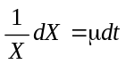
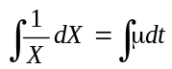
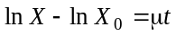
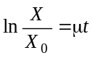
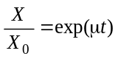
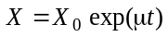

A2 After 24 h: 10²×exp(0.07×24)=5.4×10²
After 48 h: 10²×exp(0.07×48)=2.9×10³
After 72 h: 10²×exp(0.07×72)=1.5×10⁴

A3 therefore, 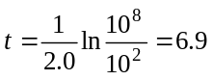h
Note: In summer, foods should be kept in refrigerator to avoid food poisoning!

A4 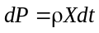
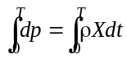
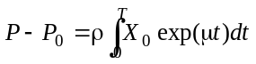
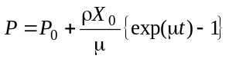

A5 At 20°C and pH 7, ρ=3 and μ=0.5 therefore 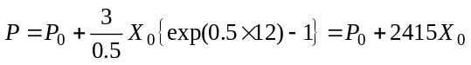
At 35°C and pH 5, ρ=5 and μ=0.3 therefore 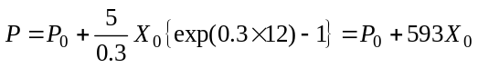
Thus, the product concentration at 20°C and pH 7 is 4 times higher than that at 35°C and pH 5 when the initial product concentration is negligible.

10³
0
50
100
150
Time (h)
Enterotoxin A (ng/mL)
10²
10¹
10⁰
10⁻¹
10⁻²
10⁻³
10⁻⁴
5°C
20°C
35°C
Homework
Figure Production of enterotoxin A at 35°C, 20°C and 5°C.

