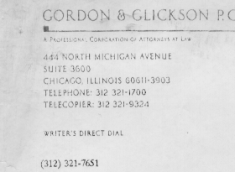
3101 S Dearborn Street
Room 166
Chicago, IL 60616
August 16, 1994

Thank in I very much for lunch yesterday. The project is certainly in an
Important are and I expect you will continue to find ideas to develop it further. As we
Discussed, you may wish to contact Peter Neumann at SRI: 415-859-2375. Also, the ISO
9000 standards for software are very useful and relevant to our discussion. If you need
references or copies, let me know.
Very truly yours,

GORDON & GLICKSON P.C.
BDW/kes
Cc: Michael Davis

