

Meeting of the
IEEE Computer Society (IEEE-CS) and
Association for Computing Machinery (ACM)
Joint Steering Committee for the Establishment of
Software Engineering as a Profession
Software Engineering Institute
Carnegie Mellon University
Pittsburgh, Pennsylvania
Saturday, May 28, 1994
Participants:
Mario Barbacci, Barry Boehm, Doris Carver, Elliot Chikofsky, Pat Douglas, Larry Druffel,
Dennis Frailey, Don Gotterbarn, Sam Redwine (guest), John Werth, Stu Zweben
Regrets:
Fletcher Buckley, Robert Melford, Mary Shaw
Agenda Topics:
Welcome and Introductions
History of the initiative and initial recommendations
Task Force Report - body of knowledge and recommended practices
Task Force Report - ethics and professional practices
Task Force Report - curriculum
Discussion and recommendations
Wrap-up and review of action items
Software engineering body of knowledge and recommended practices
Pat Douglas - the methodology (task statement) adopted based on experience at IBM. Not assuming this is the end-all, just an initial step.
• Ideally would use a "dictionary" of terms but then it would be very difficult to identify body of knowledge through surveys.
• Have collected an initial list of major topics from several sources.
• Bloom's taxonomy is too detailed (6 levels); might chunk into just 3 levels.

Software engineering ethics and professional practices
Don Gotterbarn - all professions have a definition of "obligation" by virtue of belonging to a profession. Have identified several orthogonal axes for dealing with ethical issues:
• The groups to which we have ethical responsibility (the individual, the organiza-
5/23/97
Page 1 of 5
tion, the society)
• The standard ethics taxonomy (e.g., justice, equity, privacy and autonomy or beneficence, avoidance of harm, fidelity, and integrity)
• Ethical problems of software engineers (e.g., privacy, security, testing and reliabil
ity, competence, duties to society, intellectual property, and ethical tools)
The TF has taken the approach of using IEEE Standards process [actually, ANSI] to
define professional practices. ACM has a related process of standard concurrence.
Software engineering curriculum
Doris Carver and John Werth - The community knows how to develop curricula, the issues is how to gain acceptance and not let it become shelfware. Should not focus on "software" too soon but rather on "engineering". Issues to consider include:
• How to involve the universities? How to reduce fears (e.g., fear of splitting MIS, CS, CE departments).
• Software engineering topics are moving into lower division curricula.
• Might be hard to invent yet another curriculum. The Steering Committee should think how do we sell this to academia. What are the leverage points e.g.:
• Accreditation boards
• Research agendas
Discussion
During the discussion there was a concern that mass surveys with lots of detailed/hard questions to lots of participants might be too cumbersome:
• How it is done in other disciplines? e.g., Medicine does it by defining surveys that are easy to pass.
• Address pieces of survey to groups of TC-SE/SIG SOFT members (we need to collect technical interest profiles)
• Separate questions
• What do you do?
• How do you do it?
• Identify fundamentals
• what did you learn in school and still use
• what did you learn and don't use The issue of U.S. vs. International definitions of the software engineering profession was addressed. Other countries have already defined certification/licensing for software engineers. Our strategy should be:
• 1-Will try to benefit from experience & results in other countries
• 2-Definition is broad and can be used outside US.
• 3-Will study reciprocity with existing definitions in other countries
5/23/97
Page 2 of 5

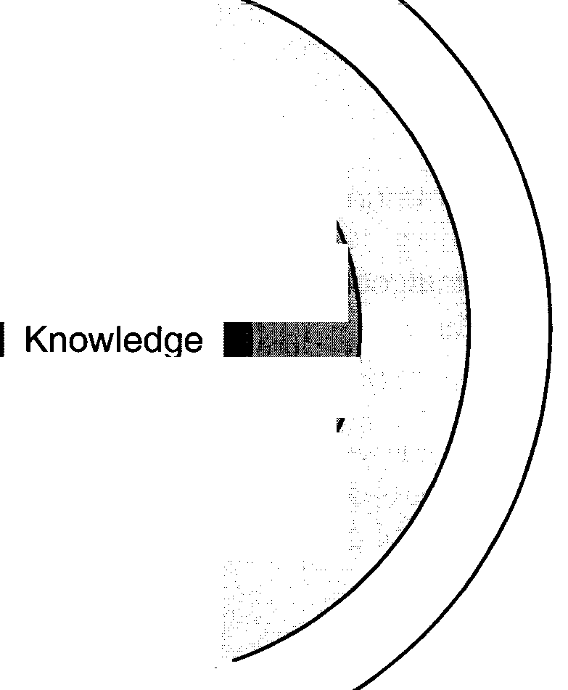
Some useful models for the body of knowledge and recommended practices
User
Interface
Real-time Controls
Numerical Analysis/ Science/
Core Skills ~ ~ Engineering
Product
MEMNON
Process
Management Metrics
Requirements/
Systems
Engineering
Engineering
• Coop Programs
• Apprenticeship
Specialization
Continuing
Education
~JiSij pren ices ip
(experience)
Medicine
5/23/97
• Internship
Page 3 of 5
Questions and issues about the models:
How unique is the core to software engineering? We define the core but do it in context of applications (the core "projects" into applications areas) How much of the model is covered by the survey(s) Must involve educational community in definition of core
The scope of the committee
The steering committee felt that it was important to define the scope of the committee. The following topics were suggested:
• Statement of scope
• Mission/vision
• Goals
• Stakeholders
• Concept of Operation
• what does the profession look like (now and in the future)?
• how does committee operate?
• Control of profession when it is in place
• Funding for activity We only had time to cover the first item:
Draft mission statement:
`To establish the appropriate sets(s) of standards for professional practice of software engineering upon which industrial decisions, professional certification, and educational curricula can be based." There was some discussion about the appropriateness of the word "standard"; this is to be resolved by email discussion.
Stakeholders:
• Educational community
• universities
• community colleges
• students
• Professional societies
• Industry
• future employer
• human resources
• developer of products
• legal
• Practitioners
• Public
• users
• others
• Governments)
5/23/97
Page 4 of 5
• federal
• state
Other providers of bodies of knowledge in SE
What is the target audience?
The target are those individuals engaged in professional practices - the middle layer in the following model of the future software market:
 | User Programming (100 million people in the US)
 | Application | Application | System Integrators
 | Generators (0.2 M) | Composition (2 M) | (2 million)
 | Infrastructure (1 million)
00.
Academics Foundation Infrastructure (0.01 million)

Resolutions
• Continue work of TF on body of knowledge and TF on ethics with appropriate changes as recommended during meeting.
• Task Force on curricula must define mission and role of educational community.
Action Items
• [Mario] Add names of appropriate TC-SE and SIGSOFT contacts for distribution of committee reports
• Barry Boehm for SIGSOFT
• Chuck Howell for TCSE
• [Mario] Distribute minutes to committee by June 3
• [Committee] Define acronym/logo for committee (email)
• [Mario] Distribute mailing lists for all Task Forces to all members (email)
• [Pat and Elliot] Define broad categories of audience interest for future surveys
• Solicit input from TCSE and SIGSOFT
• collect TSE and SIGSOFT member's profiles (for target surveys)
• [Mario and Stu] Steer draft press release from TF on Ethics and Professional Practices through CS/ACM for release at House briefing on June 21.
5/23/97
Page 5 of 5

