3
contexts and for the distinctive responsibilities they generate. The products of the project would be an exemplar of a code of professional responsibility designed for software engineers that includes its rationale, and a handbook of ethics problems and cases with commentary. These, together with initiatives the project would instigate in professional societies and in education, would be designed to accelerate the professionalization of software creators.
There follows a list of names and affiliations of likely people who might contribute to the project.
Vivian Weil, Director, Center for the Study of Ethics in the Professions (CSEP)
Michael Davis, Senior Research Associate, CSEP
Ilene Burnstein, Associate Professor of Computer Science, III
Michael S. Mahoney, History, Princeton University,
'
Ronald Staudt, Professor of Law & Director Computer Development, Chicago

Kent College of Law, III
Michael Loui, Professor of Computer Theory, U of Illinois, Urbana
Helen Nissenbaum, Associate Director, Center of Human Values, Princeton
University ,. , _' - ' T ' -

Barry Weiss, Gordon & Glickson, P.C
Vince Serritella, Software Engineering Initiative, Motorola
June Rokoff, Senior Vice President for Software Development, Lotus

Development Co.

Donald Gotterbarn, IEEE/ACM Ethics Committees
I.
Someone from the Carnegie Mellon University Center for Software

Improvements.
Chicago, Illinois 60616 - 3793
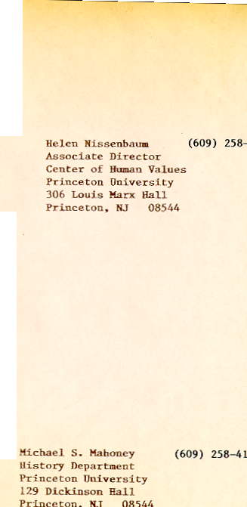
Illinois Institute of Technology
Weil/CSEP 1,6 Ls
Illinois Institute of Technology
Weil?CSEP 166 7.5

Illinois Institute of Technology
Chicago, Illinois 60616 -
3793

Chicago-Kent College of Law
Illinois Institute of Technology
565 West Adams Street
Chicago, Illinois 60661-3691
Tel 312 906 5000
Fax 312 906 5280
Ronald W. Staudt
Professor of Law & Director of
Computer Development
Tel 312 906 5301
Fax 312 906 5165
December 13, 1993
Barry Weiss
Gordon & Glickson, P.C.
444 North Michigan Avenue
Suite 3600
Chicago, IL 60611
Re: Computers, Risk & Funding
Dear Barry:
I enjoyed our meeting on December 6 at your office to discuss the USF&G/Nauman project. The Nauman collection of catastrophic risks arising out of computer hardware and software failure is a very intriguing asset. (I am intrigued by your notion for a more extensive project gathering up such information and making it available in an organized way to the public. I also am impressed with your ability to capture the attention of the USF&G people who might be interested in funding such an effort.
As you suggested, it may be best to try to locate this project at Carnegie Mellon because of its high profile in the computer science arena. IIT and Chicago-Kent offer some advantages. The Chicago-Kent Center for Law and Computers is well known around the world as a leader in research and teaching in the combined area of law and technology. The IIT Center for Ethics in the Professions is an interesting group focused on professional ethics issues in the engineering professions, architecture and, occasionally, business and law. That unit is set up in a way that might make it a particularly appropriate place to do the kind of work you imagine for the institute. In addition, the recent move of the business school to the downtown campus of IIT on the fourth floor of the law school building may offer additional synergy. They may be interested in managing risk.
Page 2
December 10, 1993
I will contact Vivian Weil at the Ethics Center and Rick Matasar to get their reactions to some of your suggestions. As soon as have some more developed ideas, I will be in touch with you.
With best regards,

Ronald W. Staudt
Professor of Law
Director of Computer Development
RWS:glf
cc: R. Matasar
V. Weil
contexts and for the distinctive responsibilities they generate. The products of the project would be an exemplar of a code of professional responsibility designed for software engineers that includes its rationale, and a handbook of ethics problems and cases with commentary. These, together with initiatives the project would instigate in professional societies and in education, would be designed to accelerate the professionalization of software creators.
There follows a list of names and affiliations of likely people who might contribute to the project.
Vivian Weil, Director, Center for the Study of Ethics in the Professions (CSEP'
Michael Davis, Senior Research Associate, CSEP
Ilene Burnstein, Associate Professor of Computer Science, IIT
Michael S. Mahoney, History, Princeton University
Ronald Staudt, Professor of Law & Director Computer Development, Chicago
Kent College of Law, IIT
Michael Loui, Professor of Computer Theory, University of Illinois, Urbana
Helen Nissenbaum, Associate Director, Center for Human Values, Princeton
University

Barry Weiss, Gordon & Glickson P.C.

Vince Serritella, Software Engineering Initiative, Motorola
June Rokoff, Senior Vice President for Software Development, Lotus Development Co.

Donald Gotterbarn, IEEE/ACM Ethics Committees
Someone from the Carnegie Mellon University Center for Software Improvements.

