|  |
| --- |
| **Build** |
| |  |  |  |  | | --- | --- | --- | --- | | **Invoke top-level Maven targets** | | |  | |  |  | |  | |  | Maven Version | (Default) maven36 |  | |  | |  |  | |  | Goals | |  |  | | --- | --- | |  |  | |  | |  | |  |  | |  |  | Advanced... |  | | Delete | | | | | **Execute shell** | | |  | |  |  | |  | |  | Command | docker build -t myapp . |  | |



deploy --- docker run -d -p 8385:8080 myapp

<http://18.216.122.191:8385/my-webapp/>

<https://github.com/thechetantalwar/java-demos>

------------------------------------------------------------------------------------------------------------------------------------------

Hook creation

<http://18.216.122.191:8080/github-webhook/>

<https://github.com/cserajib/Test/settings/hooks>

**Webhooks**

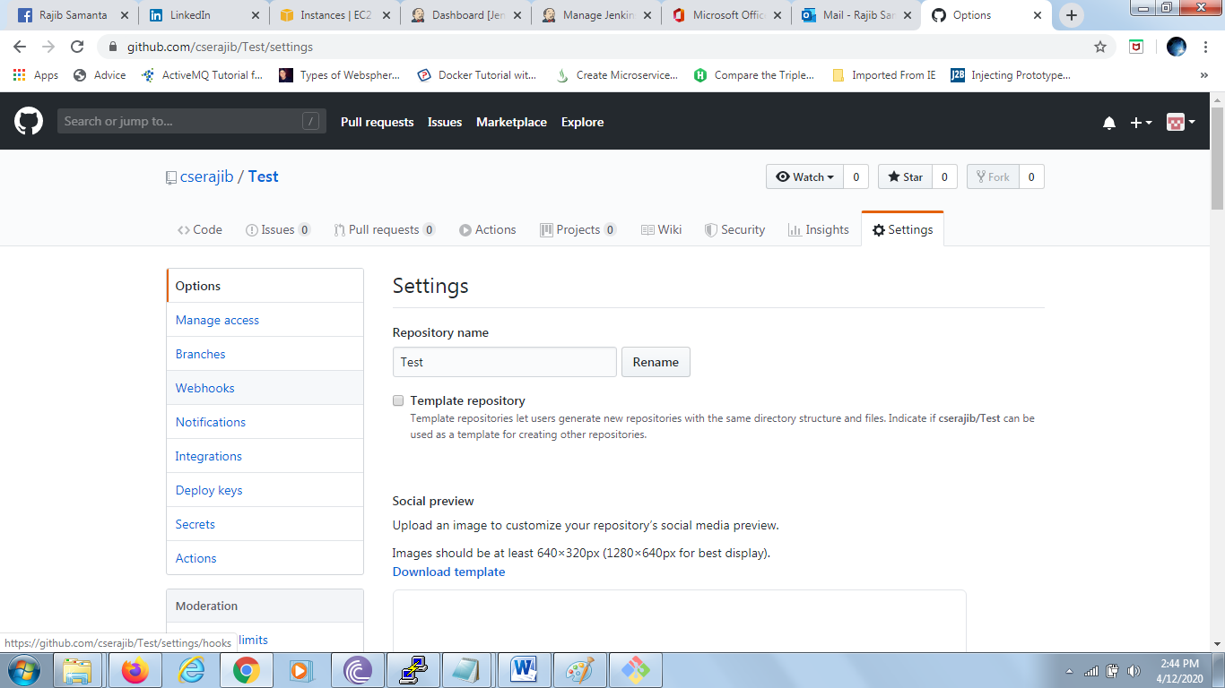

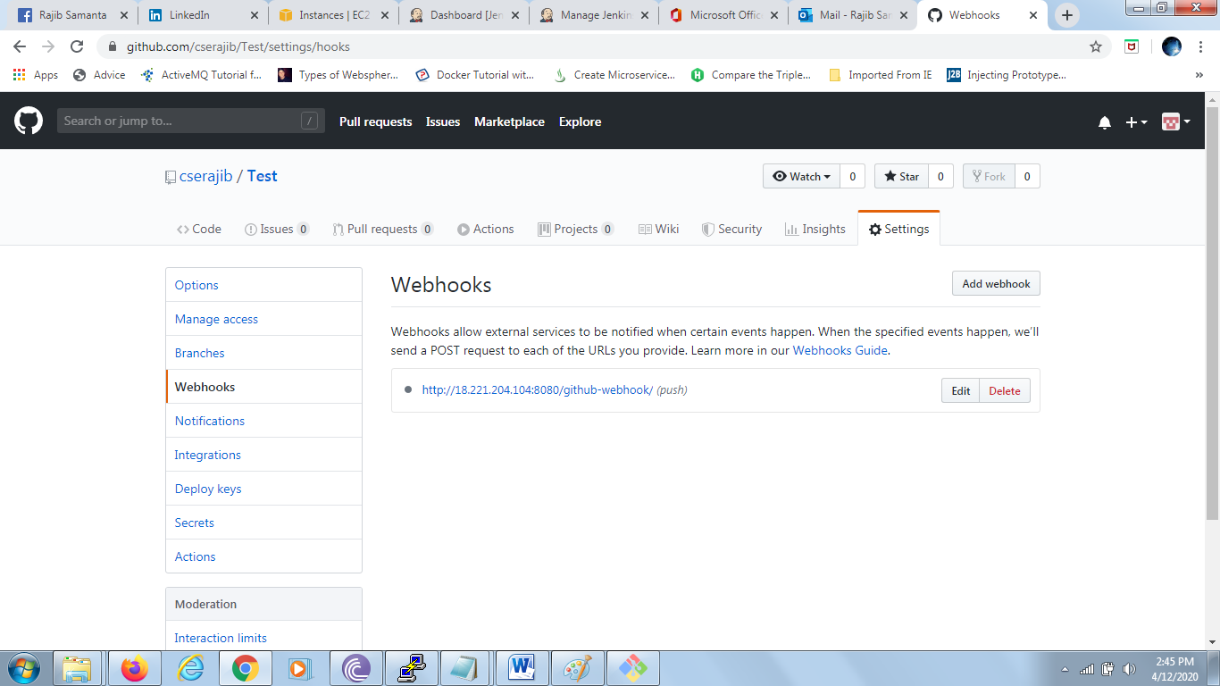

[**Add webhook**](https://github.com/cserajib/Test/settings/hooks/new)

Webhooks allow external services to be notified when certain events happen. When the specified events happen, we’ll send a POST request to each of the URLs you provide. Learn more in our [Webhooks Guide](https://developer.github.com/webhooks/).

* [http://18.216.122.191:8080/github-webhook/](https://github.com/cserajib/Test/settings/hooks/141854167)*(push)*
* To install Jenkins
* sudo su
* apt-get update
* apt-get install openjdk-8-jdk
* java -version
* wget -q -O - https://pkg.jenkins.io/debian/jenkins-ci.org.key | apt-key add
* echo deb https://pkg.jenkins.io/debian-stable binary/ | sudo tee /etc/apt/sources.list.d/jenkins.list
* apt-get update
* apt-get install Jenkins

or

1 apt-get update

    2  apt-get install docker.io

    3  docker --version

    4  docker ps

    5  docker ps -a

    6  docker run ubuntu

    7  docker ps -a

    8  docker ps

    9  docker images

   10  docker commit myapp mynginx

   11  docker commit suspicious_stallman mynginx

   12  docker images

   13  docker ps

   14  docker ps -a

   15  history

   16  docker ps -a

   17  docker tag ubuntu:7.0 rajib667/mycustom

   18  docker tag ubuntu rajib667/mycustom

   19  docker login

   20  docker push rajib667\mycustom

   21  docker push rajib667/mycustom

   22  history

PUTTY

<https://www.puttygen.com/download-putty>

AWS accout

[glcloudrajib@gmail.com/Hasnuhana@447](mailto:glcloudrajib@gmail.com/Hasnuhana@447)

GitHub

[cse.rajib@gmail.com/Hasnuhana@667](mailto:cse.rajib@gmail.com/Hasnuhana@667)

Jenkins url ---- <http://18.216.122.191:8080/>

18.216.122.191 – EC2 ubuntu instance public ip

mvn clean

mvn package

docker build -t myapp11 .

docker images

docker run -d -p 9009:8081 myapp11

docker build -t myproj .

docker run -d -p 8090:8080 myproj

-------------------------------------------------------------------------------------------

git clone https://github.com/cserajib/carservice

if image discovery1 exists delete it first using below command :otherwise wil not work properly

if running - docker stop discovery1

docker rm discovery1

mvn clean

mvn package

docker build -t discovery1 .

docker run -d -p 9008:1111 discovery1

here 1111 is port no that is same as tomcat port mentioned in application.properties and it has no connection

with expose port in dockerfile

browser url to hit - aws-ip:9008 (i.e http://18.224.1.251:9008/)- will open discovery page

---------------------------------------------------------------------------------------------

To install Jenkins

sudo su

apt-get update

apt-get install openjdk-8-jdk

java -version

wget -q -O - https://pkg.jenkins.io/debian/jenkins-ci.org.key | apt-key add

echo deb https://pkg.jenkins.io/debian-stable binary/ | sudo tee /etc/apt/sources.list.d/jenkins.list

apt-get update

apt-get install jenkins

-----------------------------------------------------------------------------------------------------------

install plugin steps: manage jenkins -> Plugin Manager-> available tab-> sear for "Build Pipeline" Plugin

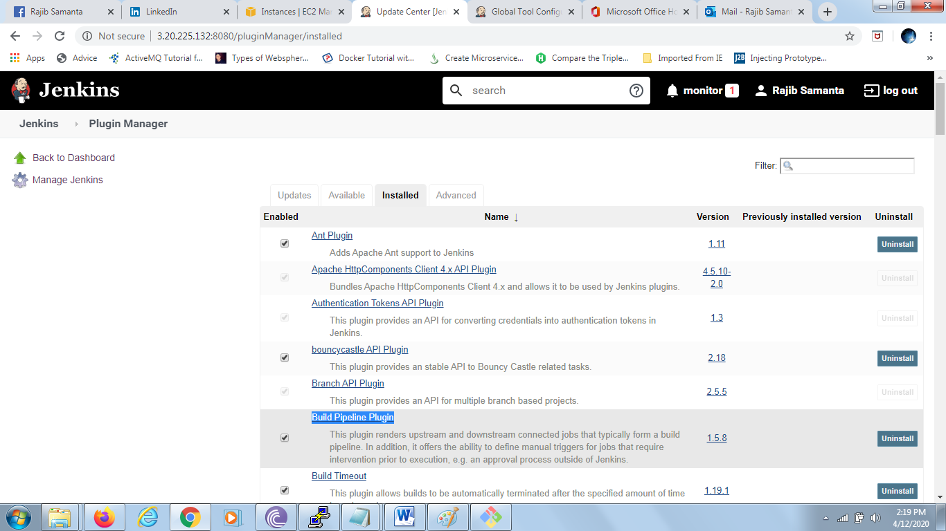

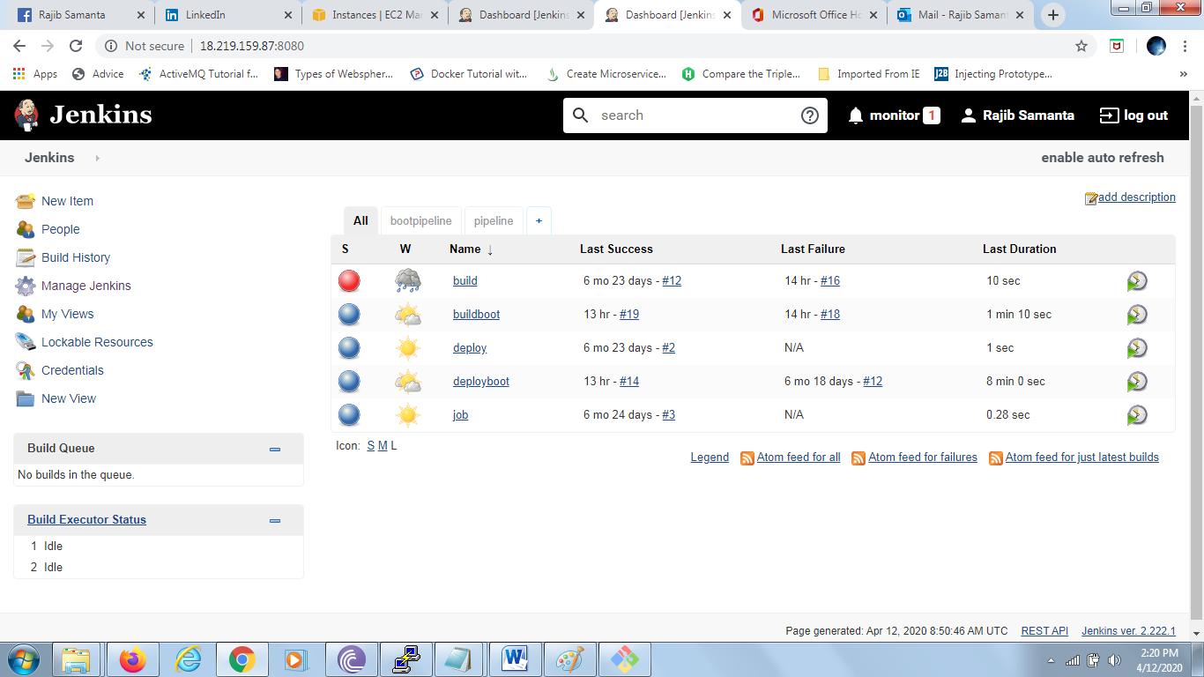

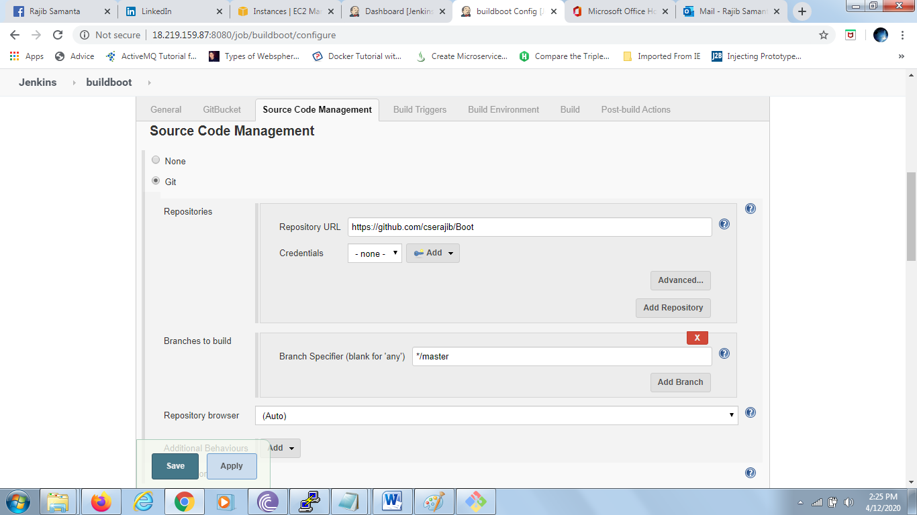

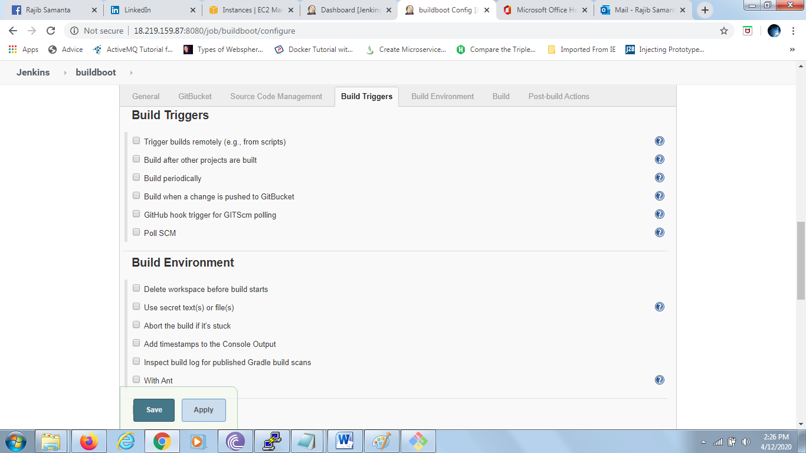

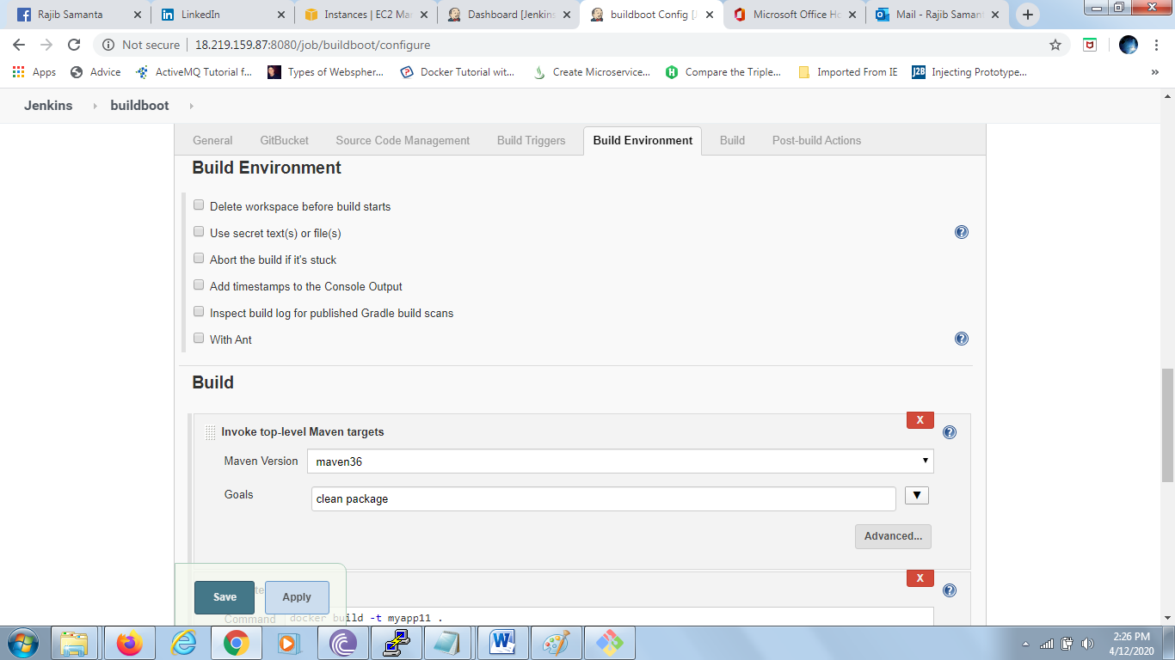

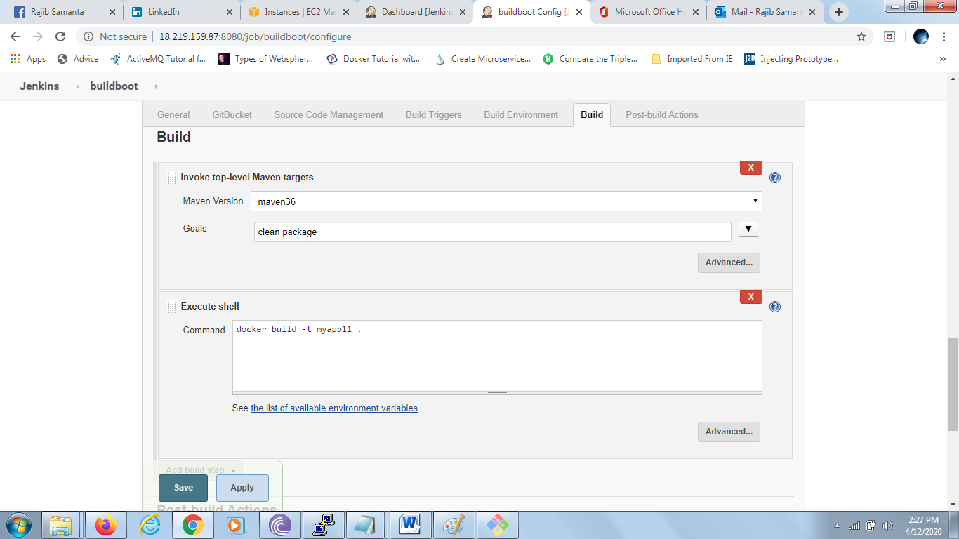

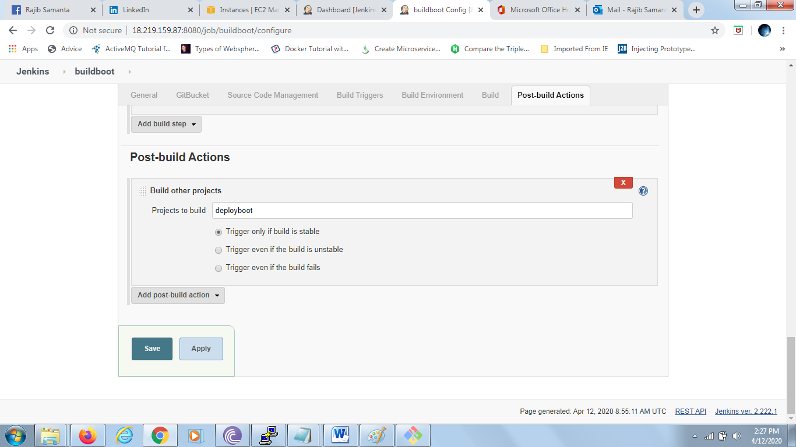

In deployboot: only change Build tab

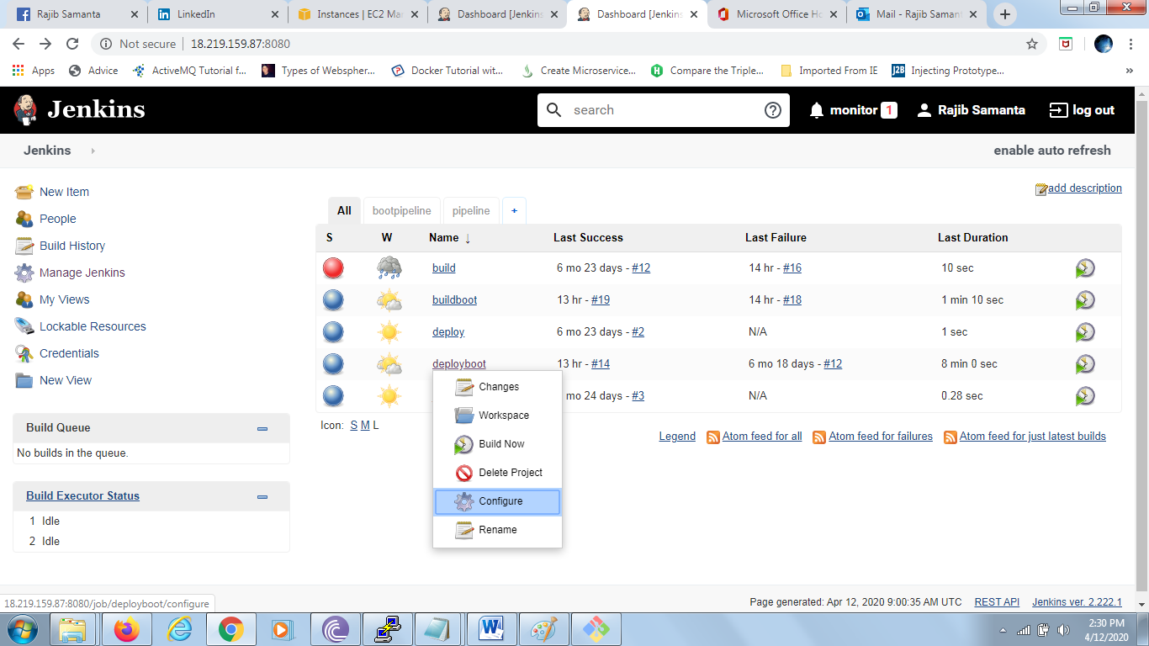

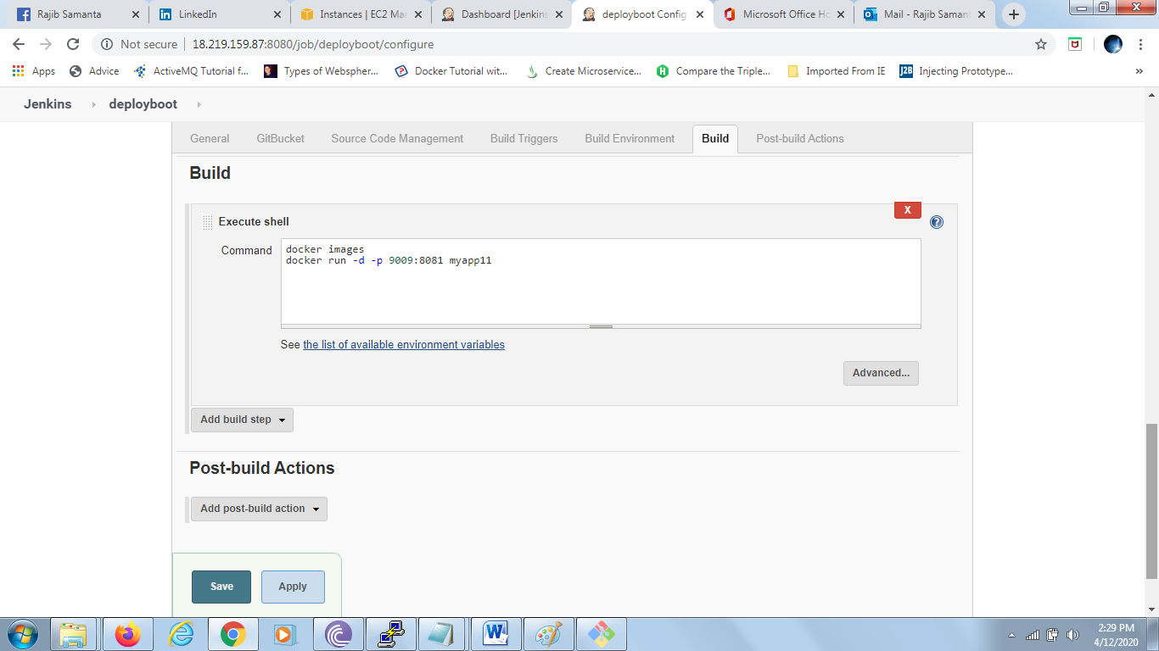

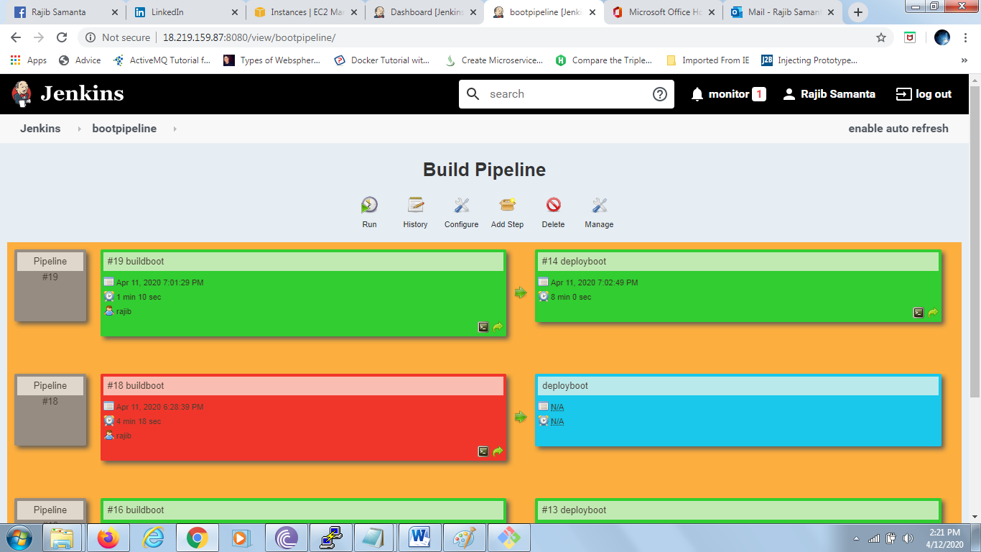

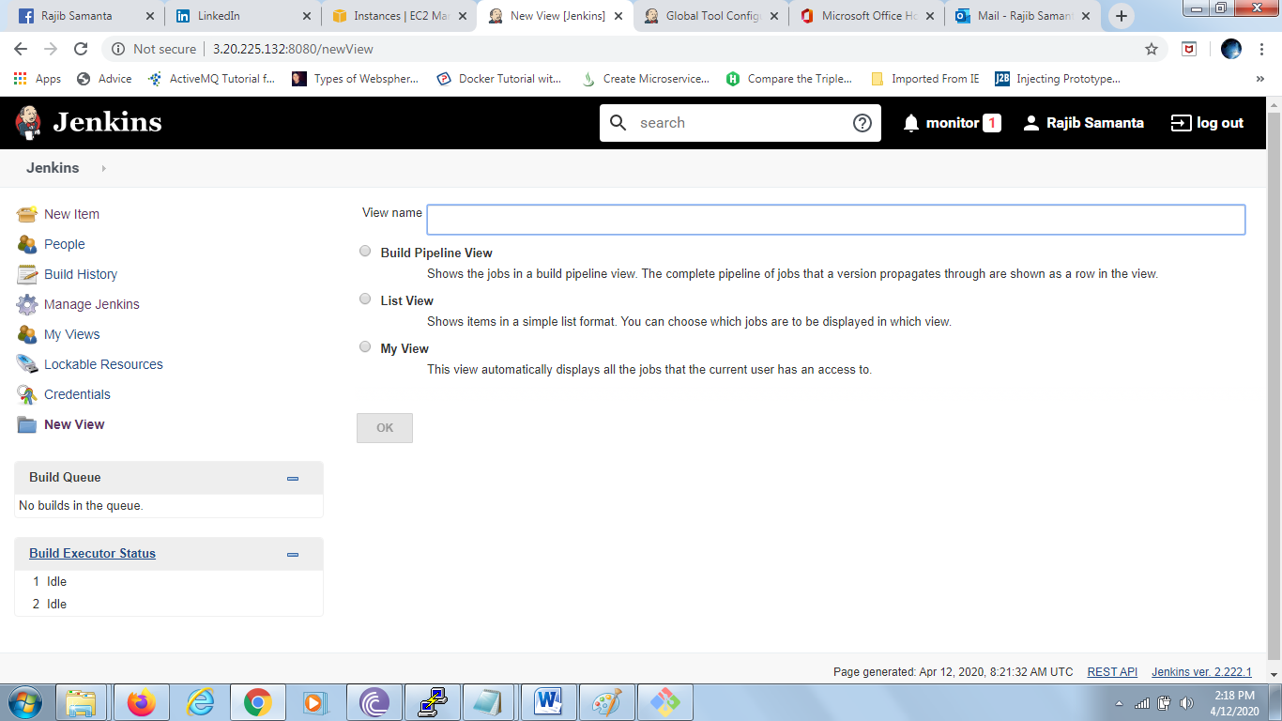

-------------------------------------------------------------------------------------------------------------

Maven set up steps : manage jenkins -> global Tool Configuration -> Maven

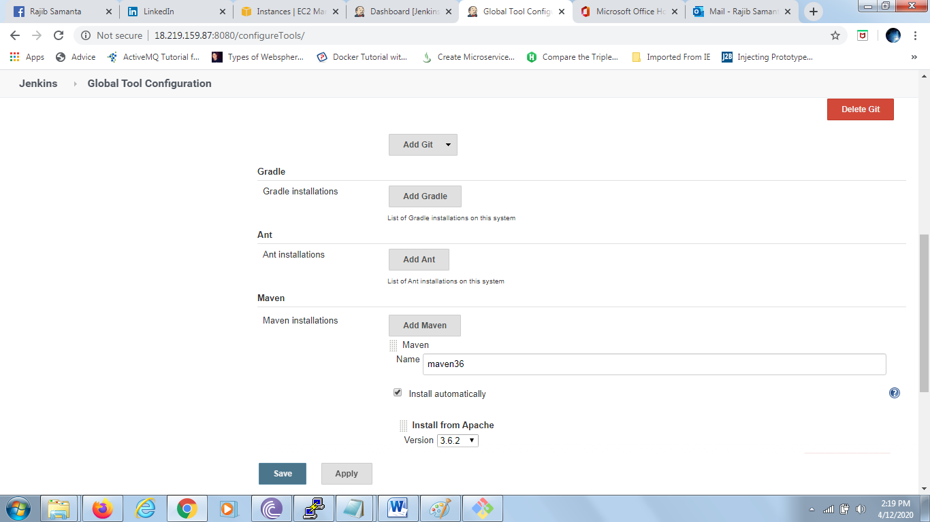

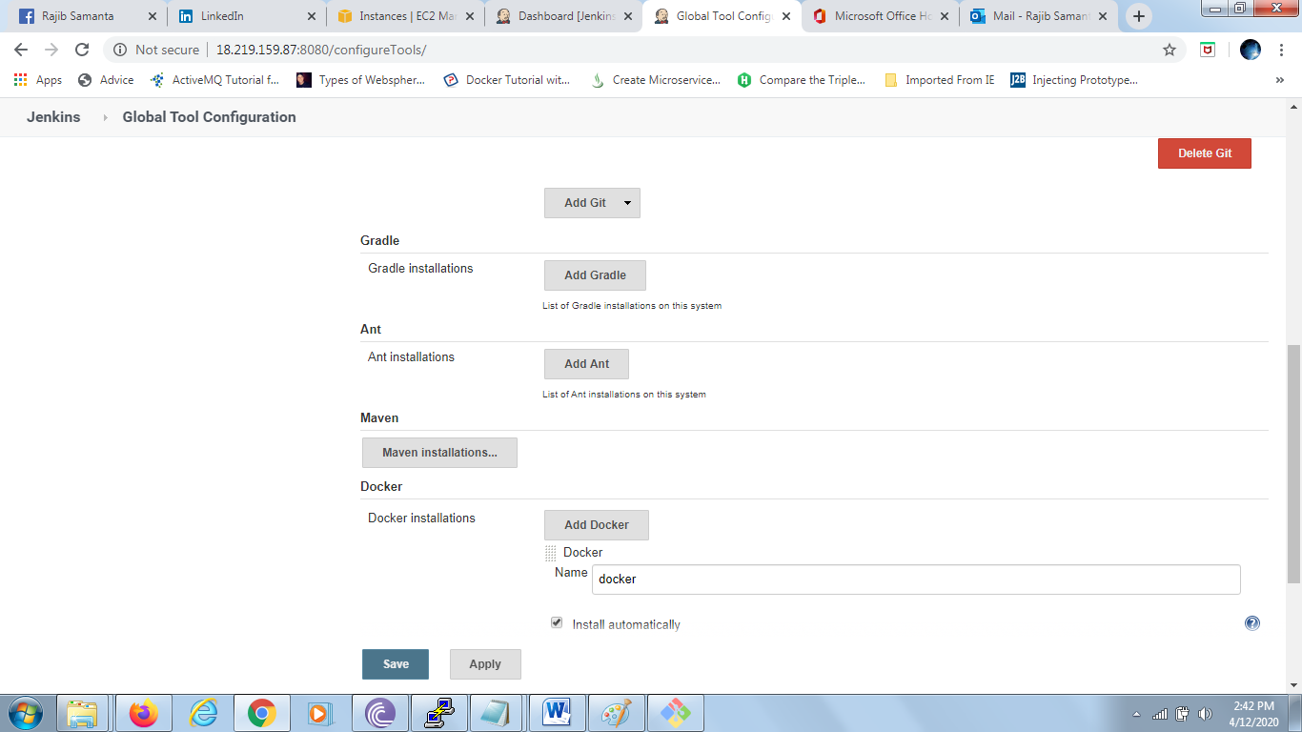

------------------------------------------------------------------------------------------------------------------------------------------Job auto execute after we modify repository in git hub.

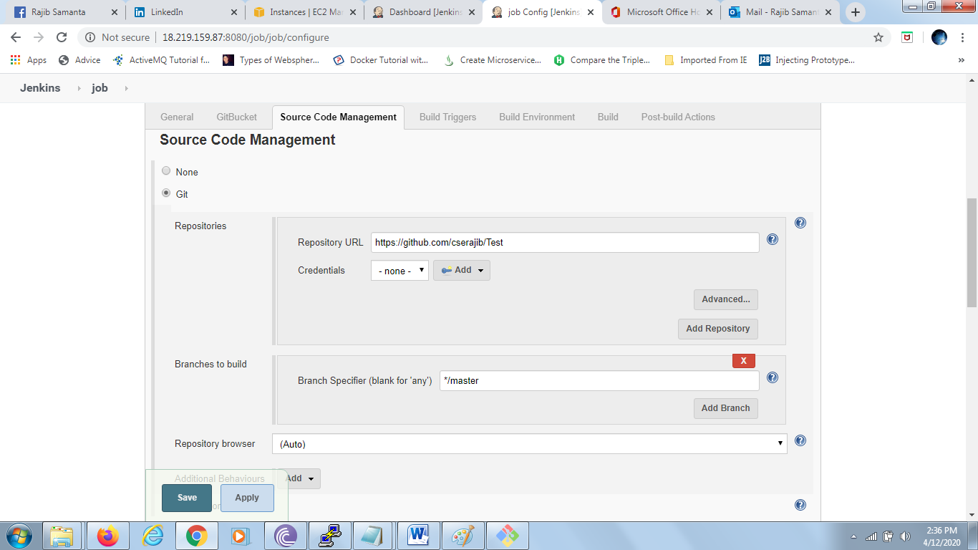

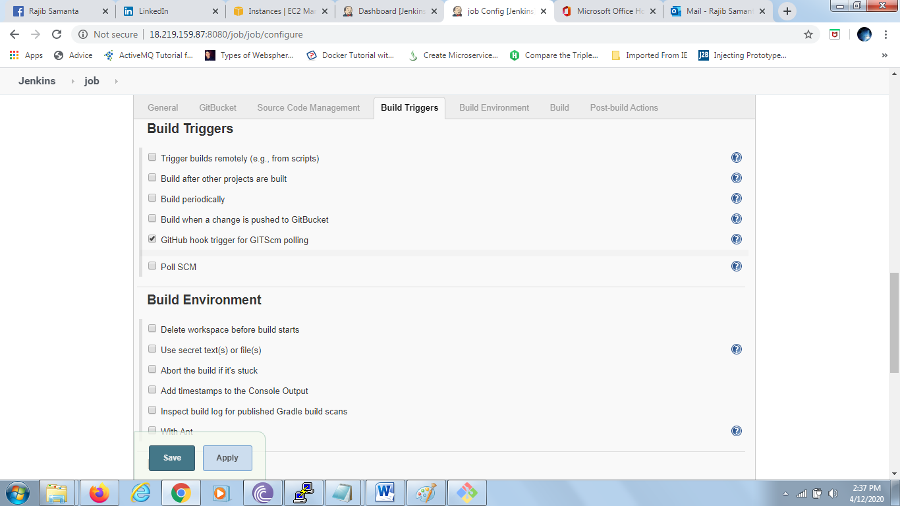

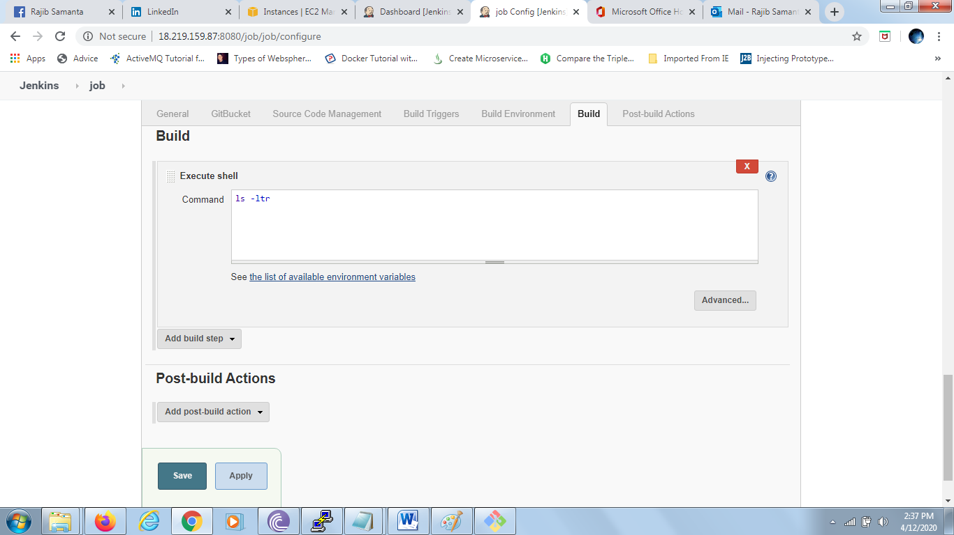

Step to create buildboot

New Item -> select Free Style Project and put name “buildboot” in text box

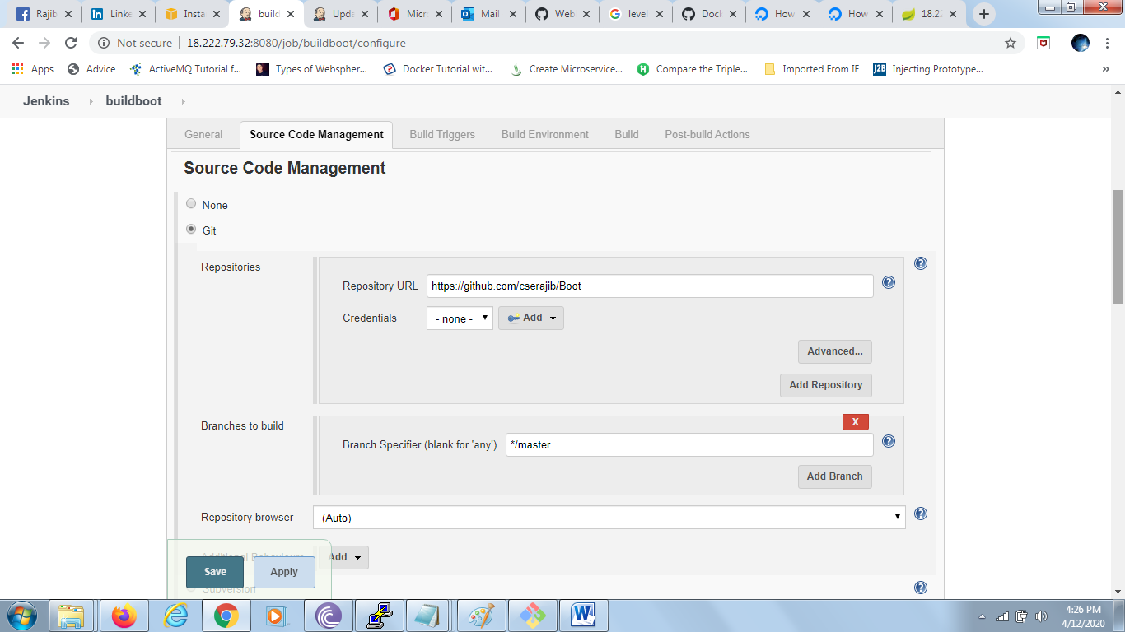

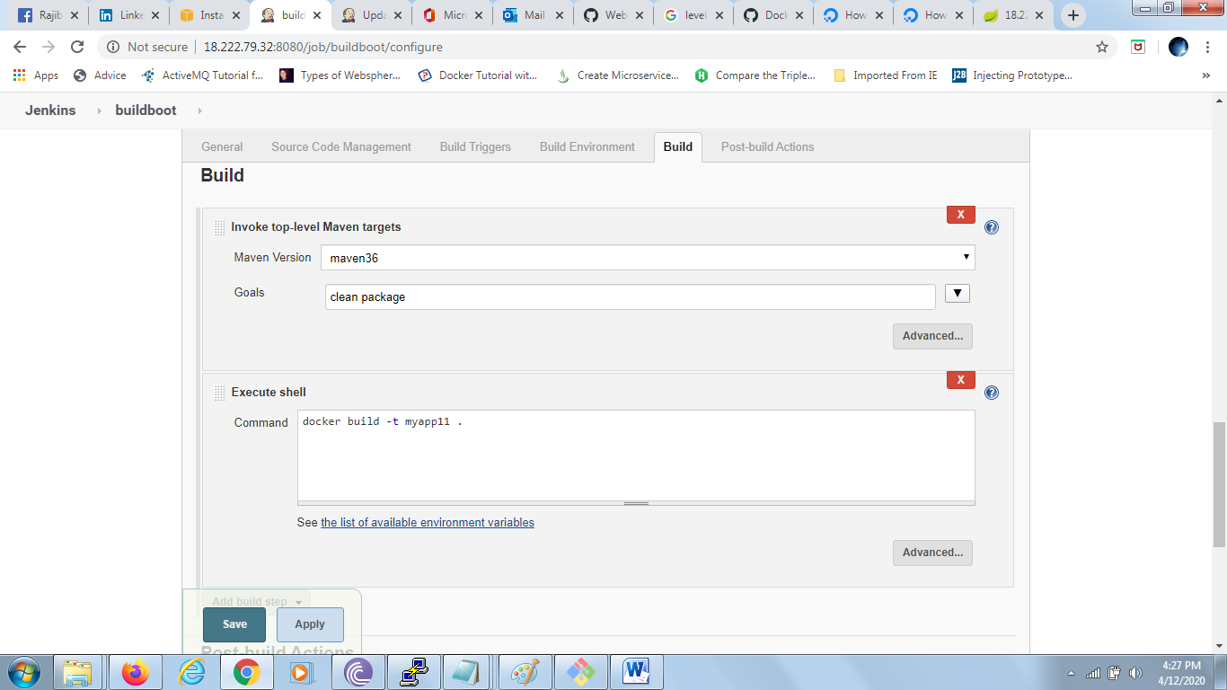

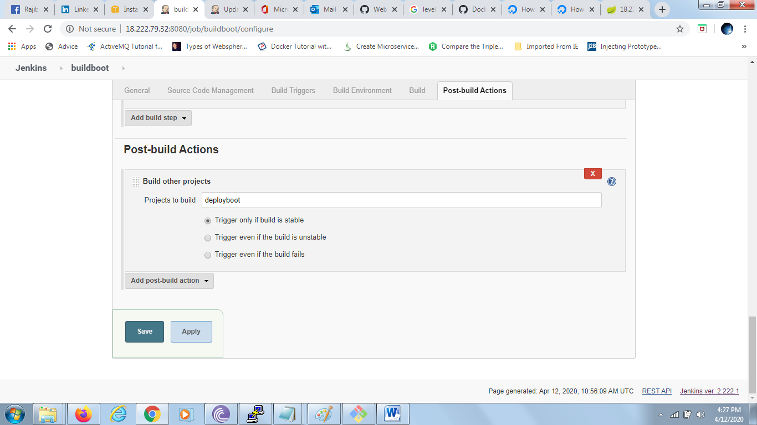

In case of following error

Got permission denied while trying to connect to the Docker daemon socket at unix:///var/run/docker.sock: Post

Then execute : sudo chmod 666 /var/run/docker.sock

Created deployboot

New Item -> select Free Style Project and put name “deployboot” in text box

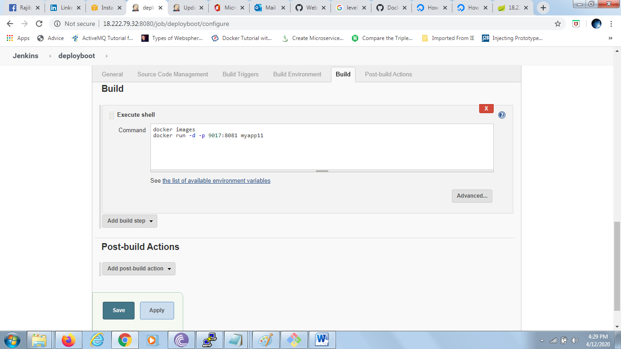

Then to create pipeline

Click + sign

Select **Build Pipeline View**

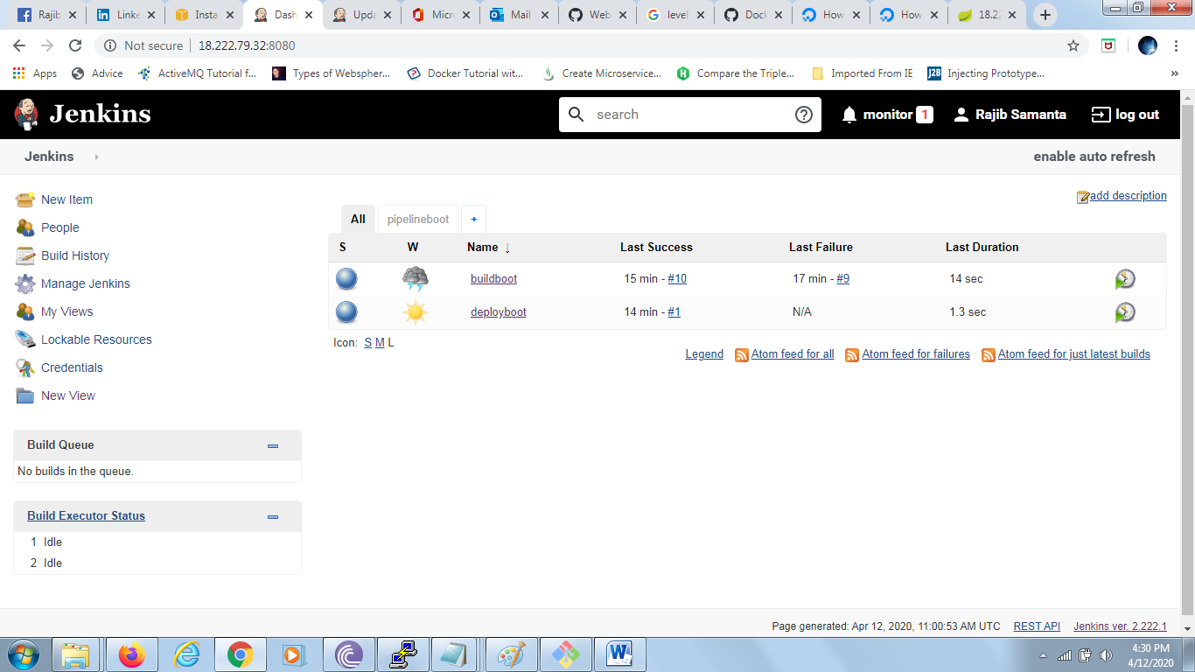

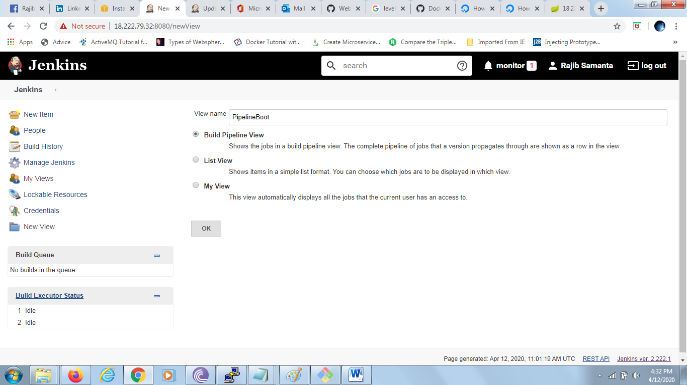

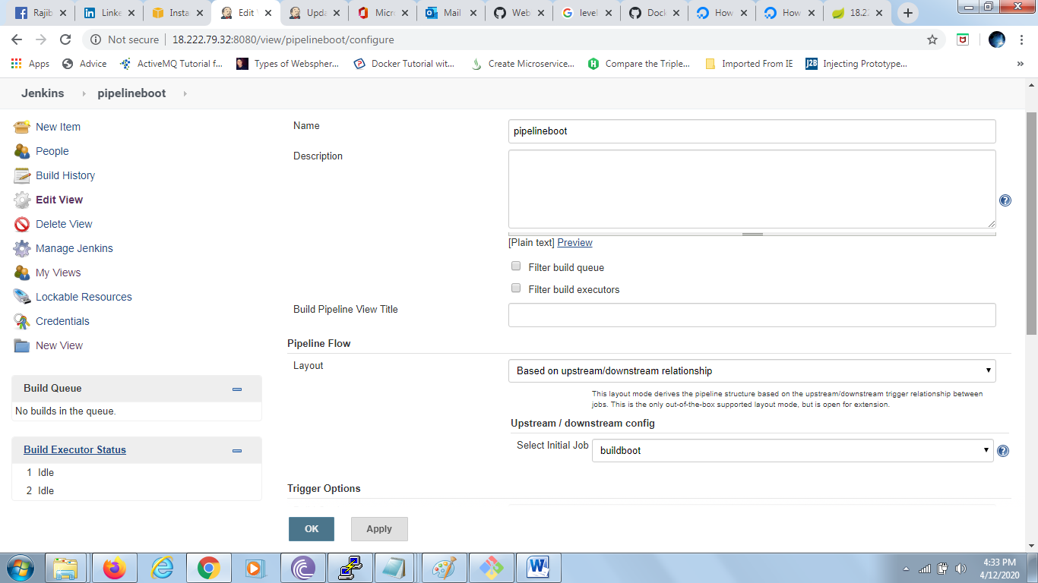

Press OK