**Chapter 1. Web applications for medical clinics**

* 1. **The objective of the project**

A tedious and unexciting waiting hall, the long queues, the hopelessness of getting inside the doctor’s chamber, the depressing faces of ailing patients— this would be the representation one would imagine maybe a decade ago while paying a visit to a medical centre. However, in recent times, this plot has been exceptionally altered thanks to the web development industry’s flourishing healthcare apps.

Furthermore, the study aims to explore how healthcare apps can contribute to reducing diagnostic errors by providing a centralized and accurate record of patients' health information, which can aid healthcare providers in making informed decisions. Additionally, the project will investigate the user experience of healthcare apps, including factors that may impact user adoption and engagement, and potential biases in user reviews. Through a comprehensive examination of these aspects, the research aims to provide insights into the potential benefits and limitations of utilizing healthcare apps in improving the efficiency and accessibility of healthcare services.

Nevertheless, minimizing the liability of misdiagnosis is also a paramount objective in healthcare, and such applications are able to have a critical role in achieving this intention. Managing patients’ records manually is sensitive to diagnostic blunders, inaccuracies and is time-wasting. However, the health web apps invalidate all such potential threats that might prove fatal for the long-suffering individuals. It is unquestionable, that maintaining a meticulous record of a patient’s health condition can aid doctors in establishing the correct medicine with the correct dosage and chemical compositions. The article "Global Misdiagnosis insides - medical error statistics by countries" only strengthens my point of view that, between diverse components that lead to misdiagnosis, system flows have a salient word to say: problems with connection or cooperativeness of care and handiness of medical record data. Delving into more quantitative specifics, the disruption amidst the patient and the medic during the clinical encounter seems to be the very first reason (79%) of why this happens.

In addition, the project will also consider potential challenges such as data privacy and security concerns, barriers to access for certain populations, and potential limitations in the accuracy and reliability of information provided by healthcare apps. By addressing these potential limitations, the research aims to provide a holistic and balanced perspective on the impact of healthcare apps on improving the efficiency of accessing healthcare services.

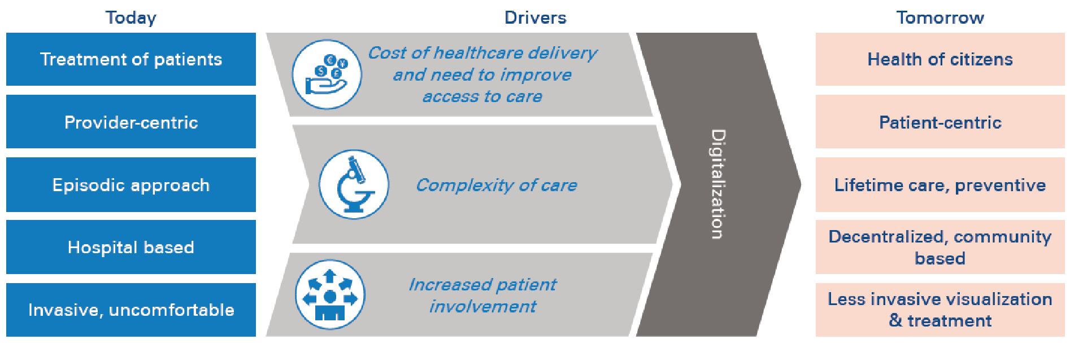

Figure - Concepts

Source: (<https://www.adlittle.com/no-en/insights/report/hospital-information-systems-digitally-enabled-era>)

This image would synthesize in a highly straightforward manner the most meaningful concepts I had the intention to be handled when I first thought about this topic. It is in clear view how the digitalization can only improve our living.

**1.2** **Application framework in web environment**

In the immediate present, the number of existing frameworks on which you can build a web app has seen an uninterrupted expansion, and this can be stated for both backend and frontend technologies. Despite this vast diversity, my preferences were React.js for the UI/UX segment, ASP.NET for the backend component, and SQL Server for the database server. The IDEs used are pretty commonplace, in order for every technology mentioned just above: Visual Studio Code, Visual Studio, and SSMS.

Bringing up an overview of the application, I can avow that my desire is to invent a straightforward application when speaking about the graphical user interface part, with the argument that this sort of application is designed to be used by the elders as well, not just by teenagers or, in general, by tech-skilled people. Furthermore, adding some intriguing functionalities would also be a part of my design.

Engaging in more detailed information, I found that the experience of this kind of web app should be nearly established on a personal account created on an email that has an obligation to abide by the requirements of the industry, meaning that it should respect the pattern...@yahoo.com or...@gmail.com, etc. depending on the email provider that the patient utilizes. What’s more, this comes in conjunction with a strong, secure password that needs to be long enough and have at least one special character. Thenceforth, after registering and logging in on the site, a home page will be uncovered, and the functionalities will be revealed to the user: ask for an examination, see the made appointments, read the reviews of the clinic, consult the price list in order to be unconditionally aware and download it as an Excel file, and ask for forthcoming services wanted. Finally, the final part of the menu is the FAQ.

Nonetheless, the local storage of the database also plays a significant role in storing various information, such as the registry of doctors with their daily availability, the price list, the reviews, and the created accounts, among others. However, I am of the opinion that special attention should be given to sensitive information. Therefore, it is imperative to store passwords in a secure manner, using hash functions and not in plain text; this comes along with the just-mentioned strong, secure password just above.

Additionally, for the local storage of the database, I tried to introduce a slight usage of what is nowadays called cloud computing. My pick, having in mind that I used technologies such as SQL Server and ASP.NET, was indubitably Microsoft Azure. As a very succinct description, Microsoft Azure is a cloud computing platform that offers different services for creating applications globally. Taking this into account, the review part is in possession of a field that allows users to upload a photo. It is self-evident that the photo won’t come to light on the page, and this feature is not a condition for the review to be posted.

## **1.3 Other such web applications**

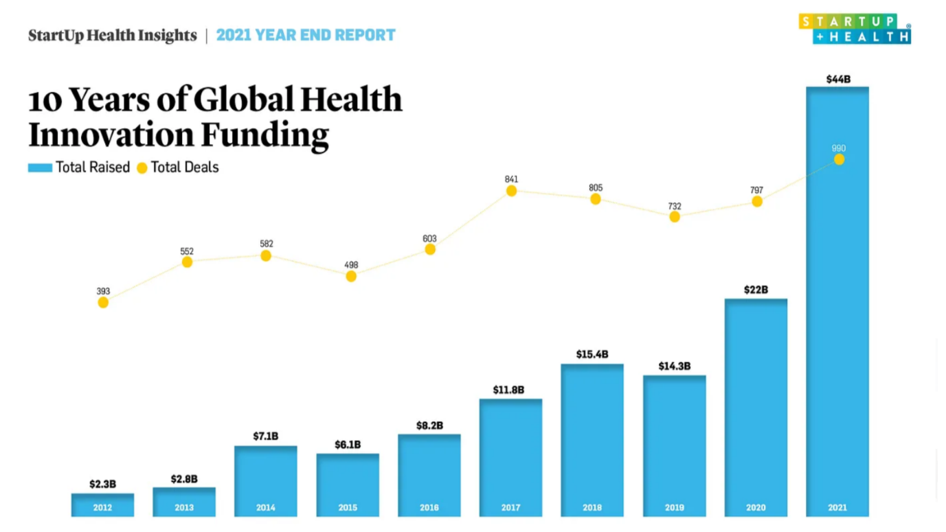

Figure - Reports

Source: 2021 Year-End Insights Report (StartUp Health)

When looking at the chart above and assessing it with a closer look, we can agree with the very clear fact that from the starting point of the investigation, 2012, and up to the last year taken into account, 2021, the digital health area of interest has established tremendous growth. According to the "2021 Year-End Insights Report: $44B Raised Globally in Health Innovation, Doubling Year Over Year" in 2011, just about $2B was deposited into this field. However, at the end of 2021, the dialogue will have undergone a complete shift, as a total of $44 billion has been allocated worldwide for funding health innovation. We are speaking about a 20x increase in just 10 years.

The exponential rise in  digital health investments, which have doubled from one year to the next in 2020, can also be imputed to the well known COVID-19 pandemic, as announced by WHO early in the year. Furthermore, it is quite paramount to observe that the conclusion was not inevitable. From square one, investors became cautious, and markets experienced a deceleration in March and April 2020, with major media outlets hinting at a theoretic cooling in the digital health market.

Nevertheless, we ought to take into account also some national providers of such services.

* **Regina Maria**

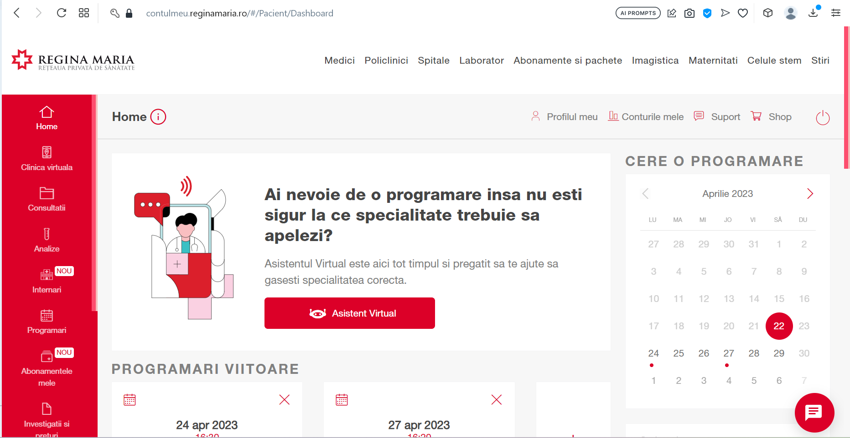

Figure - Regina Maria Dashboard

Source: Regina Maria Web Application

Stating just some words about the private health network, as how they describe themselves, it is one of the most essential supplier in this area of interest.

As it can be effortlessly discernible, the Regina Maria web application provides a great amount of information to the patient on the left side: past and forthcoming consultations, blood tests, subscriptions, and other things related. Their interface seems to be rather user-friendly, with all the features just one click away. For example, requesting an appointment would take just a few clicks in the immense, impossible-to-miss "Cere o programare" right part of the page.

According to the web site, they place a great deal of importance on some features: being able to schedule an appointment no matter what the hour is, with the details left to be handpicked by the patient, such as the desired doctor, at the adequate hour, at the nearest accessible location. What’s more, it seems like they also bring to the forefront that the application will always advise the first time slot available. This list of characteristics comes to an end with the capability of checking the price list before the actual consultation.

They also have a section with a palette of subscriptions divided into two sections: the ones for ordinary individuals and the ones for companies. Those who are built for individuals come, obviously, in a limited number, and to be more exact, 3, starting with a price of 74 RON per month and ending up with 214 RON per month. The contrast in price resulting from the features that a subscription has. The very same reasoning is the same for the companies subscriptions.

All in all, The Regina Maria web application offers a wealth of information to patients, including past and upcoming consultations, blood tests, and subscriptions. The interface is user-friendly, with easy access to features such as appointment scheduling. The application allows patients to handpick appointment details such as the desired doctor, time, and location, and advises the first available time slot. The web site also offers subscription options for individuals and companies, with varying prices based on the features included.

* **MedLife**

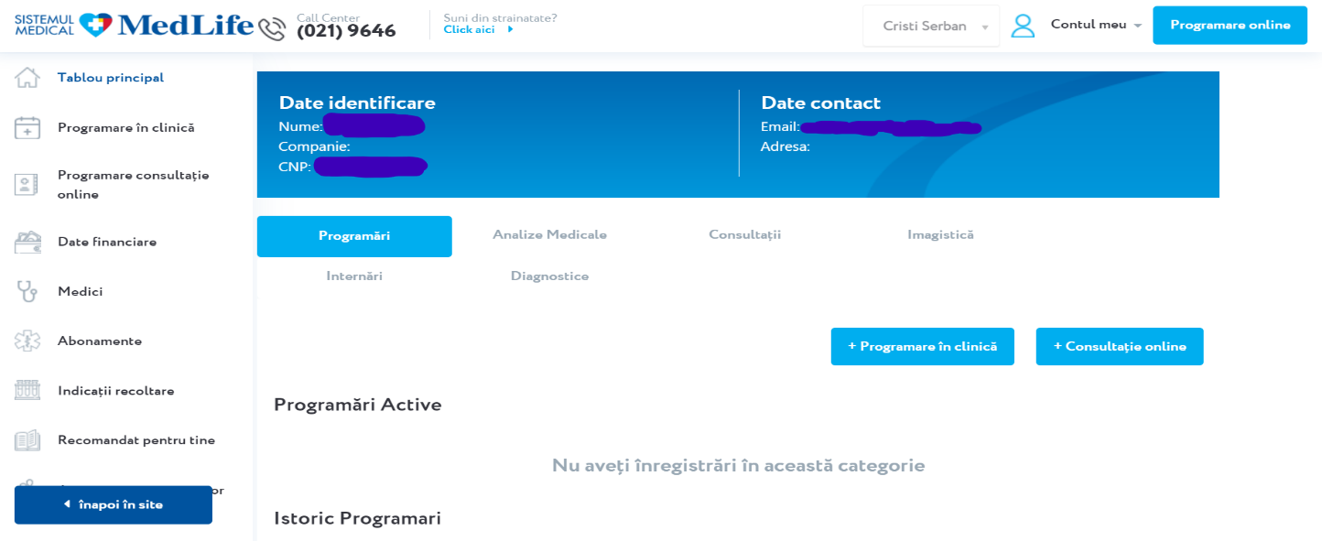

Figure - MedLife Web App Dashboard

Source: MedLife Web Application

Another company that provides health services in Romania is MedLife. Furthermore, on a simple Google search, they portray themselves as a medical system.

            Delving further into the specifics about what truly interests me, the web app, it is more or less evident that MedLife’s interface is similar to Regina Maria’s one. Based on the very same pattern, the menu is also located on the left part of the page, with the header containing some data about the owner of the account. Nearly equivalently, there is a button for asking for a consultation. Moreover, the description of the app as a whole is quite identical to the competitor’s.

            As things weren’t quite alike enough, Medlife also comes up with their very own catalog of subscriptions, the imbalance being made by the tiniest detail, indubitably not taking into account the pricing: they have 4 types of subscription instead of 3.

All things considered, MedLife, a healthcare services provider in Romania, appears to have similarities in its web app interface with its competitor, Regina Maria. The layout, menu placement, and description of the app are nearly identical, with the only notable difference being the number of subscription types offered. Despite these similarities, pricing is not taken into account.