**Chapter 2. Technologies used**

**2.1 Programming Languages used**

Habitually, when making mention of a web application we are speaking about three foremost constituents: client-side, server-side and a database server. But in spite of that, in my case, the third one has an individual role, and that is to store data. For this very rationale, the emphasis will be on the client-side, respectively server-side languages, React.js and ASP.NET.

React.js is a JavaScript framework viable for building user interfaces for web applications. Developed by Facebook at the moment of writing Meta, React empowers the innovator to bring into being reusable UI components and manage the state of those components as they convert over moments in time. The admiration for this framework has arisen because of its user-friendly nature, flexible architecture, and high productivity. It is a widely adopted tool among web developers for crafting dynamic, interactive, and responsive user interfaces for web applications.

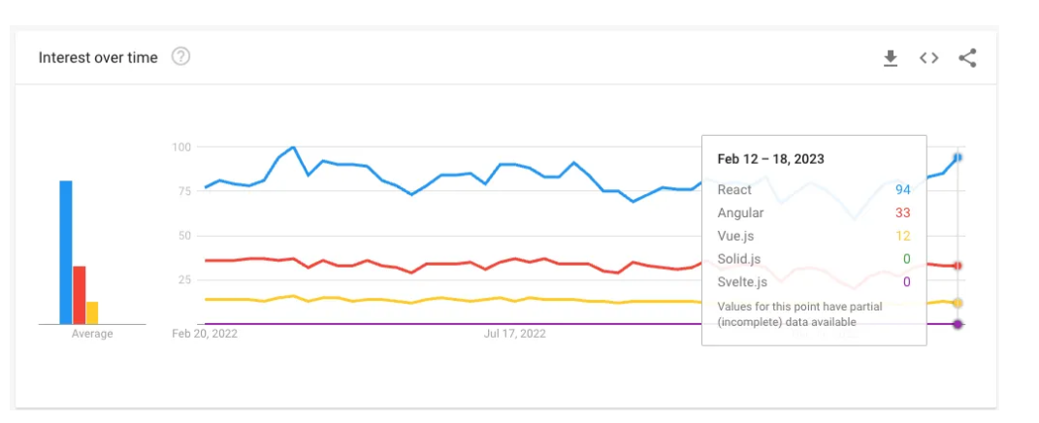

Source: Google Trends

The image above reveals the interest over time in a mixed bag of JavaScript frameworks and how React.js occupies the first place. What’s more, according to *lambdatest.com*, there are a noteworthy number of distinguished benefits when referring to this peculiar framework, and those would be: easy integration, direction dataflow, simpler syntax, virtual DOM, and the list goes on and on.

On the other side of the rationale, as mentioned at the start of the chapter, there are two central programming languages used to develop this web application, and with the discourse about React.js being accomplished, it is now ASP.NET's turn.

ASP.NET is a web framework developed by Microsoft that is open source and designed for creating modern web apps and services using .NET. It operates on top of the HTTP protocol and employs HTTP commands and procedures to enable collaboration and communication between the browser and server. While there are other alternatives to ASP.NET, such as C#, Visual Basic.Net, JScript, and J#, ASP.NET has a long history of development and has been constantly evolving since version 1.0. The latest version used for this project is ASP.NET 6.0.

To assist developers in creating strong and scalable web applications, ASP.NET offers various capabilities, including but not limited to security, caching, session management, and authentication.

**2.2 Visual Studio 2022**

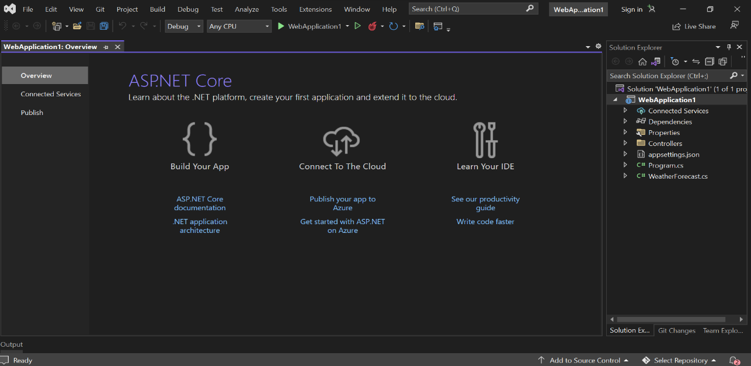

Figure 5

Source: Visual Studio 2022 ASP.NET Web Core API project

At the very cornerstone of my back-end share of the web application is ASP.NET, as detailed by Microsoft as "open source web framework [1]". For this consideration, my preferred IDE to further develop the project was indubitably Visual Studio 2022, which is also an "integrated development environment" also created by Microsoft. This platform has suffered different improvements through the years, the very first being Visual Studio 2013.

It goes without saying that Visual Studio 2022 delivers a significant amount of possibilities when referring to the options available for creating an application, starting with the indispensable debugging and ending up with advanced collaboration features such as Live Share, Azure DevOps integration; however, for the goal of the project, I will concisely characterize it as a whole.

Therefore, on the right side of the window is the solution explorer, which supplies the user with a handful of methods to instantaneously access the project: manage files, projects, and solutions. What’s more, right next to the "Solution Explorer" stands the "Git Changes" section that empowers developers to manage version control when speaking about their projects and, eventually, collaborate with team members, making teamwork and project management way more efficient.

**2.3 Visual Studio Code**

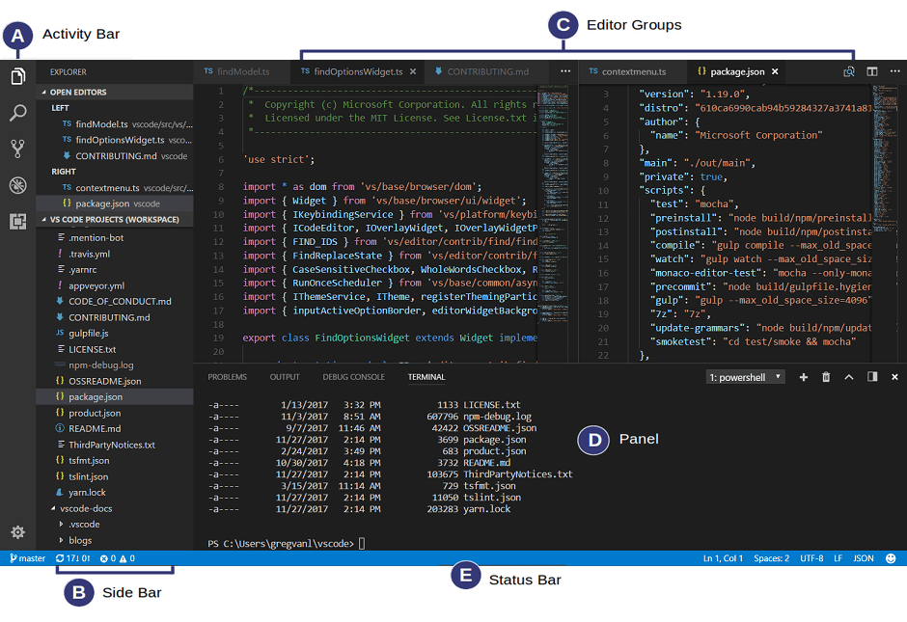

Source: Visual Studio Code Documentation (https://code.visualstudio.com/docs/getstarted/userinterface)

According to Wikipedia, Visual Studio Code is "[source-code editor](https://en.wikipedia.org/wiki/Source-code_editor) made by [Microsoft](https://en.wikipedia.org/wiki/Microsoft)". Therefore, this description could be supplemented. The list of features incorporates things such as syntax highlighting, debugging, pieces of code known as snippets, being able to change the general theme, installing extensions, and the list goes on and on. Nevertheless, as the very final piece of information, in the Stack Overflow 20222 Developer Survey, this IDE was placed in the very first place when speaking about popularity.

Nevertheless, going into slightly significant details, in agreement with the Visual Studio Code Documentation, the user interface is a mixture of five predominant parts, as can be seen: Activity Bar to be able to change the views immediately, Side Bar with data about the project, Editor being the most important part for editing the files, Groups, Panel to debug, and Status Bar with reports about the project.

Thus, with this being presented, next I can introduce the most significant technologies I used when referring to the front end.

The responsiveness of the whole front-end architecture is centered on Bootstrap. Bootstrap is a chargeless, free software with a simple and accurate central aim: to simplify the creation of responsive websites by offering collections of templates and syntax design objectives.

Why ought to use Bootstrap? The foremost justification would be rather stimulating: the simplicity of usage. Because of its widespread usage, numerous online tutorials and forums exist to assist beginners in getting started. The upcoming argument is the responsive grid. The software has in its components a pre-built grid system, which erases the requirement to bring one into being. This system is built up of rows and columns that empower you to generate a grid within the primitive grid instead of incorporating media queries directly into the CSS file. Last but not least, Bootstrap documentation, which is quite intuitive and rather approachable, has a salient word to say nonetheless, and last but not least, the ease of use, that look like this:



or this:



As a conclusion, according to w3techs.com, out of all the websites whose JavaScript libraries we are aware of, Bootstrap is utilized by 25.9%, which accounts for 21.3% of all websites. This indicates that Bootstrap is a widely adopted and popular JavaScript framework among website developers.

Another paramount factor in my web site application is the validation of the forms. This, would be done with Yup. Yup is a schema constructor for analyzing and interpreting runtime values. It facilitates modelling complex, interconnected verification or value transformation and is succinct yet powerful. Yup is an outstanding modeler which embraces both server-side and client-side validation equally well and comes with built-in asynchronous verification features.

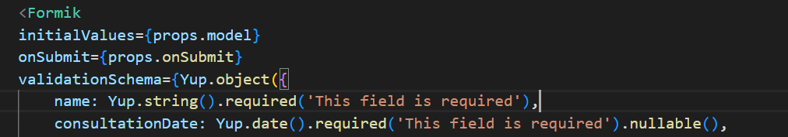

All things considered, this IDE was my alternative to building the front-end part using React.js.

**2.3 SQL Server and SQL Server Management Studio (SSMS)**

SQL Server is a relational database management system created purely by the tech giant Microsoft, and expanded on SQL, a programming language commonly used for interacting with relational databases in a standardized manner. Therefore, as a database server, its most consequential purpose is to facilitate the storage and retrieval of data requested by other software applications, either on the same computer or a remote computer, utilizing the client-server module.

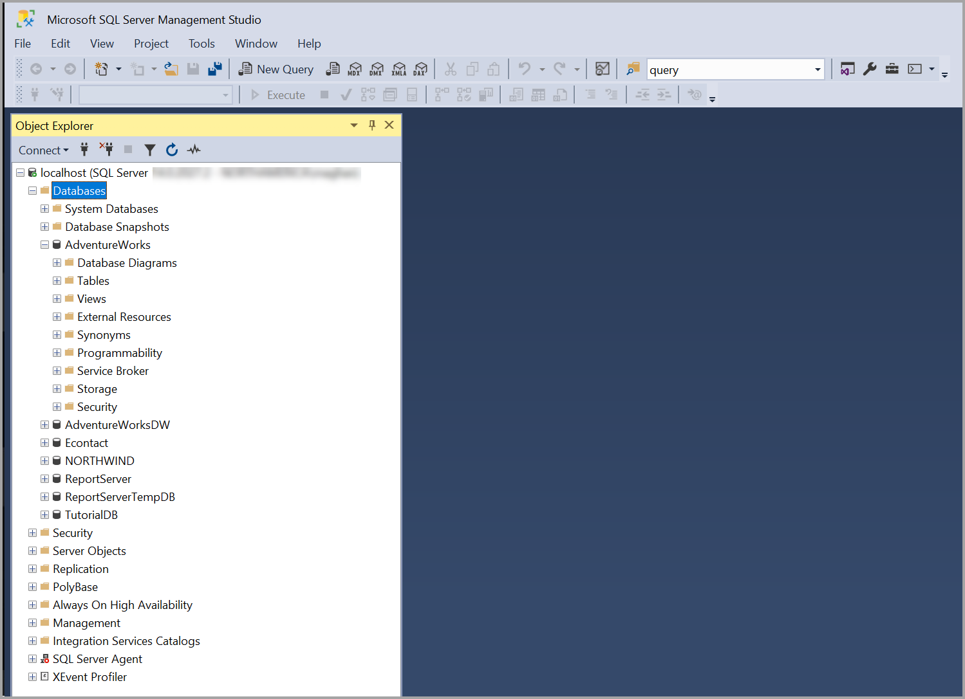

Figure 7

Source: SSMS Documentation (https://learn.microsoft.com/en-us/sql/ssms/sql-server-management-studio-ssms?view=sql-server-ver16)

In conformity with the documentation, SQL Server Management Studio is an integrated tool that bestows a graphical user interface for conducting a considerable amount of aspects of SQL infrastructure: SQL Server, Azure SQL Database, Azure SQL Managed Instance, etc. Nonetheless, it provides a panoramic range of features and benefits that empower the ability to manage database objects, write and execute queries, and design server settings. In summary, SSMS proves to be a potent and instinctive tool for handling SQL infrastructure.

Making allowance for the things suggested above, I am of the opinion that my reasoning for electing this technology to compound the local data storage of my project is absolutely unambiguous: as with other technologies, it was also created by Microsoft.

On the other hand, a critical component that send data through the API into the database is Axios library. Axios is a widely recognized JavaScript package aimed at making it less difficult to submit HTTP requests. It delivers a straightforward API with tools for controlling answers, sending HTTP queries, and manipulating data in numerous manners. Axios has proven itself as an outstanding choice for developers seeking for a trustworthy and efficient tool for managing HTTP communication in their applications due to its intuitive interface and impressive features like computerized JSON parsing and request cancellation.

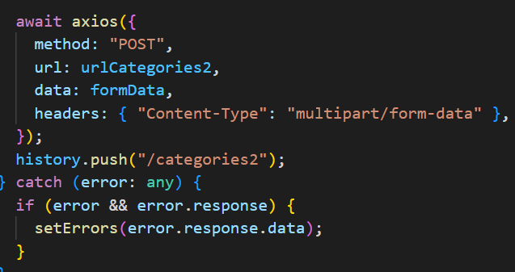

Data is able to be communicated to a server using the HTTP POST request utilizing the versatile Axios POST mechanism. Developers may basically oversee the server's response and include information within the request body, such as form inputs or JSON payloads. This approach makes the process simpler to supply data to web applications and makes it feasible for the client and server to share information properly.

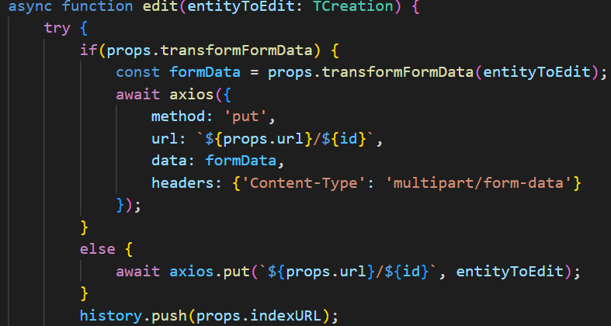

For replacing or improving an entire resource on a server, I implemented the Axios HTTP PUT method. Using an HTTP PUT request, which is frequently accompanied by an identifier or unique identifier that indicates the specific resource being changed, makes it possible for developers to communicate new data to the server. This method offers an efficient way to change or replace data on the server side and is regularly employed for full replacements of existing resources.

The POST and PUT methods are extremely significant for data submissions and resource modifications, respectively, even though Axios offers a variety of other HTTP methods like GET, DELETE, and PATCH. The aforementioned methods provide significant aptitude to control data activities in web applications through permitting effective communication between clients and servers.