**4. Modelling and describing the web application**

When addressing the matter of discussing this certain nature of application, my modest point of view would say it would rather be uncomplicated, intuitive to use. I have the belief that at some point in time we all had an emergency, and inarguably you do not want to see a complex, somewhat harsh interface to use when there is suffering to bear; this is just a nimble example. On the grounds of this rationale stands the foundation of my silhouetting the interface of the app.

The earliest page that ought to be accessed, emphasizing the fact that if the account is not created, ought to be the register page. Hardening the most crucial part of those accounted for above, I can state that the design is rather annoyingly elementary, with two fields that hold a label for what is expected to be written and a button.

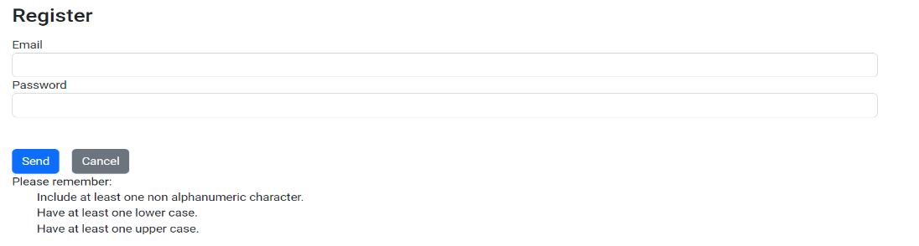

Figure 9

However, with the abundance of the twenty first century range of possible alternatives come twenty first century threats, and, I am referring to the cyber security ones. Keeping this in perspective, some non-negotiable requirements when referring to the password must be met for the account to be created, and those would be: a sizeable length, with at least one capital letter, and at least one special character. Furthermore, these restrictions come in a complementary manner with the email field, which ought to follow an email structure such as [...@yahoo.com](mailto:%20...@yahoo.com). Moreover, the validation for the above-discussed input is in real time: when the field is left empty, a red message “Required” will be displayed; As soon as a character is written into the email field, the message will metamorphose into “Invalid Email Address” as long as the format is incorrect. For this mechanism to have a closing point, the account will be stored into a local database, clearly with the password not in plain sight but hashed.

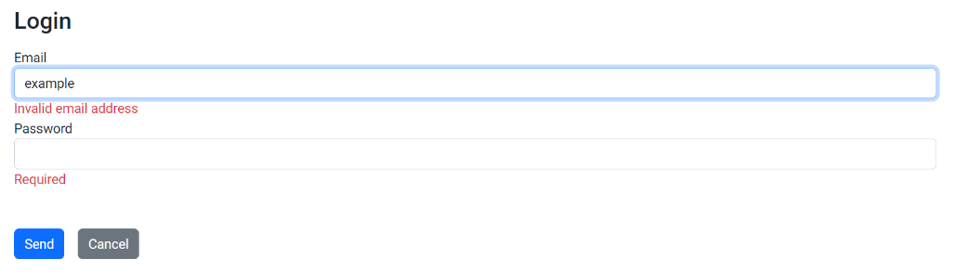

Figure 10

After this aftermath of this imperative mechanism of creating the account and logging in, if and only if the credentials are correct, the user will instinctively be redirected to the home page, and the site will disclose a handful of choices that are integrated in a menu on the top of the page, such as Ask for Examination, My Examinations, Price List, Reviews, Forthcoming Services and FAQ. Additionally, it’s worth mentioning that in the case of a logout miss click, the user will be shown a message that he/she is not allowed to see the page, foregrounding the significance of the account.

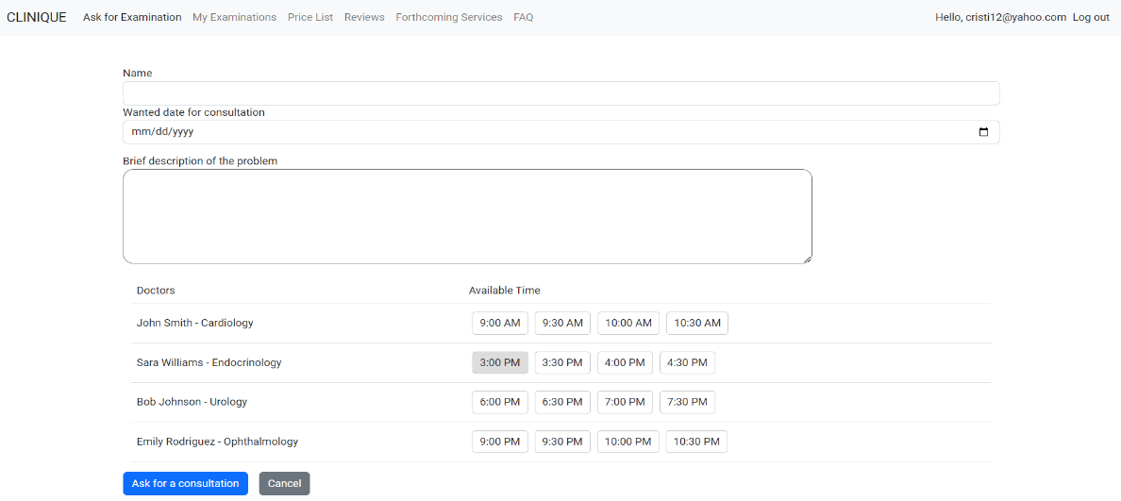

Figure 11

The Ask for Examination section of the web app is, from my standpoint, one of the most salient components. As it can be observed from the picture, the page incorporates four categories in order for the appointment to be made: name, wanted date, a brief description that is not indispensable, and the list of doctors with their specialty and schedule. In terms of validation, they were applied to the name field and the wanted date, as I consider them to be of the essence. Moreover, the fact that a past date can not be chosen is worth highlighting.

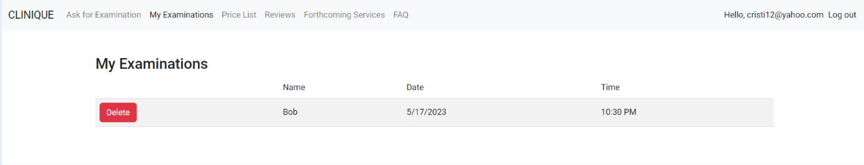

Figure 12

The following part is, unmistakably, the one committed to the arranged meeting with the doctor. As can be seen in the figure above, a collection of, according to my way of thinking, the three most paramount pieces of information is shown. Also, in my humble opinion, the competence to delete the created appointment seemed to play a huge role in all this context.