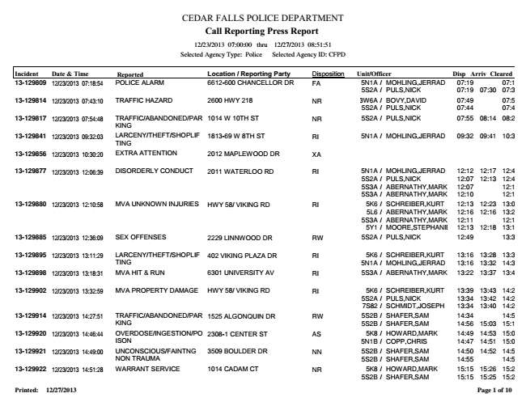

CEDAR FALLS POLICE DEPARTMENT Call Reporting Press Report

12/23/2013 07:00:00 thru 12/27/2013 08:51:51 Selected Agency Type: Police Selected Agency ID: CFPD

Incident Date & Time Reported Location / Reporting Party Disposition Unit/Officer Disp Arriv Cleared 13-129809 12/23/2013 07:18:54

POLICE ALARM 6612-600 CHANCELLOR DR FA 5N1A /

MOHLING,JERRAD 07:19 07:19 5S2A / PULS,NICK 07:19 07:30 07:35 13-129814 12/23/2013 07:43:10

TRAFFIC HAZARD 2600 HWY 218 NR 3W6A /

BOVY,DAVID 07:49 07:57 5S2A / PULS,NICK 07:44 07:46 13-129817 12/23/2013 07:54:48

TRAFFIC/ABANDONED/PAR 1014 W 10TH ST NR 5S2A / PULS,NICK 07:55 08:14 08:29 KING 13-129841 12/23/2013 09:32:03

LARCENY/THEFT/SHOPLIF TING 1813-69 W 8TH ST RI 5N1A / MOHLING,JERRAD 09:32 09:41 10:31 13-129856 12/23/2013 10:30:20 EXTRA ATTENTION 2012 MAPLEWOOD DR XA 13-129877 12/23/2013 12:06:39

DISORDERLY CONDUCT 2011 WATERLOO RD RI 5N1A /

MOHLING,JERRAD 12:12 12:17 12:42 5S2A / PULS,NICK 12:07 12:13 12:49 5S3A / ABERNATHY,MARK 12:07 12:10 5S3A / ABERNATHY,MARK 12:10 12:11 13-129880 12/23/2013 12:10:58

MVA UNKNOWN INJURIES HWY 58/ VIKING RD RI 5K6 /

SCHREIBER,KURT 12:13 12:23 13:02 5L6 / ABERNATHY,MARK 12:16 12:16 13:20 5S3A / ABERNATHY,MARK 12:11 12:16 5Y1 / MOORE,STEPHANIE 12:13 12:18 13:16 13-129885 12/23/2013 12:36:09 SEX OFFENSES 2229 LINNWOOD DR RW 5S2A / PULS,NICK 12:49 13:33 13-129895 12/23/2013 13:11:29

LARCENY/THEFT/SHOPLIF TING

402 VIKING PLAZA DR RI 5K6 /

SCHREIBER,KURT 13:16 13:28 13:39 5N1A / MOHLING,JERRAD 13:16 13:32 14:30 13-129898 12/23/2013 13:18:31 MVA HIT & RUN 6301 UNIVERSITY AV RI 5S3A / ABERNATHY,MARK 13:22 13:37 13:45 13-129902 12/23/2013 13:32:59

MVA PROPERTY DAMAGE HWY 58/ VIKING RD RI 5K6 /

SCHREIBER,KURT 13:39 13:43 14:23 5S2A / PULS,NICK 13:34 13:42 14:23 7S82 / SCHMIDT,JOSEPH 13:34 13:40 14:23 13-129914 12/23/2013 14:27:51

TRAFFIC/ABANDONED/PAR KING

1525 ALGONQUIN DR RW 5S2B /

SHAFER,SAM 14:34 14:50 5S2B / SHAFER,SAM 14:56 15:03 15:12 13-129920 12/23/2013 14:46:44

OVERDOSE/INGESTION/PO ISON

2308-1 CENTER ST AS 5K8 /

HOWARD,MARK 14:49 14:53 15:04 5N1B / COPP,CHRIS 14:47 14:51 15:04 13-129921 12/23/2013 14:49:00

UNCONSCIOUS/FAINTNG NON TRAUMA

3509 BOULDER DR NN 5S2B /

SHAFER,SAM 14:50 14:52 14:55 5S2B / SHAFER,SAM 14:55 14:56 13-129922 12/23/2013 14:51:28

WARRANT SERVICE 1014 CADAM CT NR 5K8 /

HOWARD,MARK 15:15 15:26 15:29 5S2B / SHAFER,SAM 15:15 15:25 15:29 Printed: 12/27/2013

**Page 1 of 10**

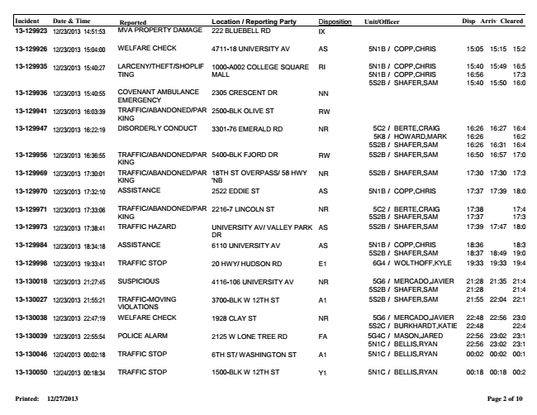

Incident Date & Time Reported Location / Reporting Party Disposition Unit/Officer Disp Arriv Cleared 13-129923 12/23/2013 14:51:53 MVA PROPERTY DAMAGE 222 BLUEBELL RD IX 13-129926 12/23/2013 15:04:00 WELFARE CHECK 4711-18 UNIVERSITY AV AS 5N1B / COPP,CHRIS 15:05 15:15 15:22 13-129935 12/23/2013 15:40:27

LARCENY/THEFT/SHOPLIF

1000-A002 COLLEGE SQUARE

RI 5N1B / COPP,CHRIS 15:40 15:49 16:56 TING

MALL

5N1B / COPP,CHRIS 16:56 17:33 5S2B / SHAFER,SAM 15:40 15:50 16:01 13-129936 12/23/2013 15:40:55

COVENANT AMBULANCE 2305 CRESCENT DR EMERGENCY NN 13-129941 12/23/2013 16:03:39

TRAFFIC/ABANDONED/PAR KING 2500-BLK OLIVE ST RW 13-129947 12/23/2013 16:22:19

DISORDERLY CONDUCT 3301-76 EMERALD RD NR 5C2 /

BERTE,CRAIG 16:26 16:27 16:49 5K8 / HOWARD,MARK 16:26 16:26 5S2B / SHAFER,SAM 16:26 16:31 16:49 13-129956 12/23/2013 16:36:55

TRAFFIC/ABANDONED/PAR KING 5400-BLK FJORD DR RW 5S2B / SHAFER,SAM 16:50 16:57 17:03 13-129969 12/23/2013 17:30:01

TRAFFIC/ABANDONED/PAR

18TH ST OVERPASS/ 58 HWY NR 5S2B / SHAFER,SAM 17:30 17:30 17:35 KING

'NB 13-129970 12/23/2013 17:32:10 ASSISTANCE 2522 EDDIE ST AS 5N1B / COPP,CHRIS 17:37 17:39 18:08 13-129971 12/23/2013 17:33:06

TRAFFIC/ABANDONED/PAR KING

2216-7 LINCOLN ST NR 5C2 /

BERTE,CRAIG 17:38 17:43 5S2B / SHAFER,SAM 17:37 17:38 13-129973 12/23/2013 17:38:41

TRAFFIC HAZARD UNIVERSITY AV/ VALLEY PARK

AS 5S2B / SHAFER,SAM 17:39 17:47 18:00 DR 13-129984 12/23/2013 18:34:18

ASSISTANCE 6110 UNIVERSITY AV AS 5N1B /

COPP,CHRIS 18:36 18:37 5S2B / SHAFER,SAM 18:37 18:49 19:04 13-129998 12/23/2013 19:33:41 TRAFFIC STOP 20 HWY/ HUDSON RD E1 6G4 / WOLTHOFF,KYLE 19:33 19:33 19:40 13-130018 12/23/2013 21:27:45

SUSPICIOUS 4116-106 UNIVERSITY AV NR 5G6 /

MERCADO,JAVIER 21:28 21:35 21:41 5S2B / SHAFER,SAM 21:28 21:41 13-130027 12/23/2013 21:55:21

TRAFFIC-MOVING 3700-BLK W 12TH ST A1 5S2B / SHAFER,SAM 21:55 22:04 22:12 VIOLATIONS 13-130038 12/23/2013 22:47:19

WELFARE CHECK 1928 CLAY ST NR 5G6 /

MERCADO,JAVIER 22:48 22:56 23:06 5S2C / BURKHARDT,KATIE 22:48 22:48 13-130039 12/23/2013 22:55:54

POLICE ALARM 2125 W LONE TREE RD FA 5G4C /

MASON,JARED 22:56 23:02 23:11 5N1C / BELLIS,RYAN 22:56 23:02 23:13 13-130046 12/24/2013 00:02:18 TRAFFIC STOP 6TH ST/ WASHINGTON ST A1 5N1C / BELLIS,RYAN 00:02 00:02 00:10 13-130050 12/24/2013 00:18:34 TRAFFIC STOP 1500-BLK W 12TH ST Y1 5N1C / BELLIS,RYAN 00:18 00:18 00:23 Printed: 12/27/2013

**Page 2 of 10**

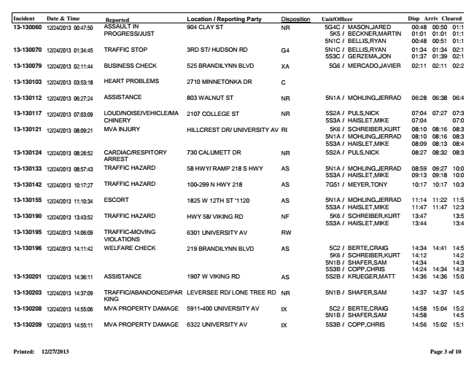

Incident Date & Time Reported Location / Reporting Party Disposition Unit/Officer Disp Arriv Cleared 13-130060 12/24/2013 00:47:50

ASSAULT IN

904 CLAY ST NR 5G4C / MASON,JARED 00:48 00:50 01:16 PROGRESS/JUST

5K5 / BECKNER,MARTIN 01:01 01:01 01:16 5N1C / BELLIS,RYAN 00:48 00:51 01:16 13-130070 12/24/2013 01:34:45

TRAFFIC STOP 3RD ST/ HUDSON RD G4 5N1C /

BELLIS,RYAN 01:34 01:34 02:12 5S3C / GERZEMA,JON 01:37 01:39 02:12 13-130079 12/24/2013 02:11:44 BUSINESS CHECK 525 BRANDILYNN BLVD XA 5G6 / MERCADO,JAVIER 02:11 02:11 02:28 13-130103 12/24/2013 03:53:18 HEART PROBLEMS 2710 MINNETONKA DR C 13-130112 12/24/2013 06:27:24 ASSISTANCE 803 WALNUT ST NR 5N1A / MOHLING,JERRAD 06:28 06:38 06:49 13-130117 12/24/2013 07:03:09

LOUD/NOISE/VEHICLE/MA

2107 COLLEGE ST NR 5S2A / PULS,NICK 07:04 07:27 07:36 CHINERY

5S3A / HAISLET,MIKE 07:04 07:04 13-130121 12/24/2013 08:09:21

MVA INJURY HILLCREST DR/ UNIVERSITY AV RI 5K6 /

SCHREIBER,KURT 08:10 08:16 08:38 5N1A / MOHLING,JERRAD 08:10 08:16 08:36 5S3A / HAISLET,MIKE 08:09 08:13 08:47 13-130124 12/24/2013 08:26:52

CARDIAC/RESPITORY 730 CALUMETT DR NR 5S2A / PULS,NICK 08:27 08:32 08:33 ARREST 13-130133 12/24/2013 08:57:43

TRAFFIC HAZARD 58 HWY/ RAMP 218 S HWY AS 5N1A /

MOHLING,JERRAD 08:59 09:27 10:00 5S3A / HAISLET,MIKE 09:13 09:18 10:00 13-130142 12/24/2013 10:17:27 TRAFFIC HAZARD 100-299 N HWY 218 AS 7G51 / MEYER,TONY 10:17 10:17 10:32 13-130155 12/24/2013 11:10:34

ESCORT 1825 W 12TH ST '1120 AS 5N1A /

MOHLING,JERRAD 11:14 11:22 11:57 5S3A / HAISLET,MIKE 11:47 11:47 12:39 13-130190 12/24/2013 13:43:52

TRAFFIC HAZARD HWY 58/ VIKING RD NF 5K6 /

SCHREIBER,KURT 13:47 13:59 5S3A / HAISLET,MIKE 13:44 13:47 13-130195 12/24/2013 14:06:09

TRAFFIC-MOVING VIOLATIONS 6301 UNIVERSITY AV RW 13-130196 12/24/2013 14:11:42

WELFARE CHECK 219 BRANDILYNN BLVD AS 5C2 /

BERTE,CRAIG 14:34 14:41 14:52 5K6 / SCHREIBER,KURT 14:12 14:24 5N1B / SHAFER,SAM 14:34 14:35 5S3B / COPP,CHRIS 14:24 14:34 14:35 13-130201 12/24/2013 14:36:11 ASSISTANCE 1907 W VIKING RD AS 5S2B / KRUEGER,MATT 14:36 14:36 15:02 13-130203 12/24/2013 14:37:09

TRAFFIC/ABANDONED/PAR LEVERSEE RD/ LONE TREE RD NR 5N1B / SHAFER,SAM 14:37 14:37 14:50 KING 13-130208 12/24/2013 14:55:06

MVA PROPERTY DAMAGE 5911-400 UNIVERSITY AV IX 5C2 /

BERTE,CRAIG 14:58 15:04 15:28 5N1B / SHAFER,SAM 14:58 14:58 13-130209 12/24/2013 14:55:11 MVA PROPERTY DAMAGE 6322 UNIVERSITY AV IX 5S3B / COPP,CHRIS 14:56 15:02 15:15 Printed: 12/27/2013

**Page 3 of 10**

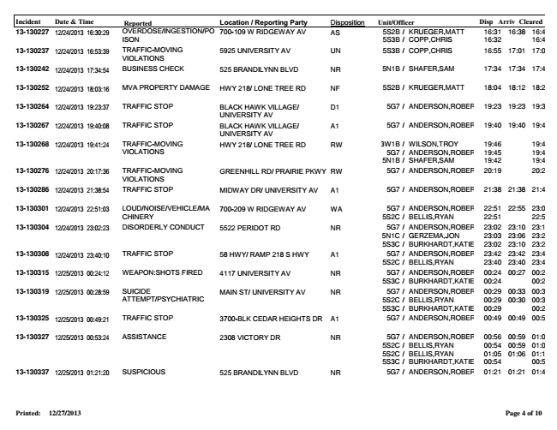

Incident Date & Time Reported Location / Reporting Party Disposition Unit/Officer Disp Arriv Cleared 13-130227 12/24/2013 16:30:29

OVERDOSE/INGESTION/PO

700-109 W RIDGEWAY AV AS 5S2B / KRUEGER,MATT 16:31 16:38 16:45 ISON

5S3B / COPP,CHRIS 16:32 16:45 13-130237 12/24/2013 16:53:39

TRAFFIC-MOVING VIOLATIONS 5925 UNIVERSITY AV UN 5S3B / COPP,CHRIS 16:55 17:01 17:06 13-130242 12/24/2013 17:34:54 BUSINESS CHECK 525 BRANDILYNN BLVD NR 5N1B / SHAFER,SAM 17:34 17:34 17:46 13-130252 12/24/2013 18:03:16 MVA PROPERTY DAMAGE HWY 218/ LONE TREE RD NF 5S2B / KRUEGER,MATT 18:04 18:12 18:24 13-130264 12/24/2013 19:23:37

TRAFFIC STOP BLACK HAWK VILLAGE/

D1 5G7 / ANDERSON,ROBERT 19:23 19:23 19:30 UNIVERSITY AV 13-130267 12/24/2013 19:40:08

TRAFFIC STOP BLACK HAWK VILLAGE/

A1 5G7 / ANDERSON,ROBERT 19:40 19:40 19:45 UNIVERSITY AV 13-130268 12/24/2013 19:41:24

TRAFFIC-MOVING VIOLATIONS

HWY 218/ LONE TREE RD RW 3W1B /

WILSON,TROY 19:46 19:48 5G7 / ANDERSON,ROBERT 19:45 19:45 5N1B / SHAFER,SAM 19:42 19:42 13-130276 12/24/2013 20:17:36

TRAFFIC-MOVING GREENHILL RD/ PRAIRIE PKWY RW 5G7 / ANDERSON,ROBERT 20:19 20:27 VIOLATIONS 13-130286 12/24/2013 21:38:54 TRAFFIC STOP MIDWAY DR/ UNIVERSITY AV A1 5G7 / ANDERSON,ROBERT 21:38 21:38 21:45 13-130301 12/24/2013 22:51:03

LOUD/NOISE/VEHICLE/MA

700-209 W RIDGEWAY AV WA 5G7 / ANDERSON,ROBERT 22:51 22:55 23:00 CHINERY

5S2C / BELLIS,RYAN 22:51 22:52 13-130304 12/24/2013 23:02:23

DISORDERLY CONDUCT 5522 PERIDOT RD NR 5G7 /

ANDERSON,ROBERT 23:02 23:10 23:11 5N1C / GERZEMA,JON 23:03 23:06 23:26 5S3C / BURKHARDT,KATIE 23:02 23:10 23:20 13-130308 12/24/2013 23:40:10

TRAFFIC STOP 58 HWY/ RAMP 218 S HWY A1 5G7 /

ANDERSON,ROBERT 23:42 23:42 23:44 5S2C / BELLIS,RYAN 23:40 23:40 23:46 13-130315 12/25/2013 00:24:12

WEAPON:SHOTS FIRED 4117 UNIVERSITY AV NR 5G7 /

ANDERSON,ROBERT 00:24 00:27 00:29 5S3C / BURKHARDT,KATIE 00:24 00:27 13-130319 12/25/2013 00:28:59

SUICIDE ATTEMPT/PSYCHIATRIC

MAIN ST/ UNIVERSITY AV NR 5G7 /

ANDERSON,ROBERT 00:29 00:33 00:37 5S2C / BELLIS,RYAN 00:29 00:30 00:38 5S3C / BURKHARDT,KATIE 00:29 00:29 13-130325 12/25/2013 00:49:21 TRAFFIC STOP 3700-BLK CEDAR HEIGHTS DR A1 5G7 / ANDERSON,ROBERT 00:49 00:49 00:55 13-130327 12/25/2013 00:53:24

ASSISTANCE 2308 VICTORY DR NR 5G7 /

ANDERSON,ROBERT 00:56 00:59 01:02 5S2C / BELLIS,RYAN 00:54 00:59 01:02 5S2C / BELLIS,RYAN 01:05 01:06 01:16 5S3C / BURKHARDT,KATIE 00:54 00:54 13-130337 12/25/2013 01:21:20 SUSPICIOUS 525 BRANDILYNN BLVD NR 5G7 / ANDERSON,ROBERT 01:21 01:21 01:42 Printed: 12/27/2013

**Page 4 of 10**

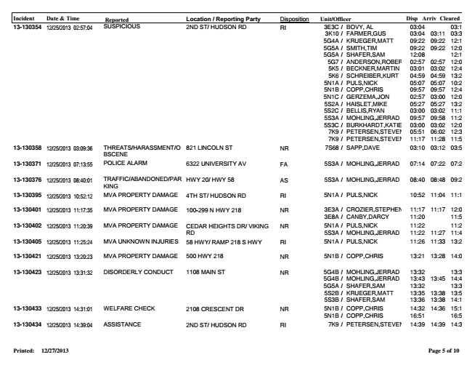

Incident Date & Time Reported Location / Reporting Party Disposition Unit/Officer Disp Arriv Cleared 13-130354 12/25/2013 02:57:04

SUSPICIOUS 2ND ST/ HUDSON RD RI 3E3C /

BOVY, AL 03:04 03:19 3K10 / FARMER,GUS 03:04 03:11 03:34 5G4A / KRUEGER,MATT 09:22 09:22 12:18 5G5A / SMITH,TIM 09:22 09:22 12:06 5G5A / SHAFER,SAM 12:08 12:18 5G7 / ANDERSON,ROBERT 02:57 02:57 12:06 5K5 / BECKNER,MARTIN 03:01 03:02 12:49 5K6 / SCHREIBER,KURT 04:59 04:59 13:23 5N1A / PULS,NICK 05:07 05:07 10:29 5N1B / COPP,CHRIS 09:57 09:57 12:40 5N1C / GERZEMA,JON 02:57 03:00 12:06 5S2A / HAISLET,MIKE 05:27 05:27 13:25 5S2C / BELLIS,RYAN 03:00 03:02 11:14 5S3A / MOHLING,JERRAD 09:57 09:58 11:22 5S3C / BURKHARDT,KATIE 03:00 03:02 12:07 7K9 / PETERSEN,STEVEN 05:51 06:02 12:38 7K9 / PETERSEN,STEVEN 11:17 11:28 11:52 13-130358 12/25/2013 03:09:36

THREATS/HARASSMENT/O BSCENE 821 LINCOLN ST NR 7S68 / SAPP,DAVE 03:10 03:12 03:55 13-130371 12/25/2013 07:13:55 POLICE ALARM 6322 UNIVERSITY AV FA 5S3A / MOHLING,JERRAD 07:14 07:22 07:24 13-130376 12/25/2013 08:40:01

TRAFFIC/ABANDONED/PAR KING HWY 20/ HWY 58 AS 5S3A / MOHLING,JERRAD 08:40 08:48 09:25 13-130395 12/25/2013 10:52:12 MVA PROPERTY DAMAGE 4TH ST/ HUDSON RD RI 5N1A / PULS,NICK 10:52 11:04 11:15 13-130401 12/25/2013 11:17:35

MVA PROPERTY DAMAGE 100-299 N HWY 218 NR 3E3A /

CROZIER,STEPHEN 11:17 11:17 12:05 3E8A / CANBY,DARCY 11:20 11:59 13-130402 12/25/2013 11:20:39

MVA PROPERTY DAMAGE CEDAR HEIGHTS DR/ VIKING

NR 5N1A / PULS,NICK 11:22 11:22 RD

5S3A / MOHLING,JERRAD 11:22 11:27 11:48 13-130405 12/25/2013 11:25:24 MVA UNKNOWN INJURIES 58 HWY/ RAMP 218 S HWY RI 5N1A / PULS,NICK 11:26 11:33 13:24 13-130421 12/25/2013 13:20:23 MVA PROPERTY DAMAGE 500 HWY 218 NR 5N1B / COPP,CHRIS 13:21 13:28 14:07 13-130423 12/25/2013 13:31:32

DISORDERLY CONDUCT 1108 MAIN ST NR 5G4B /

MOHLING,JERRAD 13:32 13:35 5G4B / MOHLING,JERRAD 13:43 13:45 14:41 5G5A / SHAFER,SAM 13:32 13:36 5S2B / KRUEGER,MATT 13:35 13:38 13:59 5S3B / SHAFER,SAM 13:36 13:38 14:14 13-130433 12/25/2013 14:31:01

WELFARE CHECK 2108 CRESCENT DR NR 5N1B /

COPP,CHRIS 14:32 14:36 15:18 5N1B / COPP,CHRIS 16:51 16:52 13-130434 12/25/2013 14:39:04 ASSISTANCE 2ND ST/ HUDSON RD RI 7K9 / PETERSEN,STEVEN 14:39 14:39 14:39 Printed: 12/27/2013

**Page 5 of 10**

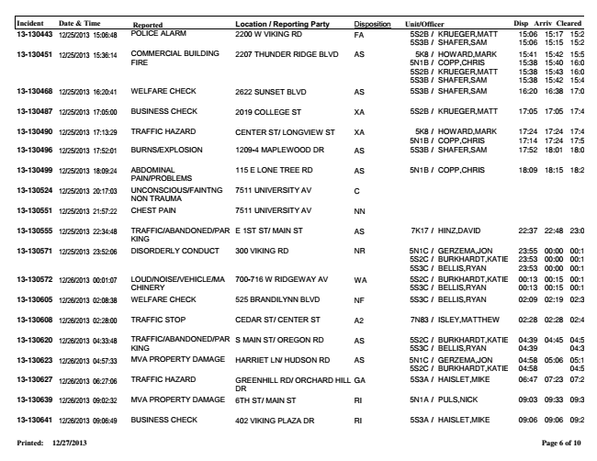

Incident Date & Time Reported Location / Reporting Party Disposition Unit/Officer Disp Arriv Cleared 13-130443 12/25/2013 15:06:48

POLICE ALARM 2200 W VIKING RD FA 5S2B /

KRUEGER,MATT 15:06 15:17 15:22 5S3B / SHAFER,SAM 15:06 15:15 15:20 13-130451 12/25/2013 15:36:14

COMMERCIAL FIRE

BUILDING

2207 THUNDER RIDGE BLVD AS 5K8 /

HOWARD,MARK 15:41 15:42 15:51 5N1B / COPP,CHRIS 15:38 15:40 16:05 5S2B / KRUEGER,MATT 15:38 15:43 16:05 5S3B / SHAFER,SAM 15:38 15:42 15:46 13-130468 12/25/2013 16:20:41 WELFARE CHECK 2622 SUNSET BLVD AS 5S3B / SHAFER,SAM 16:20 16:38 17:04 13-130487 12/25/2013 17:05:00 BUSINESS CHECK 2019 COLLEGE ST XA 5S2B / KRUEGER,MATT 17:05 17:05 17:44 13-130490 12/25/2013 17:13:29

TRAFFIC HAZARD CENTER ST/ LONGVIEW ST XA 5K8 /

HOWARD,MARK 17:24 17:24 17:44 5N1B / COPP,CHRIS 17:14 17:24 17:52 13-130496 12/25/2013 17:52:01 BURNS/EXPLOSION 1209-4 MAPLEWOOD DR AS 5S3B / SHAFER,SAM 17:52 18:01 18:09 13-130499 12/25/2013 18:09:24

ABDOMINAL 115 E LONE TREE RD AS 5N1B / COPP,CHRIS 18:09 18:15 18:24 PAIN/PROBLEMS 13-130524 12/25/2013 20:17:03

UNCONSCIOUS/FAINTNG NON TRAUMA 7511 UNIVERSITY AV C 13-130551 12/25/2013 21:57:22 CHEST PAIN 7511 UNIVERSITY AV NN 13-130555 12/25/2013 22:34:48

TRAFFIC/ABANDONED/PAR KING E 1ST ST/ MAIN ST AS 7K17 / HINZ,DAVID 22:37 22:48 23:03 13-130571 12/25/2013 23:52:06

DISORDERLY CONDUCT 300 VIKING RD NR 5N1C /

GERZEMA,JON 23:55 00:00 00:13 5S2C / BURKHARDT,KATIE 23:53 00:00 00:13 5S3C / BELLIS,RYAN 23:53 00:00 00:13 13-130572 12/26/2013 00:01:07

LOUD/NOISE/VEHICLE/MA CHINERY

700-716 W RIDGEWAY AV WA 5S2C /

BURKHARDT,KATIE 00:13 00:15 00:19 5S3C / BELLIS,RYAN 00:13 00:15 00:19 13-130605 12/26/2013 02:08:38 WELFARE CHECK 525 BRANDILYNN BLVD NF 5S3C / BELLIS,RYAN 02:09 02:19 02:30 13-130608 12/26/2013 02:28:00 TRAFFIC STOP CEDAR ST/ CENTER ST A2 7N83 / ISLEY,MATTHEW 02:28 02:28 02:41 13-130620 12/26/2013 04:33:48

TRAFFIC/ABANDONED/PAR KING

S MAIN ST/ OREGON RD AS 5S2C /

BURKHARDT,KATIE 04:39 04:45 04:56 5S3C / BELLIS,RYAN 04:39 04:39 13-130623 12/26/2013 04:57:33

MVA PROPERTY DAMAGE HARRIET LN/ HUDSON RD AS 5N1C /

GERZEMA,JON 04:58 05:06 05:12 5S2C / BURKHARDT,KATIE 04:58 04:58 13-130627 12/26/2013 06:27:06

TRAFFIC HAZARD GREENHILL RD/ ORCHARD HILL

GA 5S3A / HAISLET,MIKE 06:47 07:23 07:24 DR 13-130639 12/26/2013 09:02:32 MVA PROPERTY DAMAGE 6TH ST/ MAIN ST RI 5N1A / PULS,NICK 09:03 09:33 09:34 13-130641 12/26/2013 09:06:49 BUSINESS CHECK 402 VIKING PLAZA DR RI 5S3A / HAISLET,MIKE 09:06 09:06 09:25 Printed: 12/27/2013

**Page 6 of 10**

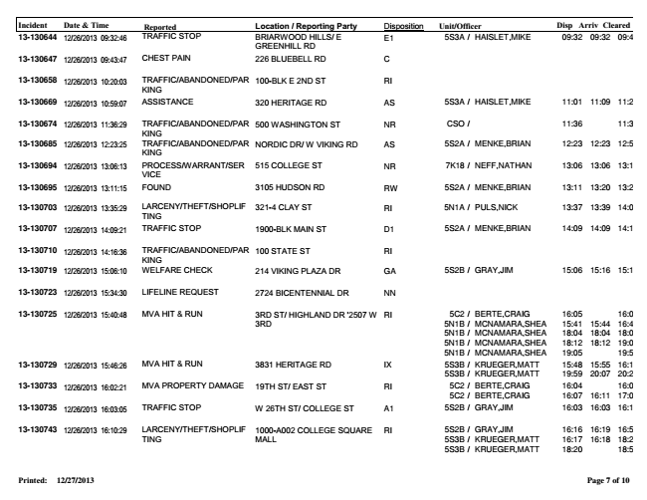

Incident Date & Time Reported Location / Reporting Party Disposition Unit/Officer Disp Arriv Cleared 13-130644 TRAFFIC STOP BRIARWOOD HILLS/ E

5S3A / HAISLET,MIKE 09:32 09:32 09:40 GREENHILL RD 12/26/2013 09:32:46 E1 13-130647 12/26/2013 09:43:47 CHEST PAIN 226 BLUEBELL RD C 13-130658 12/26/2013 10:20:03

TRAFFIC/ABANDONED/PAR 100-BLK E 2ND ST RI KING 13-130669 12/26/2013 10:59:07 ASSISTANCE 320 HERITAGE RD AS 5S3A / HAISLET,MIKE 11:01 11:09 11:21 13-130674 12/26/2013 11:36:29

TRAFFIC/ABANDONED/PAR KING 500 WASHINGTON ST NR CSO / 11:36 11:36 13-130685 12/26/2013 12:23:25

TRAFFIC/ABANDONED/PAR KING NORDIC DR/ W VIKING RD AS 5S2A / MENKE,BRIAN 12:23 12:23 12:51 13-130694 12/26/2013 13:06:13

PROCESS/WARRANT/SER VICE 515 COLLEGE ST NR 7K18 / NEFF,NATHAN 13:06 13:06 13:14 13-130695 12/26/2013 13:11:15 FOUND 3105 HUDSON RD RW 5S2A / MENKE,BRIAN 13:11 13:20 13:25 13-130703 12/26/2013 13:35:29

LARCENY/THEFT/SHOPLIF TING 321-4 CLAY ST RI 5N1A / PULS,NICK 13:37 13:39 14:03 13-130707 12/26/2013 14:09:21 TRAFFIC STOP 1900-BLK MAIN ST D1 5S2A / MENKE,BRIAN 14:09 14:09 14:11 13-130710 12/26/2013 14:16:36

TRAFFIC/ABANDONED/PAR KING 100 STATE ST RI 13-130719 12/26/2013 15:06:10 WELFARE CHECK 214 VIKING PLAZA DR GA 5S2B / GRAY,JIM 15:06 15:16 15:17 13-130723 12/26/2013 15:34:30 LIFELINE REQUEST 2724 BICENTENNIAL DR NN 13-130725 12/26/2013 15:40:48

MVA HIT & RUN 3RD ST/ HIGHLAND DR '2507 W

RI 5C2 / BERTE,CRAIG 16:05 16:07 3RD

5N1B / MCNAMARA,SHEA 15:41 15:44 16:42 5N1B / MCNAMARA,SHEA 18:04 18:04 18:08 5N1B / MCNAMARA,SHEA 18:12 18:12 19:05 5N1B / MCNAMARA,SHEA 19:05 19:50 13-130729 12/26/2013 15:46:26

MVA HIT & RUN 3831 HERITAGE RD IX 5S3B /

KRUEGER,MATT 15:48 15:55 16:16 5S3B / KRUEGER,MATT 19:59 20:07 20:22 13-130733 12/26/2013 16:02:21

MVA PROPERTY DAMAGE 19TH ST/ EAST ST RI 5C2 /

BERTE,CRAIG 16:04 16:05 5C2 / BERTE,CRAIG 16:07 16:11 17:05 13-130735 12/26/2013 16:03:05 TRAFFIC STOP W 26TH ST/ COLLEGE ST A1 5S2B / GRAY,JIM 16:03 16:03 16:16 13-130743 12/26/2013 16:10:29

LARCENY/THEFT/SHOPLIF

1000-A002 COLLEGE SQUARE

RI 5S2B / GRAY,JIM 16:16 16:19 16:55 TING

MALL

5S3B / KRUEGER,MATT 16:17 16:18 18:20 5S3B / KRUEGER,MATT 18:20 18:51 Printed: 12/27/2013

**Page 7 of 10**

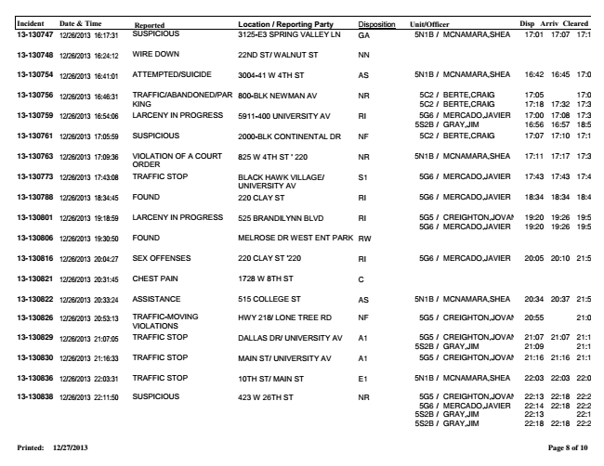

Incident Date & Time Reported Location / Reporting Party Disposition Unit/Officer Disp Arriv Cleared 13-130747 12/26/2013 16:17:31 SUSPICIOUS 3125-E3 SPRING VALLEY LN GA 5N1B / MCNAMARA,SHEA 17:01 17:07 17:10 13-130748 12/26/2013 16:24:12 WIRE DOWN 22ND ST/ WALNUT ST NN 13-130754 12/26/2013 16:41:01 ATTEMPTED/SUICIDE 3004-41 W 4TH ST AS 5N1B / MCNAMARA,SHEA 16:42 16:45 17:00 13-130756 12/26/2013 16:46:31

TRAFFIC/ABANDONED/PAR KING

800-BLK NEWMAN AV NR 5C2 /

BERTE,CRAIG 17:05 17:06 5C2 / BERTE,CRAIG 17:18 17:32 17:34 13-130759 12/26/2013 16:54:06

LARCENY IN PROGRESS 5911-400 UNIVERSITY AV RI 5G6 /

MERCADO,JAVIER 17:00 17:08 17:38 5S2B / GRAY,JIM 16:56 16:57 18:53 13-130761 12/26/2013 17:05:59 SUSPICIOUS 2000-BLK CONTINENTAL DR NF 5C2 / BERTE,CRAIG 17:07 17:10 17:18 13-130763 12/26/2013 17:09:36

VIOLATION ORDER

OF A COURT 825 W 4TH ST ' 220 NR 5N1B / MCNAMARA,SHEA 17:11 17:17 17:38 13-130773 12/26/2013 17:43:08

TRAFFIC STOP BLACK HAWK VILLAGE/

S1 5G6 / MERCADO,JAVIER 17:43 17:43 17:46 UNIVERSITY AV 13-130788 12/26/2013 18:34:45 FOUND 220 CLAY ST RI 5G6 / MERCADO,JAVIER 18:34 18:34 18:46 13-130801 12/26/2013 19:18:59

LARCENY IN PROGRESS 525 BRANDILYNN BLVD RI 5G5 /

CREIGHTON,JOVAN 19:20 19:26 19:55 5G6 / MERCADO,JAVIER 19:20 19:26 19:50 13-130806 12/26/2013 19:30:50 FOUND MELROSE DR WEST ENT PARK RW 13-130816 12/26/2013 20:04:27 SEX OFFENSES 220 CLAY ST '220 RI 5G6 / MERCADO,JAVIER 20:05 20:10 21:57 13-130821 12/26/2013 20:31:45 CHEST PAIN 1728 W 8TH ST C 13-130822 12/26/2013 20:33:24 ASSISTANCE 515 COLLEGE ST AS 5N1B / MCNAMARA,SHEA 20:34 20:37 21:59 13-130826 12/26/2013 20:53:13

TRAFFIC-MOVING HWY 218/ LONE TREE RD NF 5G5 / CREIGHTON,JOVAN 20:55 21:04 VIOLATIONS 13-130829 12/26/2013 21:07:05

TRAFFIC STOP DALLAS DR/ UNIVERSITY AV A1 5G5 /

CREIGHTON,JOVAN 21:07 21:07 21:13 5S2B / GRAY,JIM 21:09 21:12 13-130830 12/26/2013 21:16:33 TRAFFIC STOP MAIN ST/ UNIVERSITY AV A1 5G5 / CREIGHTON,JOVAN 21:16 21:16 21:18 13-130836 12/26/2013 22:03:31 TRAFFIC STOP 10TH ST/ MAIN ST E1 5N1B / MCNAMARA,SHEA 22:03 22:03 22:07 13-130838 12/26/2013 22:11:50

SUSPICIOUS 423 W 26TH ST NR 5G5 /

CREIGHTON,JOVAN 22:13 22:18 22:21 5G6 / MERCADO,JAVIER 22:14 22:18 22:21 5S2B / GRAY,JIM 22:13 22:13 5S2B / GRAY,JIM 22:18 22:18 22:21 Printed: 12/27/2013

**Page 8 of 10**

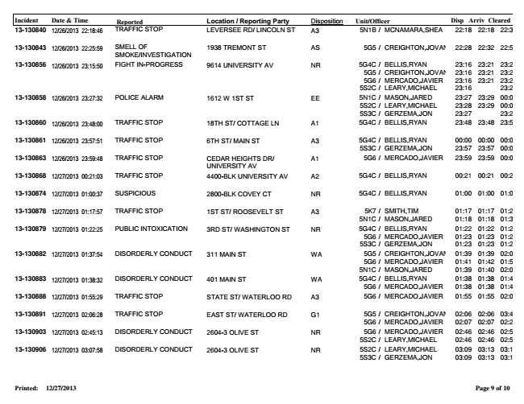

Incident Date & Time Reported Location / Reporting Party Disposition Unit/Officer Disp Arriv Cleared 13-130840 12/26/2013 22:18:46 TRAFFIC STOP LEVERSEE RD/ LINCOLN ST A3 5N1B / MCNAMARA,SHEA 22:18 22:18 22:38 13-130843 SMELL OF 5G5 / CREIGHTON,JOVAN 22:28 22:32 22:51 SMOKE/INVESTIGATION 12/26/2013 22:25:59 1938 TREMONT ST AS 13-130856 12/26/2013 23:15:50

FIGHT IN-PROGRESS 9614 UNIVERSITY AV NR 5G4C /

BELLIS,RYAN 23:16 23:21 23:29 5G5 / CREIGHTON,JOVAN 23:16 23:21 23:28 5G6 / MERCADO,JAVIER 23:16 23:21 23:29 5S2C / LEARY,MICHAEL 23:16 23:28 13-130858 12/26/2013 23:27:32

POLICE ALARM 1612 W 1ST ST EE 5N1C /

MASON,JARED 23:27 23:29 00:06 5S2C / LEARY,MICHAEL 23:28 23:29 00:06 5S3C / GERZEMA,JON 23:27 23:28 13-130860 12/26/2013 23:48:00 TRAFFIC STOP 18TH ST/ COTTAGE LN A1 5G4C / BELLIS,RYAN 23:48 23:48 23:52 13-130861 12/26/2013 23:57:51

TRAFFIC STOP 6TH ST/ MAIN ST A3 5G4C /

BELLIS,RYAN 00:00 00:00 00:02 5S3C / GERZEMA,JON 23:57 23:57 00:09 13-130863 12/26/2013 23:59:48

TRAFFIC STOP CEDAR HEIGHTS DR/

A1 5G6 / MERCADO,JAVIER 23:59 23:59 00:05 UNIVERSITY AV 13-130868 12/27/2013 00:21:03 TRAFFIC STOP 4400-BLK UNIVERSITY AV A2 5G4C / BELLIS,RYAN 00:21 00:21 00:28 13-130874 12/27/2013 01:00:37 SUSPICIOUS 2800-BLK COVEY CT NR 5G4C / BELLIS,RYAN 01:00 01:00 01:03 13-130878 12/27/2013 01:17:57

TRAFFIC STOP 1ST ST/ ROOSEVELT ST A3 5K7 /

SMITH,TIM 01:17 01:17 01:27 5N1C / MASON,JARED 01:18 01:18 01:34 13-130879 12/27/2013 01:22:25

PUBLIC INTOXICATION 3RD ST/ WASHINGTON ST NR 5G4C /

BELLIS,RYAN 01:22 01:22 01:28 5G6 / MERCADO,JAVIER 01:23 01:23 01:28 5S3C / GERZEMA,JON 01:23 01:23 01:23 13-130882 12/27/2013 01:37:54

DISORDERLY CONDUCT 311 MAIN ST WA 5G5 /

CREIGHTON,JOVAN 01:39 01:39 02:00 5G6 / MERCADO,JAVIER 01:41 01:42 01:55 5N1C / MASON,JARED 01:39 01:40 02:00 13-130883 12/27/2013 01:38:32

DISORDERLY CONDUCT 401 MAIN ST WA 5G4C /

BELLIS,RYAN 01:38 01:38 01:40 5G6 / MERCADO,JAVIER 01:38 01:38 01:40 13-130888 12/27/2013 01:55:29 TRAFFIC STOP STATE ST/ WATERLOO RD A3 5G6 / MERCADO,JAVIER 01:55 01:55 02:04 13-130891 12/27/2013 02:06:28

TRAFFIC STOP EAST ST/ WATERLOO RD G1 5G5 /

CREIGHTON,JOVAN 02:06 02:06 03:49 5G6 / MERCADO,JAVIER 02:07 02:07 02:23 13-130903 12/27/2013 02:45:13

DISORDERLY CONDUCT 2604-3 OLIVE ST NR 5G6 /

MERCADO,JAVIER 02:46 02:46 02:52 5S2C / LEARY,MICHAEL 02:46 02:46 02:53 13-130906 12/27/2013 03:07:58

DISORDERLY CONDUCT 2604-3 OLIVE ST NR 5S2C /

LEARY,MICHAEL 03:09 03:13 03:18 5S3C / GERZEMA,JON 03:09 03:13 03:18 Printed: 12/27/2013

**Page 9 of 10**

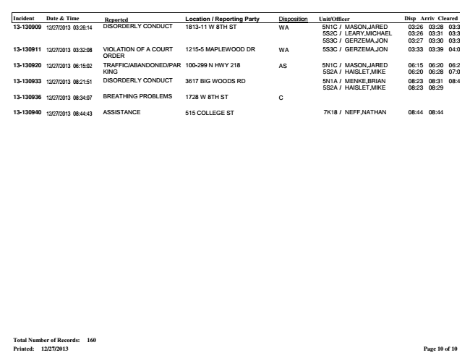

Incident Date & Time Reported Location / Reporting Party Disposition Unit/Officer Disp Arriv Cleared 13-130909 12/27/2013 03:26:14

DISORDERLY CONDUCT 1813-11 W 8TH ST WA 5N1C /

MASON,JARED 03:26 03:28 03:39 5S2C / LEARY,MICHAEL 03:26 03:31 03:39 5S3C / GERZEMA,JON 03:27 03:30 03:33 13-130911 12/27/2013 03:32:08

VIOLATION ORDER

OF A COURT 1215-5 MAPLEWOOD DR WA 5S3C / GERZEMA,JON 03:33 03:39 04:03 13-130920 12/27/2013 06:15:02

TRAFFIC/ABANDONED/PAR KING

100-299 N HWY 218 AS 5N1C /

MASON,JARED 06:15 06:20 06:28 5S2A / HAISLET,MIKE 06:20 06:28 07:05 13-130933 12/27/2013 08:21:51

DISORDERLY CONDUCT 3617 BIG WOODS RD 5N1A /

MENKE,BRIAN 08:23 08:31 08:43 5S2A / HAISLET,MIKE 08:23 08:29 13-130936 12/27/2013 08:34:07 BREATHING PROBLEMS 1728 W 8TH ST C 13-130940 12/27/2013 08:44:43 ASSISTANCE 515 COLLEGE ST 7K18 / NEFF,NATHAN 08:44 08:44 Total Number of Records: 160 Printed: 12/27/2013

**Page 10 of 10**