JS-FW-TASK-1

**1.Difference between HTTP1.1 vs HTTP2**

**HTTP 1.1:**

HTTP1.1 loads resources one after the other.so if one resource cannot be loaded, it blocks all the other resources behind it.

HTTP1.1 used to process text commands to complete request-response cycles.

HTTP1.1 server only serves content to a client device if the client asks for it and it is not always practical for modern webpages.

To Speed up web performance, compress HTTP messages to make them smaller.

**HTTP 2:**

HTTP/2 is able to use a Single TCP connection to send multiple streams of data at once. So that no resources can be blocked.

HTTP does this by splitting data into binary-code messages and numbering these messages.

HTTP/2 solves this problem by allowing a server to “push” –content to a client before the client asks for it. The server also sends a message letting the client know what pushed content to expect.

HTTP/2 uses a more advanced compression method called HPACK- it removes duplicates from HTTP header packets.

2. HTTP Version History:

**HTTP-(HyperText Transfer Protocol) was developed by Tim Berners-lee and his team in 1989-1991.**

**HTTP** is the underlying protocol of the World Wide Web.

HTTP functions as a request-response protocol in the client-server computing model.

HTTP has four versions: -HTTP/0.9,HTTP/1.0,HTTP/1.1, and HTTP/2.0.

HTTP/0.9-The One-line Protocol

* A simple client-server protocol.
* It will support only GET method.
* Cannot transfer other file types.
* There were no HTTP headers, only HTML files could be transmitted.

**HTTP/1.0 –Building Extensibility**

* Browser-friendly Protocol.
* GET, HEAD, POST methods are supported.
* Ability to transmit files other than HTML files.

**HTTP/1.1—Standardized Protocol**

🡪Currently common in use.

🡪 Persistent and pipelined connections, chunked transfers, compression/decompression, content negotiations, virtual hosting (a server with a single IP Address hosting multiple domains)

🡪GET, HEAD, POST, PUT, DELETE, TRACE, OPTIONS methods are supported.

🡪Long-lived connection.

**HTTPS:**

🡪Hyper Text Transfer Protocol Secure (HTTPS) is the secure version of HTTP. It uses SSL/TLS for secure encrypted communications.

🡪Originally developed by Netscape in mid-1990s.

🡪SSL (Secure Socket Layer) is a cryptographic protocol enhancement to HTTP, which defines how client and server should communicate with each other securely. TLS (Transport Layer Security) is the successor of SSL

🡪 SSL/TLS handshake process consumes a significant time before establishing an HTTPS connection.

**HTTP/2---Greater performance Protocol**

🡪 An alternative way of exchanging data between client and server, by implementing an experimental protocol SPDY. By Google demonstration.

🡪SPDY served as the foundations of HTTP/2 protocol.

🡪Developers can work on both browsers and severs.

🡪Increase in responsiveness and solve the problem of duplication of data transmitted.

**3. List 5 difference between Browser JS(console) vs Nodejs**

1. Building apps that run in the browser is a completely different thing than building a Node.js application.

2. In Browser we are interacting with the DOM or Web API’s, In Node they don’t have document, window and all the other objects.

3. In Browser “this” is a reference to the window object and it’s a global namespace. But In Node “this” is simply not a reference to the global namespace.

4. Node processes request object whereas Browsers processes response objects.

5. Node and Browser executes JavaScript, But Node does that in server side and browsers in client side.

**4. Abstract Working of JS engine(V8).**

V8 is a javascript engine developed by Google. It's an open-source project, written in C++. V8 can be used as standalone too.

There are several steps that the V8 engine takes to convert your code.

[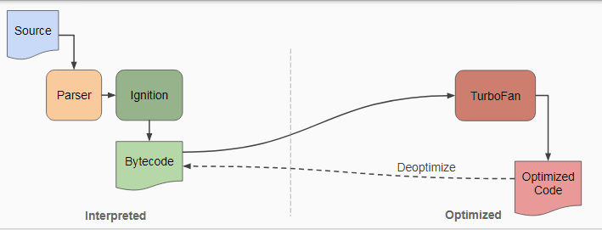](https://res.cloudinary.com/practicaldev/image/fetch/s--wH5F8J_H--/c_limit%2Cf_auto%2Cfl_progressive%2Cq_auto%2Cw_880/https:/i.imgur.com/gPpbzQ0.png)

**Parsing**

The first step is to convert into AST (Abstract Syntax Tree). Parser takes the code and parses it into AST.  
Abstract Syntax Tree is a tree representation of the source code.

There are two steps in this phase,

* Lexical Analysis
* Syntactical Analysis

**Lexical Analysis**

Before we parse the code into an AST, we first convert it into Tokens. A Scanner consumes a stream of Unicode characters, combine it into tokens, and remove all the whitespace, newlines and comments, etc.  
These tokens are keywords, operators, etc.

**Syntax Analysis**

Once the engine converts your code into tokens, again convert tokens into AST using V8 parser and the language syntax validation happens- is called Syntax Analysis.

**Ignition**

The heart of the V8 engine is Ignition and Turbo Fan. Ignition is the component that helps to interpret your byte code Then this bytecode is interpreted by a high-performance interpreter.

**Turbo Fan**

Turbo Fan is an optimizing Compiler, which compiles your code to an optimized Machine language. It generates an extremely fast Machine Code.

5. What happens when you type a URL in the address bar in the browser?

1. Enter URL in the browser tab

2. The browser looks up the IP address for the domain name via DNS.

3. The browser initiates a TCP Connection with the server

4. The browser sends a HTTP request to the server.

5. The server sends back a HTTP response.

6. The browser displays the HTML Content.