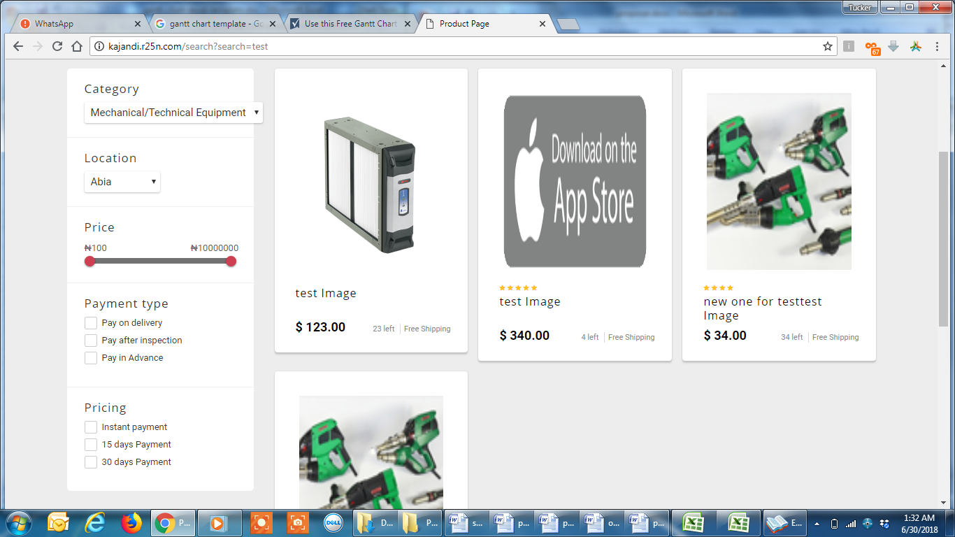

Please add units as part of the filters here.

Units include

* Piece
* Gallon
* Liter
* Carton
* Drum
* And many more

Units are added in admin and selected for each product