Usage of PIC hardware resources

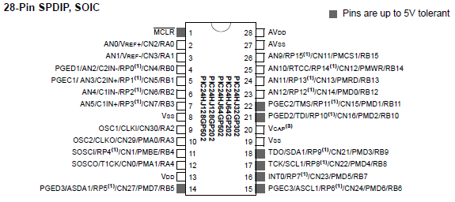

PIC Pin mapping

Description | PIC24  pin |  | PIC24  pin | Description
-MCLR / ICSP Reset | 1 |  | 28 | AVDD – 3.3 volt
RA0 - DS18 temp | 2 |  | 27 | AVSS – GND
RA1 - -CS | 3 |  | 26 | AN9 - Vbatt
RP0 – MOSI | 4 |  | 25
RP1 – SCLK | 5 |  | 24 | RP13 – RX2
RP2 – MISO | 6 |  | 23 | RP12 – TX2
RP3 – TRCLK | 7 |  | 22 | PGEC2 – ICSP Clock
Vss – GND | 8 |  | 21 | PGED2 – ICSP Data
RA2 - LED1 | 9 |  | 20 | Vcap
RA3 - LED2 | 10 |  | 19 | Vss – GND
RP4 – DT | 11 |  | 18 | SDA1 - I2C
RA4 - -PAenable | 12 |  | 17 | SCL1 - I2C
Vdd – 3.3 volt | 13 |  | 16 | RP7 - RX1
RP5 – DR | 14 |  | 15 | RP6 - TX1

ADF7242 digital IO pins

Seen from top to bottom as they approach the PIC:
Pin # | Name | Function
24 | -CS | SPI Chip Select
23 | MOSI | SPI Serial Input
22 | SCLK | SPI Clock Input
21 | MISO | SPI Serial Output
19 | TRCLK_CKO_GP3 | SPORT Bit Clock Output
17 | DT_GP1 | SPORT Transmit Data Input
16 | DR_GP0 | SPORT Receive Data Output

