Appendix A: Components of the Toolkit

This appendix summarizes the components that make up the Community Information Toolkit. These components include:

- Guidebook: The book you are now reading is the Guidebook portion of the Toolkit. It serves as a common starting point for all participants in a new community information network.
- Videos: A series of four training videos useful for giving an overview of basic topics to members of your community networking team. Video 1 is a documentary-style video offering observations of experts and from pioneering community networks in Michigan.
The remaining videos provide topical training, and are each 35 to 45 minutes in length.
- Introduction to Community Networking.
- Beginning Webmastering: an overview of HTML, an introduction to authoring tools, how to use scanners, digital cameras, and image editing software. Length: 28 minutes, 30 seconds.
- Advanced Web Content Choices: understanding image maps, animated GIFs, Shockwave, JavaScript, Java, ActiveX, Active Server Pages, and VRML.
- Web Site Maintenance and Administration: Understanding how to run your own server.
- Training Materials: A set of PowerPoint presentations on basic Web publishing, FrontPage, and principles of Web design, suitable for your use in training activities.
- Software: A set of demonstration application programs that allow you to publish a database-driven community calendar, to support on online community forum, and to administer users who are authorized to manage the calendar and forum functions. Chapter 10 of the Guidebook provides an overview of the software.

Originally, the Toolkit was distributed to a core set of public libraries in Michigan under the terms of the original grant that funded its creation. Those institutions received:

- The Guidebook in printed form.
- The videos on VHS tapes.
- A CD-ROM with the Guidebook in Adobe Acrobat PDF and Microsoft Word formats, the videos in RealVideo format, and the training materials in PowerPoint and PDF formats.

You can obtain source versions of all these materials from the Web site. The official Web address of the Toolkit is:

http://www.mel.org/citoolkit

You may wish to obtain additional copies of the Toolkit materials, such as VHS tapes of the training videos. See the Toolkit Web site for up-to-date information on the possibility of ordering such materials for a fee from a dub house.

Images depicting the speakers, topics, and organizations covered in the Toolkit video series:

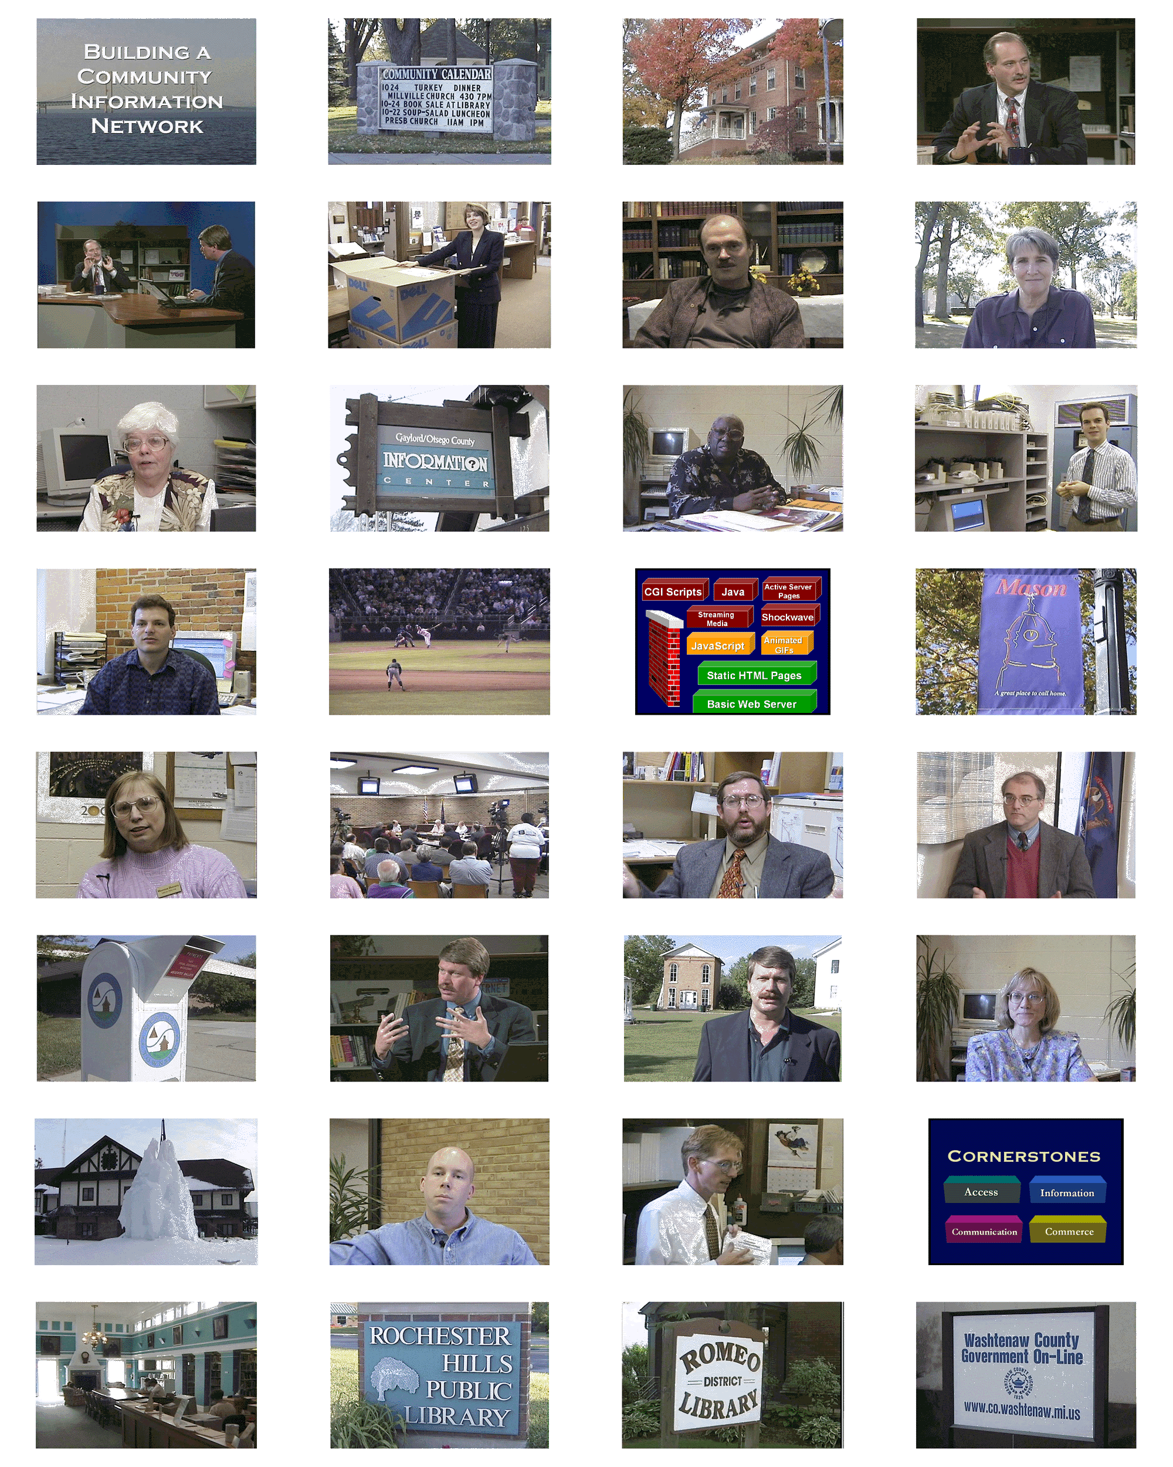
Key: Title slide; community calendar in Stockbridge, MI; Chelsea District Library; Dr. Charles Severance in training video; Severance and co-host Richard Wiggins; Cindy McIntyre, Romeo District Library; Steve Cisler, community networking expert; Cynthia Stilley, Flint Public Library; Dr. Joan Durrance, University of Michigan School of Information; Gaylord Visitor Information Center; Gloria Coles, Director, Flint Public Library; Larry Neal, Rochester Hills Public Library; Lou Rosenfeld, Information Architecture author; Lansing Lugnuts game; diagram from video; banner in Mason; Maureen Derenzy, Director, Otsego County Public Library; township meeting, Meridian Township; Mike Mosher, Merit (and Genesee Freenet founder); George Needham, state librarian; payments box in Meridian Twp; narrator; narrator in Meridian Historical Village; Kay Schwarz, Flint Public Library; community building in Gaylord, Michigan; Todd White, Merit; Richard Truxall, The Library Network; diagram; Mackinac Island Public Library; Rochester Hills sign; Romeo sign; Washtenaw County sign.

